### SUPPORT

### User Guide

**Copyright Agreement**

The purchase and use of all Software and Services is subject to the Agreement as defined in CloudActiv8’s “Click-Accept” EULA as updated from time to time by CloudActiv8 at http:/[/www.CloudActiv8.com](http://www.kaseya.com/jp/legal.aspx)/legal.aspx. If Customer does not agree with the Agreement, please do not install, use or purchase any Software and Services from CloudActiv8 as continued use of the Software or Services indicates Customer’s acceptance of the Agreement.”

Contents

SUPPORT 1

User Guide 1

About the Guide 8

How to Navigate the Software 11

Edit Access by URL 14

Dashboard (Home) 14

Custom Fields 25

Company News 27

Holidays 28

Single Sign On 29

Business Process 30

Workflow 33

HR (in Admin) 38

Service Types 39

Security 40

Roles 40

Scopes 43

Finance (in Admin) 43

Roles 43

Work Type 44

Services 45

Expense Type 46

Milestone Type 48

Account Type 48

Account Code 49

Discount Type 50

Charge Type 50

Billing Configuration 51

Sales Tax Items 52

Exchange Rates 53

Class List 53

Service Desk (in Admin) 54

Issue Types 54

Ticket Types 55

Queues 55

Priorities 56

SLAs 57

Ticket Statuses 59

Email Parser 60

Survey Integration Settings 62

Internal Survey Scores 63

RMM Integration Settings - CloudActiv8 v1 63

RMM Integration Settings - CloudActiv8 v2 – New 71

RMM Integration Settings - CloudActiv8 v2 – Upgrade 81

RMM Integration Settings – Continuum 85

Inventory (in Admin) 90

Warehouses 90

Product Categories 91

Email Logs 92

Import Data 92

Dashboard 94

Departments 94

Job Titles 95

Skill Categories 95

Employees 96

Contact Information 98

Wages 99

Shifts 100

Associated Clients 101

Associated Queues 101

Custom Fields (for Employees) 102

Employee Roles 103

Security Roles 103

Attachments (for Employees) 104

Education 105

Skills 106

Organizational Chart 107

Dashboard (Finance) 108

108

Contracts 109

Time and Materials 109

Recurring Services 111

Fixed Price 113

Retainer By Amount 116

Retainer By Hours 117

Billing Automation 119

Billing Review 125

Labor Hours 125

Expenses 126

Recurring Services 128

Fixed Price Milestone 129

Retainer Amount 130

Retainer Hours 131

Billing 133

Invoices 134

Invoice Discounts 136

Invoice Receipts 138

Invoice Attachments 138

Generate and Preview 138

Resetting a Posted Invoice 140

Sending an Invoice 140

Voiding an Invoice 141

Payments 142

Vendor Bills 142

Reimbursements 144

QuickBooks Integration 145

Dashboard 146

Accounts 147

Locations 150

Contacts 151

Assigned Resources 153

Email Domains 153

Tax Settings 154

Opportunities 154

Activities 155

Linked Accounts 156

Custom Fields (for Accounts) 158

Attachments (for Accounts) 158

RMM Integration 159

Contacts 159

Activities 161

Opportunities 163

Quotations 165

Service Quotations 166

Product Quotations 168

Processing Service Quotations 170

Processing Product Quotations 172

Sales Orders 173

Processing Sales Orders 175

Sites 177

Service Desk Dashboard 178

My Tickets 179

Tickets 179

Creating/Editing Tickets 180

Processing Tickets 181

Adding Notes to Tickets 183

Adding Time to Tickets 184

Adding Expenses to Tickets 186

Adding Charges to Tickets 187

Adding Service Calls to Tickets 188

Adding To-Dos to Tickets 189

Adding Related Tickets 190

Custom Fields, Attachments for Tickets 190

Batch Actions for Tickets 190

Unknown Tickets 191

Hardware Assets 192

Software Assets 194

Knowledgebase 195

Recurring Master Tickets 196

Service Calls 198

Projects Dashboard 199

Projects 200

Creating a New Project 201

Adding/Viewing Project Financials 202

Adding Related Opportunities to Projects 204

Adding Expenses to Projects 204

Adding Charges to Projects 206

Receipts, Custom Fields, Attachments for Projects 207

Copy Projects 207

Tasks 208

Using the Tasks Tab 208

Adding Task Basics 209

Scheduling Projects and Tasks 210

Adding Members to Tasks 211

Adding Time to Tasks 212

Adding Service Calls to Tasks 213

Adding Notes to Tasks 214

Custom Fields, Attachments for Projects 215

Adding Task Dependencies 215

Updating Tasks by Batch 216

All Tasks 217

Resource Utilization 218

Multiple Projects Gantt 218

Archived Projects 218

Template Projects 219

Inventory Dashboard 220

Manage Products 220

Product Availability 223

Purchase Orders 224

Processing Purchase Orders 226

Receiving Purchase Orders 227

Deliver Product Charges 228

Stock Adjustments 229

Dashboard (Home) 231

Views 232

My Queues 233

My Tickets 233

My Tasks 233

My Grouped Tasks 234

My Service Calls 234

My Calendar 234

Outlook Extension 235

My Projects 237

My Expense Reports 237

My Approvals 238

My Templates 239

Collaborations 240

My Timesheet 240

Dispatch Calendar 242

Adjust Timesheets 243

Adjust Expenses 243

Downloads 244

Enabling Client Portal Access 244

Client Portal Dashboard 245

My Tickets (in Client Portal) 245

My Profile (in Client Profile) 246

My Messages (in Client Profile) 247

Tickets (in Client Portal) 247

Contracts (in Client Portal) 248

Invoices (in Client Portal) 248

Authenticate 250

Create Ticket 251

Create Ticket Note 254

Export Accounts And Contacts 256

Get Accounts Locations 258

Get Client Accounts 260

Get Employees List 262

Get Expense Sheets 266

Get Projects 268

Get Tasks 270

Get Ticket Note Types 273

Get Ticket Priorities 275

Get Ticket Queues 277

Get Ticket Sources 279

Get Ticket Statuses 281

Get Ticket Types 283

Get Tickets 285

Get Time Sheets 288

Reports 291

**Getting Started**

## About the Guide

This guide is designed for the administrators responsible for setting up and managing the SUPPORT software solution. Depending on the size of your organization, you may want to limit the number of Global Administrators (the highest level of permissions) in your system.

##### How the User Guide Is Organized

The user guide is designed by module, with the premise that some administrative work and system configuration needs to be completed first.

##### Adding Basic Company Data

Before creating tickets and projects, assigning to-dos, generating invoices, and running reports, you'll want to add some basic data specific for your company in the **Admin Module.**

|  |  |
| --- | --- |
| **In this module . . .** | **You will find this kind of information . . .** |
| Admin | **Setting up Your Company**   * Creating departments, roles and rates for billing * Custom fields to add to existing forms. * Setting up account types and codes to integrate with your accounting software. * Preconfiguring drop down lists – faster and easier to complete forms * Creating work-flow rules to automate daily task and communicate with external and internal customers. |
| Human Resources - HR | **Adding/Managing the Employees**   * Selecting job titles and placing in the right department. * Tracking personal contacts, wage history, time off balances. * Applying the proper access level to SUPPORT. * Quickly producing organization charts to visually see your company structure. |
| Finance | **Set up the Contracts/Billing**   * Use roles and rates and services in the already entered into system to create T&M, * Recurring, fixed price, prepaid hours and prepaid dollar contracts. * Review time and expense entries * Generate invoices or transfer to QuickBooks. |

Getting Started

|  |  |
| --- | --- |
| Projects | **Create Projects** and **Assign Tasks**   * Manage and monitor progress on a projects dashboard. * Real time updates on estimate hours and used hours and budgets. |
| Service Desk | **Create** and manage **Support Tickets**   * Access the dashboard by priority, by issue, by client, etc. * Set up queues to manage tickets with common themes. * Store and track all the assets your customers have * Automatic alerts displayed and sent when a contract or warranty is set to expire. |
| CRM | **Store and Manage** all the **Accounts**   * Clients, prospects, vendors, etc. * Access contacts with phone numbers, emails, notes and future activities. * Create and track opportunities and see all this information in pipeline reports. |
| Reports | **Create Reports**   * Organized by modules, you will find it easy to run the reports you need for Service Desk – Projects – CRM – Finance – Time-sheet and Expenses. * With easy to use filters, you can generate and export in a multitude of formats. * New Ad Hoc Report Writer |

**System Requirements**

The PulsewayPSA cloud-based solution runs on our servers, which means that the only requirements to run our application are:

* Computer with a web browser (Internet Explorer, Chrome, Firefox, Safari.)
* iPad or tablet
* Internet Connection

So, if you are reading this now, you have everything you need to use the software. You do not need to purchase any special hardware, download anything, or apply any add-on's to run SUPPORT.

Getting Started

**How to Login**

Typically a new user receives a welcome email.

To access SUPPORT:

1. Use a browser to log into https://Support.CloudActiv8.com
2. Enter your credentials:
   * Username
   * Password
   * 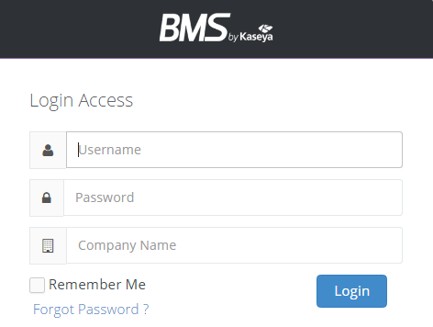Company Name



##### Forget Your Password

If you forgot your password, click the **Forgot Password** link. and the following screen appears.

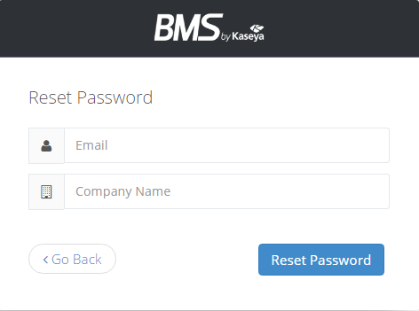



Enter your email address and Company Name

Getting Started

When you hit Reset Password it will send you an email with a new password

## How to Navigate the Software

##### Global Navigation Bar



When you login to your database, a horizontal navigation bar runs along the TOP with words such as **Service Desk**, **CRM**, **Finance** and **Projects**. This bar is called the *global navigation bar* and each of these words is the heading of a SUPPORT module.

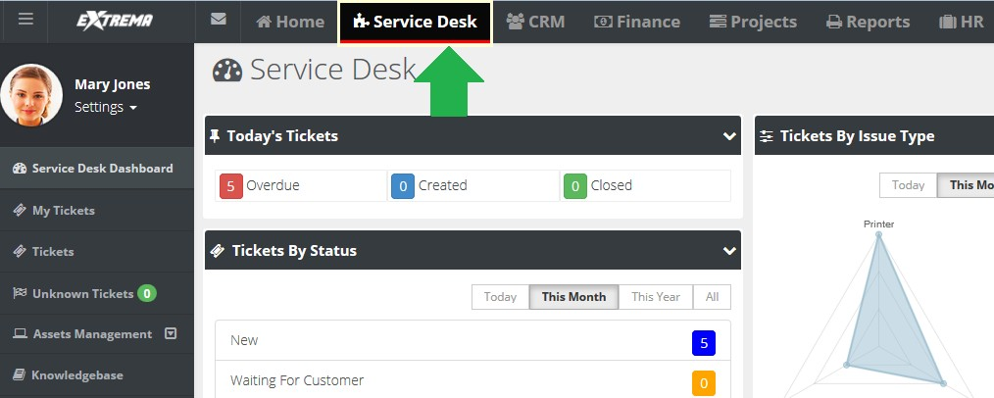When you click on a module, such as the **Service Desk** module, notice the letters Service Desk *turn white and a red line appears under the words.*



##### Local Navigation Bar

On the left side of the screen, a vertical navigation bar shows a list of options you can select.

This is called the *local navigation bar*. Selecting one of these options takes you further into the module.

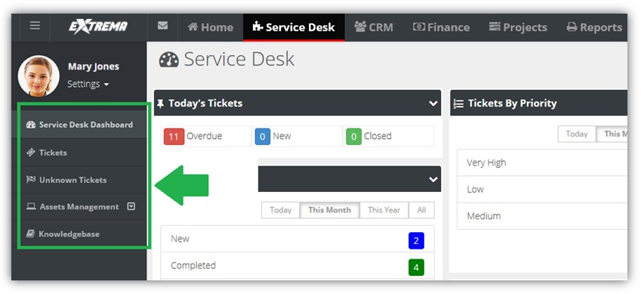Continuing in the **Service Desk** module, you can view a ticket screen by clicking the word Tickets located in the local navigation bar.



**My Profile**

**Settings > My Profile**

The **My Profile** section enables you to personalize your SUPPORT user experience.

* Sets your SUPPORT photo.
* Displays your personal ticket counts.
* Stores your personal information and contact information.
* Changes your password.
* 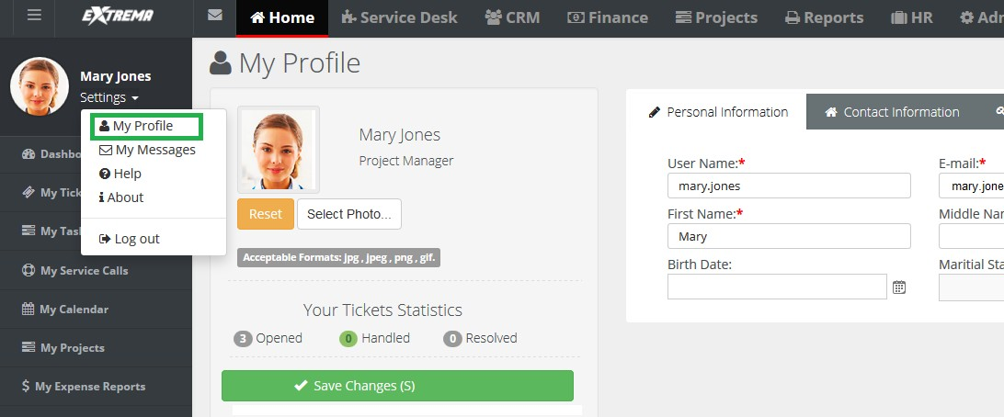Sets your default landing page when you login.



##### Reviewing My Profile

1. Select the Settings > **My Profile** page.
2. Review the **Personal Information** tab.
   * Reset (Photo)
   * **Select Photo** - jpg, jpeg, png, gif
   * Your Ticket Statistics
     + **Opened**
     + **Handled**
     + **Resolved**
   * **User Name**
   * **E-mail**
   * **First Name**
   * **Middle Name**
   * **Last Name**
   * **Birth Date**
   * **Marital Status**
   * **Gender**
3. Review the Contact Information > **Main Address** tab and **Secondary Contact** tab.
   * Address 1
   * **Address 2**
   * **City**
   * **State**
   * **Zip Code**
   * **Country**
   * **Phone**
   * **Ext**
   * **Fax**
   * **Mobile**
   * **Email**
4. Optionally change your password using the **Change Password** tab.
   * Old Password
   * **New Password**
   * **Confirm New Password**
5. Optionally set options on the **Preferences** tab.
   * **Default Landing Page** - The page displayed when you logon.
   * **Default Tickets Listing Click Behavior** - Selects how a ticket opens from a list page.
     + in the same page
     + in a new tab
     + in a new window

## Edit Access by URL

Pulse way PSA supports edit access by URL for the following types of records:

* Tickets by Ticket ID
* Projects by Project ID
* Tasks by Task ID

To identify the number of a ticket, project or task, create an Ad Hoc report that includes the Ticket ID, or Project ID or Task ID columns, along with additional columns to help identify the corresponding ID.

|  |  |  |
| --- | --- | --- |
| **Admin** |  |  |

## Dashboard (Home)

Home > Dashboard Admin > Dashboard HR > Dashboard

All modules have a dashboard to display important data. The **Administrator Dashboard** tracks important events and activities, not necessarily identified as a ticket or project or CRM activity.

1. Click the **Admin** module on the far right of the *global navigation bar*.



1. Click **Admin Dashboard**, the first selection on the *local navigator bar* on the left.

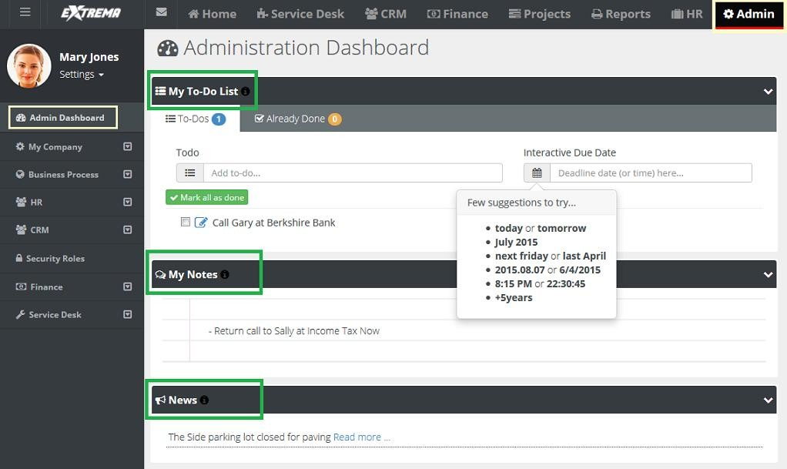



* **My To Do List** - A place to set reminders. For example: stop by HR and get benefit change form. Enter text, then click the calendar and set the date, or simply enter the word tomorrow. Press the **Enter** key on your keyboard to add the entry. To Dos created for a ticket display the name of the ticket along with a link. You can click the link to access the ticket immediately.

Admin

* **My Notes** - A quick summary of thoughts or ideas that you don’t want to forget during the day.
* **News** - **Company news** generated from the **Admin** module.

**Sharing**

If user has the rights, he or she can use the system to share information such as events, announcements, and news.

##### Removing My To-Do List Items

The user can remove items in the **My To-Do List** by clicking the red X in the **Already Done** tab and clicking on the red X. The user can reset the **My To-Do List** by clicking the yellow arrow, if an item was completed by mistake.

##### Deleting

The user can simply erase **My Notes** *by highlighting the words* and selecting delete on the keyboard.



**My Company**

**Admin > My Company**

The **My Company** menu specifies settings about your own company.

1. On the *global navigation bar*, click **Admin**.
2. 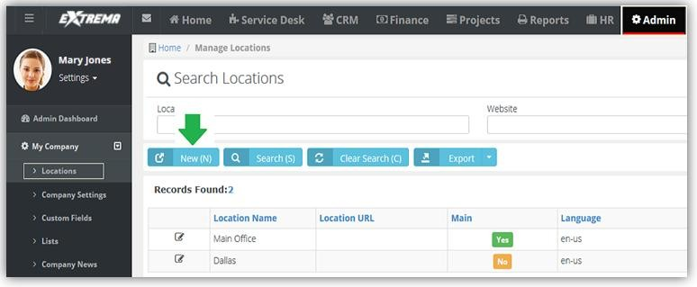On the *local navigation bar*, click **My Company**



**Locations**

Admin > My Company > Locations

The **Manage Locations** page specifies your company locations. These fields are used throughout the system to track information about your various offices.

* Address information will appear on your invoices.
* You will be able to quickly see which employees are located at which location, etc.

The Main Branch is the default. If you have other locations—like a remote sales office or a store in a different city—you will create them here as well.

##### Add Locations

1. Click **New** on the **Manage Locations** page.
2. Enter the following on the **Location Data** tab.
   * Location Name
   * **Website**
   * **Time Zone**
   * **Date Format**
     + American Format (MM/dd/yyyy)
     + European Format (dd/MM/yyyy)
   * Time Format
     + 12 Hours Format (Ex: 8:00 A.M , 8:00 P.M)
     + 24 Hours Format (Ex: 8:00 , 20:00)
   * **Main** - Yes or No.
   * Click **Save**.
3. Enter the following on the Address > **Shipping Contact** tab. Optionally click **Copy From Billing** to populate these fields from the **Billing Contact** tab.
   * First Name
   * **Last Name**
   * **Address Line 1**
   * **Address Line 2**
   * **City**
   * **State**
   * **Zip Code**
   * **Country**
   * **Phone**
   * **Ext**
   * **Fax**
   * **Mobile**
   * **Email**
4. Enter the following on the Address > **Billing Contact** tab. Optionally click **Copy From Shipping** to populate these fields from the **Billing Contact** tab.
   * First Name
   * **Last Name**
   * **Address Line 1**
   * **Address Line 2**
   * **City**
   * **State**
   * **Zip Code**
   * **Country**
   * **Phone**
   * **Ext**
   * **Fax**
   * **Mobile**
   * **Email**
5. Click **Save**.

***Moving Users***

Admin > My Company > Locations > Edit > Users

The **Users** tab associates users with a single location. Users initially are members of the Main Branch

location.

**To Move Users Between Locations**

1. Click **Move**.
2. A **Search and Select** screen appears.
3. Select the employees you want to move.
4. Click **OK**.
5. Click **Save**.

#### Location Hours

Admin > My Company > Locations > Edit > Working Hours

The **Working Hours** section specifies the working hours for your location.

1. Use the check box and select the **Week Day** days your location is open.
2. Enter your hours per day by clicking on the next to **Start time** and **End time**.
3. Click **Save**.

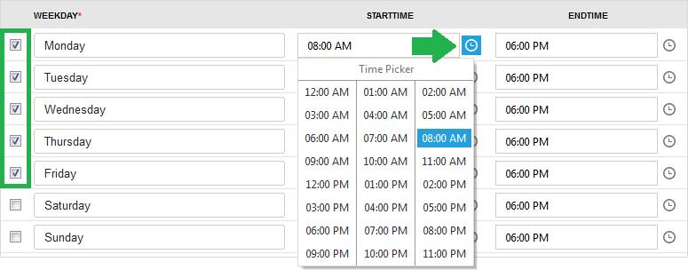

**Company Settings**

Admin > My Company > Company Settings

In the section, you set global settings and defaults for modules and the entire system.

***General***

Admin > My Company > Company Settings > General

The **General** tab specifies how your company name and logo is displayed in the user interface and in communications with your customers. It also specifies currency and dashboard settings.

* **Business Name** - The business name displayed in invoices.
* **Business Email** - The FROM address of emails sent to recipients.
* **Business Email Display Name** - The display name included with the FROM email address. Optional.
* **Business Logo** - The business logo shown on this page displays throughout the user interface, for both users and clients accessing client portal. To change the business logo:
  + Click **Select**.
  + Upload your business logo. Uploaded business logos are re-sized to 20px in height.
  + Click **Save**.
* **Report Logo** - The report logo is shown on all reports and forms. To change the report logo:
  + Click **Select**.
  + Upload your report logo. Uploaded report logos are re-sized to 20px in height.
  + Click **Save**.



* **Listing Auto Refresh in** - Set how frequently, in minutes, you want your dashboards to refresh their data.
* **Currency** - Select which currency you want to display in your system.
  1. Delete the existing text and a list of available currencies display.
  2. Select the currency from the data list.
  3. Click **Save**.
  4. Log out and then login for the change to apply.

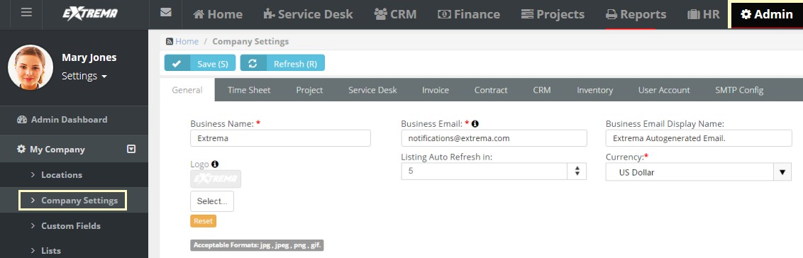



***Time Sheet***

Admin > My Company > Company Settings > Time Sheet

The **Time Sheet** tab sets defaults and global settings for your company’s timesheets. A timesheet period

is one week.

* **Time Sheet Week Day Starts On** - Select a day of the week to start each timesheet.
* **Allow Future View of Timesheets** - The number of weeks into the future employees can view their timesheets. Maximum 2 years.
* **Allow Past View of Timesheets** - The number of weeks into the past employees can view their timesheets. Maximum 2 years.
* **Preload Timesheets** - If Yes, tickets and project tasks preload *future* timesheets. If No, tickets and project tasks do *not* preload *future* timesheets. Many project focused organizations are accustomed to seeing all of their assigned tasks displayed immediately on timesheets *at the beginning of the week* as well as on future timesheets.
* **Limit of items to preload in Timesheets** - Limits the number of items preloaded in timesheets.
* **Round Time Logs** - Rounds time entries in logs to the nearest specified interval, in minutes. Enter 0 to 60.
* 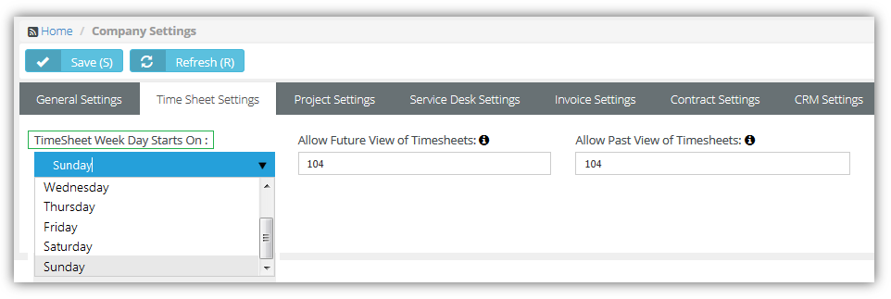**Up/Down** - Select to round time entries up or down.

#### Project

Admin > My Company > Company Settings > Project

The **Project** tab sets defaults for new projects.

* **Project Number Prefix** - Specifies the default prefix for new projects.
* **Project Starting Number** - Specifies the default starting number for new projects.

Whenever a new project is created, the default time sheet approval route and expense sheet approval route are automatically assigned to the new project. A project manager can override these default approval routes or select None. *If* None is selected, *submitted timesheets and expenses are auto-approved.* Approval routes are created in the Admin > Business Process > **Approval Routes** folder.

* Default Timesheet Approval Route
* **Default Expense sheet Approval Route**

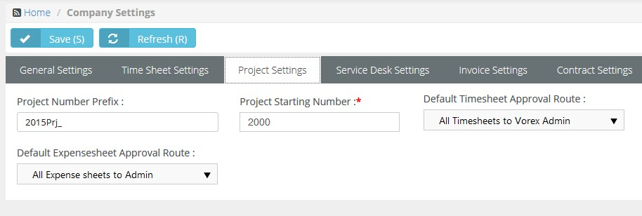

***Service Desk***

**Admin > My Company > Company Settings > Service Desk**

The **Service Desk** tab sets defaults for new tickets. For example, when a customer calls in and user clicks **New Ticket...** the priority and source will already be populated with the values you specify here.

* **Default Ticket Priority** - Select the default ticket priority. Priorities are maintained using the Admin > Service Desk > **Priorities** page.

You can set up approval routes for timesheets and expense sheets in the system. If you are using the **Service Desk** module and you want all timesheets with entries from tickets to route to a specific person or manager, select default approval routes here.

* **Default Timesheet Approval Route**: Select approval routes that are create in the Business Process >

**Approval Routes** section in Admin Module.

* **Default Expense sheet Approval Route**: Select approval routes that are created in the Business Process > Approval Routes section in Admin Module.
* **Default Ticket Source** - The default method of communication used by the customer to initiate the creation of ticket.
* **Default SLA** - The default service level agreement. Applies to customers that do not have a contract. SLAs are maintained using the Admin > Service Desk > **SLA** page.
* **Sort Status By** - Sorts ticket pages by **ticket status** either alphabetically or by ticket status order.
* **Ticket Number Prefix** - Adds a prefix to ticket identifiers. Defaults to blank.
* **Ticket Number Format** - Specifies the date and count format of the ticket identifier. Defaults to

COUNT-MMDDYYYY. Changing the format affects new tickets only.

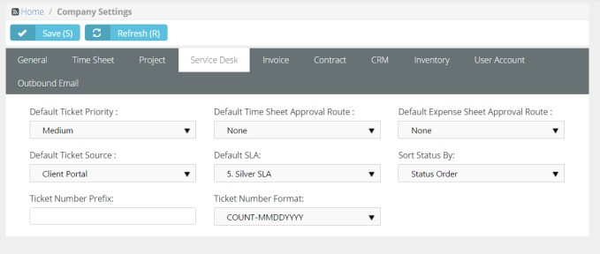

***Invoice***

**Admin > My Company > Company Settings > Invoice**

The **Invoice** tab sets defaults and global settings for your invoices.

* **Invoice Number Prefix** - Specifies the default prefix for new invoices.
* **Invoice Starting Number** - Specifies the default starting number for new invoices.
* **Issue Invoice on** - When an invoice is issued. You can override this default setting in the header of a contract.
  + Beginning of Billing Cycle - Invoices are created in advance and will appear in the Billing review folder *on the first day* of the month or quarter.
  + End of Billing Cycle - Invoices are created in advance and will appear in the Billing review folder *on the last day* of the month or quarter.
* Post T&M Entries
  + **Only Approved** - Only approved timesheet entries and expense entries are posted to billing.
  + **All** - All timesheet entries and expense entries are posted to billing.
* **Post Zero Entries** - If Yes, zero value hours are posted for fixed price and recurring services on the Finance > Billing Review > **Labor Hours**and **Recurring Services** pages.
* **Bill Zero Value Items** - If Yes, show zero value items in billing pages. If No, hide them.
* **Use Classes** - In QuickBooks Desktop version, you can create classes that you assign to transactions. These classes enable you to track account balances by department, business office or location, separate properties, or by any other meaningful breakdown of your business. Use classes are maintained using the Admin > Finance > Class List page.
* **Show VAT Number** - If Yes, a VAT identifier displays on printable documents.
* **VAT Number Text** - Specifies the string portion of the VAT identifier shown on printable documents.
* **VAT Number** - Specifies the numerical portion of the VAT identifier shown on printable documents.
* **Billing End Date** - Sets the default number of days or months into the future future date shown by the **Default End Date** search field on the Finance > **Billing Review**page. This same change also applies to the **To Date** search field on the Finance > **Billing** page.
* **Invoice Title** - Customizes the title at the top of the invoice. The default is 'Invoice'.
* **Notes to clients** - Any notes entered here will display on all invoices generated from the Finance module.

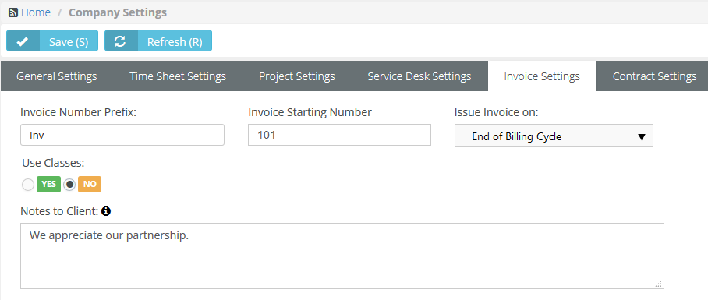

#### Contract

Admin > My Company > Company Settings > Contract

The **Contract** tab sets defaults for contracts. Contracts are maintained in the **Finance** module.

1. **Contract Number Prefix** - Enter a string prefix for the names of new contracts. Optional.
2. **Contract Starting Number** - Enter a starting number for new contracts.

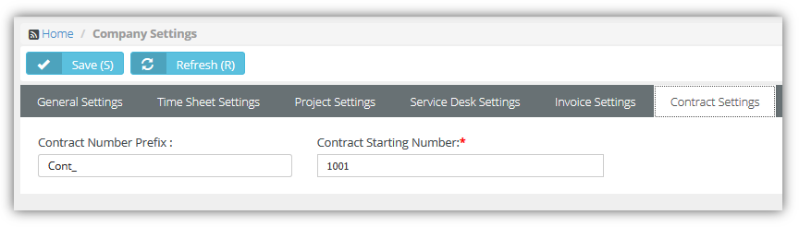

#### 

#### CRM

Admin > My Company > Company Settings > CRM

The **CRM** tab sets defaults for the CRM module

* **Quotation Number Prefix** - A prefix added to the names of new quotations.
* **Quotation Starting Number** - The starting number for new quotations.
* **Pipeline Factor** - The default probability that sales opportunities in the sales pipeline will be converted into sales. Used by the CRM dashboard and the Pipeline Value portion of the Pipeline Report CRM Dashboard.
* **Quotations Terms and Conditions** - New CRM > Service Quotations and Product Quotations use the value in this field by default.

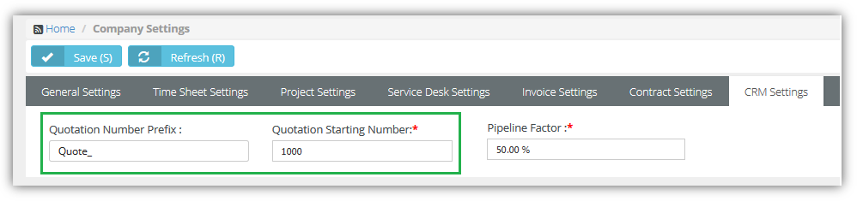

#### Inventory

Admin > My Company > Company Settings > Inventory

The **Inventory** tab sets defaults for records that affect inventory management. Types of records include:

* PO - purchase order
* RO - received order
* UPC - universal product code
* DO - dispatch order
* SO - sales order
* AD - inventory stock adjustment

These are the default settings for each field:

* **PO Number Prefix** - PO_
* PO Starting Number - 1
* **RO Number Prefix** - RO_
* RO Starting Number - 1
* **UPC Prefix** - 111111
* **UPC Length** - 5
* **Adjustment Number Prefix** - AD_
* **Adjustment Starting Number** - 1
* **SO Number Prefix** - SO_
* **SO Starting Number** – 1000

#### User Account

Admin > My Company > Company Settings > User Account

The **User Account** tab sets defaults for new employees and clients.

* **New Employee Email Template** - Select an email template for new employees to use.
* **New Client Portal User Email Template** - Select an email template for new portal user clients to use.
* Password Reset Email Template -

**Outbound Email**

The **Outbound Email** page enables you to configure a custom outgoing mail server. This forces your instance of SUPPORT to send all outgoing email and notifications through your company's mail server instead of the default SMTP server.

* **Use Custom SMTP Settings** - If Yes, enables the other fields.
* **Outgoing Mail Server (SMTP)** - The name of your outbound mail server.
* **Username** - The account username for outbound mail.
* **Password** - The account password for outbound mail.
* **Server Port Number** - 465 (default)
* **Encryption Type** - SSL (default), TLS, Non-Encrypted

### Custom Fields

Admin > My Company > Custom Fields

The **Custom Fields** page maintains custom fields you can use in forms in many different modules. For example, you can add custom fields to forms in:

* **CRM** - Accounts, Contacts, CRM Activities, CRM Opportunities, CRM Quotes and Sites, Sales Order.
* **Projects** - Projects and Project Tasks
* **Service Desk** - Tickets, Pending Tickets and Assets (Physical and Software).
* **Inventory** - Dispatch Orders, Products, Product Quotations, Receiving Purchase Orders.
* **HR** - Employee Records

Custom fields can also be included in **Ad Hoc Report Writer** reports.

**Editable Fields**

* **Field Name** - The name of the custom field.
* **Field Type** - Free Text, Date, Data List, Numeric, or Money
* **Module Name** - The module using the custom field.
* **Order** - The order custom fields display in a form.
* **Status** - Active or Inactive
* **Required Custom Field** - If Yes, entering a value in a custom fields is required to save a form.

**Lists**

**Admin > My Company > Lists**

The **Manage Lists** page maintains the list of values displayed by list fields used in standard forms. Each list is predefined. You cannot add a new list. Click any row in the **Manage Lists** page to edit that list.

##### Manage Lists

If you want to populate a drop-down field with list items, you should have the Admin permissions and do the following steps:

1. Navigate to Admin > My Company > **Lists**.
2. Choose the List Name(or name of a drop-down field).
3. Select the Add button.
4. Enter the Name for a list item you would like to see in the drop-down of the selected field.
5. Select Save button.

You can add more than one drop-down list items.

##### Editable Fields

* **List Name** - A value in the drop-down list.
* **Is Default** - Sets a single item to be the default.
* **Is Active** - If checked, the value displays in the drop-down list.

##### Types of Lists and Where They are Used

* CRM
  + Accounts - Business Types
  + Contacts - Phone Type
  + Contacts - Email Type
  + Activities - CRM Activity Type ( like Call, Email)
  + Activities - CRM Activity Status ( New, In progress, Complete)
  + Opportunities - CRM Opportunity Type
  + Opportunities - CRM Opportunity Status
  + Opportunities - CRM Opportunity Rating
  + Opportunities - CRM Opportunity Lead Source
  + Sites - Site Market Type\
* Projects
  + Projects - Project Type
  + Projects - Project Assessment
  + Projects - Collaboration Type
* Service Desk
  + Tickets - Ticket Note Type
  + Software Assets - Asset Software Category
  + Hardware Assets - Asset Hardware Category
  + Hardware Assets - Asset Vendors
  + Hardware Assets - Asset Brands
  + Hardware Assets - Asset Business Impact
  + Knowledgebase - Knowledge Category
* Inventory
  + Purchase Orders - Ship Method
  + Purchase Orders - Payment Term
  + Purchase Orders - Purchase Order Charge Type
  + Products - Product Composition Materials
  + Products - Product Brand
  + Products - Product Manufacture
  + Products - Product Cost Codes
  + Products - Product Pricing Levels
  + Stock Adjustment - Warehouse Adjust Reason
* HR
  + Employees - Education Institute Name
  + Employees - Education Field of Study
  + Employees - Education Degree

### Company News

Admin > My Company > Company News

The **Company News** page manages communications published in module dashboards and the client portal dashboard. Types of communications include:

* Announcement
* Event
* Information
* Message
* 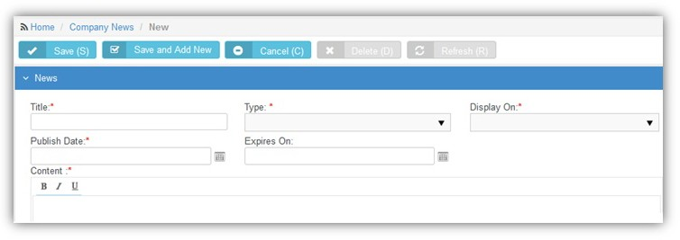News

**Editable Fields**

* **Title** - The title of the communication.
* **Type** - The type of communication.
* **Display On** - Select the module dashboards this communication will be published to.
  + Admin
  + Client Portal
  + CRM
  + Finance
  + Home
  + HR
  + Inventory
  + Projects
  + Reports
  + Service Desk
* **Publish Date** - The date the communication start being displayed on dashboards.
* **Expires On** - The date the communication stop being displayed on dashboards.
* **Content** - The body text of the communication.

### Holidays

Admin > My Company > Holidays

The **Manage Holidays** page specifies the holidays recognized by your company. Holidays are shown on company calendars, so customers will know with your team is unavailable.

**Editable Fields**

* **Holiday Name** - The name of the holiday.
* **From** - The date the holiday begins.
* **To** - The date the holiday ends.
* **Is Recurring** - If Recurring, the holiday recurs each year.
* **Status** - If Active, the holiday displays on company calendars.
* **Holiday Locations** - The locations this holiday applies to.

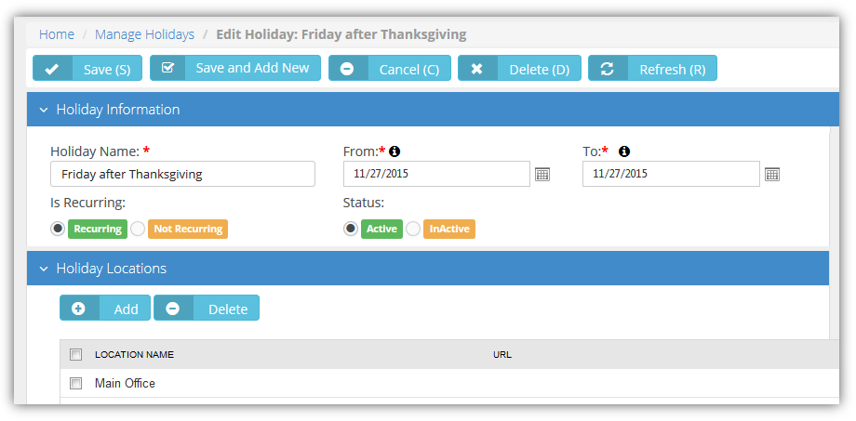

**Administrative Work**

**Admin > My Company > Administrative Work**

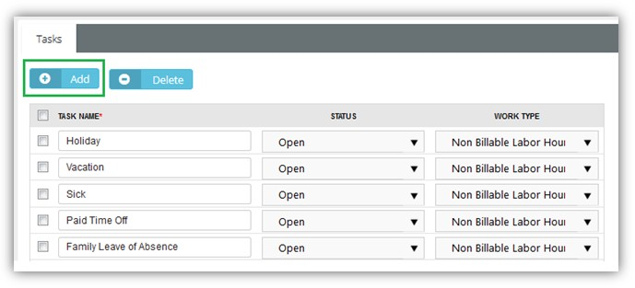The **Administrative Work** page creates tasks used to track time against company activities not associated with projects or tickets. Typically **Administrative Work** tasks are non-billable. Once created, tasks are available on employee timesheets to classify time entries. Examples include paperwork, meetings, training, holidays, sick days, vacation, jury duty, etc.

##### Editable Header Fields

The following header fields apply to all Administration Work tasks.

* **Name** - The display name for Administration Work category tasks.
* **Status** - The default status.
* **Manager** - The manager.
* **Timesheet Route** - The timesheet approval route.
* **Expensesheet Route** - The expense sheet approval route

##### Editable Task Fields

* **Task Name** - The name of the task
* **Status** - The status of the task
* **Assign Work Type to the Administrative Task** - The work type associated with this task. In most cases

**Administrative Work** tasks are set to Non Billable Labor Hours.

### Single Sign On

The **Single Sign On** page enables/disables integration with a single sign on (SSO) server.

* **Enable Single Sign On to AuthAnvil™** - Yes or No
* **Reply to URL** - The URL of the single sign on SSO server.
* **Upload Certificate / Delete Certificate** - Uploads/deletes the certificate provided by the SSO service provider.

## Business Process

Admin > Business Process

The Admin > **Business Process** menu provides access to templates and records used by the **Business Process** module.

**Email Templates**

Admin > Business Process > Email Templates

The emails you create and send to customers or employees are based on standard templates you maintain using the **Email Templates** page. Email templates are classified by the *module* they apply to.

Many default email templates used by the system are not shown on the **Email Templates** page. You must create your own custom email template and select it elsewhere in the system to override the default email template being used by the system.

Email template examples include:

* **Service Desk** - Sending communications based on ticket creation, assignment, status changes, requests for information and closure
* **CRM** - Sending quotations to prospects or customers
* **HR** - Welcoming new employees to logon the first time.
* **Inventory** - Sending a purchase orders to suppliers
* **Finance** - Sending invoice to your customers
* **Client Portal** - Sending new client portal user and reset client portal user password emails to your customers.

##### Field Placeholders

*Field placeholders* inserted into the body text of email templates enable you to quickly send out customer-specific or employee-specific emails.

##### Editable Header Fields

* **Email Template Name** - The name of the email template.
* **Description** - A longer description of the email template.
* **Module** - The module using this email template.
* 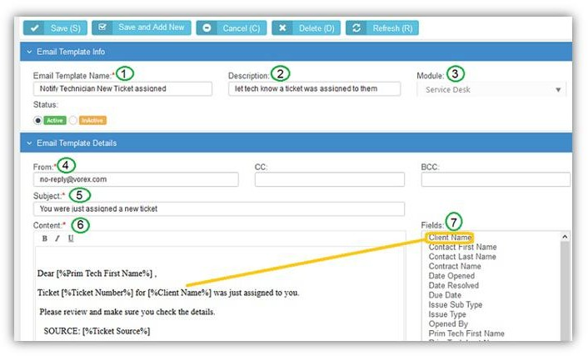**Status** - If Active, this email template can be used.

**Editable Email Template Details**

* **From** - Defaults from the Admin > My Company > Company Settings > General > Business Email field.
* **CC** - Additional recipients to copy.
* **BCC** - Additional recipients to blind copy.
* **Subject** - The subject of the message.
* **Content** - The body text of the message.
* **Fields** - Insert your cursor anywhere in the body text area of your message, then click any field listed in the **Fields** list. A *field placeholder* will be inserted into the body text. When a message is sent these field placeholders are resolved to specific values. The list of fields available to select is based on the module you select in the **Module** field in the header.

**Approval Routes**

Admin > Business Process > Approval Routes

The **Approval Routes** page defines approval processes in your company. An **approval route** refers to a specific sequence of approval steps. Each step requires one or more approvers to approve that step.

* You can define an unlimited number of routes. Each route can have any number of approval steps.
* Modified routes only impact *new* employee actions, not those already in-route.
* Designated approvers get notified by email and the internal messaging system.
* Recursive approvals can be forwarded from one supervisor to the next, ascending the levels of the organizational chart, for the number of levels you specify.

**Approving Timesheets and Expense Reports**

* Submitted time-sheets and expense-sheets can be managed using approval routes. Each employee's **My Approvals** page in the **Home** module displays the timesheets and expense sheets waiting for their approval. If an expense report is submitted and the approval route split, the report is split into sub reports, one for each project manager approver.
* For projects, approval routes are assigned at the project-level. Each project may have its own unique approval route to follow. If no route is assigned to a project, it defaults to auto-approval. Default approval routes for timesheets and expense reports are assigned to Projects using the Admin > My Company > Company Settings > **Project** tab.
* Default approval routes for timesheets and expense reports are assigned to tickets using the Admin > My Company > Company Settings > **Service Desk** tab.
* Default approval routes for timesheets and expense reports are assigned to administrative work using the Admin > My Company > **Administrative Work**tab.

**Creating New Approval Routes**

1. Select the Admin > Business Process > **Approval Routes** page.
2. Click **New**.

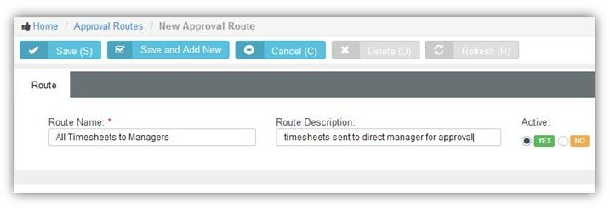

1. Enter the following header fields:
   * **Route Name** - The name of the approval route.
   * **Route Description** - A one line description of the approval route.
   * **Active** - Yes
   * Click **Save**. A new **Steps** section displays below the header fields.
2. Click **Add Step**.

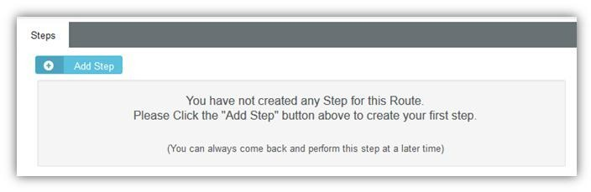

1. Enter the following step fields:
   * **Step Name** - The name of the step.
   * **Pick Step Type** - The person approving this step.
     + **Specific Person(s)** - A specific employee. Select one or more people from a drop-down list.
     + **Manager of Submitter** - The manager of the employee. Managers of employees are specified in the HR module.
     + **Project Manager** - The manager of a project. Project managers are specified in the Projects module.
     + **Recursive Approval** - Approvals are forwarded from one supervisor to the next, ascending the levels of the **organizational chart** *,* for the number of levels you specify.
2. 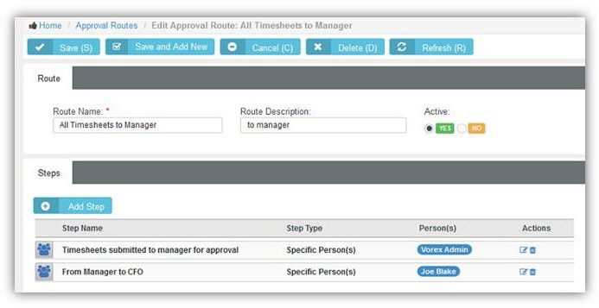Repeat steps 4 and 5 to add as many additional approval steps as your approval process requires.

### Workflow

Admin > Business Process > Workflow

The **Workflows** page defines workflows that automate the processing of tickets when triggers and conditions are met. For example you can use a **Workflow**:

* **When Tickets are Assigned** - Based on the *source*, *priority*, *issue* or *client*, or any combination of these conditions, automatically assign the ticket to the best person in your company.
* **When Tickets are Reassigned or Escalated** - If a ticket sits idle for too many days or hours, automatically send a reminder or re-assign the ticket to another technician and bump the priority to a higher level.
* **When Tickets are Edited** - We can send a notification if a note or time is entered on a ticket.
* **When Tickets are Resolved** - Send an email with a summary of what was done with a 'thank you' message included.

**Creating Workflows**

1. Select the Admin > Business Process > **Workflow** page.
2. Click **New**.
3. Ensure the **Workflow Rule** tab is selected.
4. Enter the following header fields:
   * **Workflow Name** – The name of the workflow.
   * **Description** - A one line description of the workflow.
   * 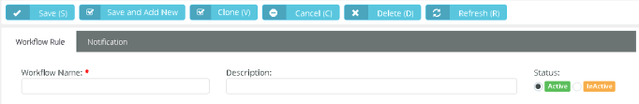**Active** - If Yes, the workflow is being used.
5. Define **Triggers** for ticket workflows in the **Triggers** section.
   * **Created By** - Anyone, Employees, Clients
   * **Updated By** - Anyone, Employees, Clients
   * **Activity Added By** - Anyone, Employees, Clients
   * **Activity Type** - Time, Expense, Activity
   * **Idle For** - The tickets sit idle—with no activities or no time entries—for hours or minutes.
   * **Due In** - The ticket has a due date on it and that date is approaching, in hours or minutes
   * **Overdue By** - The due date has passed, in hours or minutes.
   * **SLA First Response Due In** - Specifies when an SLA first response is due and sends an alert, in hours or minutes.
   * SLA First Response Overdue By
   * **SLA Resolution Due In** - Specifies when an SLA resolution is due and sends an alert, in hours or minutes.
   * **SLA Resolution Overdue By** - Specifies when an SLA resolution is past due and sends an alert, in hours or minutes.
6. Select the **Conditions** tab.
   * Each condition provides a set of comparison operators. Comparison operators can include:

, Changed From, Changed To, Is Empty, Is Not Empty, Like, Not

|  |  |  |  |
| --- | --- | --- | --- |
| In, | Not In, | | Changed |
| Like, | | Greater Than | |

, Less Than, Greater or equal, Less or equal, Between

The following fields are set in the **Tickets** section of the **Conditions** tab. These conditions test for values in the ticket.

1. Use the **Tickets** section to set conditions for values in the ticket.
   * **Status** - Changes the status of a ticket.
   * **Priority** - Sets the item's priority
   * SLA
   * **Issue Type** - Updates the issue type.
   * **Sub-issue Type** - Updates the sub-issue type.
   * Source
   * **Ticket Type** - Updates the ticket type.
   * **Queue** - Assigns a ticket to a queue.
   * **Primary Assignee** - Assigns a primary technician
   * Title
   * **Details**
   * **Satisfaction Score**
   * **Ticket Sender Email**
   * **Service Contract**
   * **Work Type**
   * **Open Data**
   * **Due Date**
   * **Account Type**
   * **Account**
   * **Service Type**
2. Use the **Accounts** section to set conditions for values in the CRM account associated with the ticket.
   * Account Type
   * **Account Name**
   * **Location**
   * **Description**
   * **Service Type**
   * **Account Code**
   * **Business Type**
   * **Account Manager**
   * **Status**
   * **Acquired Date**
3. Use the **Contacts** section to set conditions for values in the CRM account contact record associated with the ticket.
   * First Name
   * **Middle Name**
   * **Last Name**
   * **Job Title**
   * **Status**
   * **Point of Contact**
   * **Receive Invoices**
   * **Has Client Portal Access**
4. Use the **Assets** section to set conditions for assets associated with the ticket.
   * Name
   * **Description**
   * **Category**
   * **Business Impact**
   * **State**
   * **Brand**
   * **Manufacturer**
   * **Machine Group ID**
   * **Product Name**
   * **Serial**
   * **Model Number**
   * **Asset Tag**
   * **Acquisition Date**
   * **Expiration Date**
   * **Warranty Expiration Date**
   * **Barcode**
   * **Vendor**
5. Use the **Custom Fields** section to set conditions for custom fields added to the ticket. 12.Define the actions taken using the **Updates** tab.
   * **Account -** Assigns the ticket to an account.
     + Updates the ticket with the default contract for the account.
     + Updates the SLA with the SLA specified by the default contract.
   * **Status** - Changes the status of a ticket.
   * **Priority** - Sets the item's priority
   * SLA
     + Updates the SLA with this SLA, overriding the SLA specified by any contract.
   * **Issue Type** - Updates the issue type.
   * **Sub-issue Type** - Updates the sub-issue type.
   * **Ticket Type** - Updates the ticket type.
   * **Queue** - Assigns a ticket to a queue.
   * **Primary Assignee** - Assigns a primary technician
   * **Contract** - *Enter an account to enable this drop-down list.*
     + Updates the ticket with this contract, overriding the default contract for the account.
     + Updates the SLA with the SLA specified by the specified contract.

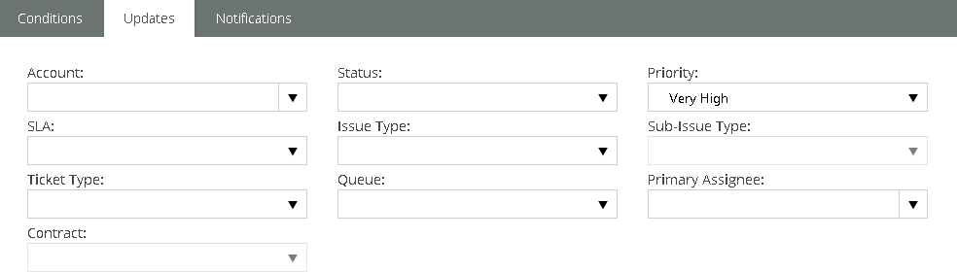

1. Select the **Notification** tab.
2. Specify who will be notified when a workflow is triggered.
   * **Assigned Queues** - Yes or No. Notifies all users who are members of the listed **queue**

assigned to the ticket.

* + **Assigned Resources** - Yes or No. Notifies the primary assignee or secondary assignees assigned to the ticket.
  + **Account Associate Resources** - Yes or No. Notifies all resources added to the CRM > Account >

**Associated Resources**tab for this client.

* + 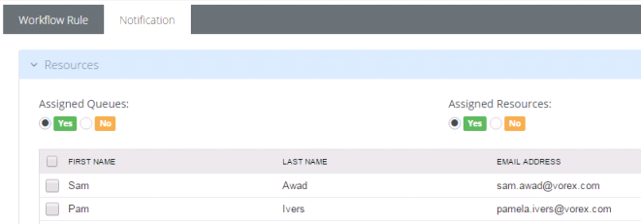You can also add specific employees by name.

1. Select the customers to be notified in the **Client** section. Contacts only display in this section if clients were selected in the Workflow Rule > Conditions > Client drop-down list.
   * **Ticket Contact** - If Yes, clients are notified if they submitted a ticket.
   * 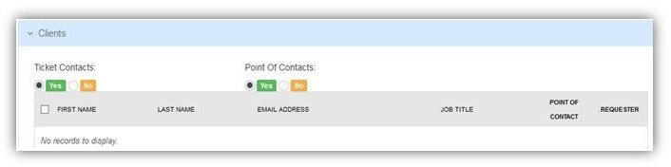**Point of Contacts** - If Yes, clients are notified if they are designated the point of contact for a customer account.
2. Select the email template used to create notifications for this workflow.

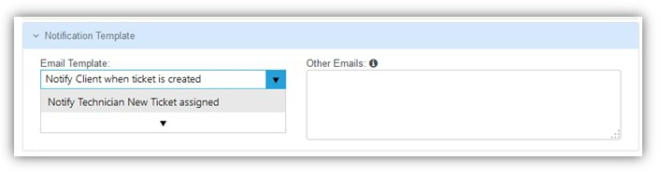

1. Click **Save**.

## 

## HR (in Admin)

Admin > HR

**CRM (in Admin)**

**Admin > CRM**

CRM stands for *customer relationship management.* A CRM solution allows you to manage the business relationship and interactions you have with customers, prospects, vendors, etc., and store all the data about these relationships. These interactions can be sales related—calls, emails, meetings and demonstrations—as well as support related—service tickets and projects. The benefit of a CRM is having all your business data stored and accessible from one central location. The **CRM** module provides:

* Immediate employee access to the data they need.
* Sharing of important data between departments.
* Management insight into activity across the organization and helps them understand where they can improve processes.

Customers are first added as accounts in CRM. After that you can create projects, open tickets, and set up contracts on their behalf.

**Accounts**

Admin > CRM > Accounts

**Opportunity Statuses**

**Admin > CRM > Opportunity Statuses**

The **CRM Account Types** page maintains a status list for opportunities.

##### Creating Opportunity Statuses

1. Select the Admin > CRM > **Opportunity Statuses** page.
2. Click **New**.
3. Enter the following fields.
   * Name
   * **Base Status**
   * **Probability**
   * **Is Active** - Yes or No
   * Include in Pipeline - Yes or No
   * Description

**CRM Account Types**

**Admin > CRM > CRM Account Types**

The **CRM Account Types** page maintains a list used to identify primary business relationships with accounts. By default, this list includes Client, Competitor, Former Client, Miscellaneous, Partner, Unknown, Vendor. In addition you can flag an account as either a client or vendor or both.

##### Creating Account Types

1. Select the Admin > CRM > **CRM Account Types** page.
2. Click **New**.
3. Enter the following fields in the **Account Types** header section.
   * Account Type Name
   * **Status** - Active or InActive
   * **Client** - Yes or No
   * **Vendor** - Yes or No

### Service Types

Admin > CRM > Service Type

The **Service Type** page defines basic records used to classify CRM accounts. Service types are subsequently assigned to scopes. A scope determines which users have access to which tickets, based on security types assigned the scope and the CRM account assigned the ticket.

You define the following for a service type:

* Name
* **Description**
* **Active**
* **Default**

## Security

### Roles

Admin > Security > Roles

The **Roles** page determine the access an employee has to different modules, menus and selected settings. The system provides several predefined security roles for both internal and external users. You can also add custom security roles. A person assigned multiple security roles has access to the combined privileges of all assigned roles. Certain permission categories include special features.

**Pre-Defined Security Roles**

* **Six (6) pre-defined internal roles** - Administrator, Project Manager, CRM Manager, Finance Manager, Service Desk Manager, and User.
* **Two (2) pre-defined external roles** - External User and External Manager. These are used by clients using **Client Portal**.

|  |  |
| --- | --- |
| **Pre-Defined Internal Roles** | **Description** |
| Administrator | The highest level of permissions. Complete access to add/edit/delete, and configure any record across the system. |
| Project Manager | Access to Project Management modules and related reports. Add/edit/delete projects, clients, approval routes, and employees. Also, adjust/approve time and  expense-sheets. |
| CRM Manager | Access to CRM modules and related reports. Add/edit/delete customer contacts, opportunities, activities, and customer quotes. |
| Finance Manager | Access to Finance modules and related reports. View/update/process billing, invoicing, receivables, account setups, and payments. |
| Service Desk Manager | Access to Service Desk module and related reports. Add/edit/delete service desk settings in Admin module. Create workflow rules, etc. |
| User | Access restricted to personal information, time and expense sheet entries, and  time-off requests. |

##### Special Features

You can enable special features for certain categories of permissions.

* Home
  + Access to All Employees Timesheet Data ORG Chart
  + **Access to All Employees Expense Data (Bypasee ORG Chart)**
* Service Desk
  + **Quick Add Ticket** - If checked, a blue **New Ticket** button displays in the header. Users can click the button to add a new ticket immediately from anywhere in the user interface.
  + **CloudActiv8 Live Connect** - If checked, enables **Live Connect** access from a ticket to a corresponding hardware asset.
  + **Customer Survey Scores** - If checked, enables visibility of **survey score** data.
* CRM
  + Access to All Employees CRM Data (Bypass ORG Chart)
* Projects
  + Access to All Employees Project Data (Bypass ORG Chart)
  + **Hide Financials Tab on Projects**
* HR
  + Bypass Timesheet and Expense Sheet Approvals

**Quick Tickets**

Security roles have a **Client Portal** option called **Quick Tickets**. When checked in a security role, customers are presented with a simplified page layout when adding new tickets. If unchecked, customers are presented with the same page layout that employees see.

##### Adding Security Roles

1. Select the Admin > **Security Roles** page.
2. Click **New**.
3. Enter the following fields in the **Security Role Information** header section.
   * Name
   * **Description**
   * **Client**
     + Internal - This security role can only be assigned to employees and not to CRM customer account **Contacts** given client portal access.
     + External - This security role can be assigned to both employees and to CRM customer account **Contacts** given client portal access.
   * 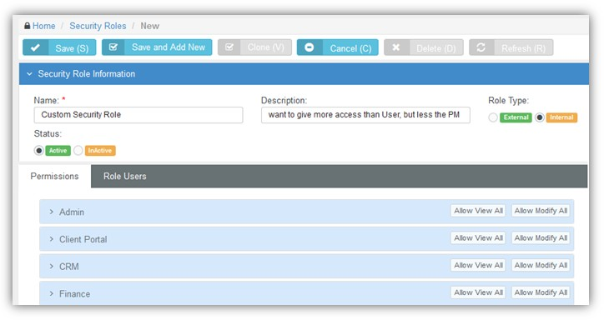**Status** - Active or InActive
4. Expand each permission category displayed on the **Permissions** tab.
5. Optionally toggle the **Allow View All** or **Allow Modify All** buttons to check or uncheck all checkboxes in a permission category.
   * **View** - Allows users assigned this security role to view data.
   * **Modify** - Allows users assigned this security role to change data.
6. Optionally check or uncheck each item in an expanded category separately.
7. 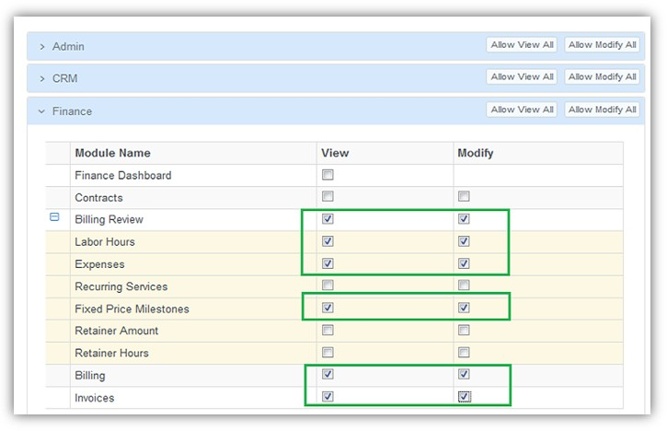Optionally enable special features at the bottom of each category. Not all categories have them.

example of special features:

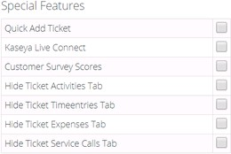

1. Click the **Role Users** tab.
2. Click **Add**.
3. Select one or more users to assign them to this security role. 11.Click **OK**.

12.Click **Save** the save the security role.

### Scopes

Admin > Security > Scopes

The **Scopes** page determines employee access to user-defined data in the system. Currently scopes only control employee access to user-defined data in Service Desk tickets, and only if the CRM account has been assigned a *service type*.

**Configuration**

1. Create **Service Types**
2. Assign service types to accounts using the CRM > **Accounts** > Account tab > **Service Type** field.
3. Create a new scope using the Admin > Security > **Scopes** page.
4. Add service types to the scope record you just created.
   * Each scope can include multiple service types.
   * Select the **Service Desk Permission Type**.
     + Read/Write
     + Read Only
     + No Access
5. Add users to the scope record you just created.

## Finance (in Admin)

Admin > Finance Roles

The **Finance** menu in the Admin module defines support tables used by all your financial transactions. This includes:

### Roles

Admin > Finance > Roles

The **Manage Roles** page defines roles used by employees to classify the work bill billed to customers.

* Each role has a defined default billing rate.
* Roles are applied when entering labor time on tickets or project tasks.
* Roles are assigned to by employee or by job title.
* Employees assigned multiple roles can usually select any of their roles when working a task or ticket.
* In **Projects**, the project manager can lock down the role when assigning a task to an employee.
* You can override role rates by creating a 'New Time and Material Contract' for a specific customer.

**Creating Roles and Rates**

1. Select the Admin > Finance > **Roles** page.
2. Click **New**.
3. Enter the following fields.
   * Role Name
   * **Description**
   * **Billing Rate** - The per hour billing rate.
   * **Status** - Active or InActive
4. 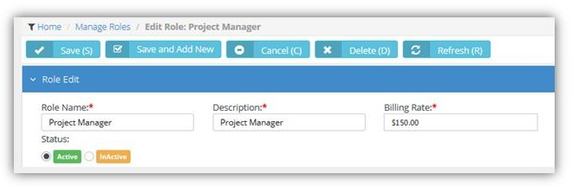Click **Save**.

### Work Type

Admin > Finance > Work Type

The **Work Type** page maintains a list used to classify the work performed on tickets and tasks. You can optionally specify a custom billing rate by work type that overrides the billing rate specified by a user's selected role on a ticket or task.

* Work types are used for tracking and reporting purposes
* Work types are match them to your general ledger codes on the **Billing Configuration**

page.

* You can create additional work types to apply a *custom rate* to labor time entries on a ticket.

**Creating Work Types**

1. Select the Admin > Finance > **Work Types** page.
2. Click **New**.
3. Enter the following fields.
   * Work Type Name
   * **Description**
   * **Status** - Active or InActive
   * Invoice
     + Non-Billable do not show on Invoice
     + Non-Billable show on Invoice
     + Billable
   * **Overtime Multiplier Rate** - Multiplies the hourly billing rate for overtime. Defaults to 1.
   * Billing
     + Use Role Rate - Billings use the hourly rate specified for the role the user selects in a ticket or task.
     + Use Custom Rate - If selected, the **Custom Rate** field displays. Enter a custom hourly billing rate for this work type.
4. 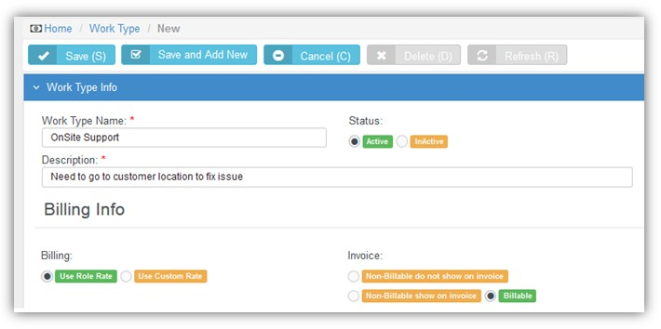Click **Save**.

### Services

Admin > Finance > Services

The **Services** page maintains a list of standard services. A service is work performed for a customer that is billed on a weekly, monthly, quarterly, or annual basis and is typically part of a recurring service contract. A flat fee is specified for each type of device or service that is supported in your client’s environment. These services are available in a drop-down list when building recurring contracts using the Finance Module > Contracts page.

**Creating Services**

1. Select the Admin > Finance > **Services** page.
2. Click **New**.
3. Enter the following fields.
   * Service Name
   * **Description**
   * **Unit Price**
   * **Unit Cost**
   * **Status** - Active or InActive
   * **GL Account** - Select general ledger account to record postings.
   * **Taxable** - Taxable or Non Taxable
4. 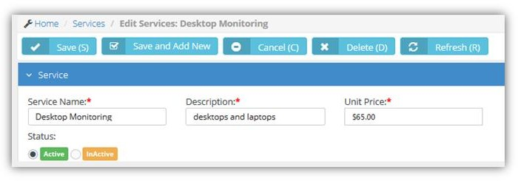Click **Save**.

### 

### Expense Type

**Admin > Finance > Expense Type**

The **Expense Type** page maintains a list of standard expenses types—meals, travel, lodging., etc.—that employees may incur during work related activities. Expenses can be:

* Entered costs on a ticket, project task, or regular expense sheet
* Marked as billable
* Marked as reimbursable
* Defined on a per unit basis. For example, mileage. Expense rules can:
* Limit the expense amount entered per category
* Allow a specific user to enter an amount over the standard limit
* Require a receipt be attached to expense.
* Be applied by individual employee
* Be applied by department

##### Creating Expense Types

1. Select the Admin > Finance > **Expense Type** page.
2. Click **New**.
3. Enter the following fields in the **Details** section.
   * Name
   * **Description**
   * **Per Unit** - If Yes, a **Unit Amount** field displays. For example, mileage.
   * **Billable** - Yes or No
   * **Allow Billable Modification** - Yes or No
   * **Is Attachment Required** - If Yes, an attachment, typically a receipt, is required to record an expense.
   * **GL Account** - Select general ledger account to record postings.
   * **Taxable** - Taxable or Non Taxable
   * Available for
     + Employees
     + Vendors - For example, you may wish to specify rent or utilities to as a vendor expense type those expenses appear in the **Finance** module to pay vendors.
     + Employees and Vendors
   * 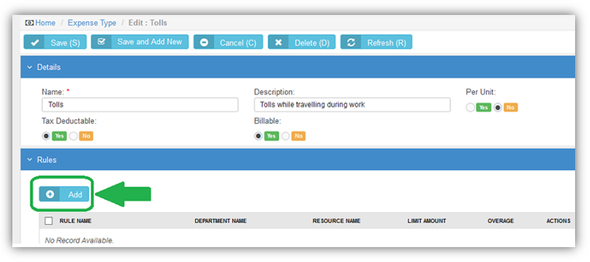**Active** - Yes or No
4. Specify rules by clicking **Add** in the **Rules** section.
   * **Name** - The name of the expense type rule.
   * **Department** - The department this expense type is applied to.
   * **Resources** - The employee this expense type is applied to.
   * **Limit Amount** - The amount this expense type is limited to.
   * **Overage** - If yes, the use or department, can override the **Limit Amount**.
5. Repeat step 4 for as many rules as appropriate for this expense type.
6. 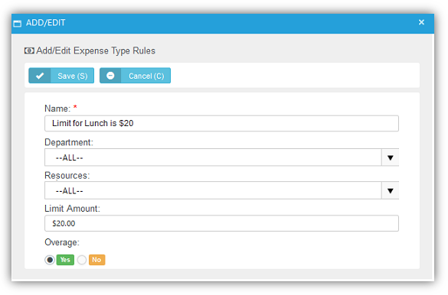Click **Save**.

### Milestone Type

Admin > Finance > Milestone Type

The **Milestone** page maintains a list of standard milestone types. A milestone type specifies the % total fee a client pays over the course of a project. Instead of paying everything upfront, payments are divided into milestones. For example a client could pay you 40% upfront, then 30% mid-project, then pay the last 30% on project completion. In the Contracts module, when creating a fixed price contract, these milestones are available in a drop-down list to quickly create phased billing.

**Creating Milestone Types**

1. Select the Admin > Finance > **Milestone Types** page.
2. Click **New**.
3. Enter the following fields.
   * Milestone Type Name
   * **Description**
   * **Status** - Active or InActive
   * **GL Account** - Select general ledger account to record postings.
   * **Taxable** - Taxable or Non Taxable
4. 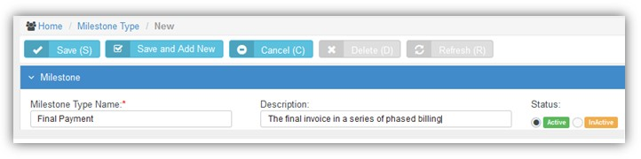Click **Save**.

### Account Type

**Admin > Finance > Account Type**

The **Account Type** page maintains a list of standard account types. Account types are used to group general ledger **account codes.** For example, Accounts Receivable (A/R), Accounts Payable (A/R), and Expenses.

##### Creating Account Types

1. Select the Admin > Finance > **Account Types** page.
2. Click **New**.
3. Enter the following fields.
   * Account Type Name
   * **Description**
   * **Status** - Active or InActive
   * **GL Account** - Select general ledger account to record postings.
   * **Taxable** - Taxable or Non Taxable
4. 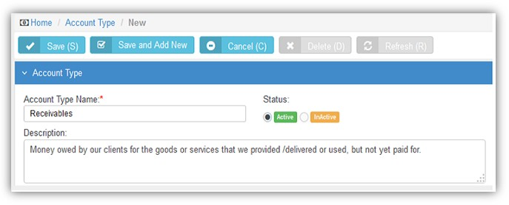Click **Save**.

### Account Code

Admin > Finance > Account Code

The **Account Type** page maintains a list of account codes. Sub-accounts are supported by specifying the parent account of an account code. Account codes are used to integrate SUPPORT with matching accounts codes in an integrated accounting software package such as QuickBooks.

**Creating Account Types**

1. Select the Admin > Finance > **Account Code** page.
2. Click **New**.
3. Enter the following fields.
   * Account Code
   * **Description**
   * **Status** - Active or InActive
   * Account Type
   * **Parent Account**
4. 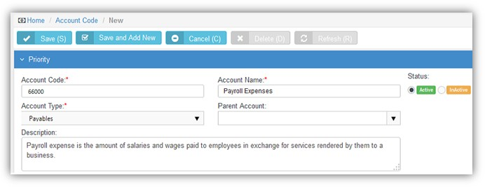Click **Save**.

### Discount Type

Admin > Finance > Discount Type

The **Discount Type** page maintains a list of standard discounts types. A discount type specifies a percentage or amount to optionally discount an invoice. The default value can be overridden.

**Creating Account Types**

1. Select the Admin > Finance > **Discount Types** page.
2. Click **New**.
3. Enter the following fields.
   * Name
   * **Value**
   * **Discount Type** - Amount or Percentage
   * Description
   * **GL Account**
   * **Taxable** - Taxable or Not Taxable
4. 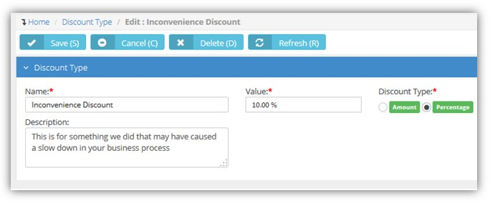Click **Save**.

### Charge Type

Admin > Finance > Charge Type

The **Charge Type** page maintains a list of standard charge types. Charge types specify additional charges entered when maintaining an invoice. For example, you may wish to add a one time handling fee to an invoice.

**Creating Account Types**

1. Select the Admin > Finance > **Charge Type** page.
2. Click **New**.
3. Enter the following fields.
   * Charge Type Name
   * **Description**
   * **Status** - Active or InActive
   * GL Account
   * **Taxable** - Taxable or Not Taxable
4. Click **Save**.

### Billing Configuration



Admin > Finance > Billing Configuration

The **Billing Configuration** page assigns accounts codes to values defined in other Finance setup tables. Accounts codes can be specified separately for each value in each Finance setup table. Account codes are used to integrate SUPPORT with matching accounts codes in an integrated accounting software package such as QuickBooks.

**Creating Billing Configuration**

1. Select the Admin > Finance > **Billing Configuration** page.
2. Enter accounts for fields in the **Work Types** tab.
   * Income Account
   * **Expense Account**
   * **Taxable**



1. 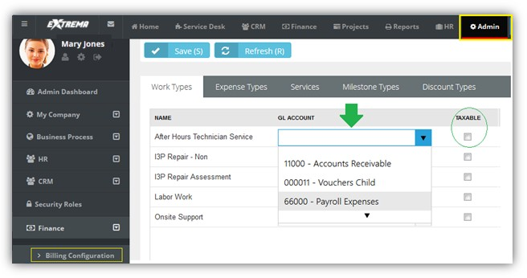Repeat step 2 for each of the following tabs.
   * Expense Types
   * **Services**
   * **Milestone Types**
   * **Discount Types**
   * **Products**
   * **Charge Types**
   * **Taxable**
2. Click **Save**.

### Sales Tax Items

Admin > Finance > Sales Tax Items

The **Sales Tax Items** page maintains a list of standard sales tax items. You can also group tax rates together using *group tax items*.

**Creating Sales Tax Items**

1. Select the Admin > Finance > **Sales Tax Items** page.
2. Click **New**.
3. Enter the following fields.
   * Name
   * **Tax Rate** - Enter a percentage.
   * **Tax Agency** - A CRM account classified as a vendor.
   * **Tax Group** - Accept default No.
   * Description
4. Click **Save**.

##### Creating Group Tax Items

1. Select the Admin > Finance > **Sales Tax Items** page.
2. Click **New**.
3. Enter the following in the **Sales Tax Item Info** tab.
   * Name
   * **Tax Group** - Yes.
   * Description
4. Enter the following in the **Group Tax Items** tab.
   * Click **Add**.
   * Select one or more sales tax items.
   * Click **OK**.
5. Click **Save**.

### Exchange Rates

Admin > Finance > Exchange Rates

The **Exchange Rates** page maintains a list of exchange rate records, one for each pair of currencies in the system. After saving an exchange record for the first time, you can add additional records specifying exchange rate values and the dates these exchange rates take effect.

**Creating Exchange Rate**

1. Select the Admin > Finance > **Exchange Rates** page.
2. Click **New**.
3. Enter the following fields.
   * **Currency From** - Select a currency.
   * **Currency To** - Select a currency.
4. Click **Save**. An **Exchange Rate Values** tab displays.
5. Click Add and enter values for the following fields.
   * **Exchange Rate Date** - The date the exchange rate takes effect.
   * **Exchange Rate Value** - The multiplier used to convert FROM currency amounts to currency amounts.
6. Repeat step 5 each time you want define a new exchange rate and the date when it takes effect.
7. Click **Save** again.

### Class List

**Admin > Finance > Class List**

The **Class List** page maintains a multi-level list of class names. Classes provide an alternate way of classifying income and expenses from the chart of accounts. For example you could classify income and expenses by department, location, property, project or event. Once created and assigned to transactions, you can filter reports by class.

##### Creating Class Lists

1. Select the Admin > Finance > **Class Lists** page.
2. Click **New**.
3. Enter the following fields.
   * Class Name
   * **Status** - Active or InActive
   * **Add Parent Class** - If Yes, select a **Parent Class** from the drop-down list.
4. Click **Save** again.

## Service Desk (in Admin)

Admin > Service Desk

The **Service Desk** menu in the Admin module defines support tables used by all your service desk operations. This includes values required to create, classify, assign, track and report on tickets in the system.

### Issue Types

Admin > Service Desk > Issue Types

The **Issue Types** pages maintains the list of issues and sub-issues that customers typically request support for in your system. This list is useful for tracking and reporting purposes. You can use workflows to automate responses to customer support requests, based on the issue type assigned to the request. Issue types and issue sub types can be included in an **SLA** objective.

##### Creating Issue Types

1. Select the Admin > Service Desk > **Issues Types** page.
2. Click **New**.
3. Enter the following fields in the **Issue Type Info** section.
   * Issue Type Name
   * **Description**
   * **Status** - Active or InActive
4. Click **Add** to add a new record in the **Issues Sub Types** section.
   * Name
   * **Description**
   * **Status** - Active or InActive
5. Repeat step 4 to add more issue sub types.
6. 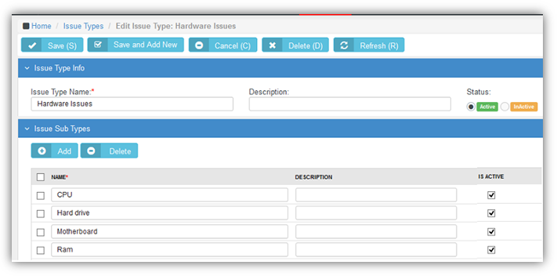Click **Save**.

### Ticket Types

Admin > Service Desk > Ticket Types

The **Ticket Types** pages maintains a list of ticket types used to classify tickets. You can create a workflow, run reports and create views based on ticket type.Types of tickets could include:

* **Service Request**: A request from a user for information, or advice. A service request can be for a move, add or change, which relocates, changes or installs some equipment or service. This could be an installation of an application, purchasing hardware or providing additional access.
* **Incident Ticket**: An unplanned interruption to an IT service. An Incident is when something the customer currently has is broken and needs to be fixed as soon as possible. These are commonly referred to as "break/fix tickets."
* **Problem Ticket**: A cause of one or more Incidents. A *problem* is a condition often identified as a result of multiple incidents that exhibit common symptoms. A problem can also be identified from a single incident, but this incident is significant any can affect many users. For example, a server is down, this problem would create multiple incident request and affects many.
* **Change Request**: A ticket requesting a significant change that may require approval from someone within the clients’ organization.

**Creating Issue Types**

1. Select the Admin > Service Desk > **Ticket Types** page.
2. Click **New**.
3. Enter the following fields.
   * Ticket Type Name
   * **Description**
   * **Status** - Active or InActive
4. Click **Save**.

### Queues

Admin > Service Desk > Queues

The **Queues** page maintains the ticket queues used by your **Service Desk** module. Tickets are assigned to queues. Technicians assigned to a queue are responsible for working the tickets in that queue. A workflow can automatically assign a ticket to a queue, based on the settings of the ticket. You can search for all tickets assigned to the queues you are a member of using the **Queue** search parameter on the **My Tickets** page.

* You create a queue first.
* Then you add employees to the queue.

**Creating Queues**

1. Select the Admin > Service Desk > **Queues** page.
2. Click **New**.
3. Enter the following fields in the **Queue Information** section.
   * Name
   * **Description**
   * **Status** - Active or InActive
4. Click **Add** to add one or more employees in the **Queue Users** section.
   * Select one or more rows in the employee list.
   * Click **OK**.
5. 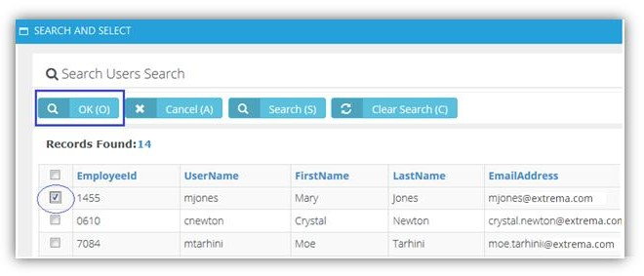Click **Save**.

### Priorities

Admin > Service Desk > Priorities

The **Priorities** pages maintains a list of priorities used to rank the urgency or importance of tickets in the Service Desk module. Each priority is assigned a color to help you quickly identify high priority tickets in your dashboard. Priorities can be included in an **SLA** objective.

**Creating Priorities**

1. Select the Admin > Service Desk > **Priorities** page.
2. Click **New**.
3. Enter the following fields.
   * Priority Name
   * **Description**
   * **Color** - Select a background color from the color picker.
4. 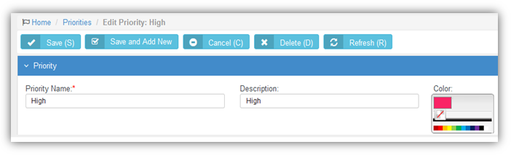Click **Save**.

### SLAs

Admin > Service Desk > SLAs

The **SLAs** page maintains a list of service level agreements. A service level agreement (SLA) is an agreement between a service provider and the customer that defines the level of service expected from the service provider. It defines the response time, escalations and potentially, resolution times per incident in a contract format between you and your customer. The SLA specifies, in measurable terms, how your company responds to the client’s needs and service requests. SLAs are critical towards formalizing expectations around services with end users and customers. Without these, customer expectations will assume that everything will be delivered and available at a 100% level all the time. These SLAs can be individualized for each client based upon your contract agreement with them.

*Tickets*

* A **Default SLA** is set for all tickets using the Admin > My Company > Company Settings > **Service Desk** tab.
* **Email parsers** calculate the *SLA Time to Resolution* when a new ticket is added.
* The *SLA Time to Resolution* is paused whenever a ticket is in the waiting for customer **status**
* For tickets assigned an SLA, when editing a ticket you will see a link next to an **SLA Status** field on the **Ticket View** tab. Click this link to see the estimated and actual times specified for resolving the ticket by the SLA.

###### Workflows

**Workflows**contain several SLA options that affect how tickets are processed. Triggers

* **SLA First Response Due In** - Specifies when a SLA first response is due and sends an alert, in hours or minutes.
* **SLA Resolution Due In** - Specifies when a SLA resolution is due and sends an alert, in hours or minutes.
* **SLA Resolution Overdue By** - Specifies when a SLA resolution is past due and sends an alert, in hours or minutes.

Conditions

* **SLA** - A ticket is assigned/not assigned to one or more selected SLAs. Update
* **SLA** - Assigns a ticket to a specified SLA.

###### Contracts

* Contracts can also be assigned to SLAs. A contract associated with an SLA overrides the **Default SLA** when the ticket is linked to the contract.

**Creating SLAs**

1. Select the Admin > Service Desk > **SLAs** page.
2. Click **New**.
3. Enter the following fields in the **Service Level Agreement Information** section.
   * SLA Name
   * **Description**
   * **Business Hours Of:** - Select one of your company's locations. Each location specifies the hours it is available to be contacted by customers.
   * **Status** - Active or InActive
4. 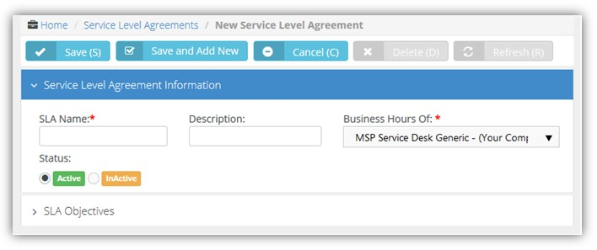Click **Save**.
5. Click the new SLA row you just created to open it again.
6. Click **Add** and enter the following fields in the **SLA Objectives** section.
   * Priority
   * **Issue Type**
   * **Issue Sub Type**
   * **Timeframe** - The timeframe specifies how SLA response times are calculated:
     + All (24x7) - Using all 24 hours, seven days a week.
     + Business Hours - Using the business hours defined for this location. For example, a location defines business hours as 8:00 a.m to 5:00 p.m., Monday through Friday. You have a 4 hour SLA for an incident and the ticket comes in at 3:00 p.m. on Monday. Based on these hours of operation, you have until 10:00 a.m. on Tuesday to respond.
     + Extended - Using business hours and the hours beyond the normal end of the same workday for this location. Excludes weekends and holidays. For example, a location defines business hours as 8:00 a.m to 5:00 p.m., Monday through Friday. You have an 8 hour SLA for an incident and the ticket comes in at 3:00 p.m. on Monday. Based on these hours of operation, you have until 11:00 p.m. of the same day, Monday, to respond.
   * Resolve Time (in hours)
   * Click **Save**.
7. Repeat step 6 to add as many **SLA Objectives** as you require.
8. 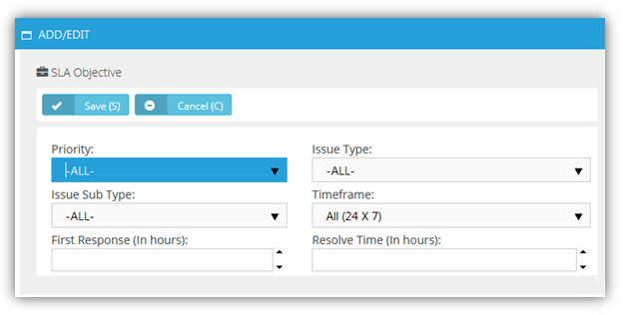Click **Save**.

### Ticket Statuses

Admin > Service Desk > Ticket Statuses

The **Ticket Statuses** page maintains a list of ticket status records. A ticket's status identifies where it is in the process of being resolved. The system comes with several pre-defined statuses. You can create additional statuses to meet your business requirements. Each status is assigned a color to help you quickly identify the status of tickets in your dashboard. Typically statuses include:

* New - The ticket has not yet been worked on.
* In Progress - The ticket is being worked on.

▪

Waiting for customer

company.

- The ticket is waiting for the customer to respond to a query from your

* Complete - The ticket has been resolved.

New,

Waiting for Customer

**Creating Ticket Statuses**

and Completed statuses cannot be made inactive.

1. Select the Admin > Service Desk > **Ticket Statuses** page.
2. Click **New**.
3. Enter the following fields:
   * Status Name
   * **SLA Event** - The selected SLA event is calculated based on setting a ticket to this status.
   * **Display Order** - Tickets can be sorted in drop-down lists based on this ranking. The sort order of ticket pages can also be optionally affected by the **Sort Status By** option.
   * Description
   * **Color** - Displays the status of a ticket using this background color.
   * **Font Color** - Displays the status of a ticket using this font color.
   * **Status** - Active or InActive
4. 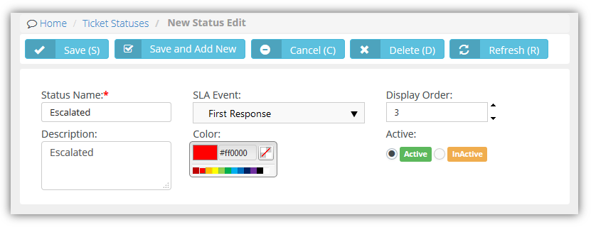Click **Save**.

### Email Parser

Admin > Service Desk > Email Parser

The **Manage Mailboxes** page maintains configuration settings for email parsers. Each active email parser converts incoming email into support tickets. Email messages are parsed into separate elements, then each element is mapped to the appropriate field of a new service desk ticket. With the email parser you can:

* Create new tickets from emails sent to [support@mycompany.com](mailto:support@mycompany.com)
* Add attachments from emails to the ticket
* Auto notify the sender of the success or failure of ticket creation
* Auto assign the ticket to a queue
* Take email responses from customers and add it as note to an existing ticket
* Review "unknown" submissions and convert them to tickets or discard them using the Service Desk > **Unknown Tickets** page.

**Email Submitted by Employees**

Email parsers create tickets using the internal client account when the email is submitted by an employee that has no contact record. When a new ticket is created using the email address of both an employee and a contact, the new ticket is associated with the client account of the contact. Subsequent replies to tickets using an email address shared by a contact and employee are added as employee notes and not as client notes.

##### Logs and Notifications

Use the **Logs** tab to help troubleshoot issues with processing inbound emails using an email parser. The **Notifications** tab specifies who to notify for different types of email parser events.

##### Creating Email Parsers

1. Select the Admin > Service Desk > **Email Parser** page.
2. Click **New**.
3. Enter the following fields in the **Basics** section.
   * Mailbox Name
   * **Email**
   * **Password**
   * **User Name**
   * **Status** - Active or InActive
   * **Add Attachments to Tickets** - Yes or No
4. Enter the following fields in the **Defaults** tab. These are the default values for the ticket created from email.
   * Priority
   * **Queue**
   * **Primary Assignee**
   * **Ticket Type**
   * **Ticket Note Type**
5. Enter the following fields in the **IMAPs** tab.
   * **Incoming Mail Server** - Must be an IMAP server. POP is not supported.
   * **Server Port Number** - Defaults to a value based on the encryption type selected.
   * **Encryption Type** - SSL, TLS or Non-Encrypted
   * **Search Folder** - Optionally specify a different email folder to check for new inbound email. Defaults to Inbox.
6. Enter the following fields in the **Notifications** tab > **Notify Sender** section.
   * On Success Template
   * **On Failure Template**
   * **Reply to**
     + **Sender** - Sends reply email only to the sender of the original inbound email.
     + **All (CC)** - Sends reply email to all email recipients, including recipients copied (CC) on the original inbound email.
7. Enter the following fields in the **Notifications** tab > **Notify Internal Resources** section.
   * On Success Template
     + **Notified Internal Resources** - Select one or more employees.
     + **Notified Others** - Email recipients.
   * On Failure Template
     + **Notified Internal Resources** - Select one or more employees.
     + **Notified Others** - Email recipients.
8. Enter the following fields in the **Black List** tab. Ignores email sent from these addresses.
   * Email Address
9. Click **Save**. 10.Click **Save**.

### Survey Integration Settings

Admin > Service Desk > Survey Integration Settings

The **Survey Integration Settings** page maintains records that create customer survey links in email notifications. Settings include:

* The customer survey provider.
* The HTML layout presented to a user when he or she clicks a link in a notification email to take a survey.
* The mapping of customer survey responses to 'satisfaction scores' maintained internally within SUPPORT.

**Configuration**

*In SUPPORT*

1. Create a set of internal 'satisfaction scores' using the Admin > Service Desk > **Internal Survey Scores** page.
2. Create a **Survey Integration Settings** record.
   * Currently only *Customer Thermometer* survey integration records are supported.
   * Leave the **Template Layout** tab blank.
   * Click **Save**.
3. After the first save, a **Survey Score Mappings** tab displays.
   * The **External Score** column of values on this tab is fixed, and based on the customer survey provider selected for the integration record.
   * Map your **Internal Survey Scores** to the **External Score** values.
   * Click **Save**.

*In Customer Thermometer*

1. Watch a video that explains how to 'Embed 1-click icons inside your ticket notifications' provided by *Customer Thermometer*.
2. Generate *Customer Thermometer* feedback buttons and tracking links.
3. Copy the code in the 'HTML code for pasting' text box provided by *Customer Thermometer*.

###### In SUPPORT

1. Paste code from the 'HTML code for pasting' text box into the **Template Content** tab of your new integration record on this page.
2. Add the %CUSTOMER_SURVEY_Customer_Thermometer%] field placeholder to any **email template** you wish to use to display a survey link when an email notification based on that template is sent out.
3. Optionally configure a workflow notification to use the email template with the survey link. Otherwise you must remember to select the email template when sending email notifications manually.

**Processing**

Once a survey score is submitted:

* Workflows can use the mapped results to evaluate the **Satisfaction Score** submitted and trigger a subsequent update to the ticket. For example, if a ticket was closed and a customer was dissatisfied, the ticket could be re-opened.
* Opening a ticket shows the *latest* survey score submitted for the ticket on the **Ticket View** tab.
* A **Survey History** tab in the opened ticket shows the complete history of all survey scores submitted for the ticket.
* The results of survey scores can also be shown in reports.
* Visibility of survey score results can be controlled by a **Customer Survey Scores** permission in the Service Desk section of **security roles.**

### Internal Survey Scores

Admin > Service Desk > Internal Survey Scores

The **Internal Survey Scores** page maintains the internal records used to classify survey scores provided by survey score providers. A numerical value is associated with each survey score record.

### 

### RMM Integration Settings - CloudActiv8 v1

**Admin > Service Desk > RMM Integration Settings**

The **RMM Integration Settings** page maintains configuration settings for integrating SUPPORT with a remote monitoring and management (RMM) systems. Once integration is complete you can monitor machines and devices using an integrated RMM and manage their corresponding tickets in SUPPORT.

**CloudActiv8 v.1 Integration Summary**

* **Integrating Servers**
* **Integrating Ticket Settings**
* Integrating Customer Accounts and Locations
* **Assets Synchronization**
* **Testing Ticket Integration**

#### Integrating Servers

Admin > Service Desk > RMM Integration Settings

In this first procedure you integrate your SUPPORT instance with a CloudActiv8 CLOUDACTIV8 server.

**CLOUDACTIV8 Prerequisites**

* Identify the CLOUDACTIV8 address.
* Create a dedicated CLOUDACTIV8 user account used by SUPPORT to access the CLOUDACTIV8. Example: SUPPORT_service
* Ensure ticket creation events in the CLOUDACTIV8 create tickets in the **Ticketing** module of the CLOUDACTIV8.

##### Procedure

1. 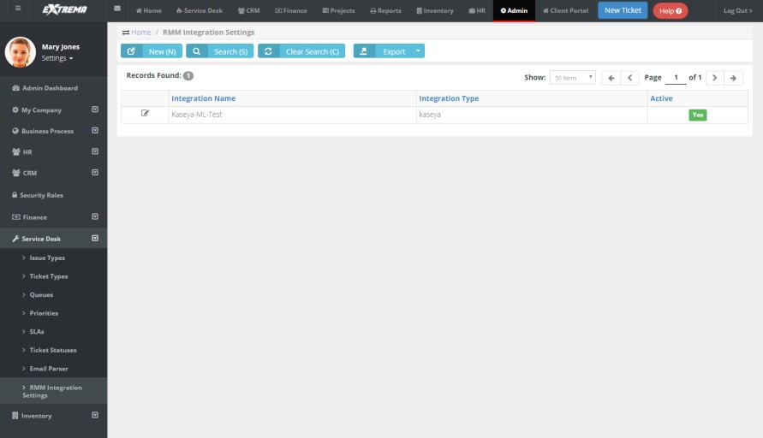Select the Admin > Service Desk > **RMM Integration Settings** page.



1. Click **New**.
2. Enter the following fields in the **General Settings** tab, **Configuration Options** section.
   * **Enable RMM Integration** - Enable or Disable
   * **Integration Name** - Enter a unique name for this integration.
   * **Integration Type** - CloudActiv8
   * **Integrator Username** - Enter the CLOUDACTIV8 username SUPPORT uses to access the CLOUDACTIV8. This should be a dedicated service account, such as SUPPORT_service.
   * **Integrator Password** - Enter the password for the SUPPORT service account.
   * **Server Address (IP-Port)** - Enter the IP address for the CLOUDACTIV8.
   * **Callback URL** - Enter the URL used by the CLOUDACTIV8 to update the SUPPORT,
   * 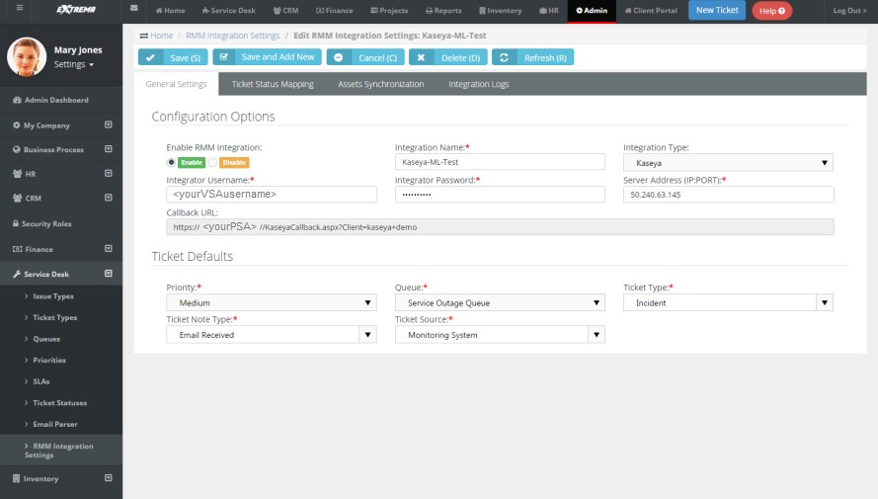Click **Save** to save the integration.



#### Integrating Ticket Settings

Admin > Service Desk > RMM Integration Settings

In this procedure you review default ticket settings and map ticket statuses between SUPPORT and the CLOUDACTIV8.

1. Select the Admin > Service Desk > **RMM Integration Settings** page.
2. Select the integration record you just created.
3. Optionally change the default values in the **General Settings** tab, **Ticket Defaults** section. All SUPPORT ticket values created from an RMM ticket are initially set to these values. They can be automatically changed—based on the ticket's content—using a SUPPORT **workflow.**
   * Priority
   * **Queue**
   * **Ticket Type**
   * **Ticket Note Type**
   * **Ticket Source**
4. Select the **Ticket Status Mapping** tab.
5. Select values for mapping ticket statuses between SUPPORT and the CLOUDACTIV8.
   * Ticket Status Mapping From SUPPORT
   * **Ticket Status Mapping To SUPPORT**

1. 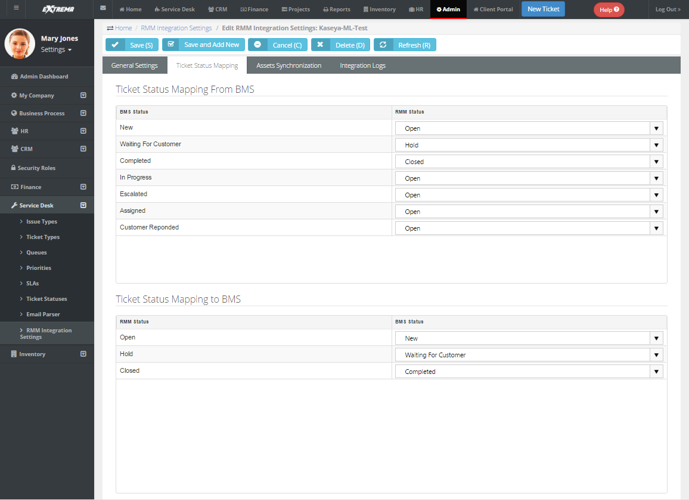Click **Save** to save the ticket defaults and ticket mapping.



#### Integrating Customer Accounts and Locations

Admin > Service Desk > RMM Integration Settings

In each SUPPORT customer account you choose to integrate, you must map SUPPORT customer accounts to CLOUDACTIV8 organizations. You must also map machine groups in each integrated CLOUDACTIV8 organization to locations in each SUPPORT customer account.

1. Select the CRM > **Accounts** page.
2. Select an account.
3. Click the **RMM Integration** tab.
4. Select the CloudActiv8 **Organization ID** that corresponds to this SUPPORT customer account.
5. Add or edit a location on the **Location** tab.
6. Click the **RMM Integration** tab in the dialog.
7. Select the CLOUDACTIV8 machine group that corresponds to this SUPPORT location.
8. Repeat steps 5 through 7 for each machine group and location you want to integrate.
9. Click **Save** to save the customer account.
10. Repeat this procedure for each customer account you want to integrate.



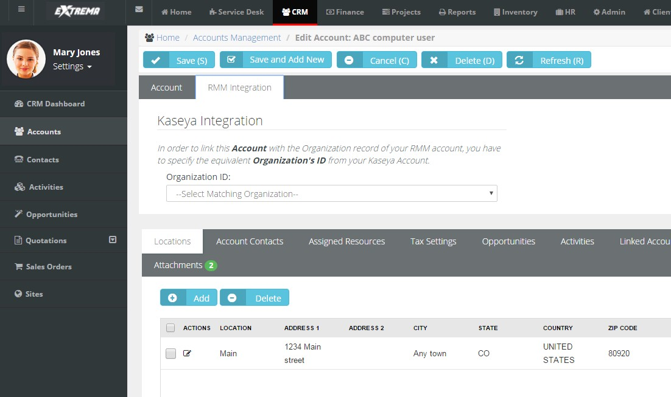



#### Assets Synchronization

**Admin > Service Desk > RMM Integration Settings**

This procedure provides bulk synchronization. Even if this bulk procedure is not run, asset synchronization occurs automatically *for integrated customer accounts and locations* when:

* A ticket is created for an existing agent.
* A new agent is installed.

**Synchronizing Assets**

1. Select the Admin > Service Desk > **RMM Integration Settings** page.
2. Click the integration record you created earlier.
3. Select the **Assets Synchronization** tab.
4. Optionally filter the loading of asset data from the CLOUDACTIV8 into SUPPORT using the **Load Assets** tab.
   * Machine Group ID
   * **Group Name**
   * **MAC Address**
   * **IP Address**



* + **First Check In**

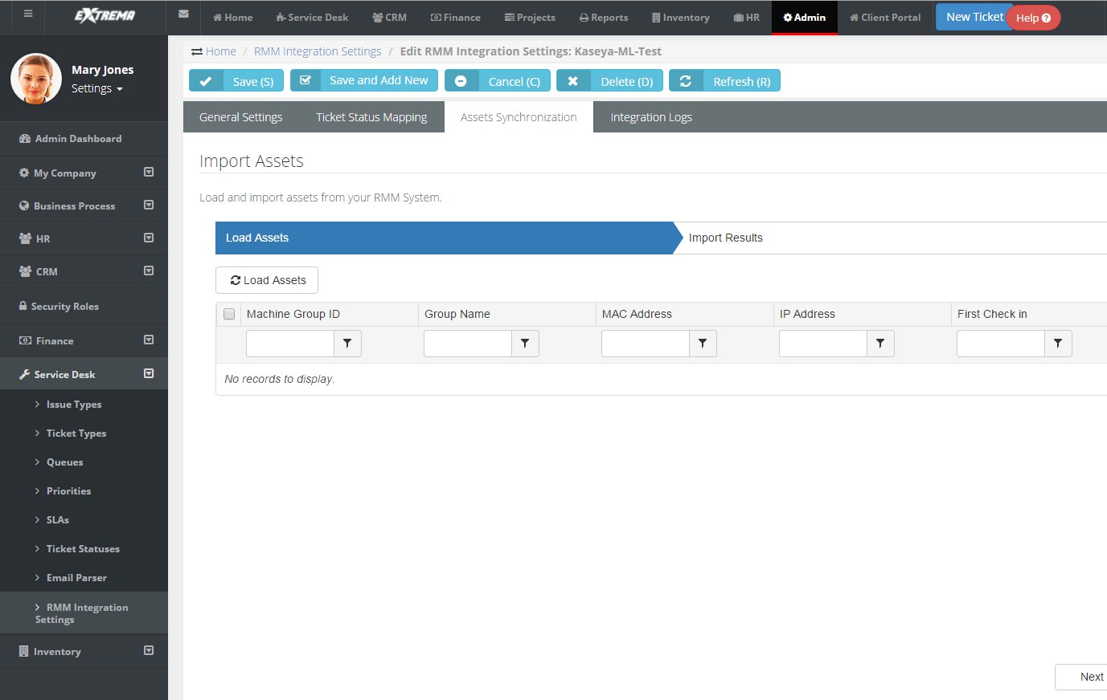



1. Click the **Load Assets** button to load asset data from the CLOUDACTIV8 into SUPPORT.
2. Check the assets you want to import. You can also select the 'select all' checkbox in the upper left-hand corner of the table to select all listed assets.

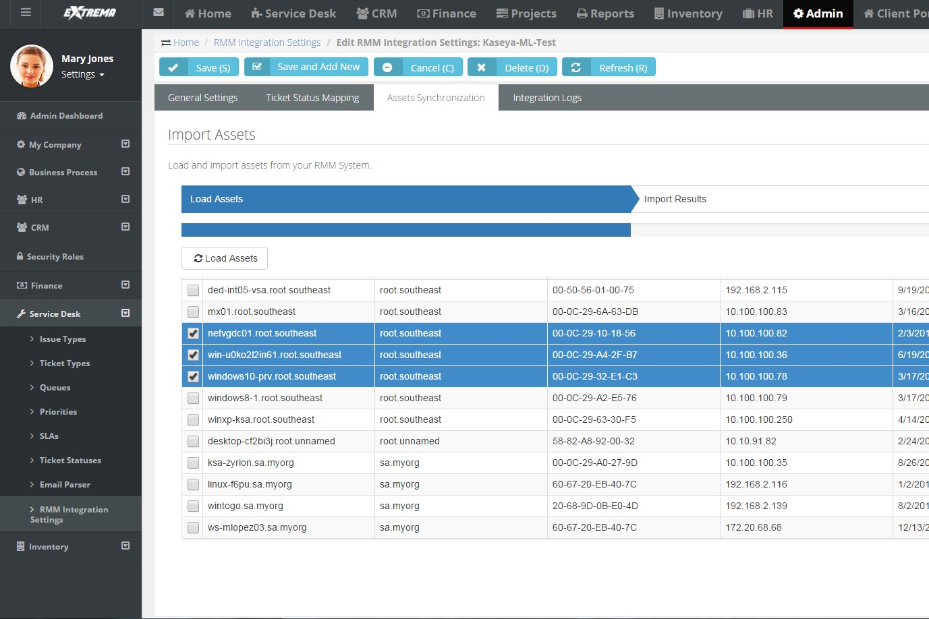



1. Review the **Import Results**.



* + If the customer account and location is mapped and the asset exists or is added, the import shows success.
  + If the customer account or location is not mapped, the import shows failure.

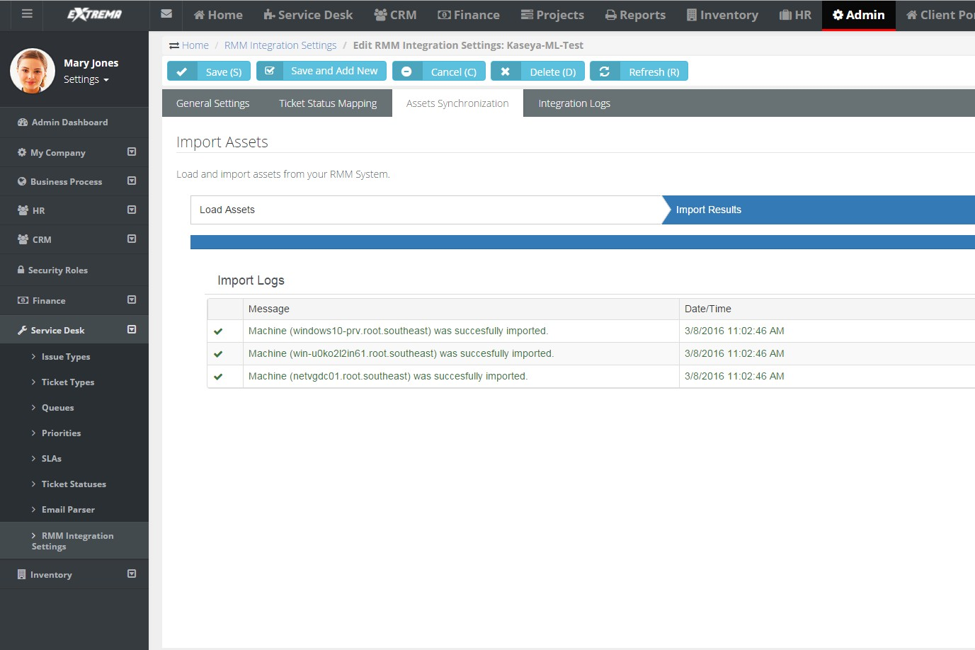



1. Review synchronized asset properties using the SUPPORT > Service Desk > Asset Management >

**Hardware Assets** page.

#### Testing Ticket Integration

Admin > Service Desk > RMM Integration Settings

Once integration is configured, you can test it by triggering a system-generated ticket in the CLOUDACTIV8, then view the corresponding ticket in the SUPPORT.

1. In the CLOUDACTIV8, use a monitoring event to create a **Ticketing** ticket for an agent in an integrated organization and machine group.
2. In SUPPORT select the Service Desk > **Tickets** page.
3. Select the SUPPORT ticket created for the CLOUDACTIV8 monitoring event.
   * 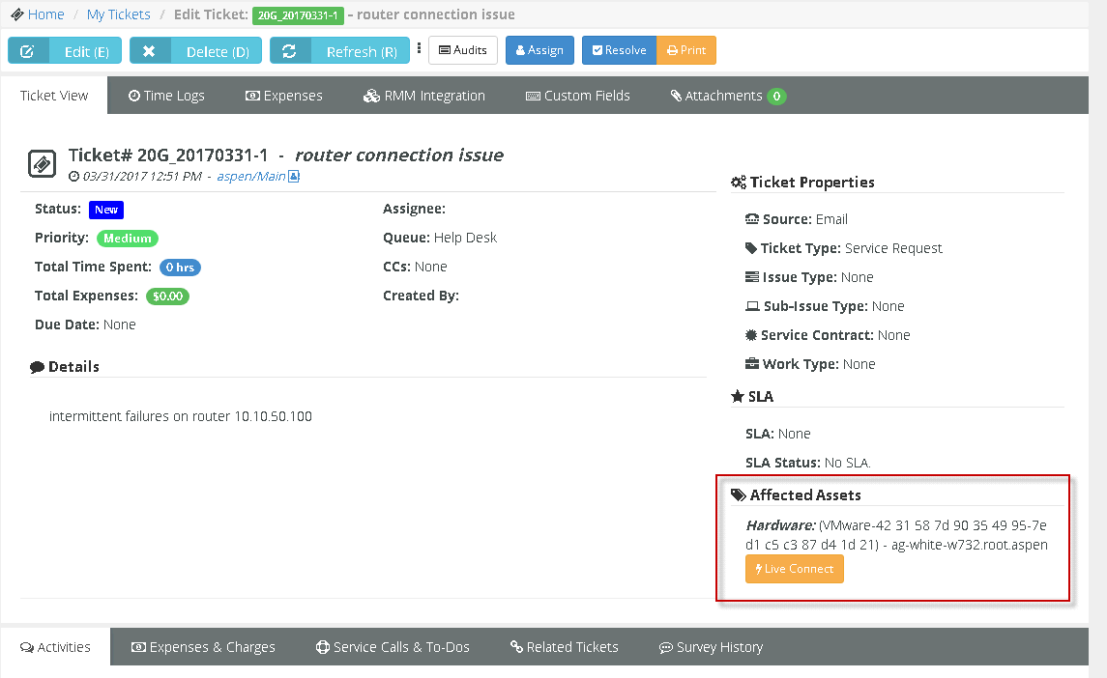The **Ticket View** > Assets section identifies the machine, group and organization of the agent account in the CLOUDACTIV8.



1. Select the **RMM Integration** tab.
   * The **Ticket Reference** identifies the ticket in the CLOUDACTIV8.

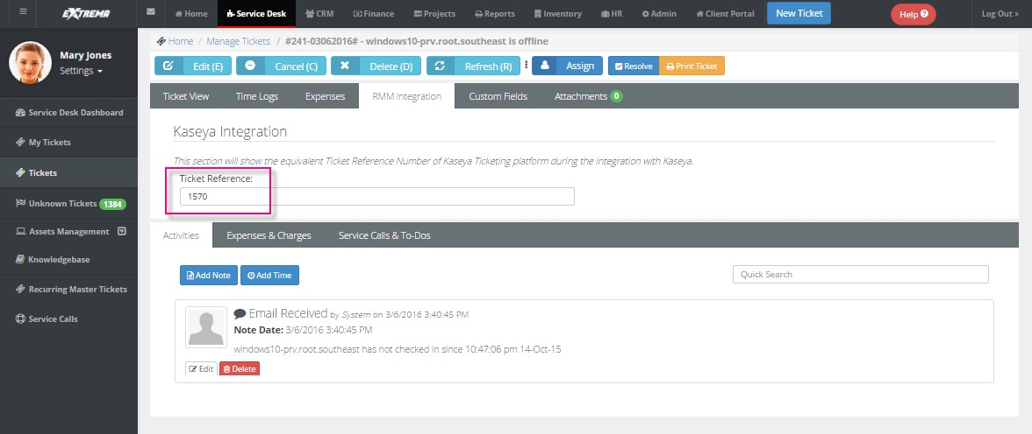



### RMM Integration Settings - CloudActiv8 v2 – New

**Admin > Service Desk > RMM Integration Settings**

The **RMM Integration Settings** page maintains configuration settings for integrating SUPPORT with multiple remote monitoring and management (RMM) systems. Once integration is complete you can monitor machines and devices using an integrated RMM and manage their corresponding tickets in SUPPORT.

* RMM Integration - CloudActiv8 v2 (pdf)

**Version Requirements**

CLOUDACTIV8 must be running 9.3.0.11 or later. SUPPORT must be running 3.9 or later.

##### RMM Integration - CloudActiv8 v2 – New

These five topics contain all instructions required for a *new* integration and should be performed in sequence.

1. **Integrating Servers v2**
2. **Synchronizing Accounts v2**
3. **Assets Synchronization v2**
4. **Integrating Live Connect v2**
5. **Activating CLOUDACTIV8 Integration v2**
6. **Review Ticket Integration v2**

##### RMM Integration - CloudActiv8 v2 - Upgrade from CloudActiv8 v1

* **Upgrading to RMM Integration - CloudActiv8 v2** - This single topic contains all instructions required for *upgrading*.

#### Integrating Servers v2

Admin > Service Desk > RMM Integration Settings > General Settings

In this first procedure you integrate your SUPPORT instance with a CloudActiv8 CLOUDACTIV8 server. You also select default ticket settings for tickets sourced from the CLOUDACTIV8.

**Integration Prerequisites**

* CLOUDACTIV8 must be running 9.3.0.11 or later. SUPPORT must be running 3.9.
* Identify the CLOUDACTIV8 address you will integrating with SUPPORT.
* Create a dedicated CLOUDACTIV8 user account used by SUPPORT to access the CLOUDACTIV8. Example: SUPPORT_service. The CLOUDACTIV8 user account should have access to all organizations.
* Identify the "root" user in SUPPORT. The root user is the top most employee tile in the HR > **Organizational Chart** *(page* *104**)* page. Using this user for RMM Integration is recommended to ensure all SUPPORT > CRM customer accounts and SUPPORT > Service Desk tickets can be accessed.
* Disable the CLOUDACTIV8 > **Ticketing** email server by checking the **Disable email reader** checkbox on the CLOUDACTIV8

> Ticketing > Email Reader page.

* If the **Service Desk** module is installed in the CLOUDACTIV8:
  + Click the **Disable** button on the CLOUDACTIV8 > Service Desk > Incoming Email and Alarm Settings page.
  + Uncheck the **Activate Service Desk** checkbox on the CLOUDACTIV8 > Service Desk > Global Settings page.

**Procedure**

1. Select the Admin > Service Desk > **RMM Integration Settings** page.



1. Click **New**.
2. Enter the following fields in the **General Settings** tab, **Configuration Options** section.
   * **Enable RMM Integration** - Enable or Disable
   * **Integration Name** - Enter a unique name for this integration.
   * **Integration Type** - CloudActiv8 Ver.2
   * **Integrator Username** - Enter the CLOUDACTIV8 username SUPPORT uses to access the CLOUDACTIV8. This should be a dedicated service account, such as SUPPORT_service.
   * **Integrator Password** - Enter the password for the SUPPORT service account.
   * **Server Address** - Enter the URL or IP address for the CLOUDACTIV8. Optionally include a port.
   * **Push CRM Accounts automatically to CLOUDACTIV8** - Enable or Disable - If enabled, new CRM customer accounts create corresponding organizations in the CLOUDACTIV8, as soon as the CRM customer account is created. The CRM customer account and CLOUDACTIV8 organization remains mapped to each other from then on. *This option does not apply to existing CRM accounts.*
3. Select default values in the **Ticket Defaults** section. All SUPPORT ticket values created from an RMM ticket are initially set to these values. They can be automatically changed—based on the ticket's content—using a SUPPORT **workflow** 
   * Priority
   * **Queue**
   * **Ticket Type**
   * **Ticket Note Type**
   * **Ticket Source**
4. Click **Save** to save your settings.
5. Click **Test Connection** to ensure SUPPORT can connect with the CLOUDACTIV8 instance you have specified.

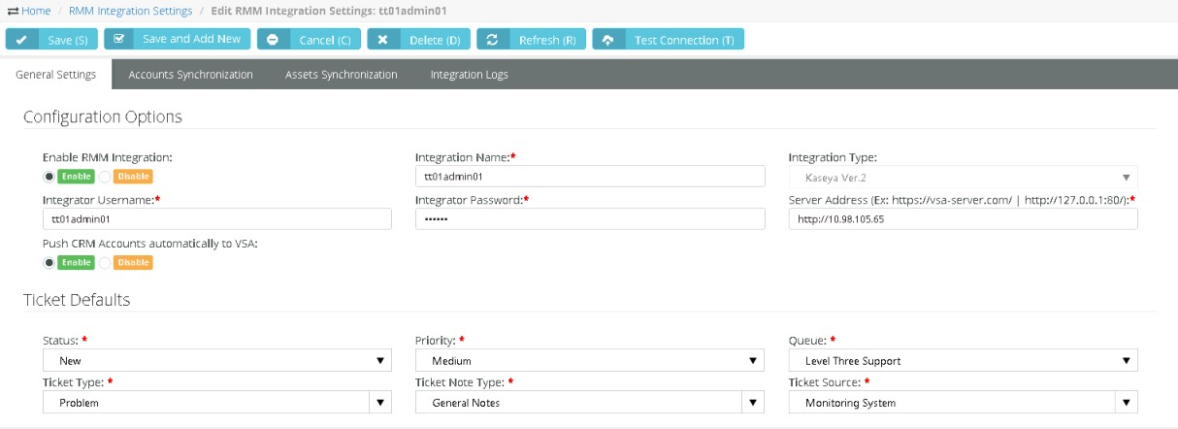

#### Synchronizing Accounts v2

Admin > Service Desk > RMM Integration Settings > Accounts Synchronization

Once a *CloudActiv8 version 2* **RMM Integration Settings** record has been saved, you can bulk import CLOUDACTIV8 organizations into SUPPORT to create corresponding CRM customer accounts. Minor spelling differences are ignored to intelligently match accounts. The SUPPORT remembers the mapping so you can reimport as often as you like. This would typically occur at least once during your initial configuration. You can also export *existing* CRM customer accounts to create corresponding organizations in the CLOUDACTIV8.

**Additional Guidelines**

* *Running* **Accounts Synchronization** *initially is recommended.* Whether or not **Accounts Synchronization** is run. Once SUPPORT integration is activated in the CLOUDACTIV8, SUPPORT will create a new CRM customer account for any new CLOUDACTIV8 organization referenced by a new ticket or new asset.
* Changing the name of the organization or asset in the CLOUDACTIV8 does not update SUPPORT unless you run

Accounts Synchronization and Assets Synchronization again.

* You can also manually associate an existing CRM customer account with an existing CLOUDACTIV8 organization, using the CRM > Accounts > (selected account) > **RMM Integration** tab.

##### Import Accounts Procedure

1. Click **Load Accounts**.
2. Optionally filter the loading of data from the CLOUDACTIV8 into SUPPORT using the **Filter by Name...** field. Click

**Load Accounts** again to re-display the filtered list.

1. Select the organizations you want to import into SUPPORT.
2. Optionally click:

➢  to edit the mapping

➢  to delete the mapping

* + (SUPPORT account name) to display its account record in SUPPORT

1. Click **Import Results**.

##### Export Accounts Procedure

Use this procedure to export *existing* CRM customer accounts in SUPPORT to the CLOUDACTIV8. Any *new* CRM account you create is automatically added to the CLOUDACTIV8 without having to use this feature.

1. Click **Load Accounts**.
2. Optionally filter the loading of data from the CLOUDACTIV8 into SUPPORT using the **Filter** field.
3. Select the CRM customer accounts you want to export to the CLOUDACTIV8.
4. Click **Export Results**.

#### Assets Synchronization v2

Admin > Service Desk > RMM Integration Settings

This procedure provides bulk synchronization of assets. Even if this bulk procedure is not run, asset synchronization occurs automatically *for integrated organizations/customer accounts* when:

* An asset is detected using CLOUDACTIV8 > Discovery.
* A new agent is installed in the CLOUDACTIV8.

**Additional Guidelines**

* Changing the name of the organization or asset in the CLOUDACTIV8 does not update SUPPORT unless you run

Assets Synchronization.

* Once assets are imported, you can also manually create a ticket in SUPPORT and select the imported asset, without having to initiate a ticket creation event in the CLOUDACTIV8.

##### Procedure

1. Select the Admin > Service Desk > **RMM Integration Settings** page.
2. Click the integration record you created earlier.
3. Select the **Assets Synchronization** tab.
4. 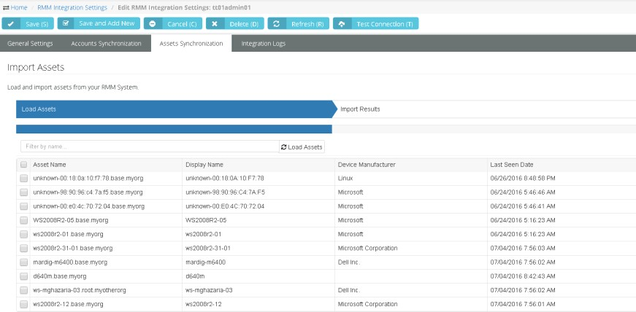Click **Load Assets**.
5. Optionally filter the loading of data from the CLOUDACTIV8 into SUPPORT using filter fields.
   * Asset Name
   * **Machine Group**
   * **Is Computer Agent** - No or Yes - If Yes, the computer has a CloudActiv8 agent installed.
6. Select the assets you want to import into SUPPORT.
7. Click **Import Results**.
8. Review synchronized asset properties using the SUPPORT > Service Desk > Asset Management >

**Hardware Assets** page.

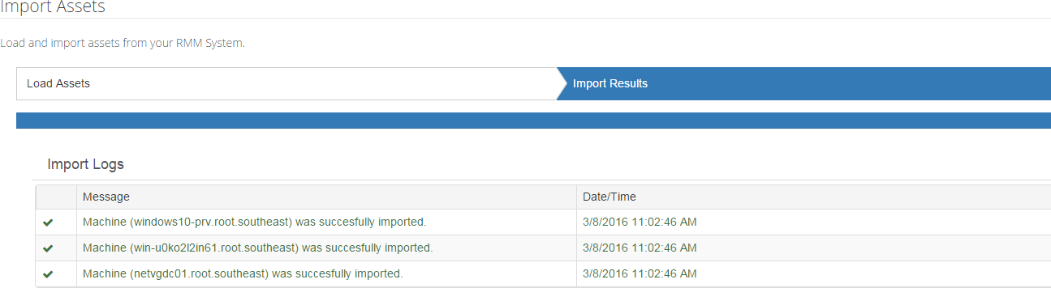

#### Integrating Live Connect v2

From within a SUPPORT ticket you can launch a CLOUDACTIV8 **Live Connect** session to a machine by clicking the associated hardware asset.

##### Prerequisites

* CLOUDACTIV8 v9.4
* SSL enabled on CLOUDACTIV8 with valid certificate
* The latest version of the **CloudActiv8 Live Connect** app from CLOUDACTIV8 v9.4.
* Allow popups for all sites on the browser you are using during configuration.

##### Configuration

1. Register your SUPPORT instance in the target CLOUDACTIV8.
   * See the CLOUDACTIV8 > System > **OAuth Clients**
   * Provide a **Redirect URL**.
   * Provide an email address that will send you a **Client ID** and **Client Secret**.
2. Enter the **Client ID** and **Client Secret** from the mail into the **Live Connect** tab in SUPPORT.
3. Save the **RMM Integration Settings** record with the new **Client ID** and **Client Secret** values entered.
4. Click the **Connect via OAuth** button.
5. Save your changes to this **RMM Integration Settings** record.
6. Navigate to the SUPPORT > Admin > **Security Roles** page.
7. Edit the security roles used by your **Service Desk** technicians. For example: Service Desk Manager.
8. For each security role that applies, ensure the **CloudActiv8 Live Connect** special feature is checked in the

**Service Desk** section of the **Permissions** tab.

1. For each user that will be using the SUPPORT **Live Connect** feature, download and install the CLOUDACTIV8 **Live Connect** app on his or her local computer.
2. Verify the **Live Connect** integration when you get to step 4 of **Review Ticket Integration v2** *.* **Live Connect** can be launched from:
   * The Service Desk > Asset Management > **Hardware Assets** page
   * The **View Ticket** tab of an open ticket.
   * The **Search Hardware Assets** dialog used to select a hardware asset and link it to a ticket.

#### Activating CLOUDACTIV8 Integration v2

**CLOUDACTIV8 > System > SUPPORT Integration > Sync Configuration**

In the CLOUDACTIV8 the **Sync Configuration** page configures CLOUDACTIV8 access to data in SUPPORT. Once the configuration is activated, SUPPORT creates tickets for the CLOUDACTIV8, based on ticket creation events detected in the CLOUDACTIV8.

##### Prerequisites

* The *RMM Integration - CloudActiv8 v2* record for the corresponding SUPPORT company you wish to integrate must already be configured and enabled for your CLOUDACTIV8.
* The **Activate Service Desk** checkbox in the CLOUDACTIV8 > **Service Desk** module—if installed—must be deactivated.

##### Actions

* **Edit** - Configures the SUPPORT company account that creates tickets for this CLOUDACTIV8.
* **Test** - Tests the connection with the SUPPORT server and company account.
* Resume / Enable Sync Processing
  + Resumes creating tickets in SUPPORT.
  + Any ticket creation events in the CLOUDACTIV8 that have occurred since sync processing was paused are forwarded to SUPPORT.
* Pause Sync Processing
  + Halts ticket creation in SUPPORT.
  + Ticket creation events continue to be queued, ready to create tickets when you resume sync processing.
* Activate Integration Module
  + The CLOUDACTIV8 > **Service Desk** and **Ticketing** modules will no longer create tickets for any ticket creation events in the CLOUDACTIV8. This includes tickets created for alerts and for inbound emails.
  + The email readers for **Service Desk** and **Ticketing** will no longer be polled.
* Deactivate Integration Module
  + Ticket creation events in the CLOUDACTIV8 begin creating tickets in the **Ticketing** module.

##### Procedure

1. In the CLOUDACTIV8, select the System > SUPPORT Integration > **Sync Configuration** page.
2. Click **Edit**.
3. Enter the following in the **Edit Settings** dialog.
   * **URL of SUPPORT Server** - Enter the URL of your SUPPORT server.
   * **Company** - Enter your SUPPORT company name.
   * **Username** - Enter a SUPPORT login username. The SUPPORT "root" user account is recommended. See the prerequisites in **Integrating Servers v2** *.*
   * **Password** - Enter the password for your SUPPORT login username.
   * Select Asset Push Rule
     + Agent Assets Only - Only computers with agents installed on them are pushed to SUPPORT.
     + All Assets - Devices without agents can be promoted to assets. Both computers and devices promoted to assets are pushed to SUPPORT.
     + None - No assets are pushed to SUPPORT.
   * Ticket Processing Rules
     + Deduplicate matching tickets updated within <N> hours – Matching tickets can

be sent to SUPPORT as a single ticket with a duplicate count of X within the designated time frame.

* + - Reopen closed duplicate tickets – Closed duplicate tickets can be reopened after synchronization to SUPPORT.

1. Click **Test** to verify your CLOUDACTIV8 can access the SUPPORT server.
2. Click the **Activate Integration Module**.
3. Click the **Resume/Enable Sync Processing** button.
   * Both buttons must have a green checkmark to trigger the creation of tickets in SUPPORT.
4. Configure ticket creation events in the CLOUDACTIV8.
5. Optionally review log entries created by the CLOUDACTIV8 for ticket requests sent to SUPPORT
   * System > SUPPORT Integration > **Sync Transaction Log** - Displays a log of sync transactions between the CLOUDACTIV8 and SUPPORT.
   * System > SUPPORT Integration > **SUPPORT API Log** - Displays a log of REST API requests related to the integration between the CLOUDACTIV8 and SUPPORT.



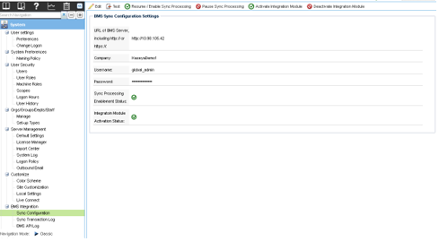

#### 

#### Review Ticket Integration v2

Service Desk > Tickets > (selected ticket) > Edit > RMM Integration

Once integration is configured, you can test it by triggering a system-generated ticket in the CLOUDACTIV8, then view the corresponding ticket in the SUPPORT.

**Procedure**

1. In the CLOUDACTIV8, use a monitoring event to create a **Ticketing** ticket for an agent in an integrated organization and machine group.
2. In SUPPORT select the Service Desk > **Tickets** page.

* + Select the SUPPORT ticket created for the CLOUDACTIV8 monitoring event.The **Ticket View** > Affected Assets section identifies the machine, group and organization of the agent account in the CLOUDACTIV8.

1. Click **Live Connect** to start a session to this machine.
   * A separate **Live Connect** window opens. If this is the first time during your session you have used Live Connect, you will be required to enter a CLOUDACTIV8 username and password. Your credentials determines the **Live Connect** assets you are authorized to access.
   * If no **Live Connect** asset is shown, you can add one manually. Click Edit, then click the plus icon next to the **Affected Hardware Asset** field. In the Search dialog you can start a **Live Connect** session on any of the assets listed, without having to link it to the ticket.
2. Select the **RMM Integration** tab.
   * The **Ticket Reference** identifies the value shown in the **Record Reference** column in the **Sync Transaction Log** page in the CLOUDACTIV8.
   * 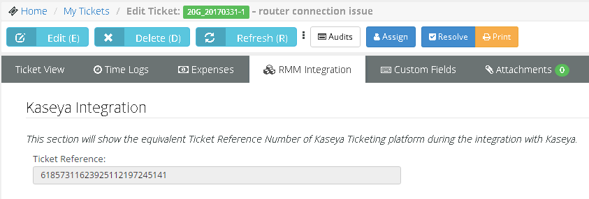The **Status** column in the **Sync Transaction Log** displays the SUPPORT ticket number created.
3. Select the Service Desk > Assets Management > **Hardware Assets** page.
   * Click any row that displays a **Live Connect ** icon. A separate **Live Connect** window opens.
   * If a  icon displays, this is the first time during your session you have used **Live Connect**. Click the icon to enter a CLOUDACTIV8 username and password. Your credentials determines the **Live Connect** assets you are authorized to access.

### RMM Integration Settings - CloudActiv8 v2 – Upgrade

Customers who have already integrated their CLOUDACTIV8 with SUPPORT using *RMM Integration - CloudActiv8 v1* may wish to upgrade to *RMM Integration - CloudActiv8 v2*. Upgrading to *RMM Integration - CloudActiv8 v2*:

* Provides better performance and efficiency.
* Enables users to take advantage of future integration enhancements.
* Provides enhanced logging and tracking of integration transactions.
* Enables temporary pausing of ticket creation events without loss of data.
* Eliminates duplicate creation of tickets in both the CLOUDACTIV8 and SUPPORT.
* Supports cutover from either the CLOUDACTIV8 Service Desk module or the CLOUDACTIV8 Ticketing module.
* Supports both on premises and SaaS CLOUDACTIV8 implementations.
* Closing the SUPPORT ticket also closes the alarm in the CLOUDACTIV8 that was created by the same alert. This feature requires the System > Configure > **Enable auto close of alarms and tickets** checkbox be checked in the CLOUDACTIV8.

##### Upgrade Prerequisites

* CLOUDACTIV8 must be running 9.3.0.11 or later. SUPPORT must be running 3.9.
* The following two files are required to complete the uninstall of your existing *RMM integration - CloudActiv8 v1* configuration. You can download them from the **CloudActiv8 Community** Copy these two files to the

//CloudActiv8/SUPPORTSync folder of your CLOUDACTIV8. **Do not run these files until instructed to do so in the procedure below.**

* + RemoveSUPPORTSync.bat - You will run this from a command line on the system hosting your CLOUDACTIV8.
  + RemoveSUPPORTSync.sql - You will execute this SQL query on the system hosting the SQL Server used by your CLOUDACTIV8.
* Identify or create a new dedicated CLOUDACTIV8 user account used by SUPPORT to access the CLOUDACTIV8. Example: SUPPORT service. The CLOUDACTIV8 user account should have access to all organizations. You can re-use the same one you're already using for your existing RMM Integration - CloudActiv8 v1.
* Identify the "root" user in SUPPORT. The root user is the top most employee tile in the HR > **Organizational Chart** *(page* *104**)* page. Using this user for RMM Integration is recommended to ensure all SUPPORT > CRM customer accounts and SUPPORT > Service Desk tickets can be accessed.
* Disable the CLOUDACTIV8 > **Ticketing** email server by checking the **Disable email reader** checkbox on the CLOUDACTIV8

> Ticketing > Email Reader page.

* If the **Service Desk** module is installed in the CLOUDACTIV8:
  + Click the **Disable** button on the CLOUDACTIV8 > Service Desk > Incoming Email and Alarm Settings page.
  + Uncheck the **Activate Service Desk** checkbox on the CLOUDACTIV8 > Service Desk > Global Settings page.

##### In CLOUDACTIV8

1. In the CLOUDACTIV8, select the System > SUPPORT Integration > **Sync Configuration** page.
2. Click the **Activate Integration Module** button.
   * This disables the creation of tickets in SUPPORT using your existing RMM Integration - CloudActiv8 v1 record.
   * *Ticket creation events in the CLOUDACTIV8 will continue to be collected with no loss of data.* Tickets will resume being created when the new integration has been configured and activated.

**In SUPPORT**

1. Select the Admin > Service Desk > **RMM Integration Settings** page.
2. Select the existing *RMM Integration - version 1* record you have been using.
   * Set **Enable RMM Integration** option to Disable.
   * **Save**, then close this record.
3. Click **New** to create a new integration record.
4. Enter the following fields in the **General Settings** tab, **Configuration Options** section.
   * **Enable RMM Integration** - Enable or Disable
   * **Integration Name** - Enter a unique name for this integration.
   * **Integration Type** - CloudActiv8 Ver.2
   * **Integrator Username** - Enter the CLOUDACTIV8 username SUPPORT uses to access the CLOUDACTIV8. This should be a dedicated service account, such as SUPPORT_service.
   * **Integrator Password** - Enter the password for the SUPPORT service account.
   * **Server Address** - Enter the URL or IP address for the CLOUDACTIV8. Optionally include a port.
   * **Push CRM Accounts automatically to CLOUDACTIV8** - Enable or Disable - If enabled, new CRM customer accounts create corresponding organizations in the CLOUDACTIV8, as soon as the CRM customer account is created. The CRM customer account and CLOUDACTIV8 organization remains mapped to each other from then on. *This option does not apply to existing CRM accounts.*
5. Optionally change the default values in the **Ticket Defaults** section. All SUPPORT ticket values created from an RMM ticket are initially set to these values. They can be automatically changed—based on the ticket's content—using a SUPPORT **workflow.**
   * Priority
   * **Queue**
   * **Ticket Type**
   * **Ticket Note Type**
   * **Ticket Source**
6. Click **Save** to save your settings.
   * Do not run the Account Synchronization and Asset Synchronization tabs yet. These are run later.
7. Click **Test Connection** to ensure SUPPORT can connect with the CLOUDACTIV8 instance you have specified.



##### In CLOUDACTIV8

The following two steps assume you downloaded these files as described in the pre-requisites above.

1. In a command line with administrator-level privileges.
2. Login into SQL Server used by your CLOUDACTIV8 and execute the SUPPORTSync.sql script.

##### In SUPPORT

1. Select the Admin > Service Desk > **RMM Integration Settings** page.
2. Select your new *RMM Integration - CloudActiv8 v2* record you just configured and enabled.
3. Click the **Accounts Synchronization** tab.
4. Click **Load Accounts**.
5. Optionally filter the loading of data from the CLOUDACTIV8 into SUPPORT using **Filter** headers.
6. Select the organizations you want to import into SUPPORT.
7. Click **Import Results**.
8. Select the **Assets Synchronization** tab.
9. Click **Load Assets**.
10. Optionally filter the loading of data from the CLOUDACTIV8 into SUPPORT using **Filter** headers. 11.Select the assets you want to import into SUPPORT.

12.Click **Import Results**.

**In CLOUDACTIV8**

1. Select the System > SUPPORT Integration > **Sync Configuration** page.
2. Click **Edit**.
3. Enter the following in the **Edit Settings** dialog.
   * **URL of SUPPORT Server** - Enter the URL of your SUPPORT server.
   * **Company** - Enter your SUPPORT company name.
   * **Username** - Enter a SUPPORT login username. The SUPPORT "root" user account is recommended. See the prerequisites in **Integrating Servers v2**
   * **Password** - Enter the password for your SUPPORT login username.
4. Click **Test** to verify your CLOUDACTIV8 can access the SUPPORT server.
5. Click the **Activate Integration Module**.
6. Click the **Resume/Enable Sync Processing** button.
   * Both buttons must have a green checkmark to trigger the creation of tickets in SUPPORT.

### RMM Integration Settings – Continuum

The **RMM Integration Settings** page maintains configuration settings for integrating SUPPORT with a remote monitoring and management (RMM) systems. Once integration is complete you can monitor machines and devices using an integrated RMM and manage their corresponding tickets in SUPPORT. Linked Continuum assets are created in CloudActiv8 SUPPORT as the tickets are created.

*RMM Integration - Continuum* integrates SUPPORT with **Continuum**, a remote monitoring and management (RMM) system. Perform the following procedures to configure and activate integration.

##### Continuum Integration Summary

* **Step 1 - Recommended Settings**
* **Step 2 - RMM Integration Settings**
* **Step 3 - Ticket Status Mapping**
* **Step 4 - Account Mapping**
* Step 5 - PSA Integration and Activation

#### 

#### Step 1 - Recommended Settings

Add the following records in CloudActiv8 SUPPORT to support data provided by Continuum.

##### Ticket Statuses

Admin > Service Desk Folder > Ticket Statuses

Add the following two statuses.

* Pending
* NOC Completed

##### Priorities

Admin > Service Desk Folder > Priorities

Add the following priorities.

* Low
* Emergency

##### Queue

Admin > Service Desk Folder > Queues

Add the following queue.

* Monitoring Alert Tickets

#### Step 2 - RMM Integration Settings

Add a Continuum integration record in CloudActiv8 SUPPORT.

1. 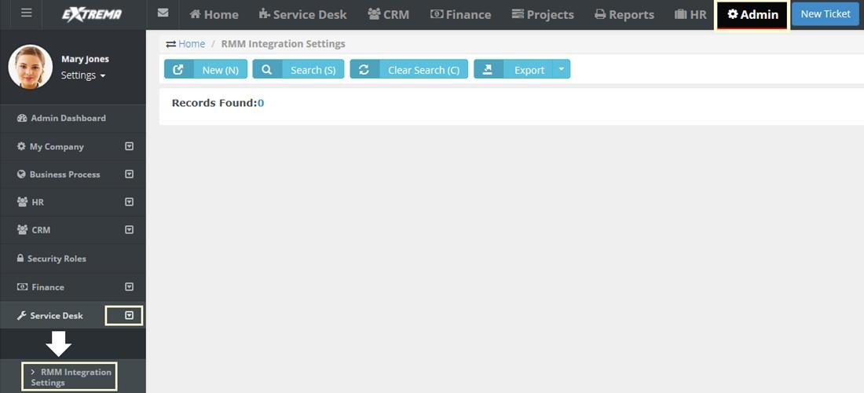Select Admin > Service Desk > **RMM Integration Settings**.



1. Click **New** to create your integration.

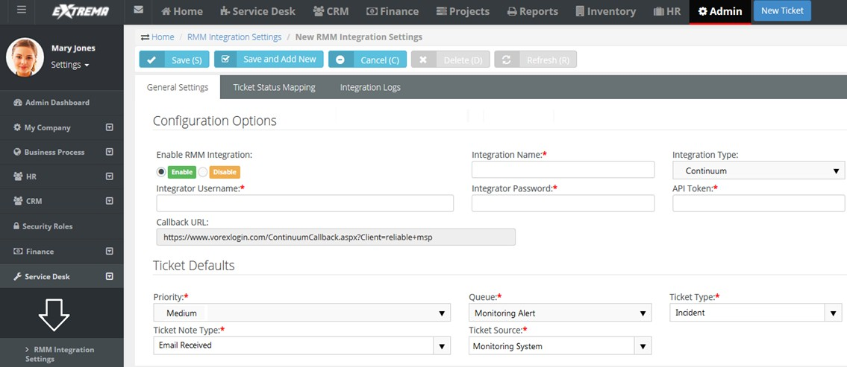



1. Enter the following in the General Settings > **Configuration Options** section.
   * **Integration Name** - Enter a name that is easy to understand. You may want to add other integrations later.
   * **Integration Type** - Select Continuum from the drop-down list.
   * **Integrator Username** - Create an "integrator username" you will use later to integrate with Continuum.
   * **Integrator Password** - Create an "integrator password".
   * **API Token** - Enter the API token provided by Continuum.

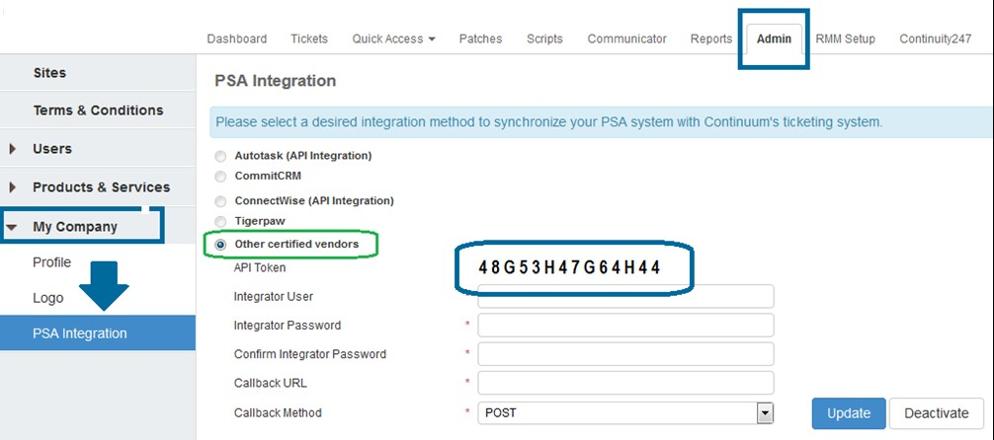

1. In CloudActiv8 SUPPORT, enter the following in the General Settings > **Ticket Defaults** section.
   * **Priority** - Select a default priority.
   * **Queue** - Select the queue you want *tickets created from Continuum monitoring alerts* to be assigned to. For example, Monitoring Alert Tickets, if you created that in step 1.
   * **Ticket Type** - Select a default ticket type.
   * **Ticket Note Type** - Select a default note type. General Notes is fine.
   * **Ticket Source** - Select a default ticket source. Monitoring System is recommended.
2. Click **Save**.

#### Step 3 - Ticket Status Mapping

Admin > Service Desk > RMM Integration > Continuum Integration > Ticket Status Mapping

In CloudActiv8 SUPPORT:

* Map Continuum ticket statuses to CloudActiv8 SUPPORT ticket statuses.
* Map CloudActiv8 SUPPORT ticket statuses to Continuum ticket statuses.

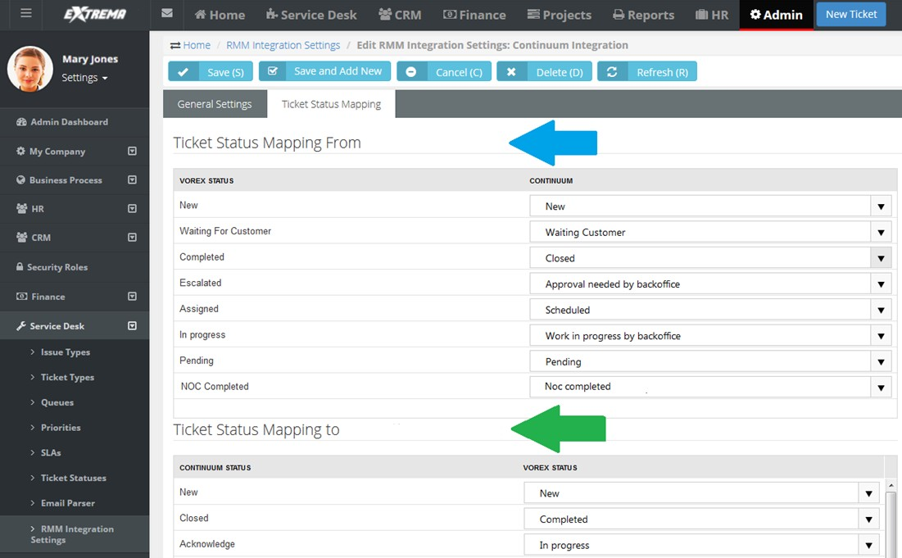



#### Step 4 - Account Mapping

1. 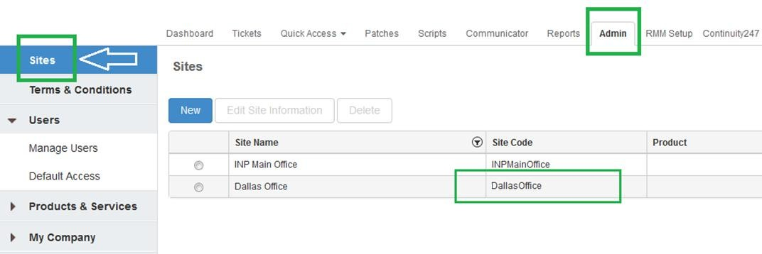In Continuum, select the Admin > **Sites** page.
2. Copy the <site_code> value.
   * In Continuum, a site code equals an account in CloudActiv8 SUPPORT.
3. In CloudActiv8 SUPPORT, select the CRM > **Accounts** page.
4. 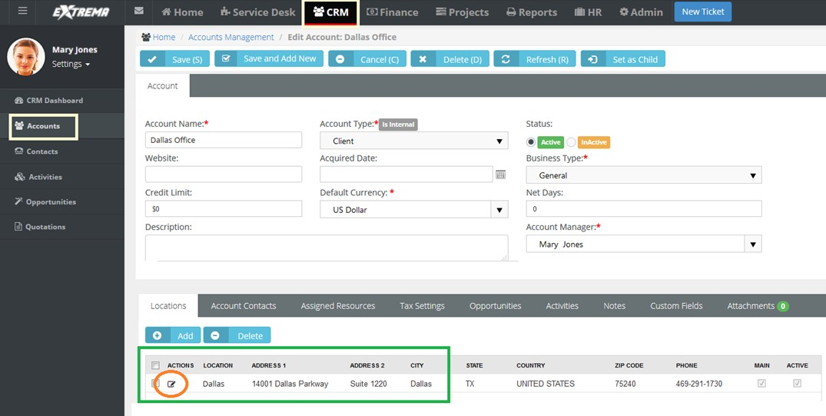Open an account that matches the <site_code> information.



1. Double-click a **Location** record to edit.
   * 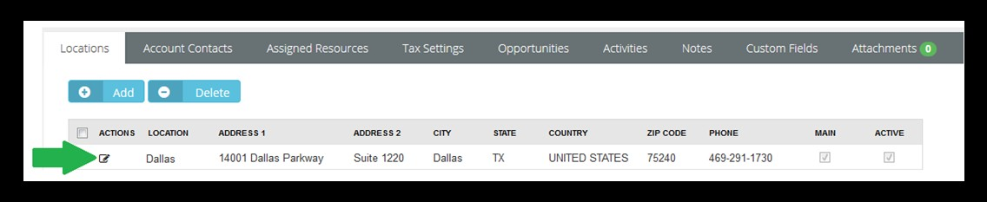The location record should correspond to the <site_code> for this account. You may have several locations defined for this account.
2. Click the **RMM Integration** tab.
3. Paste the <site_code> into the **Continuum Location Code** field.
4. 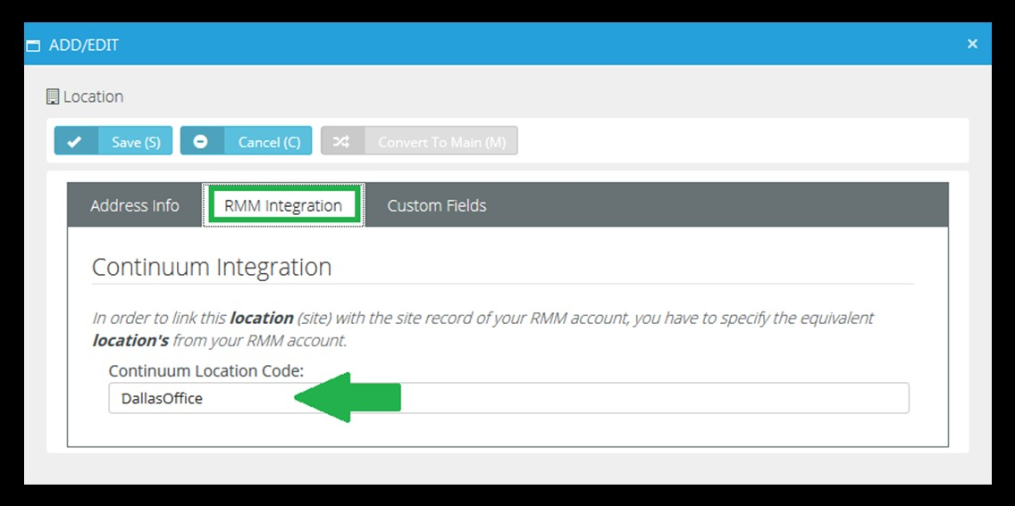Click **Save**.

#### Step 5 - PSA Integration and Activation

Configure Continuum to use CloudActiv8 SUPPORT as its PSA Integration solution.

1. 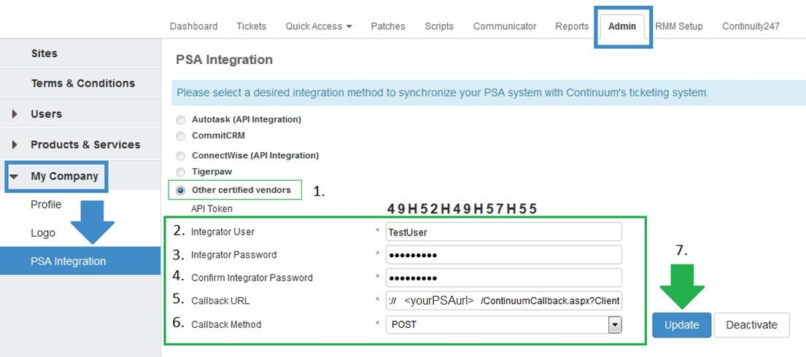In Continuum, select the Admin > My Company > **PSA Integration** page.
2. Select the **Other certified vendors** option.
   * **Integrator User** - Enter the **Integrator Username** you specified in **Step 2 - RMM Integration Setup**
   * **Integrator Password** - Enter the **Integrator Password** you specified in **Step 2 - RMM Integration Setup**
   * **Confirm Integrator Password** - Re-enter the **Integrator Password**.
   * **Callback URL** - Enter a URL similar to the following:
   * **Callback Method** - Select POST from the drop-down list.
3. Click on the **Update** button.
   * A ticket originates in Continuum and gets created in CloudActiv8 SUPPORT.
   * Linked Continuum assets are created in CloudActiv8 SUPPORT as the tickets are created.
   * Updates to the status and notes of a CloudActiv8 SUPPORT ticket are posted back to its corresponding ticket in Continuum.
   * If a ticket is manually created new in CloudActiv8 SUPPORT Continuum is not updated.

## Inventory (in Admin)

Admin > Inventory

The **Inventory** menu in the Admin module defines support tables used by your inventory operations.

### Warehouses

Admin > Inventory > Warehouses

The **Warehouses** page specifies the physical dimensions and maximum weight allowed for each

*warehouse*. Warehouses are required to store inventory quantities.

Inventory quantities are stored in a default "virtual" location. Received quantities are also stored temporarily in the default virtual location. The location is identified by the **Warehouse Prefix** and word

Default. For example, W0987_:Default.

**Creating Warehouses**

1. Select the Admin > Inventory > **Warehouses** page.
2. Click **New**.
3. Enter the following fields in the **Warehouse** section.
   * Warehouse Name
   * **Description**
   * **Width / (unit of length)**
   * **Height / (unit of length)**
   * **Depth / (unit of length)**
   * **Max Weight / (unit of weight)**
   * **Warehouse Prefix**
4. Click **Save**.

### Product Categories

Admin > Inventory > Product Categories

The **Product Categories** page specifies categories and sub categories products. These are used to classify inventory.

**Creating Product Categories**

1. Select the Admin > Inventory > **Product Categories** page.
2. Click **New**.
3. Enter the following fields in the **Category Info** section.
   * Category Name
   * **Description**
   * **Status** - Active or InActive
4. Click **Add** to add a sub categories in the **Sub Categories** section.
   * Name
   * **Description**
   * **Is Active**
5. Repeat step 4 to add additional sub categories as required.
6. Click **Save**.

## Email Logs

Admin > Logs > Email Logs

The **Email Logs** page provides an audit of all *outbound* email used to notify customers.

On the list page you can:

* Search for emails using the **From**, **To**, **Display Name**, **Subject** and **Body** fields, or by date range.
* **Export** the email log.

Click any single row to see the details of that email:

* The **Email Log Info** tab shows the content of the email.
* The **Email Log History** tab shows a history of email sending events.
* You can **Delete**, **Resend** or **Forward** the email.
* Clicking **Forward** displays dialog that enables you to edit the email before you forward it.

## 

## Import Data

Admin > Imports & Exports > Import Data

The **Import Data** page imports customer accounts and contacts from other PSA vendor systems. Currently only *ConnectWise* systems can be imported.

**Importing Data from *ConnectWise***

*In ConnectWise*

Create public and private keys.

1. Login into *ConnectWise*.
2. Navigate to **My Account**.

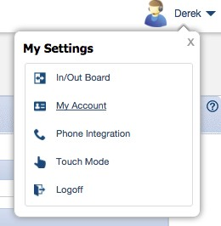

1. Click the **API Keys** tab.

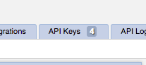

1. Click the + icon.
2. Enter SUPPORT Integration as the **Description**, then save the record. The page should refresh.
3. Make note of the displayed **Public Key** and **Private Key**.

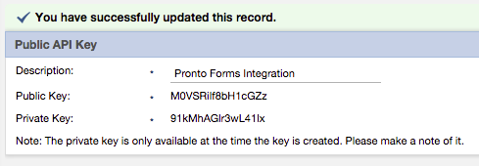

###### In SUPPORT

Start a data import job.

1. Login into SUPPORT.
2. Select the Admin > Imports & Exports > **Import Data** page.
3. Click the *ConnectWise* logo
4. Enter the following *ConnectWise* authentication details:
   * Public Key
   * **Private Key**
   * **Server**
     + If your customer login URL looks like this...

na.myconnectwise.net

... the API URL for Data Import needs to be entered as this:

api-na.myconnectwise.net/v4_6_release/apis/3.0/

* + - In this example, na changes to api-na.
    - Append /v4_6_release/apis/3.0/ to the end of the URL.
  + Company

*Job Processing and Notification*

SUPPORT will queue your job and process it. When processing completes you will be notified by email. The following is a sample email:

<your_SUPPORT_account_name>,

Your ConnectWise data import has been completed.

8 Client Accounts and 13 Contacts were imported from your

ConnectWise account to CloudActiv8 SUPPORT.

For questions and assistance, contact Support. Thank you,

CloudActiv8 SUPPORT

C h a p t e r 3

**Human Resources**

The following support tables are configured for human resource tracking and reporting purposes. When completed you will be able to:

* Run reports based on your company's job titles and departments.
* Send messages to your company's departments.
* Classify projects worked on by your company's departments.
* Generate an organization chart in the **Human Resources** module based on your company's departments and job titles.

## Dashboard

## Departments

HR > Departments

**Admin > HR > Departments**

**Creating Departments**

1. Select the Admin > HR > **Departments** page.
2. Click **New**.
3. Enter the following fields:
   * Department Name
   * **Description**
   * **Manager**
   * **Annual Budget** - The annual budget of this department.
   * **Cost Center** - The account cost center associated with this department.

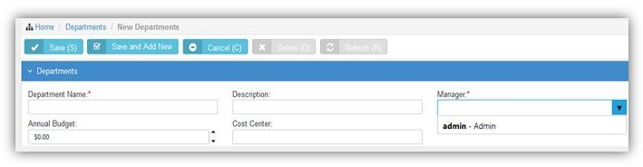

## Job Titles

HR > Job Titles

**Admin > HR > Job Titles**

**Creating Job Titles**

1. Select the Admin > HR > **Job Titles** page.
2. Click **New**.
3. Enter the following fields:
   * Job Title
   * **Description**
   * **Status** - If Yes, this job title is used.

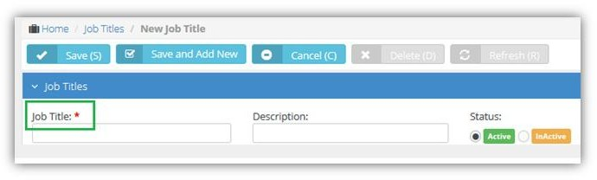

## Skill Categories

HR > Skill Categories

**Admin > HR > Skill Categories**

The **Skill Categories** page defines job skills referenced by other modules. For example:

* Admin > HR > Employees
* Projects > (any project) > (any task)

**Creating Skill Categories**

1. Select the Admin > HR > **Skill Categories** page.
2. Click **New**.
3. In the **Skill Category** section add the following:
   * Skill Category Name

**Human Resources**

* + **Description**

1. In the **Skill** section enter the following:
   * Name
   * **Description**
2. 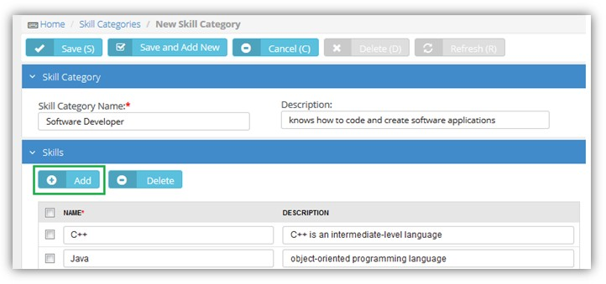Click **Add** to add addition skills as necessary.

## Employees

HR > Employees

**Admin > HR > Employees**

The **Employees** page maintains your company's employee profiles. This same page displays in the **HR** module if you have permission. Initially you create a basic profile. After you save an employee profile the first time, multiple tabs display for you to enter additional details.

**Creating Employee Profiles**

1. Select the Admin > HR > **Employees** page.
2. Click **New**.
3. Enter the following basic fields in the **New Employee** page.
   * User Name
   * **First Name**
   * **Last Name**
   * **Emp ID**
   * **Email Address**
   * **Job Title**
   * **Department**
   * **Manager**
   * **Employment Type**
   * **Employee Roles**
   * **Security Roles**
   * 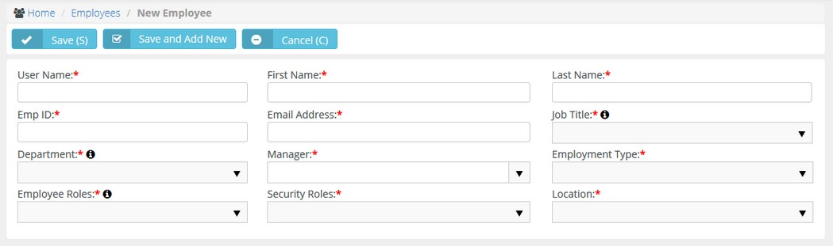**Location**
4. Click **Save**.
   * A new user can start using the system with just this basic information.
   * The new user is automatically sent an email with login credentials, similar to the image below.
5. Click the row of the employee profile you just created to add additional information.
   * The **Edit Employee** page displays.
   * Use the additional fields and tabs to maintain more details about an employee.
6. The first tab, the **Personal Details** tab, provides the following additional fields.
   * Hire Date
   * **Termination Date**
   * **Birthday**
   * **SSN** - Social security number
   * Marital Status
   * **Status** - If Yes, this is a current employee.
   * Gender
   * **Photo** - Upload a photograph of your employee. Employee photos display on their dashboard when they login
   * Password Management
     + **Reset and Email Password** - Resets the user password when the user has forgotten the password. A randomly generated password is sent by email to the user.
     + **Unlock User's Account** - Unlocks a user account if the account has become locked after several invalid login attempts.

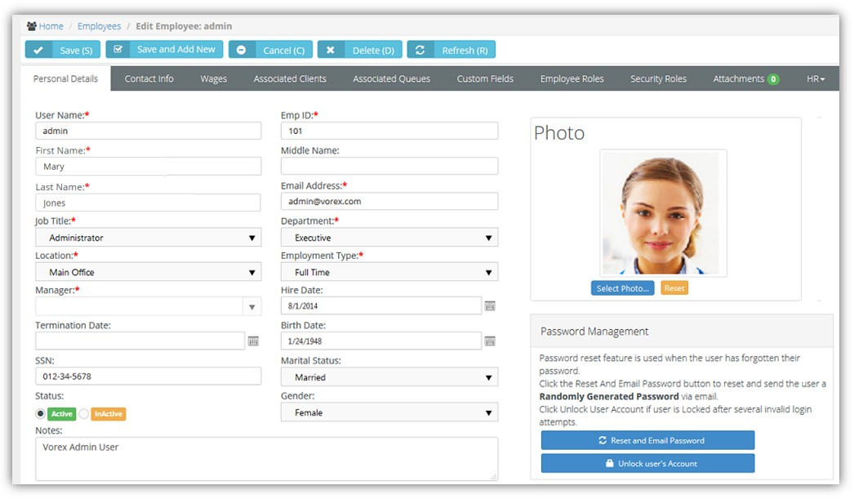

### Contact Information

**HR > Employees > Contact Info**

**Admin > HR > Employees > Contact Info**

The **Contact Info** page records contact information for an employee.

* Use the **Main Address** for the employee’s workplace address.
* 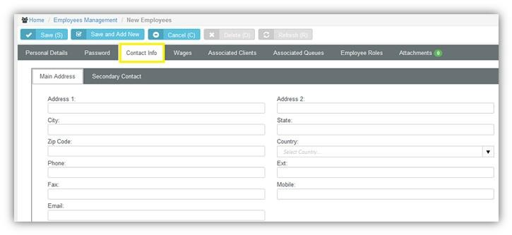Use the **Secondary Contact** tab for an emergency contact record.

### Wages

**HR > Employees > Wages**

**Admin > HR > Employees > Wages**

The **Wages** page records the wages paid an employee.

##### Hourly Pay

* **Hourly Pay Rate** - The hourly pay rate for the employee.
* **Burden Rate** - The allocation rate at which indirect costs are applied to the direct costs of either labor or inventory. These costs can include but are not limited to payroll taxes, pension costs, health insurance, dental insurance, and any other benefits that a company provides an employee.
* Over Time Pay Rate - The hourly overtime pay rate for an employee.
* **Pay Period** - Weekly, Monthly, Quarterly, Yearly, Contract Length.
* Currency

**Rate Calculation Guide**

This is just a guide to help quickly calculate the hourly wage for an employee. It's a basic calculation of annual salary divided by working hours.

* **Working Hours Per Year** - There are 52 weeks x 40 hours a week = 2080 hours. Adjust for part time employees
* **Annual Salary** - Put the annual salary in this field and then click **Calc** to display an hourly wage. Does not include the **Burden Rate**.

##### External Employee

* **Vendor** - Links this employee to a vendor. Required to add expense entries and time entries associated with projects and tickets to **Vendor Bills** *.*Vendor bills can be processed in Quickbooks.

**Employee Financials**

* 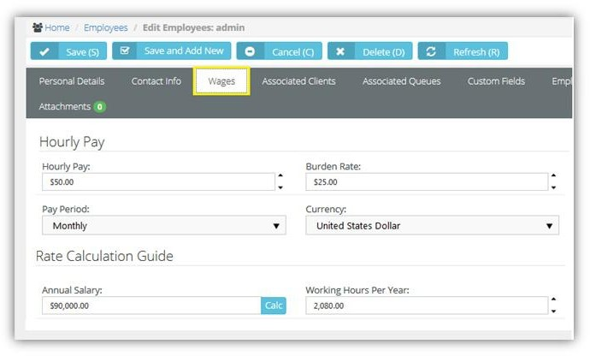**quivalent Vendor Record** - Creates a vendor alias for an employee. The vendor alias is required to process **reimbursements** in Quickbooks. For example, use the employee's name with a _v suffix in this field.

### Shifts

HR > Employees > Shifts

**Admin > HR > Employees > Shifts**

The **Shifts** page records the weekly work schedule for an employee.

**Creating Work Schedules**

1. Select the Admin > HR > Employees > **Shifts** tab.
2. Set **Allow Overtime** - Yes or No. The pay rate for overtime is set on the **Wages** tab.
3. Click **Add** to add a new shift.
4. Enter the following:
   * Week day
   * **Start Time**
   * **End Time**
5. Repeat steps 3 and 4 to add as many shifts for this employee as required.

### Associated Clients

HR > Employees > Associated Clients

**Admin > HR > Employees > Associated Clients**

The **Associated Clients** tab links your employee, typically a technician, to one or more clients. When a client opens **Client Portal**, linked employees are listed as primary contacts for messaging.

**Adding Clients**

1. Select the Admin > HR > Employees > **Associate Clients** tab.
2. Click **Add**.
3. Select one or more clients.
4. 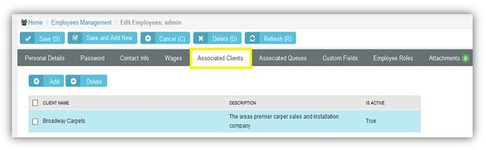Click **OK**.

### Associated Queues

HR > Employees > Associated Queues

**Admin > HR > Employees > Associated Queues**

The **Associated Queues** tab assigns an employee to one or more ticket queues. Queues group tickets by the state they are in. Employees work tickets in the queues they are assigned to. Queues are maintained using the Admin > Service Desk > **Queues** page.

**Adding Queues**

1. Select the Admin > HR > Employees > **Associate Queues** tab.
2. Click **Add**.
3. Select one or more queues.
4. 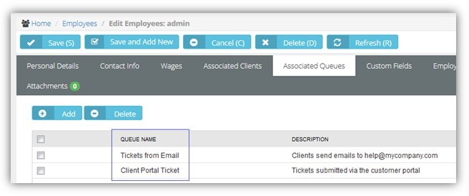Click **OK**.

### Custom Fields (for Employees)

**HR > Employees > Custom Fields**

**Admin > HR > Employees > Custom Fields**

The **Custom Fields** tab maintains data entered in custom fields for employee profiles. Data types for custom fields can be Free Text, Date or Data List. Custom fields can be set to required. Custom fields are created using the Admin module > My Company > **Custom Fields** page.

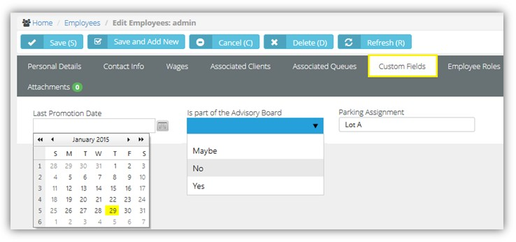

### 

### Employee Roles

HR > Employees > Employee Roles

**Admin > HR > Employees > Employee Roles**

The **Employee Roles** tab assigns roles to an employee. Each role determines the work billed to customers on tickets and tasks. Roles and rates are maintained using the Admin > Finance > **Roles and Rates** page. Employees assigned multiple roles can usually select any of their roles when working a task or ticket. In **Projects**, the project manager can lock down the role when assigning a task to an employee.

**Adding Roles**

1. Select the Admin > HR > Employees > **Employee Roles** tab.
2. Check the **Has Role** checkbox for any role that applies to this employee.
3. 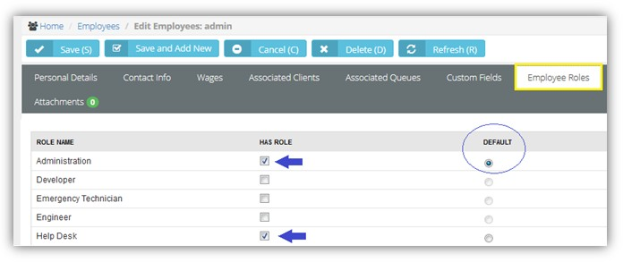Select the **Default** role for this employee. This role automatically populate the **Role** field when the user enters time on a task or ticket.

### Security Roles

**HR > Employees > Security Roles**

**Admin > HR > Employees > Security Roles**

The **Security Roles** tab assigns security roles to an employee. Security roles determine the access an employee has to different modules, menus and selected settings. The system provides several predefined security roles for both internal and external users. You can also add custom security roles. Security roles are configured using the Admin > **Security Roles** page.

##### Adding Security Roles

1. Select the Admin > HR > Employees > **Security Roles** tab.
2. Check the **Has Role** checkbox for any security role that applies to this employee.

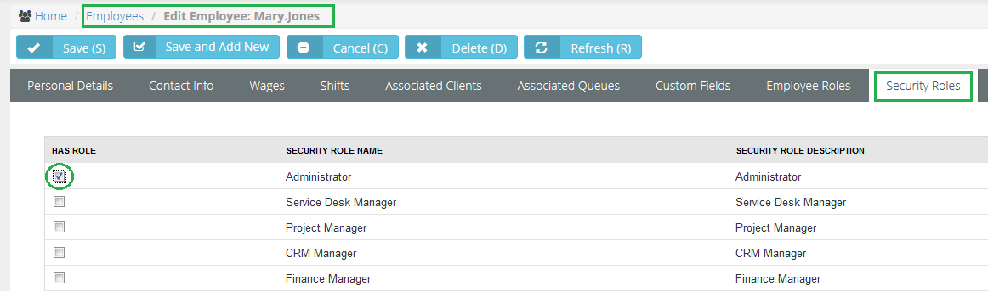

### Attachments (for Employees)

HR > Employees > Attachments

**Admin > HR > Employees > Attachments**

Use the **Attachments** tab to upload files to an employee profile.

**Adding Attachments**

1. Select the Admin > HR > Employees > **Attachments** tab.
2. Click **Upload a new file**.
3. Browse, then **Select** a file to upload.
4. Optionally enter an **Alias** name.
5. Click **Save**.

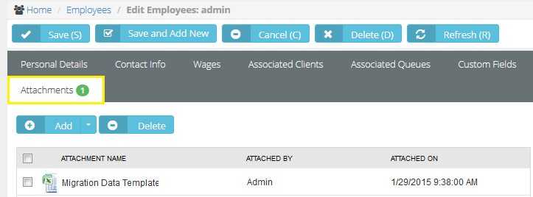

### Education

**HR > Employees > HR > Education**

**Admin > HR > Employees > HR > Education**

The **Education** tab documents the education of an employee. The **Institute Name**, **Degree** and **Field of Study**

drop-down lists are maintained using the Admin > My Company > Lists page.

##### Adding Education Records

1. Select the Admin > HR > Employees > HR > **Education** option.
2. Click **Add**.
3. Enter the following:
   * Institute Name
   * **Date Attended**
   * **Degree**
   * **Field of Study**
   * **Grade**
   * **Description**
4. 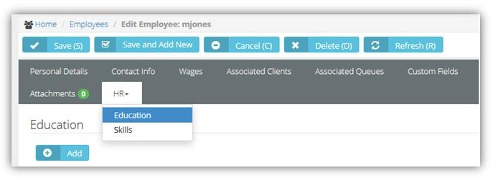Click **Save**.

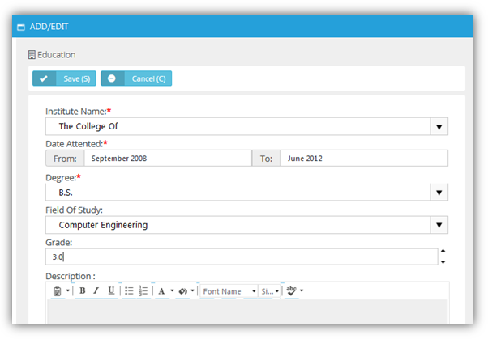

### Skills

HR > Employees > HR > Skills

**Admin > HR > Employees > HR > Skills**

The **Skills** tab identifies the job skills an employee has. This helps users determines the types of tickets and tasks a user should be assigned to. Job skills are maintained using the Admin > HR > Skill Categories page.

**Adding Education Records**

1. Select the Admin > HR > Employees > HR > **Skills** option.
2. Click **Add**.
3. Enter the following fields:
   * **Category**
   * **Skill**
   * **Year(s) Of Experience**
   * **Experience Level**
4. 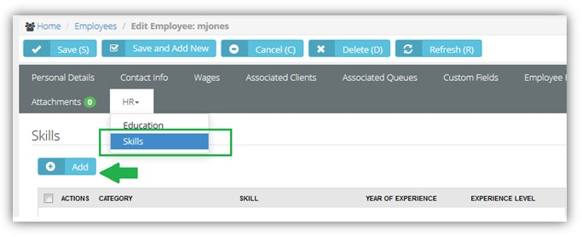Click **Save**.

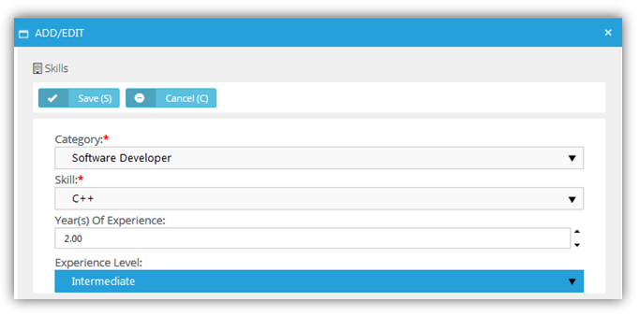

## Organizational Chart

HR > Organization Chart

An **Organizational Chart** page displays a hierarchical chart of all employees in your company, based on supervisor and subordinate relationships. Org charts:

* Helps clarify the working relationships between executives and managers.
* Establishes the hierarchical structure for decision-making and authority.
* Serves as an information portal, by clicking an employee's name in the chart to open up that employee's record.
* Helps visualize changes to the company's structure.
* Helps executive officers establish clear management procedures within a company.
* Helps guide employees about who to contact in other parts of the organization. You can generate an organization chart in two ways:



* By Manager
* By Department

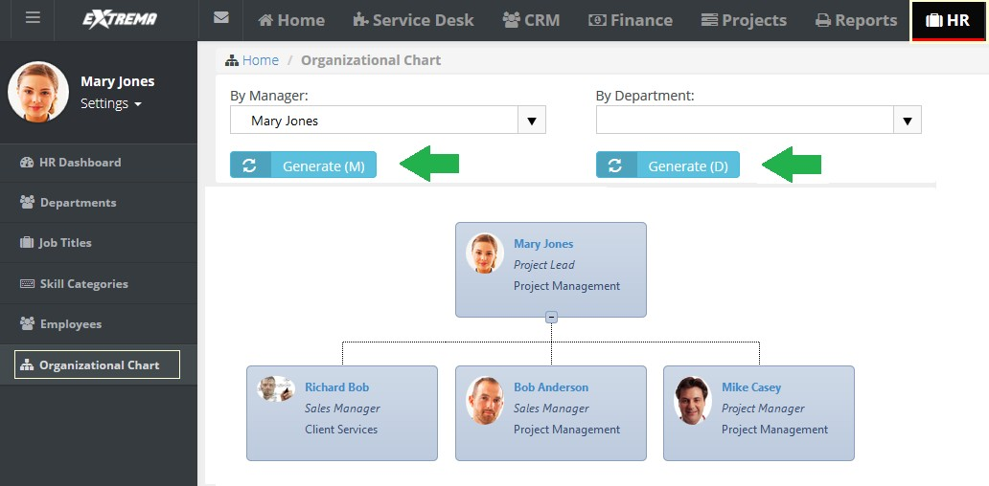



|  |  |  |
| --- | --- | --- |
| Chapter 4  **Finance**  **In This Chapter** |  |  |

## Dashboard (Finance)



Finance > Dashboard

The **Dashboard** displayed in the **Finance** module includes specialized dashlets highlighting important financial concerns.

* Revenue by Client
* **Revenue Still To Invoice Current Month**
* **Contracts Expiring Next 90 Days**

See **Dashboard (Home)** for a description of general purpose dashlets that also display on this page.

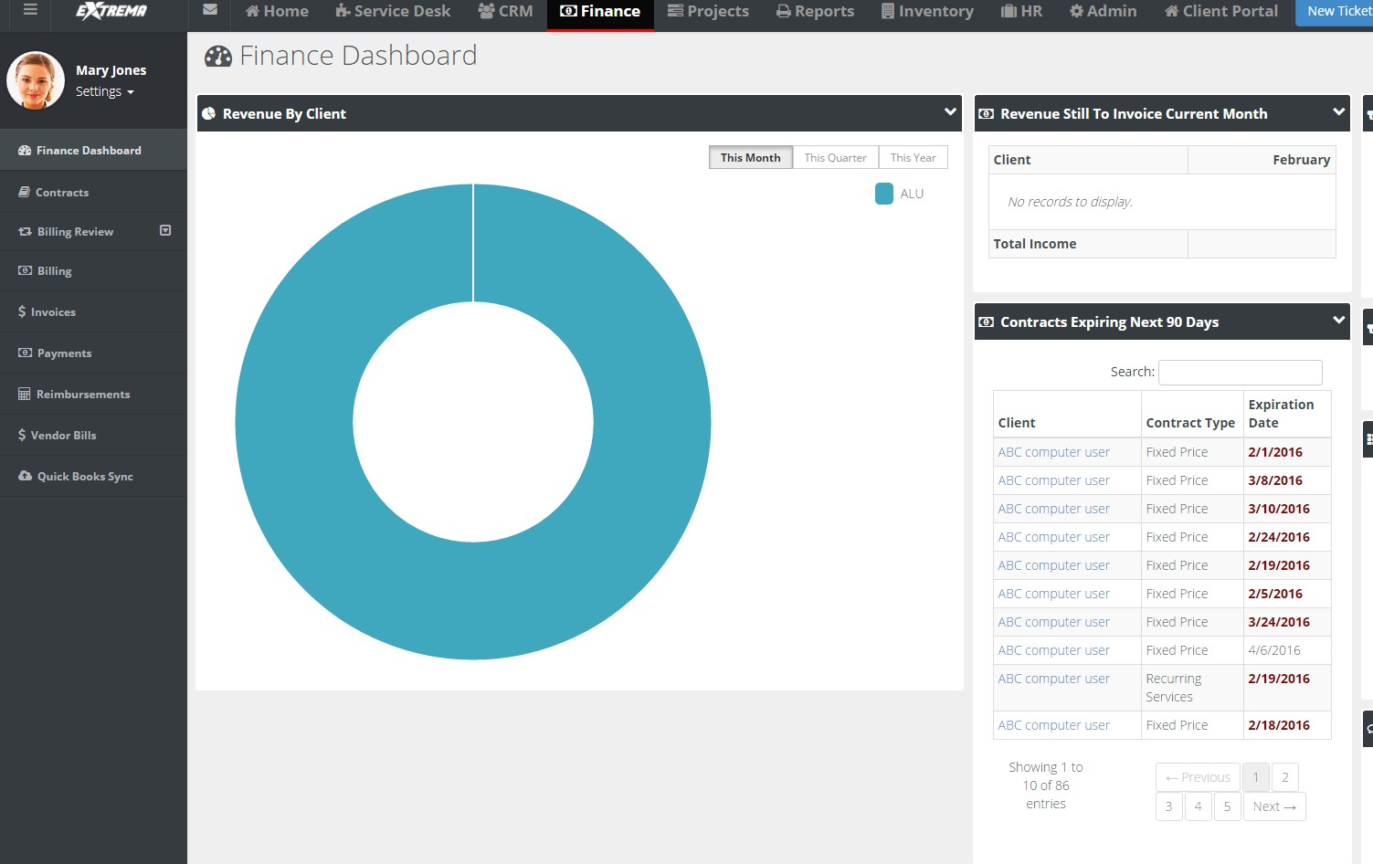



## Contracts

Finance > Contracts

The **Contracts** page registers billing agreements between you and your clients. The selected **contract type** determines how billing is processed. There are five contract types.

* **Time and Material** - The customer is charged for all of hours of work performed, any direct expenses incurred, and all materials purchased to support the resolution of tickets and the completion of projects. Time entered on tickets and tasks generates billable amounts for labor on invoices. The role assigned a labor time entry determines the rate charged for that labor. Default rates for roles can be adjusted on a per contract basis.
* **Recurring Services** - Services are billed on a contract length, weekly, monthly, quarterly, or yearly basis.
* **Fixed Price** - A fixed priced contract is not subject to any adjustment on the basis of the provider’s cost experience in performing the contract. A fixed price contract is typically tied to a single project, but some users use them for support contracts. In many contracts the fixed price is divided into smaller milestone payments.
* **Retainer by Amount** - The total price of the contract is prepaid. Clients schedule services when needed. Billings decrement the contract amount purchased.
* **Retainer by Hours** - Hours of service are prepaid. Clients schedule services when needed. Labor time entries decrement the retainer hours purchased. The total price of contract is calculated by multiplying the number of contract hours purchased by an average rate.

Additional guidelines:

* A customer can have multiple contracts.
* You can pick a default contract for service tickets for a client, thus eliminating the guess work if something is covered or not.
* You can link a service level agreements (SLA) to a contract

### Time and Materials

Finance > Contracts > New > Time and Materials

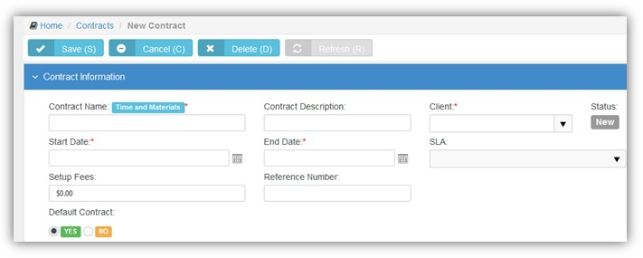The customer is charged for all of hours of work performed, any direct expenses incurred, and all materials purchased to support the resolution of tickets and the completion of projects. Time entered on tickets and tasks generates billable amounts for labor on invoices. The role assigned a labor time entry determines the rate charged for that labor. Default rates for roles can be adjusted on a per contract basis.

**Creating Time and Materials Contracts**

1. Select the Finance > **Contracts** page.
2. Click New > **Time and Materials**.
3. Enter the following in the **Contract Information** section.
   * **Contract Number** - Only displays when editing a contract.
   * Contract Name
   * **Contract Description**
   * **Client**
   * **Start Date**
   * **End Date**
   * **SLA -** A contract associated with an **SLA** overrides the **Default SLA** when the ticket is linked to the contract.
   * Setup Fees
   * **Issue Invoice on** - Overrides the default value set for the 'Issue Invoice on' field, either Start of Billing Cycle or End of Billing Cycle. The default is set using the Admin > Company Settings > **Invoice** tab.
   * Reference Number
   * **Default Contract** - Yes or No
4. Enter additional information in the **Custom Fields** section.
5. Click **Save**.
   * Adjust rates for roles for this contract in the **Billing Information** tab.
   * **Maximum Hours** - Limits the hours billable for this role.
   * **Contract Billing Rate** - Adjusts the default billing rate for this role.
6. Optionally exclude roles and work types that can report hours to this contract using the **Exclusions**

tab.

* + If hours are reported using an excluded role or work type, the hours are reported against the

**Default Fallback Contract** you specify.

1. Upload files to the contract using the **Attachments** tab.
2. 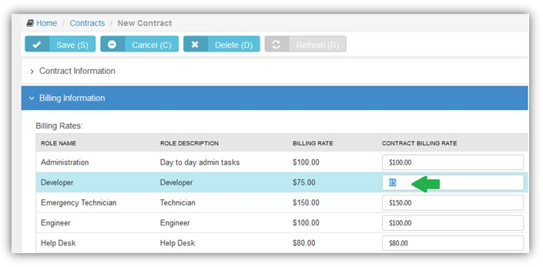Click **Save**.
3. Optionally reopen the contract and click **Activate** to begin using this contract to create billing entries.

### Recurring Services

Finance > Contracts > New > Recurring Services

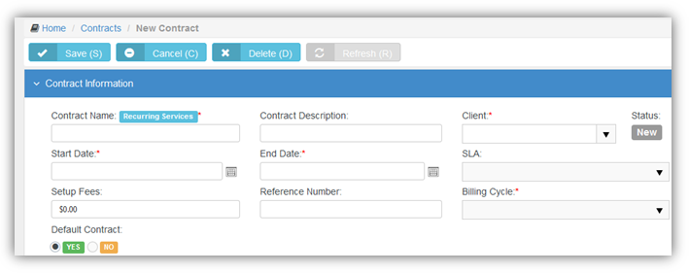Services are billed on a contract length, weekly, monthly, quarterly, or yearly basis.

**Creating Recurring Services Contracts**

1. Select the Finance > **Contracts** page.
2. Click New > **Recurring Services**.
3. Enter the following in the **Contract Information** section.
   * **Contract Number** - Only displays when editing a contract.
   * Contract Name
   * **Contract Description**
   * **Client**
   * **Start Date**
   * **End Date**
   * **SLA -** A contract associated with an **SLA** overrides the **Default SLA** when the ticket is linked to the contract.
   * Setup Fees
   * **Reference Number**
   * **Billing Cycle** - Contract Length, Weekly, Monthly, Quarterly, Yearly
   * Issue Invoice on –
   * **Default Contract** - Yes or No
   * **Billing Periods based on Calendar Year** - Yes or No

Examples:

Recurring Service Contract billing periods can be established based on the Contract Start Date or based on the Calendar Year. For example, a monthly contract based on Start Date beginning on January 17 would have billing periods that begin on the 17th and end on the 18th of each month. A monthly contract based on Calendar year would have the first period beginning on January 17th and ending January 31st (prorated first month), and each subsequent period would begin on the 1st of the month and end on the last day of the month.

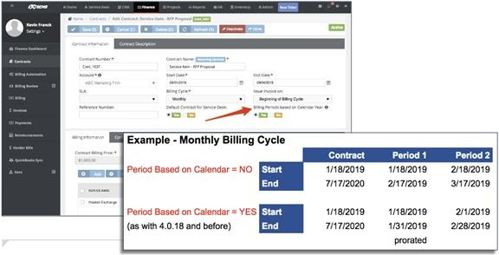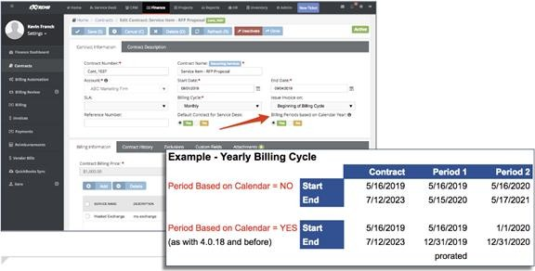

1. Enter additional information in the **Custom Fields** section.
2. Click **Save**.
3. Click **Add** to add services in the **Billing Information** tab. You can adjust the calculated extended cost and price for each service add to this contract.
   * Service
   * **Effective Date**
   * **Unit Price**
   * **Extended Unit Price**
   * **Unit Cost**
   * **Extended Unit Cost**
   * **Units**
   * **Total Price**
   * **Total Cost**
4. Click **Save**.
5. Review the **Contract Billing Price**. This is the total price for all the services added.
6. Optionally exclude roles and work types that can report hours to this contract using the **Exclusions**

tab.

* + If hours are reported using an excluded role or work type, the hours are reported against the

**Default Fallback Contract** you specify.

1. Upload files to the contract using the **Attachments** tab. 11.Click **Save**.
2. Optionally reopen the contract and click **Activate** to begin using this contract to create billing entries.
3. 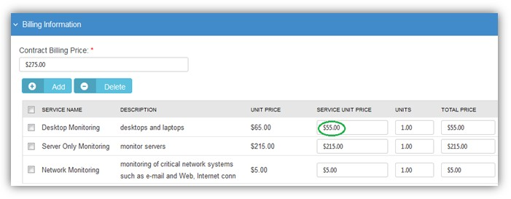When the contract changes, you can review those changes using the **Contract History** tab.

### Fixed Price

Finance > Contracts > New > Fixed Price

A fixed priced contract is not subject to any adjustment on the basis of the provider’s cost experience in performing the contract. A fixed price contract is typically tied to a single project, but some users also use them for support contracts. In many contracts the fixed price is divided into smaller milestone payments.

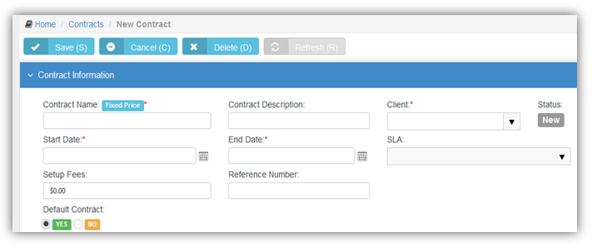

**Creating Fixed Priced Contracts**

1. Select the Finance > **Contracts** page.
2. Click New > **Fixed Price**.
3. Enter the following in the **Contract Information** section.
   * **Contract Number** - Only displays when editing a contract.
   * **Contract Name**
   * **Contract Description**
   * **Client**
   * **Start Date**
   * **End Date** - Milestones due dates default to this date.
   * **SLA -** A contract associated with an **SLA** overrides the **Default SLA** when the ticket is linked to the contract.
   * Setup Fees
   * **Reference Number**
   * **Default Contract** - Yes or No
   * **Accumulating Contract** - If Yes, the total contract amount starts at zero (0) and increases each time you add a new milestone. If No, the total contract amount is set to that fixed amount. You can add milestones whenever you like, so long as the total contract amount does not exceed the fixed amount.
   * **Alter From Project** - If Yes, a *project phase milestone* is added to the project linked to this contract each time you add a new milestone to the contract.
4. Enter additional information in the **Custom Fields** section.
5. Click **Save**.
6. Click **Add** to add milestone payments in the **Billing Information** tab.
   * Name
   * **Type**
   * **Amount**
   * **Due Date** - Defaults to the end date of the contract. For milestone payments **Billing Review** lists billable amounts using this date. You may wish to adjust this date for earlier milestone payments to ensure they display sooner in **Billing Review**.
   * Description
7. Click **Save**.
8. Review the following in the **Billing Information** tab
   * **Contract Billing Price** - The total of all milestone amounts.
   * Billed Amount
   * **Remaining Amount**
9. Optionally exclude roles and work types that can report hours to this contract using the **Exclusions**

tab.

* + If hours are reported using an excluded role or work type, the hours are reported against the

**Default Fallback Contract** you specify.

1. Upload files to the contract using the **Attachments** tab. 11.Click **Save**.

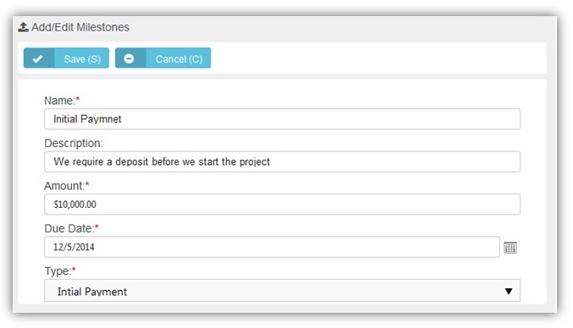12.Optionally reopen the contract and click **Activate** to begin using this contract to create billing entries.

### Retainer By Amount

Finance > Contracts > New > Retainer by Amount

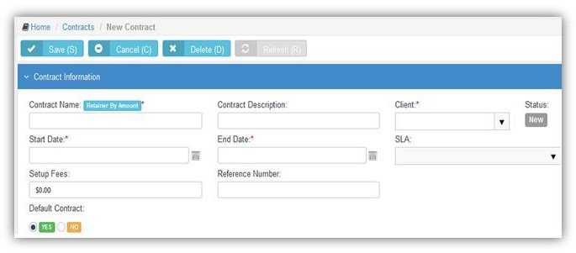The total price of the contract is prepaid. Clients schedule services when needed. Billings decrement the contract amount purchased. Billable labor time on tickets and tasks consume the amount. Charges and expenses do *not* consume the amount.

**Creating Retainer by Amount Contracts**

1. Select the Finance > **Contracts** page.
2. Click New > **Retainer by Amount**.
3. Enter the following in the **Contract Information** section.
   * **Contract Number** - Only displays when editing a contract.
   * Contract Name
   * **Contract Description**
   * **Client**
   * **Start Date**
   * **End Date**
   * **SLA -** A contract associated with an **SLA** overrides the **Default SLA** when the ticket is linked to the contract.
   * Setup Fees
   * **Reference Number**
   * **Default Contract** - Yes or No
4. Enter additional information in the **Custom Fields** section.
5. Click **Save**.
6. Adjust rates for roles for this contract in the **Billing Information** tab.
   * **Contract Billing Rate** - Adjusts the default billing rate for this role.
7. Review the following in the **Billing Information** tab
   * **Contract Billing Price** - Enter the total amount that can billed to this contract.
   * **Consumed Amount** - The total amount of billings applied to this contract.
8. Optionally exclude roles and work types that can report hours to this contract using the **Exclusions**

tab.

* + If hours are reported using an excluded role or work type, the hours are reported against the

**Default Fallback Contract** you specify.

1. Upload files to the contract using the **Attachments** tab. 10.Click **Save**.

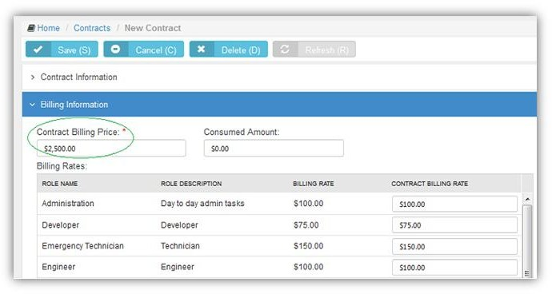11.Optionally reopen the contract and click **Activate** to begin using this contract to create billing entries.

### Retainer By Hours

**Finance > Contracts > New > Retainer by Hour**

Hours of service are prepaid. Clients schedule services when needed. Labor time entries decrement the retainer hours purchased. The total price of contract is calculated by multiplying the number of contract hours purchased by an average rate. Retainer by Hour contracts are billed by billing periods. The total hours specified by the contract are distributed

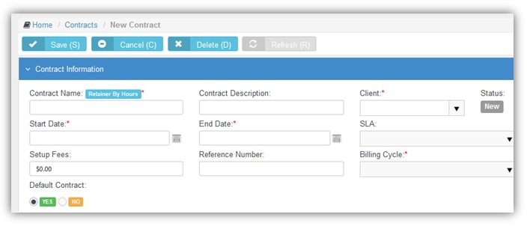evenly across all the billing periods contained by the contract's date range. When a billing period within the contract is closed, unconsumed retainer hours can be optionally carried forward to the next billing period.

##### Creating Retainer by Hours Contracts

1. Select the Finance > **Contracts** page.
2. Click New > **Retainer by Hours**.
3. Enter the following in the **Contract Information** section.
   * **Contract Number** - Only displays when editing a contract.
   * Contract Name
   * **Contract Description**
   * **Client**
   * **Start Date**
   * **End Date**
   * **SLA -** A contract associated with an **SLA** overrides the **Default SLA** when the ticket is linked to the contract.
   * Setup Fees
   * **Reference Number**
   * **Billing Cycle** - Contract Length, Weekly, Monthly, Quarterly, Yearly
   * **Default Contract** - Yes or No
4. Enter additional information in the **Custom Fields** section.
5. Click **Save**.
6. Click **Add** to add milestone payments in the **Billing Information** tab.
   * Average Rate
   * **Contract Hours**
   * **Bill For** - Actual Hours or Actual Hours + Overage
   * **Carry Over Extra Hours to the Next Billing Cycle** - If Yes, unconsumed retainer hours are carried forward to the next billing period when a billing period is closed using Billing Review > **Retainer Hours** page.
7. Click **Save**.
8. Review the following in the **Billing Information** tab
   * 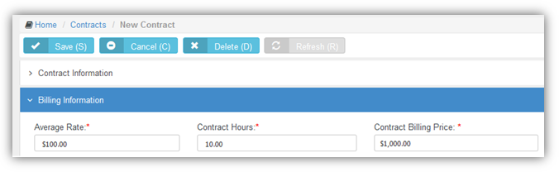**Contract Billing Price** - The **Average Rate** times the **Contracts Hours**.
9. Optionally exclude roles and work types that can report hours to this contract using the **Exclusions**

tab.

* + If hours are reported using an excluded role or work type, the hours are reported against the

**Default Fallback Contract** you specify.

1. Upload files to the contract using the **Attachments** tab. 11.Click **Save**.
2. Optionally reopen the contract and click **Activate** to begin using this contract to create billing entries.
3. When labor time entries are applied to this contract, you can review the hours consumed using the **PrePaid Hours Summary** tab.

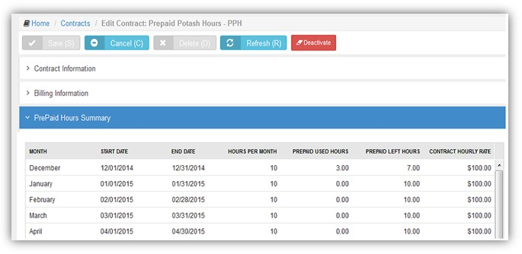

## Billing Automation

Finance > Billing Automation

**Job setting**

1. Login to SUPPORT.
2. Navigate to Finance > Billing Automation.
3. Click “New”.
4. In the “Job Settings” tab, add a name for the job.
5. Select an Action Type:
   1. Post: Items will be posted and ready to be billed at anytime.
   2. Post & Bill: Items will be posted and billed and the corresponding Invoice(s) will be created.
   3. Generate Invoice: This is the same as Post & Bill where the items will be posted and billed and the invoice will be created. The Invoice PDF will be generated and attached to the invoice.
6. Select Billing Type:
   1. Time Entries
   2. Expense Entries
   3. Charges
   4. Recurring Services
   5. Fixed price milestones
7. Select Invoice Template: In case the Action Type is “Generate Invoice”, the invoice template will be required so that the generated invoice follows the format of the chosen template.
8. Select Email template: In case “Send Invoice to Customer” is set to “Yes”, the “Email Template” field becomes required.
9. Status:
   1. Active
   2. Inactive
10. Send Invoice to Customer: If set to “Yes”, the generated invoice(s) will be sent as an email to the account contacts who have “Receive Invoice” Flag set to true.
11. Generate Invoice by Project: If set to “Yes”, the generated invoice(s) will be separated by the project.

**Automation Filter**

These filters specify which items are the targets of the billing automation job.

1. Get Past Items and Get Future Items: These two fields represent a time interval. All items added within this time interval will be subjected to the automated job.
   1. Example: If “Get Past Items” is set to “One Week Ago” and “Get Future Items” is set to “One Week After”, this automated job will execute the selected action type on all items that are within this date range.
2. Bill Zero Value Items.
3. Department.
4. Time/Expense Sheet Status.
5. Work type.
6. Role.
7. Expense type.
8. Tickets/Projects.
9. Ticket/Project/Task Status.
10. Reimbursable: Yes/No.

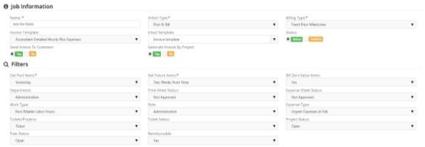

##### Contracts & Job Schedule

*Job Settings & Filters*

Upon saving, the following tabs appear: Contracts & Job Schedule.

1. Contracts: This automation job can run on all contracts or specified contracts chosen.

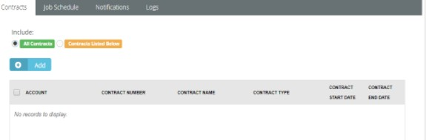

*All Contracts or Contacts listed Below*

1. Job Schedule: In this section, the recurrence interval is defined. The repetition rate could be one of the following:
2. Daily

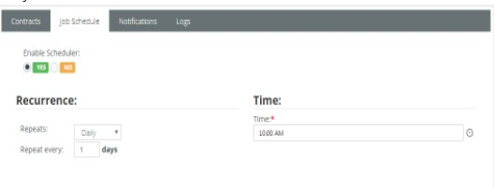*Daily Repetition*

1. Weekly

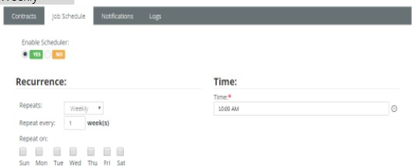

*Weekly Repetition*

1. 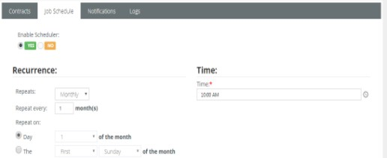Monthly

*Monthly Repetition*

**Note:** If “Enable Scheduler” is set to “Yes”, the job will work based on the schedule and recurrence defined. If not, the scheduled process will work, only, when “Run Now” at the top right of the page, is clicked.

**Notifications**

The user can add the user emails to be notified on success or failure of the job automation.

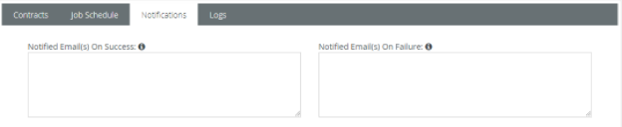

*Notified Emails on Success & Failure*

##### Logs

Everytime the job executes, all the execution steps will be added to the log grid along with the Creation Date of the step and whether or not the job was executed successfully.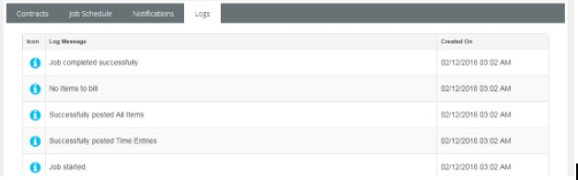

## Billing Review

Finance > Billing Review

The **Billing Review** menu enables you to review billing entries and create invoices. Invoices can be sent out before or after the customer receives services. A separate billing review page is provided to review each type of billing entry.

### Labor Hours

**Finance > Billing Review > Labor Hours**

The **Labor Hours** page lists billing entries for labor hours entered on tickets and tasks. Review one or more entries, make adjustments if necessary, then post them. Posting moves billing entries to **Billing. For** a billing entry to display on this page:

* Hours must be reported in a ticket or task. The ticket or task may be optionally linked to a **time and materials contract**. The contract must be active.
* The billing entry must match search filter parameters.
* Zero value hours can be posted or ignored using the Admin > Company Settings > **Invoice**>

**Post Zero Entries** option.

**Reviewing Labor Hour Billing Entries**

1. Select the Finance > Billing Review > **Labor Hours** page.
2. Optionally change **Search** filter settings. The default date range is from today's date to 3 months into the future. This can be customized using the Admin > Company Settings > **Invoice** tab > **Billing End Date** setting.
3. 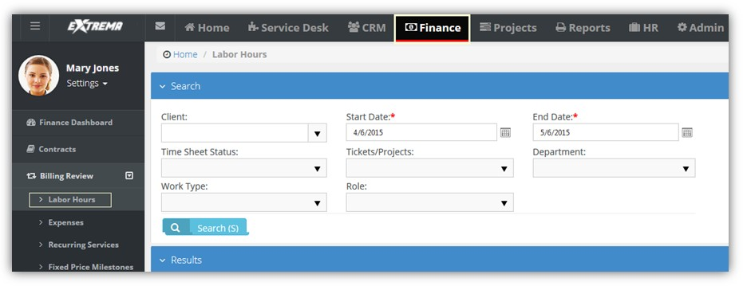Click **Search**. A list of entries displays in the **Results** tab.



1. Optionally review the *ticket or task* for a billing entry by clicking the link in the **Ticket/Project** column.
   * The icon indicates a ticket billing entry.
   * The icon indicates a project/task billing entry.
2. 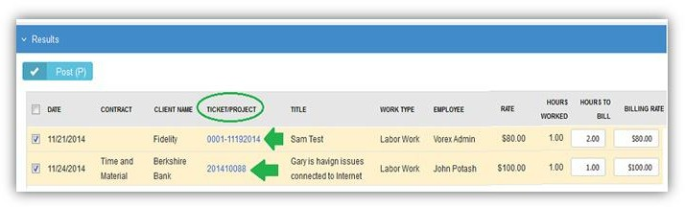Optionally review the *contract* for a billing entry by clicking the link in the **Contract** column.
3. Optionally adjust billing entries.
   * Overtime Hours to Bill
   * **Overtime Billing Rate**
   * **Hours to Bill**
   * **Billing**

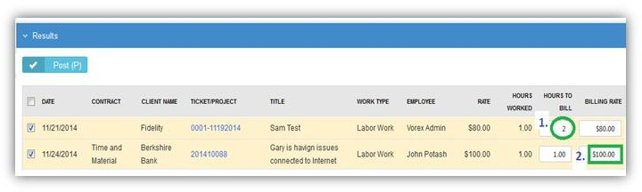

1. Check one or more rows you want to post.
2. Click **Post** to post checked rows.

### Expenses

Finance > Billing Review > Expenses

The **Expenses** page lists billing entries for expenses entered on tickets and tasks. Review one or more entries, make adjustments if necessary, then post them. Posting moves billing entries to **Billing**. For a billing entry to display on this page:

* An expense must be added to a ticket or task or expense report.
* The billing entry must match search filter parameters.

**Reviewing Expense Billing Entries**



1. Select the Finance > Billing Review > **Expenses** page.
2. Optionally change **Search** filter settings. The default date range is from today's date to 3 months into the future. This can be customized using the Admin > Company Settings > **Invoice** tab > **Billing End Date** setting.

1. 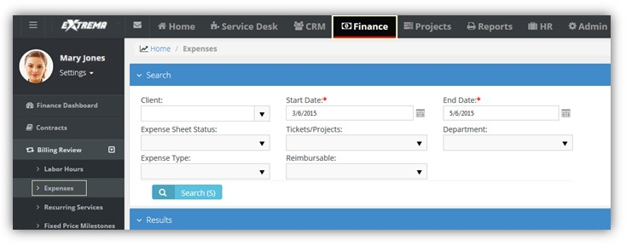Click **Search**. A list of entries displays in the **Results** tab.



1. Optionally review the *ticket or task* for a billing entry by clicking the link in the **Ticket/Project** column.
   * The icon indicates a ticket billing entry.
   * The icon indicates a project/task billing entry.
2. Optionally review the *contract* for a billing entry by clicking the link in the **Contract** column.
3. Optionally adjust billing entires.
   * Billing Price

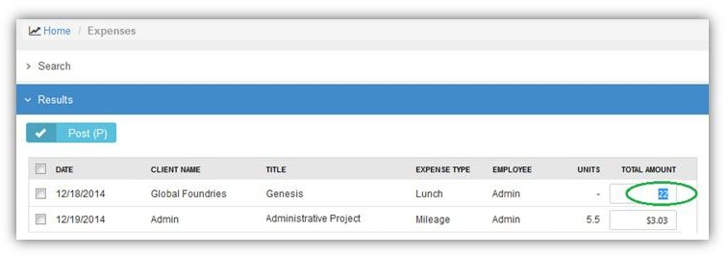

1. Check any row you want to post.
2. Click **Post** to post checked rows.

### Recurring Services

Finance > Billing Review > Recurring Services

The **Recurring Services** page lists billing entries for recurring services. For a billing entry to display on this page:

* A recurring service must be added to a **recurring services contract.**
* The contract must be active.
* The billing entry must match search filter parameters.

Billing is by contract billing period. Once a recurring services contract is active, any of the time periods can be billed at any time. Review one or more entries, make adjustments if necessary, then post them. Posting moves billing entries to **Billing**

* *Billing entries are not generated for hours reported on tickets and tasks linked to a recurring service contract.* To prevent generating billing lines for labor hours independently of a contract, set the **Default Contract** option to Yes for that contract. When a new ticket or task is created, the default contract is linked to the ticket or task automatically.
* Zero value hours can be posted or ignored using the Admin > Company Settings > **Invoice**>

**Post Zero Entries** option.

**Reviewing Recurring Services**

1. Select the Finance > Billing Review > **Recurring Services** page.
2. Optionally change **Search** filter settings. The default date range is from today's date to 3 months into the future. This can be customized using the Admin > Company Settings > **Invoice** tab > **Billing End Date** setting.
3. 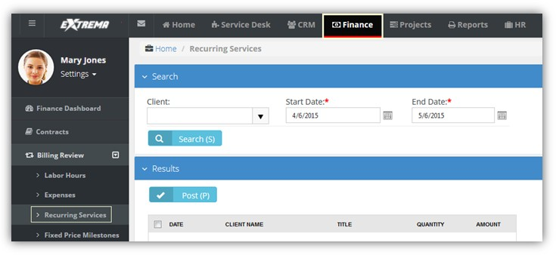Click **Search**. A list of entries displays in the **Results** tab.



1. Optionally adjust billing entries.
   * Quantity
   * 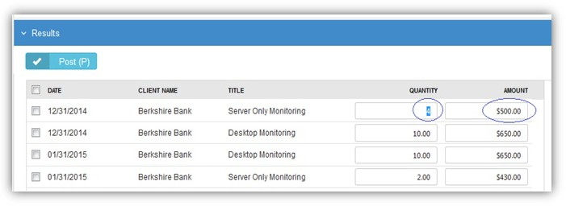**Unit Price**
2. Check any row you want to post.
3. Click **Post** to post checked rows.

### Fixed Price Milestone

Finance > Billing Review > Fixed Price Milestones

The **Fixed Price Milestone** page lists billing entries for fixed price milestones. Milestones are created using fixed price **contracts**. Review one or more entries, make adjustments if necessary, then post them. Posting moves billing entries to **Billing**. For a billing entry to display on this page:

* A fixed priced milestone must be added to a **fixed priced contract.**
* The contract must be active.
* The billing entry must match search filter parameters.

A fixed priced contract is typically linked to a project. Once a fixed price contract is active, you can bill any of its fixed price milestones at any time.

**Reviewing Recurring Services**

1. Select the Finance > Billing Review > **Fixed Priced Milestones** page.
2. Optionally change **Search** filter settings. The default date range is from today's date to 3 months into the future. This can be customized using the Admin > Company Settings > **Invoice**tab > **Billing End Date** setting.
3. 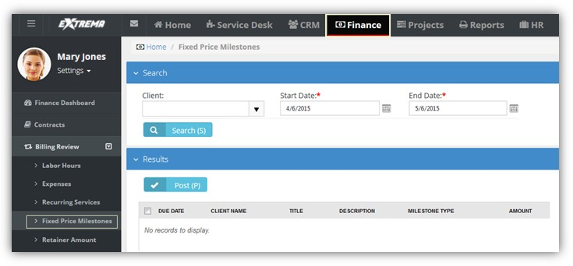Click **Search**. A list of entries displays in the **Results** tab.



1. Optionally adjust billing entries.
   * Amount

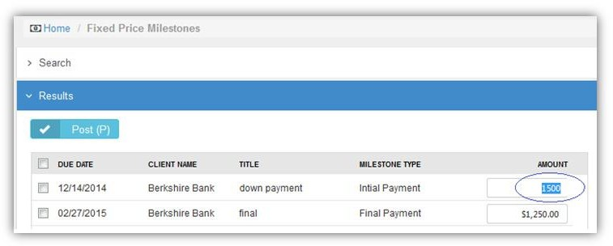

1. Check any row you want to post.
2. Click **Post** to post checked rows.

### Retainer Amount

Finance > Billing Review > Retainer Amount

The **Retainer Amount** page lists billing entries for retainer by amount contracts. Review one or more entries, make adjustments if necessary, then post them. Posting moves billing entries to **Billing**. For a billing entry to display on this page:

* A retainer by amount contract must be active.
* The billing entry must match search filter parameters.

Once a retainer by amount contract is active, the total price of the contract can be billed at any time.

**Reviewing Recurring Services**

1. Select the Finance > Billing Review > **Retainer Amount** page.
2. Optionally change **Search** filter settings. The default date range is from today's date to 3 months into the future. This can be customized using the Admin > Company Settings > **Invoice**tab > **Billing End Date** setting.
3. 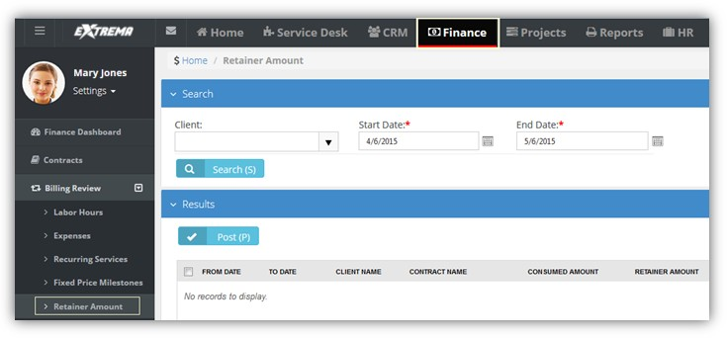Click **Search**. A list of entries displays in the **Results** tab.



1. Check any row you want to post.
2. 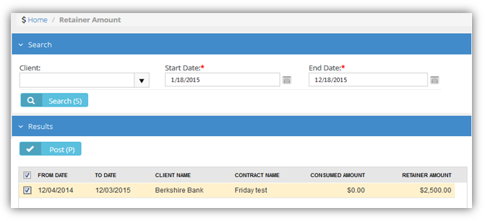Click **Post** to post checked rows.

### Retainer Hours

Finance > Billing Review > Retainer Hours

The **Retainer Hours** page lists billing entries for retainer hours. Retainers hours are consumed when hours are reported on tickets or tasks linked to a **retainer by hours contract**. Billing is by contract billing period. Review one or more entries, make adjustments if necessary, then post them. Posting moves billing entries to **Billing**. For a billing entry to display on this page:

* Hours must be reported in a ticket or task.
* The ticket or task must be linked to a **retainer by hours contract**.
* The contract must be active.
* The billing entry must match search filter parameters.

Once a retainer hours contract is active, any of the time periods can be billed at any time, unless the billing period has been closed.

**Reviewing Recurring Services**

1. Select the Finance > Billing Review > **Retainer Hours** page.
2. Optionally change **Search** filter settings. The default date range is from today's date to 3 months into the future. This can be customized using the Admin > Company Settings > **Invoice** tab > **Billing End Date** setting.
3. 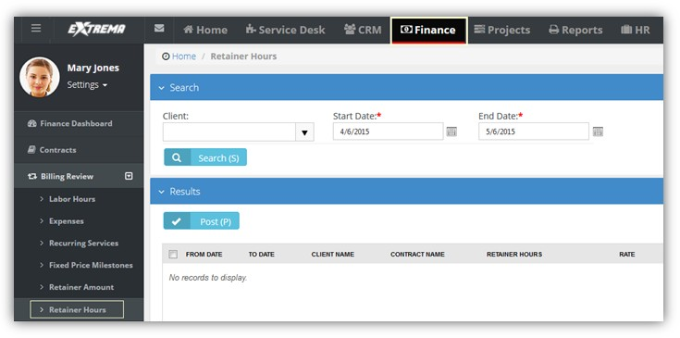Click **Search**. A list of entries displays in the **Results** tab.



1. Check any row you want to post.
2. 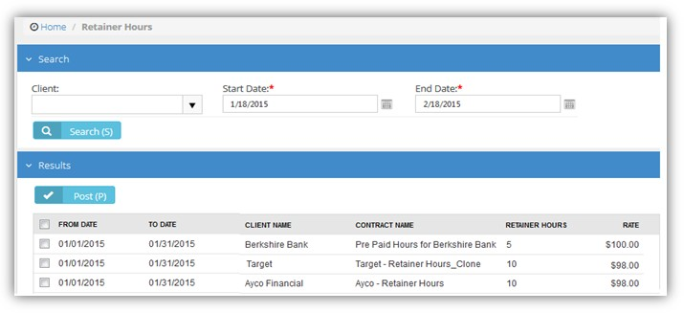Click **Post** to post checked rows.
3. Optionally close billing periods using the **Billing Periods** tab.
   * **Close Billing Periods** - If checked, clicking this button closes checked billing periods. If the **Carry Over Extra Hours to the Next Billing Cycle** option is set to Yes in the **retainer by hours contract**,

unconsumed retainer hours are carried forward to the next billing period when a billing period is closed.

## Billing

Finance > Billing

The **Billing** page creates invoices from *posted* billing lines.

**Creating Invoices**

1. Select the Finance > **Billing** page.
2. Optionally change **Search** filter settings. The default date range is from today's date to 3 months into the future. This can be customized using the Admin > Company Settings > **Invoice** tab > **Billing End Date** setting.
3. Click **Search**. A list of entries displays in the **Results** tab. Review the rows displayed.
4. Select one or more rows to invoice.
   * By default, a single invoice is generated for each customer, for all selected items.
   * To generate additional invoices, one for each project for each customer, set the **Generate Invoices by Project** option to Yes.
5. 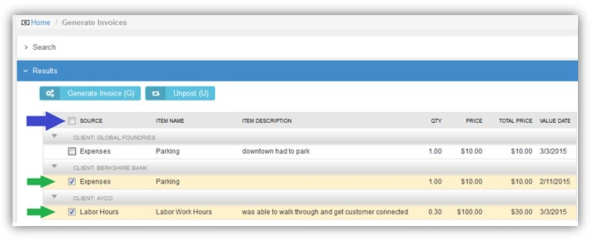Click **Generate Invoice**.

**Un-posting Billing Lines**

Instead of creating an invoice, you can un-post billing lines and send them back to **Billing Review**

1. Select the Finance > **Billing** page.
2. Optionally change search filter settings. The default date range is today's date.
3. Click **Search**. A list of entries displays in the **Results** tab. Review the rows displayed.
4. Select one or more rows to un-post.
5. Click **Un-post**.



## Invoices

Finance > Invoices

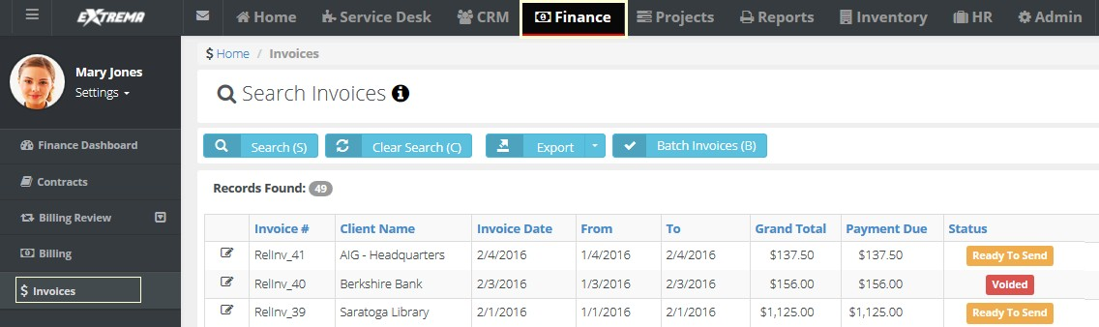The **lnvoices** page manages and generates invoices. Batch generation of invoices is supported.



To manage a single invoice, click any row to display the following:

* Invoice information
* Billing address
* Tax calculations
* Invoice details
* Attached receipts
* Attached files

You can also perform the following actions:

* Generate the invoice
* Preview the invoice
* Edit the invoice and regenerate it
* Send the invoice
* Void the invoice
* Discount the invoice
* 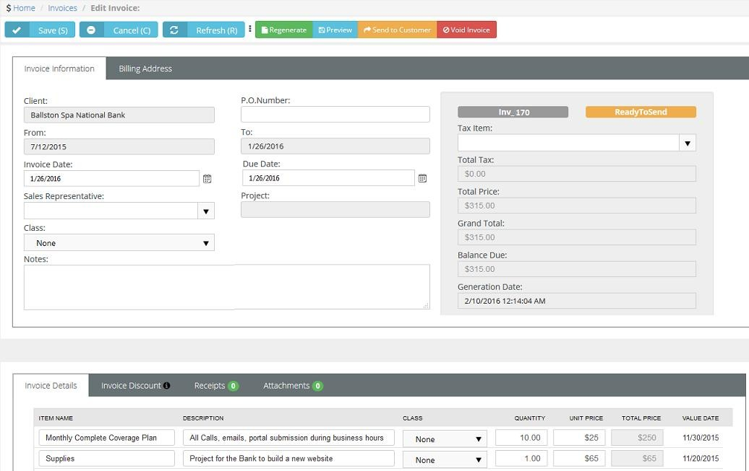Add hidden notes

**Finance > Invoices > (selected invoice) > Invoice Details**

The **Invoice Details** tab lists each line item in the invoice. For each line item, you can edit the following fields:

* Item Name
* **Description**
* **Class**
* **Quantity**
* **Unit Price**

**Reviewing Invoice Details**

1. Select the Finance > **Invoices** page.
2. Select a row with a **Status** of Ready to Send.
3. Review and optionally edit rows listed in the **Invoice Details** tab.
   * **Item Name** - The labor, entry, recurring services, milestone payment type, etc.
   * **Item Description** - Depends on the type of line item:
     + *Labor* - the note entered for the labor entry on the ticket or task
     + *Milestone Payment* - the milestone name
     + *Expense* - the expense note field
     + *Recurring Services* - the description entered for the service name. This supports multiple lines, including line breaks as entered in the service page, as opposed to all the lines merged into a single line
     + *Retainer By Hours* - the **Contract Description** field in the contract. This supports multiple lines, including line breaks as entered in the service page, as opposed to all the lines merged into a single line
     + *Retainer By Amount* - the **Contract Description** field in the contract
   * **Quantity** - The number of each item.
   * **Unit Price** - The price per item.
   * **Total Price** - Unit price times the quantity.
   * **Value Date** - The date the time entry was made or the date the expense was entered.

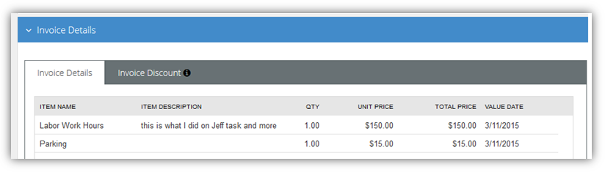

### 

### Invoice Discounts

**Finance > Invoices > (selected invoice) > Invoice Discount**

The **Invoice Discount** tab enables you to apply a discount to the invoice. A discount can be a percentage or dollar amount.

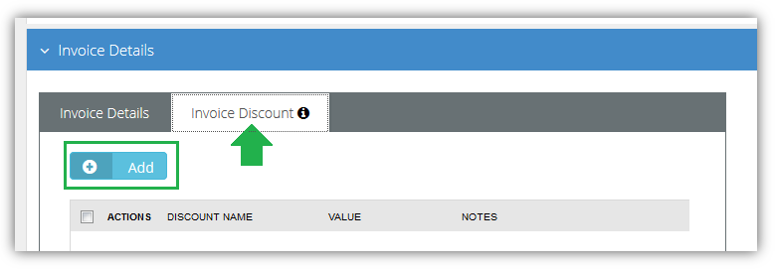

##### To Apply a Discount

1. Select the Finance > **Billing** page.
2. Click an invoice row with a **Status** of Ready to Send.
3. Click the **Invoice Discount** tab.
4. Click **Add**.
   * **Discount Type** - Assigns a default **discount type** percentage or amount.
   * **Class** - The finance **class** of this discount. Optional.
   * **Default Value** - Accept or override.
   * **Notes** - *Entered notes display on the invoice.*
   * Click **Save**. The **Grand Total** reflects the discount immediately.
5. 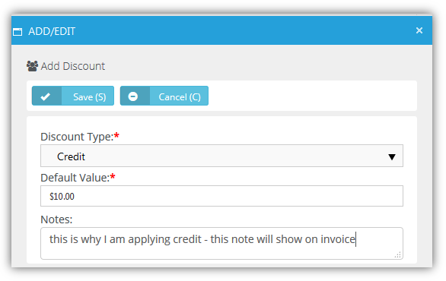Click **Save**.

### Invoice Receipts

**Finance > Invoices > (selected invoice) > Receipts**

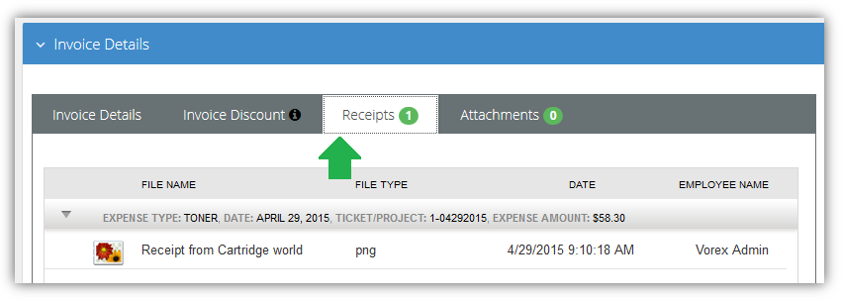The **Receipts** tab displays receipts for line items included in the invoice. For example, if expenses require a receipt be attached, you would see receipts for expense line items here. When you send the invoice to the customer, the receipts will be included in the email.

### Invoice Attachments

Finance > Invoices > (selected invoice) > Attachments

The **Attachments** tab enables you to upload attachments to an invoice. When you send the invoice to a customer, the attachment will be included in the email.

### Generate and Preview

Finance > Invoices > (selected invoice) > Regenerate

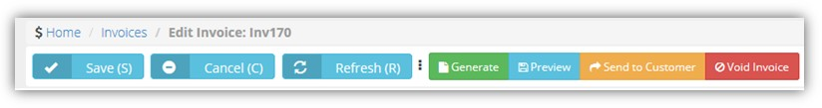Invoices are generated by clicking the **Regenerate** button.

You can generate either a detailed or summary invoice.

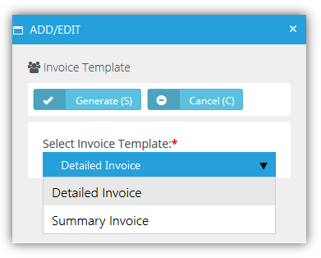

A message indicates the successful creation of your invoice.

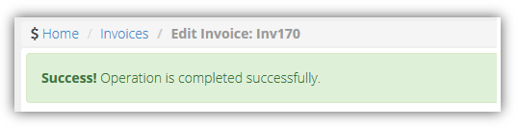



Click **Preview** to review this invoice before sending it.



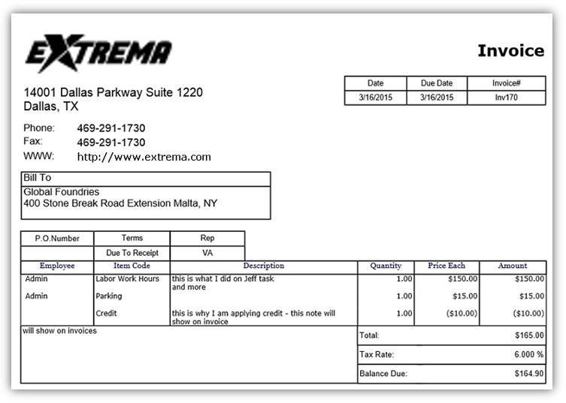



### Resetting a Posted Invoice

**Finance > Invoices > (selected invoice) > Reset Posted to Accounting**

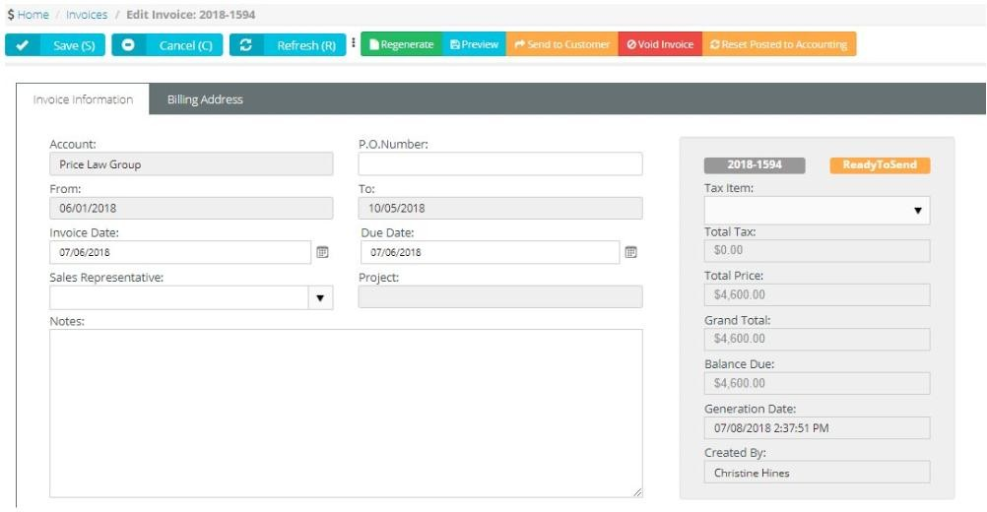If you want to adjust an Invoice that has already been posted to Quickbooks Accounting, click "Reset Posted to Accounting" button so that you can edit the Invoice data in the Finance > Billing. Once you are done with editing the bill, you have to post the invoice to Quickbooks Accounting once again.

You can also click the "Reset Posted to Accounting" button, if you have posted an Invoice to Quickbooks, but for some reason the invoice has not been successfully synchronized by Quickbooks app. In this case, you will cancel the previously posted invoice and will be able to submit it to Quickbooks Accounting once again.

### Sending an Invoice

Finance > Invoices > (selected invoice) > Send to Customer

Send an invoice by clicking the **Send to Customer** button.

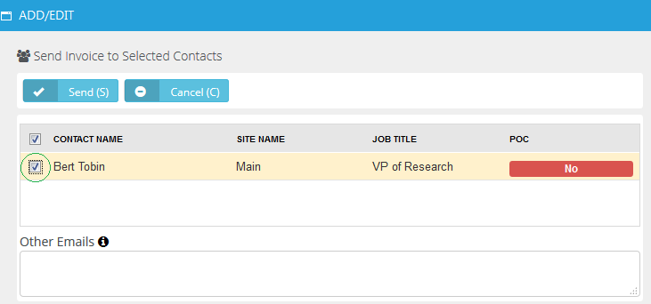Select the contacts you wish to send the invoice to, then click **Send**.

A message indicates the invoice was sent.

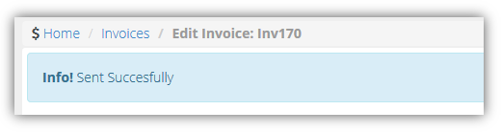

### Voiding an Invoice

Finance > Invoices > (selected invoice) > Void Invoice

Voice an invoice by clicking the **Void Invoice** button. Voiding un-posts all the billing lines in the invoice and sends them back to **Billing Review**

A message indicates the invoice was voided.

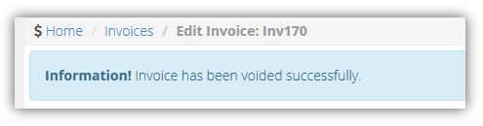

## Payments

Finance > Payments

The **Payments** page matches payments received from customers to invoices. For each invoice linked to a payment you can optionally edit the payment **Amount** received and enter an additional **Discount** amount. To set an invoice line to Fully Paid, the **Amount** and **Discount** must equal the **Total**. You can also upload attachments to a payment record.

**Header Fields**

* Client
* **Payment Date**
* **Reference**
* **Payment Type**
* **Amount**
* **Memo**

**Invoice Fields**

* **Status**
* **Invoice Number**
* **Client**
* **Date**
* **Due Date**
* **Total**
* **Paid**
* **Due**
* **Amount**
* **Discount**

## Vendor Bills

**Finance > Vendor Bills**

The **Vendor Bills** page records time and expenses incurred by vendors and contractors. This includes:

* Labor entries linked to a ticket or task.
* Expenses linked to a ticket or task.
* New expenses not necessarily linked to a ticket or task.

Entries added to vendor bills can be marked up in price, posted and billed to your customers. Billing can occur at any time, regardless of the status of the entry on the **Vendor Bills** page.

##### Prerequisites

On the SUPPORT > Admin > Finance > **Expense Type** page:

* An expense type must be set to **Available For:** Vendor or Employees or Vendors.
* For Quickbooks integration, expense items must be linked to both an income account and an expense account.

To add items to the SUPPORT > Finance > Vendor Bills > (vendor bill) > **Item** tab:

* Adhoc items do not have to be approved.

To add items to the SUPPORT > Finance > Vendor Bills > (vendor bill) > **Expense Entries** tab and **Time Entries**

tab:

* The employee must be linked to a vendor using the HR > Employees > (employee) > **Wages**> Vendor field.
* For timesheet entries, on the same employee **Wages** page, specify a **Burden Rate** > 0.
* The roles specified for billable entries require an Admin > Finance > **Roles** > **Billing Rate**.
* Vendor-linked employee expense entries or timesheet entries must be approved.

##### Processing Vendor Bills

1. Create and save a new vendor bill.
   * The vendor bill status will be New.
2. Add entries for **Items**, **Expense Entries** and **Time Entries.****Finance**
   * Ensure entries are checked as billable if you intend on billing the customer for the work outsourced to the vendor.
3. Click **Save**
   * The vendor bill status will be Processed the first time you save the vendor bill with an entry.
   * Saved vendor bill entries cannot be edited. You can still add new entries.
4. Use the Finance > Billing Review > **Expenses** page to post billable vendor bill expense entries.
5. Use the Finance > Billing Review > **Labor Hours** page to post billable vendor bill labor entries.
6. Use the Finance > **Billing** page to create an invoice that includes posted vendor bill entries.

##### Header Fields

* Vendor
* **Created On**
* **Created By**
* **Due Date**
* **Reference #**
* **Amount**

**Items tab**

* **Expense Type**
* **Date**
* **Amount Spent**
* **Mark up / down**
* **Total Amount**
* **Notes**
* **Expense Associated With** - Project, Ticket, Internal Expense - Internal expenses are added to the Administration Project for your company.

##### Expense Entries tab

Click **Add** to select expense entries.

##### Time Entries tab

Click **Add** to select labor time entries.

##### Attachments

Click **Upload a new file** to upload files to a **Vendor Bill** record.

## Reimbursements

Finance > Reimbursements

The **Reimbursements** page records payments to employees who have incurred expenses on behalf of your company.

**Prerequisites**

On the SUPPORT > Admin > Finance > **Expense Type** page:

* An expense type must be set to **Available For:** Employees or Employees or Vendors. For Quickbooks integration:
* Expense items must be linked to both an income account and an expense account.
* The employee must have a vendor alias defined using the SUPPORT > HR > Employees > (employee)

> **Wages** > **Equivalent Vendor Record** field.

To add items to the SUPPORT > Finance > **Reimbursements** page:

* The employee's expense entries must be approved.

**Creating Reimbursements**

1. Select the Finance > **Reimbursements** page.
2. Click **New**.
3. Enter the following fields.
   * Employee
   * **Created On**
   * **Created By**
   * **Payment Type**
   * **Reference #**
   * **Amount**
   * **Memo**
4. Click **Save**.

C h a p t e r 4

## QuickBooks Integration

**Finance > QuickBooks**

The **QuickBooks Integration** allows you to exchange financial data between your system and an instance of Quickbooks. For more information download the **Quickbooks Online Integration or Quickbooks Desktop Integration guides**.

SUPPORT QuickBooks Sync is supported in the following countries:

* Australia
* Canada
* India
* United Kingdom
* United States

The following versions of QuickBooks Desktop are supported:

* 2018
* 2017
* 2016
* 2015
* 2014
* 2013
* 2012
* 2011

**QuickBooks Integration** does not support Apple Online QuickBooks.

C h a p t e r 5

**CRM Module**

CRM stands for *customer relationship management.* A CRM solution allows you to manage the business relationship and interactions you have with customers, prospects, vendors, etc., and store all the data about these relationships. These interactions can be sales related—calls, emails, meetings and demonstrations—as well as support related—service tickets and projects. The benefit of a CRM is having all your business data stored and accessible from one central location. The **CRM** module provides:

* Immediate employee access to the data they need.
* Sharing of important data between departments.
* Management insight into activity across the organization and helps them understand where they can improve processes.

Customers are first added as accounts in CRM. After that you can create projects, open tickets, and set up contracts on their behalf.

## Dashboard

Finance > Dashboard

The **Dashboard** displayed in the **CRM** module includes additional dashlets that highlight important sales cycle concerns.

Specialized dashlets provided by the CRM > **Dashboard** include:

* **Pipeline** - The dollar value of opportunities in the system:
  + **Pipeline value** - The value of all opportunities equal to or greater than the **Pipeline Factor** set in Admin > My Company > CRM > **Opportunities**. Click **View Details**.
  + **Total Value** - All opportunities in the system regardless of the **Pipeline Factor**, meaning any opportunity with a percent between 0% and 99%. Click **View Details**.
* **Opportunity Amount Value by Lead Source** - A chart of the opportunities grouped by lead source. Hover the cursor over any color to display its dollar value. Filter the chart by **This Month**, **This Quarter**, **This Year**.
* **Opportunity Pipeline Value** - A chart of the pipeline value. Filter the chart by **This Month**, **This Quarter**, **This Year**.
* **Opportunities Converted to Projects** - A chart of the number of opportunities converted to projects.
* **Opportunity Performance** - An opportunity performance table by sales representative. The **Probability** is the average for all opportunities for the selected period: **This Month**, **This Quarter**, **This Year**. Provides the value of opportunities **Won**, **Lost** and **Open**.

See **Dashboard (Home)** for a description of general purpose dashlets that also display on this page.

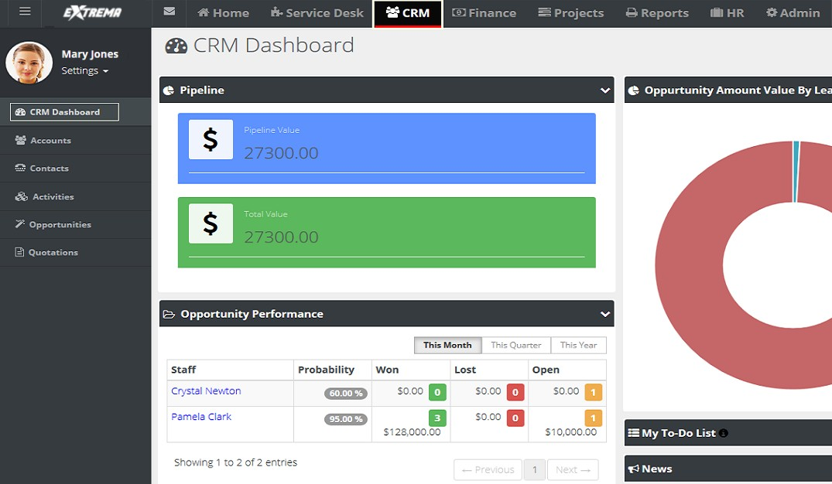



## Accounts

Admin > CRM > Accounts

The **Accounts Management** page maintains your account profiles for every organization you do business with. This includes clients, prospects, vendors, competitors, former clients, business partners, and miscellaneous organizations. This same page displays in the **CRM** module if you have permission.

Initially you create a basic account. After you save an account the first time, multiple tabs display for you to enter additional details.

**Creating Accounts**

1. Select the Admin > CRM > **Accounts** page.
2. Click **New**.

You can select two types of accounts.

* + **Account Code** - An account code associated with this customer organization.
  + **Account Name** - The main account name for a customer organization.
  + **Child Account** - An subordinate account for a larger customer organization. If **Route Invoice to Parent** is set to Yes for this child account, billables are routed to the parent organization for payment. If set to No, parent-child accounts are used for reporting purposes only.

1. Select **Account**.
2. Enter the following fields in the **Account** header section.
   * Account Name
   * **Account Type** - Client, Competitor, Former Client, Miscellaneous, Partner, Unknown, Vendor
   * **Business Type** - This list is maintained using Admin > My Company > Lists page.
   * Website
   * **Acquired Date**
   * **Credit Limit**
   * **Default Currency**
   * **Net Days**
   * **Account Manager** - The employee in your company assigned to manage this account.
   * 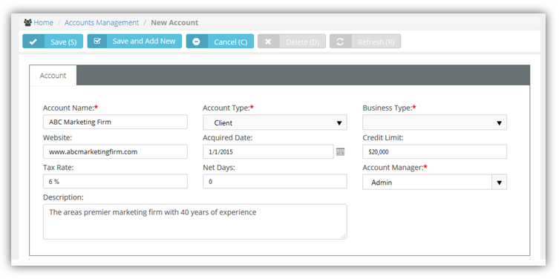Description
3. Enter the main business address in the **Main Address Info** tab. Optionally click **Copy From Billing** to populate these fields from the **Billing Address Info** tab.
   * Address Line 1
   * **Address Line 2**
   * **City**
   * **State**
   * **Post Code**
   * **Country**
   * **Phone Number**
   * **Fax Number**
   * **Longitude**
   * 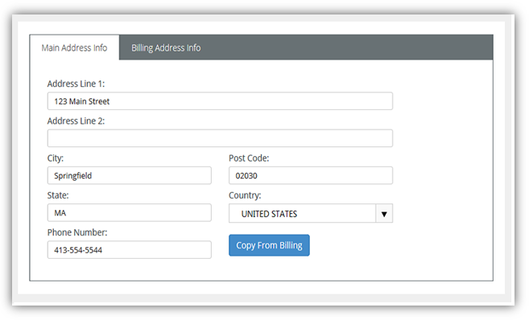**Latitude**
4. Enter the billing account address in the **Billing Address Info** tab. Optionally click **Copy From Main** to populate these fields from the **Main Address Info** tab.
   * Email Address
   * **Address Line 1**
   * **Address Line 2**
   * **City**
   * **Post Code**
   * **State**
   * **Country**
   * **Phone Number**
   * **Fax Number**
   * **Longitude**
   * **Latitude**
5. Click **Save**.
6. Click the row of the new account you just created to add additional information.
   * 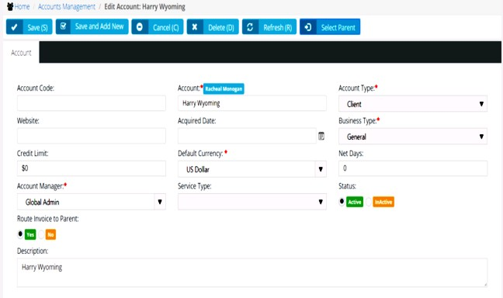The **Status** option in the header is now available to maintain. If Yes, the account is being used.
7. Use the tabs at the bottom of the page to maintain more details about each account.

### Locations

CRM > Accounts > Locations

**Admin > CRM > Accounts > Locations**

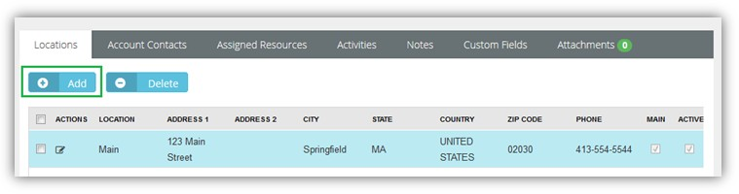Use the **Locations** tab to maintain physical address locations for each account.

**Adding New Account Locations**

1. Select the Admin > CRM > Accounts > **Locations** tab.
2. Click **Add**.
3. Enter the following fields in the **Address Info** tab.
   * Location Name
   * **Status**
   * **Address Line 1**
   * **Address Line 2**
   * **City**
   * **Post Code**
   * **State**
   * **Country**
   * **Phone Number**
   * **Fax Number**
   * **Longitude**
   * **Latitude**
4. Optionally click **Convert to Main (M)** set a location as the 'main address' for an account.
5. 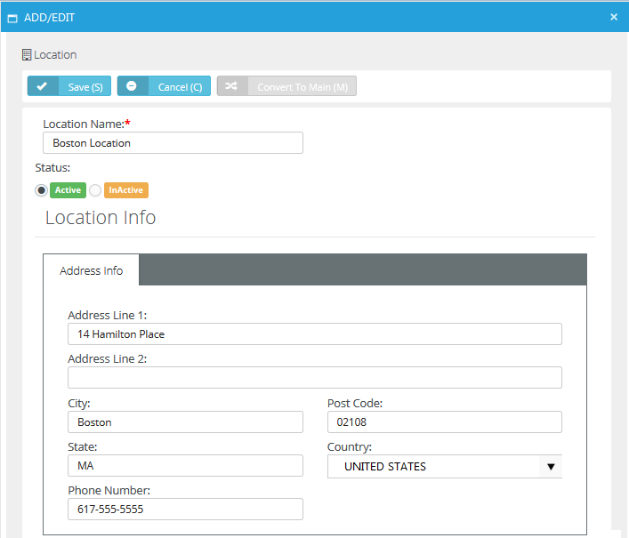Click **Save**.
6. Click the **Custom Fields** tab.
   * Enter values in the custom fields, as appropriate for this record.
   * Custom fields are maintained using the Admin > My Company > Custom Fields page.

### Contacts

CRM > Accounts > Account Contacts

**Admin > CRM > Accounts > Account Contacts**

* **Similar to CRM > Contacts**

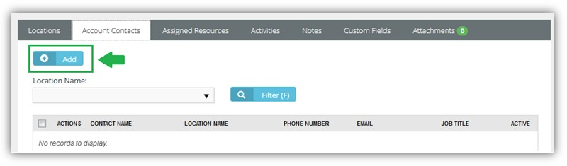Use the **Account Contacts** tab to maintain contacts for each account. These are the individuals that the sales teamwork with to sell products and services. These are the people that your project team is delivering a completed project to. These are the people that are calling you for support and who you are opening tickets for.

**Adding New Account Contacts**

1. Select the Admin > CRM > Accounts > **Account Contacts** tab.
2. Click **Add**.
3. Enter the following fields in the **Account Contact** tab.
   * First Name
   * **Middle Name**
   * **Last Name**
   * **Location Name**
   * **Job Title**
   * **Phone Type**
   * **Phone**
   * **Status**
   * **Email Type**
   * **Email**
   * **Point of Contact** - If Yes, this person will be notified if a workflow rule is configured to send notifications to Point of Contact.
   * Has Client Portal Access - If Yes, the client has portal access. Two extra fields Username and Security Role display. The first time this setting is saved, the contact is sent an email with a user name, password and instructions on how to login to the portal.CRM Module
   * 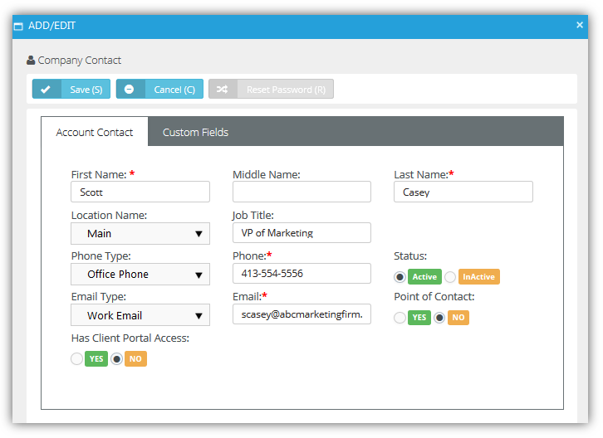**Receive Invoices**
4. Click the **Custom Fields** tab.
   * Enter values in the custom fields, as appropriate for this record.
   * 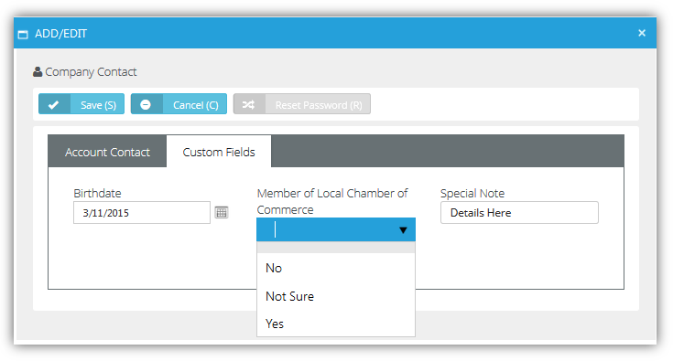Custom fields are maintained using the Admin > My Company > Custom Fields page.

### Assigned Resources

CRM > Accounts > Assigned Resources

**Admin > CRM > Accounts > Assigned Resources**

Use the **Assigned Resources** tab to link employees—typically a technician—to an account.

* When a client composes a message in **Client Portal**, **Assigned Resources** display in the client's recipient search list.
* **Assigned Resources** can be notified when a ticket **workflow** is triggered.

**Adding Assigned Resources**

1. Select the Admin > CRM > Accounts > **Assigned Resources** tab.
2. Click **Add**.
3. Check one or more employee rows.
4. Click **OK**.

### Email Domains

CRM > Accounts > Email Domains

**Admin > CRM > Accounts > Email Domains**

Associate one or more **Email Domains** with a CRM customer account. This enables the SUPPORT email parser to determine the related account to create tickets for in Service Desk. If used, creates a new **contact** record for the sender of the email and associates that new contact with the new ticket.

* Only applies if the sender's email address is not recognized as an *existing* contact record. In this case, a ticket is created and associated with the existing contact.
* If an email cannot be associated with any existing contact or email domain record, the email parser creates the ticket and identifies its sender as Unknown.
* Specified email domain names should not be public domains such as yahoo.com, google.com or

hotmail.com, and should be unique for each account.

**Adding Email Domains**

1. Select the Admin > CRM > Accounts > **Email Domains** tab.
2. Click **Add**.
3. Check one or more email domains rows.
4. Click **OK**.

### Tax Settings

CRM > Accounts > Tax Settings

**Admin > CRM > Accounts > Tax Settings**

The **Tax Settings** tab specifies tax related information for an account.

* **Tax ID** - The tax identifier for this account.
* **Tax Rate** - Applies to the labor entered on tickets and tasks. Displays on invoices.
* **Is Taxable** - Yes or No.

### Opportunities

CRM > Accounts > Opportunities

**Admin > CRM > Accounts > Opportunities**

* **Similar to CRM > Opportunities**

The **Opportunities** tab maintains opportunities for each account.

**Adding Opportunities**

1. Select the Admin > CRM > Accounts > **Opportunities** tab.
2. Click **Add**.
3. Enter the following fields.
   * Subject
   * **Next Step**
   * **Account**
   * **Type**
   * **Status**
   * **Location**
   * **Probability**
   * **Rating**
   * **Contact**
   * **Sales Representative**
   * **Customer PO#**
   * **Phone**
   * **Close Date**
   * **Lead Source**
   * **Amount**
   * **Probability Adjusted Revenue**
   * **Description**
4. Click **Save**.

### Activities

CRM > Accounts > Activities

**Admin > CRM > Accounts > Activities**

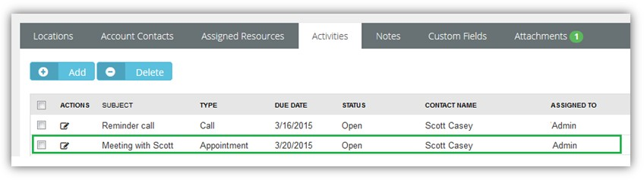The **Activities** tab maintains a history of the interactions between your company and the contacts for an account. Many activities may need to be tracked to support converting an opportunity into a sale.

**Adding Activities**

1. Select the Admin > CRM > Accounts > **Activities** tab.
2. Click **Add**.
3. Enter the following fields.
   * **Subject** - Summary of this activity.
   * **Status** - Status of this activity.
   * **Type** - Appointment, Ask for Sale, Call, Demo, Email, Follow up, Inquiry, Marketing, Memo, Proactive Call, Quote, Renew Agreement, Task
   * **Due Date** - Due date for this activity.
   * **Reminder** - Reminder date for this activity.
   * **Contact** - Contact for this activity.
   * **Start Time** - Start time for this activity.
   * **Assigned To** - Employee assigned this activity.
   * **Phone** - Contact's phone.
   * **End Time** - End time for this activity.
   * **Assigned By** - Employee who assigned this activity.
   * **Notes** - Additional notes about this activity.
4. Click **Save**.

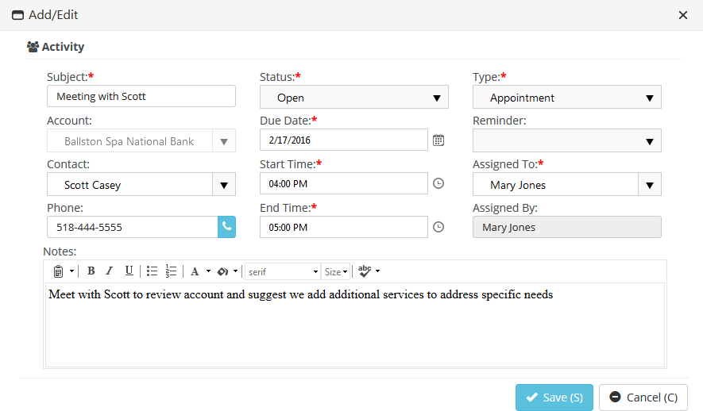

### Linked Accounts

CRM > Accounts > Linked Accounts

**Admin > CRM > Accounts > Linked Accounts**

The **Linked Activities** tab associates an accounts with other accounts in your system.

**Adding Linked Accounts**

1. Select the Admin > CRM > Accounts > **Linked Accounts** tab.
2. Click **Add**.
3. Enter the following fields in the **Linked Account** tab.
   * **Account** - Select another account to link with this account.
   * **Link Type** - General
   * Notes
4. Click **Save**.
5. Click the **Custom Fields** tab.
   * Enter values in the custom fields, as appropriate for this record.
   * Custom fields are maintained using the Admin > My Company > Custom Fields page.

**Notes**

**CRM > Accounts > Notes**

**Admin > CRM > Accounts > Notes**

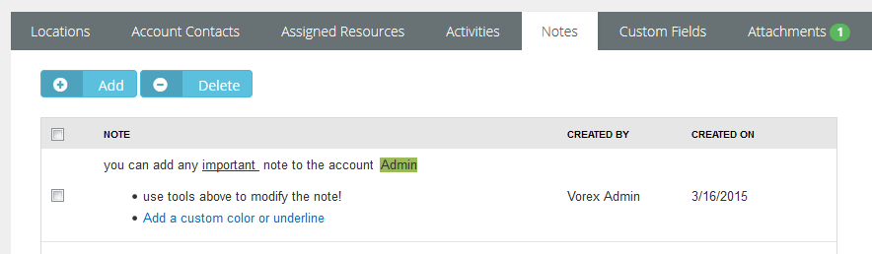The **Notes** tab stores notes for an account. Copy text from proposals, signed contracts, statements of work, network diagrams, user guides, etc.—anything important about this client you want to reference quickly.

##### Adding Notes

1. Select the Admin > CRM > Accounts > **Notes** tab.
2. Click **Add**.
3. Type or paste text into the **Note Text** edit box.,
4. 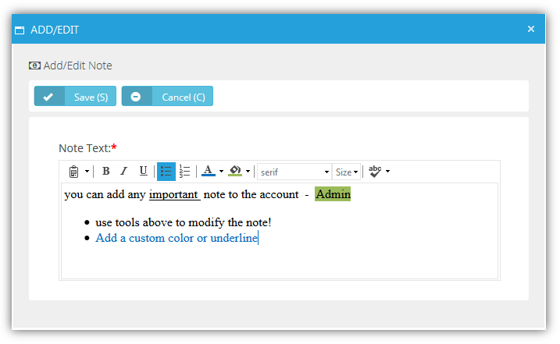Click **Save**.

### Custom Fields (for Accounts)

**CRM > Accounts > Custom Fields**

**Admin > CRM > Accounts > Custom Fields**

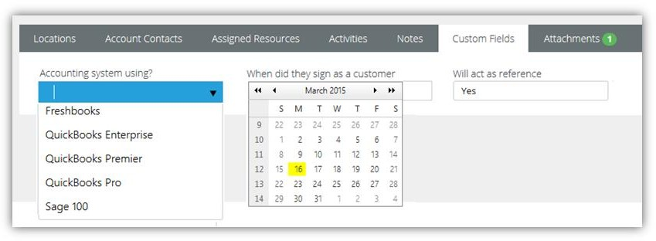The **Custom Fields** tab maintains data entered in custom fields for account profiles. Data types for custom fields can be Free Text, Date or Data List. Custom fields can be set to required. Custom fields are created using the Admin module > My Company > **Custom Fields**page.

### Attachments (for Accounts)

CRM > Accounts > Attachments

**Admin > CRM > Accounts > Attachments**

Use the **Attachments** tab to upload files to an account profile.

**Adding Attachments**

1. Select the Admin > CRM > Accounts > **Attachments** tab.
2. Click **Upload a new file**.
3. Browse, then **Select** a file to upload.
4. Optionally enter an **Alias** name.
5. Click **Save**.

### RMM Integration

CRM > Accounts > RMM Integration

**Admin > CRM > Accounts > RMM Integration**

The **RMM Integration** page manually maps an individual SUPPORT account with an an individual account in an RMM. This can be done by batch using the Admin > Service Desk > RMM Integration Settings page.

* **Organization ID** - Select a RMM account. This list only displays RMM accounts that are not already linked to a CRM customer account in SUPPORT.

## Contacts

CRM > Contacts

* **Similar to CRM > Accounts > Account Contacts and Admin > CRM > Accounts > Account Contacts**

Use the **Contacts** tab to maintain contacts for each account. These are the individuals that the sales team work with to sell products and services. These are the people that your project team is delivering a completed project to. These are the people that are calling you for support and who you are opening tickets for.

**Adding New Account Contacts**

1. Select the Admin > CRM > Accounts > **Account Contacts** tab.
2. Click **Add**.
3. Enter the following fields in the **Account Contact** tab.
   * First Name
   * **Middle Name**
   * **Last Name**
   * **Job Title**
   * **Account**
   * **Location Name**
   * **Status** - Active or Inactive
   * **Point of Contact** - If Yes, this person will be notified if a workflow rule is configured to send notifications to Point of Contact.
   * **Receive Invoices** - Yes or No
   * 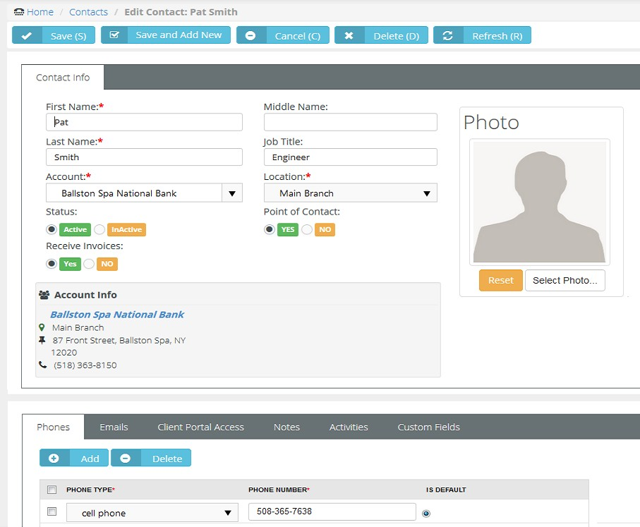**Photo** - Reset or Select Photo
4. Click the **Phones** tab and enter the following. Click **Add** to add additional rows.
   * Phone Type
   * **Phone Number**
   * **Is Default** - The default phone number displays when you create an activity.
5. Click the **Emails** tab and enter the following. Click **Add** to add additional rows.
   * Email Type
   * **Email**
   * **Is Default**
6. Click the **Client Portal Access** tab.

If you are using the **Service Desk** module, you can turn on **Client Portal** for all contacts in your accounts that are clients. The client portal is a secure place for your customers to submit and track help tickets. There is also a Message center that allows the user to send messages directly to their service provider, making it easier to follow up with any tickets and questions that may not be support related. Security roles are provided that makes it easy to turn on the portal and give the right permission levels to your clients.

* + **Has Client Portal Access** - If Yes, the client has portal access and two extra fields **Username** and **Security Role** display. The first time this setting is saved, the contact is sent an email with a user name, password and instructions on how to login to the portal.
  + **Username** - The username the client will use to logon to the client portal.
  + **Reset and Email Password** - Enabled if the user requests a new password.
  + Security Role
    - Client Access
    - External User - Allow the client to view/edit their own profile and messages, as well as tickets assigned to them.
    - External Manager - Allow the client to view/edit their own profile and messages. However, unlike 'External User' this option will allow the client to view all tickets.

1. Click the **Notes** tab. Click **Add** to add notes.
2. Click the **Activities** tab. Click **Add** to add additional activities.

Activities are a history of the interactions between your company and the contacts for an account. Many activities may need to be tracked to support converting an opportunity into a sale.

* + **Subject** - Summary of this activity.
  + **Status** - Status of this activity.
  + **Type** - Appointment, Ask for Sale, Call, Demo, Email, Follow up, Inquiry, Marketing, Memo, Proactive Call, Quote, Renew Agreement, Task
  + **Account** - The customer account.
  + **Due Date** - Due date for this activity.
  + **Reminder** - Reminder date for this activity.
  + **Contact** - Contact for this activity.
  + **Start Time** - Start time for this activity.
  + **Assigned To** - Employee assigned this activity. **Phone** - Contact's phone.
  + **End Time** - End time for this activity.
  + **Assigned By** - Employee who assigned this activity.
  + **Notes** - Additional notes about this activity.

1. Click the **Custom Fields** tab.
   * Enter values in the custom fields, as appropriate for this record.
   * Custom fields are maintained using the Admin > My Company > **Custom Fields** page.

## Activities

CRM > Activities

* **Similar to CRM > Accounts > Activities and Admin > CRM > Accounts > Activities**

The **Activities** tab maintains a history of the interactions between your company and an account. Many activities may need to be tracked to support converting an opportunity into a sale. The page:

* Does not require you to enter an account or contact with an activity.
* Enables you to link an activity to a project, opportunity or ticket.

**Adding Activities**

1. Select the Admin > CRM > **Activities** tab.
2. Click **New**.
3. Enter the following fields.
   * **Subject** - Summary of this activity.
   * **Status** - Status of this activity.
   * **Type** - Appointment, Ask for Sale, Call, Demo, Email, Follow up, Inquiry, Marketing, Memo, Proactive Call, Quote, Renew Agreement, Task
   * **Account** - The customer account.
   * **Due Date** - Due date for this activity.
   * **Reminder** - Reminder date for this activity.
   * **Contact** - Contact for this activity.
   * **Start Time** - Start time for this activity.
   * **Assigned To** - Employee assigned this activity.
   * **Phone** - Contact's phone.
   * **End Time** - End time for this activity.
   * **Assigned By** - Employee who assigned this activity.
   * **Project** - *Requires an account be selected.* An associated project.
   * **Opportunity** - *Requires an account be selected.* An associated opportunity.
   * **Ticket** - *Requires an account be selected.* An associated ticket.
   * **Notes** - Additional notes about this activity.
4. 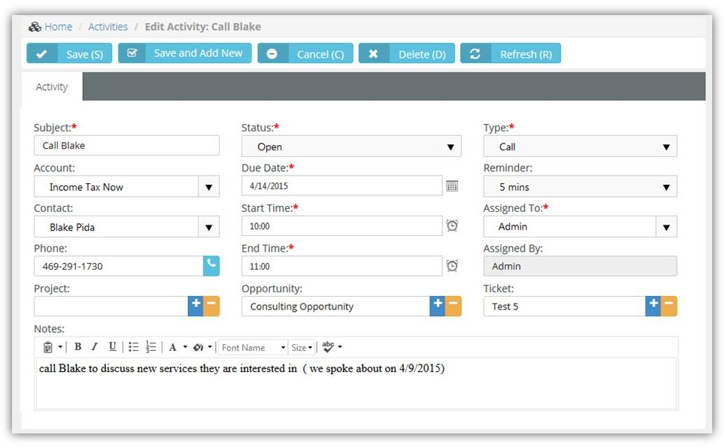Click **Save**.

## Opportunities

**CRM > Opportunities**

The **Opportunities** tab maintains opportunities across all accounts. Creating opportunities helps the sales team track and manage the sale pipeline.

##### Leads vs Opportunities

Lead

* A qualified prospect that proactively wants to learn more about your products and services.
* A type of prospect who has a problem we can solve and we can sell to.
* The prospect is proactively looking: requested a white paper, a demonstration. They have questions.
* A list of names to cold call is not a lead. It's a prospect list.

Opportunity

* When the conversation turns into near-term purchase possibility.
  + They have a defined time-line to make a purchase.
  + You are talking with the decision maker(s) and they are actively seeking to solve problem / issue.
  + Budget has been discussed and is available.
  + The buyer has agreed upon next steps, which may or may not be to purchase from you.
* If you've converted a lead into an opportunity, you have an expected close date.

##### Adding Opportunities

1. Select the CRM > **Opportunities** tab.
2. Click **New**.
3. Enter the following fields.
   * Subject
   * **Next Step**
   * **Account**
   * **Type**
   * **Status**
   * **Location**
   * **Probability**
   * **Rating**
   * **Contact**
   * **Sales Representative**
   * **Customer PO#**
   * **Phone**
   * **Close Date**
   * **Lead Source**
   * **Amount**
   * **Probability Adjusted Revenue**
   * 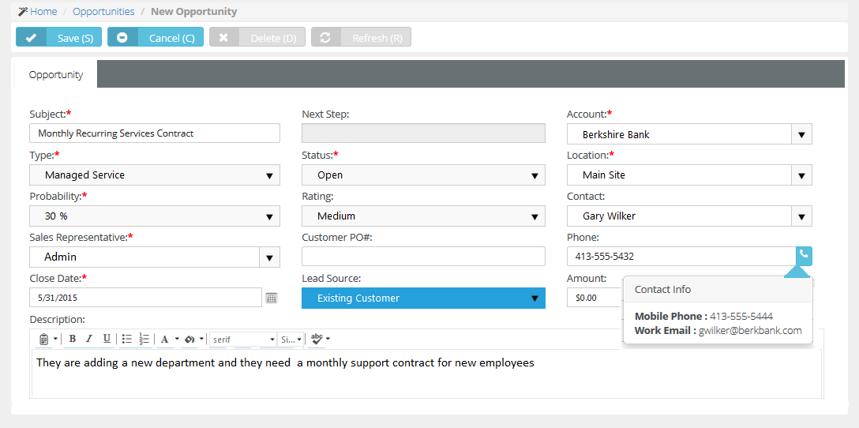**Description**
4. Select the **Activities** tab and enter the following. Click **Add** to add additional rows.
   * **Subject** - Summary of this activity.
   * **Status** - Status of this activity.
   * **Type** - Appointment, Ask for Sale, Call, Demo, Email, Follow up, Inquiry, Marketing, Memo, Proactive Call, Quote, Renew Agreement, Task
   * **Account** - The customer account.
   * **Due Date** - Due date for this activity.
   * **Reminder** - Reminder date for this activity.
   * **Contact** - Contact for this activity.
   * **Start Time** - Start time for this activity.
   * **Assigned To** - Employee assigned this activity.
   * **Phone** - Contact's phone.
   * **End Time** - End time for this activity.
   * **Assigned By** - Employee who assigned this activity.
   * **Notes** - Additional notes about this activity.
5. Select the **Quotations** tab and enter the following. Click **Add** to add additional rows.

A **quote** is a form that you send to your prospect or client that lists the prices for the items and services you are selling.

* + Quotation Number
  + **Status**
  + **Name**
  + **Expiry Date**
  + **Created By**
  + **Creation Date**
  + **Summary**
  + Click **Save**.
    - After you save a quotation, a new **Line Items** tab displays. You can use it to **Add** line

items to the quotation.

* + - You can subsequently **Generate**, **Preview**, and **Send to Customer** all from within this tab.
    - You can then set the **Status** of the quotation to Approved from within this tab. Once approved, you can **Convert** the quotation into one or more contracts and a single project.
    - For more information see **Quotations.**

1. Click the **Notes** tab. Click **Add** to add notes.
2. Click the **Custom Fields** tab.
   * Enter values in the custom fields, as appropriate for this record.
   * Custom fields are maintained using the Admin > My Company > **Custom Fields** page.
3. Click **Attachments** tab.
   * Click **Upload a new file** to upload files to this record. For example, a request for proposal (RFP).
4. Click **Save**.

## Quotations

CRM > Quotations

Part of the sales process is sending your prospects or customers a quote for your products and services. A sales quote allows the prospective buyer to see the cost for the products and services and make a decision. SUPPORT allows you to generate **Quotations** that are linked to your opportunities.

### Service Quotations

CRM > Quotations > Service Quotations

The **Service Quotations** page manages quotes for service items. You can also include product items in service quotations. Each service line item can override the default prices specified for labor and services. A service quotation supports the following types of line items:

* Service Items
* Labor Items
* Fixed Labor Item
* Fixed Price Item
* Product Item
* Retainer by Hour Item
* Retainer by Amount Item

##### Create New Service Quotations

1. Select the CRM > Quotations > **Service Quotations** tab.
2. Click **New**.
3. Enter the following in the **Customer Info** panel.
   * One of the following:
     + By Opportunity
     + **By CRM Account**
     + **By Project**
   * **Contact**
4. Enter the following fields in the **Quotation Info** tab.
   * Quotation Number
   * **Status**
   * **Name**
   * **Expiry Date**
   * **Created By**
   * **Creation Date**
   * **Summary**
5. Click the **Custom Fields** tab.
   * Enter values in the custom fields, as appropriate for this record.
   * Custom fields are maintained using the Admin > My Company > **Custom Fields**

page.

1. Click **Save**. Two additional tabs display: **Line Items** and **Attachments**.
2. Click the **Line Items** tab.
3. Click **Add**. Select one of the following service items.
   * Service Item
   * **T&M Labor Item**
   * **Fixed Labor Item**
   * **Fixed Price Item**
   * **Product Item**
   * **Retainer by Hour Item**
   * **Retainer by Amount Item**
4. When adding a **Service Item** enter the following:
   * **Service** - Select a service.
   * **Unit Price** - Accept the default or override.
   * **Quantity** - Accept the default or override.
   * **Period** - Recurring or One Time
   * **Description** - Enter a description.
5. When adding a **T&M Labor Item** entering the following:
   * **Role** - Select a role.
   * **Unit Price** - Accept the default or override.
   * **Quantity** - Accept the default or override.
   * **Period** - Per Hour or Per Day
   * **Description** - Enter a description.
6. When adding a **Fixed Labor Item** entering the following:
   * **Name** - Enter a name.
   * **Unit Price** - Accept the default or override.
   * **Quantity** - Accept the default or override.
   * **Period** - Per Hour or Per Day
   * **Description** - Enter a description.
7. When adding a **Fixed Price Item** entering the following:
   * **Name** - Enter a name.
   * **Milestone Type** - Select a milestone type.
   * **Unit Price** - Accept the default or override.
   * **Quantity** - Accept the default or override.
   * **Period** - Per Hour or Per Day
   * **Description** - Enter a description.
8. When adding a **Product Item** enter the following:
   * Product
   * **Price Level**
   * **Discount**
   * **QTY**
   * **Price**
   * **Description**
9. When adding a **Retainer by Hour Item** entering the following:
   * **Name** - Enter a name.
   * **Unit Price** - Accept the default or override.
   * **Quantity** - Accept the default or override.
   * **Period** - Contract Length, Weekly, Monthly, Quarterly, Yearly
   * **Description** - Enter a description.
10. When adding a **Retainer by Amount Item** entering the following:
    * **Name** - Enter a name.
    * **Retainer Amount** - Enter an amount.
    * **Description** - Enter a description. 16.Click **Attachments** tab.
    * Click **Upload a new file** to upload files to this record. For example, a request for proposal (RFP).

17.Click **Save**.

### Product Quotations

CRM > Quotations > Product Quotations

The **Product Quotations** page manages quotes for products. Products are typically defined in inventory first. But product quotations also supports specifying "free form" products not in your inventory. Each quotation can override the default prices specified for products.

**Create New Product Quotations**

1. Select the CRM > Quotations > **Product Quotations** tab.
2. Click **New**.
3. Enter the following in the **Customer Info** panel.
   * **Destination Type** - Location, Site, Warehouse
   * **Destination**
   * **Contact**
4. Enter the following fields in the **Quotation Info** tab.
   * Quotation Number
   * **Quotation Date**
   * **PO**
   * **PO Date**
   * **Ship by Method**
   * **Ship by Date**
   * **Project**
   * **Payment Term**
   * **Sales Rep**
   * **Pricing Level**
   * **Shipment Type**
   * **Status**
   * **Notes**
5. Click **Save**. Tabs display at the bottom of the page.
6. Click the **Inventory Items** tab.
   * Click **Add**.
   * Select one or more products.
   * Click **OK**.
7. Update the following default values for each inventory item added. Changes are reflected in the

**Grand Total** at the bottom of this tab after you save.

* + Pricing Level
  + **Quantity**
  + **Unit Price**
  + **Discount**

1. Click the **Items** tab and click **Add**. These are "free form" items that are not defined in your inventory. After you save a row, click the row to edit it. Changes are reflected in the **Grand Total** at the bottom of this tab after you save. Repeat this step to add as many rows as you require.
   * Item
   * **Item Description**
   * **QTY**
   * **Unit Price**
   * **Discount**
   * **Taxable** - Yes or No
   * Total
   * Click **Save**.
2. Click the **Charges** tab click **Add**. After you save a row, click the row to edit it. Repeat this step to add as many rows as you require.
   * Charge
   * **Currency**
   * **Amount**
   * **Date**
   * **Notes**
   * Click **Save**. 10.Click **Notes** tab.
   * Click **Add** to add a note.
   * 11.Click the **Custom Fields** tab.
   * Enter values in the custom fields, as appropriate for this record.
   * Custom fields are maintained using the Admin > My Company > **Custom Fields**

page.

1. Click **Attachments** tab.
   * Click **Upload a new file** to upload files to this record. For example, a request for quote (RFQ). 13.Click **Save**.

### Processing Service Quotations

CRM > Quotations > Service Quotations

**Statuses**

Typically each service quotation progresses through one or more of the following statuses:

* New
* Ready to Send
* Sent
* Approved
* Rejected
* Convert to Projects/Contracts

Note that a Rejected quotation can be subsequently Approved.

**Actions**

Clicking the **Action** button sets the appropriate status for the service quotation and usually displays a dialog or window for you to complete the action or review the results.

* **Copy Quotation** - Copies this quotation to a new quotation
* **Generate Quotation** - Creates a printable quotation.
* **Print Quotation** - Displays a printable PDF of the quotation
* **Send Quotation** - Sends the PDF to email recipients.
* A quotation is changed to Approved or Rejected by selecting either status from the **Status** field in the header.
* **Convert to Projects/Contracts** - Converts a quotation to contracts, projects, or both. A quotation must be Approved before it can be converted.

Messages confirm an action has completed successfully.

##### Processing Service Quotations

1. Select the CRM > Quotations > **Service Quotations** tab.
2. Click a quotation with a **Status** of New.
3. Click Actions > **Generate Quotation**.

The **Status** is set to Ready to Send.

1. Click Actions > **Print Quotation**.
   * Review the PDF to ensure it is correct.
   * If necessary, make changes to the quotation, regenerate and review the PDF again.
2. Click Actions > **Send Quotation**.
   * Email Template
   * **Attach Quotation** - Yes or No.
   * **Send Email** - Separate Recipients or Combined Recipients
   * **Contacts** - Optionally uncheck to *exclude*.
   * **Other Email** - Enter email addresses manually.
   * **Attachments** - Optionally check to *include*.
   * Click **Send**.
   * The **Status** is set to Sent.
3. When a client approves or rejects the quotation, set the **Status** field to:
   * Approved
   * Rejected
4. Click **Save**. If the quotation is Approved, you can convert the quotation.
   * If converting to a project, only one project will be created. You can optionally copy the structure of an existing project during conversion.
   * If converting to contracts, one contract will be created for each contract type included in your quotation—*Service Items, Labor Items, Fixed Labor Item, Fixed Price Item*. You must activate contracts before you can bill for them.
   * If both a contract and project are converted, you must activate the contract before the corresponding project shows itself linked to the contract. If multiple contracts and a project were created, *ensure the correct contract is linked to the project.*
5. Click Actions > **Convert to Projects/Contracts**.
   * A three-step wizard dialog displays.
6. **Convert to Project** - Set to Yes to enable the other fields in this wizard page.
   * Name
   * **Start Date**
   * **End Date**
   * **Project Manager**
   * **Department**
   * **Copy Project From** - Project Templates or All Projects
   * **Project** - Select the specific project template or project to copy from.
   * Description
7. **Convert to Contract** - Set to Yes to enable the other fields in this wizard page.
   * Select one or more service quotation line items to convert to contracts.
   * If the quotation is also being converted to a project, any contracts you create will be linked to the project.
8. **Convert to Sales Order** - Set to Yes to enable the other fields in this wizard page.
   * PO #
   * **PO Date**
   * **Ship By**
   * **Price Level**
   * **Delivery Method**
   * **Payment Term**
   * **Delivery Type**
   * **Link To Project**:- Existing Project or Converted Project
   * **Project** - Select if Existing Project was selected.
   * **Sales Rep**
   * **Notes**
9. After conversion, click the **Project/Contract** button.
   * Click the project created for this service quotation, if created. A new window or tab displays the project.
   * Click any of the contracts created for this service quotation, if created. A new window or tab displays the contract. You must activate created contracts to begin billing for their delivery.

### Processing Product Quotations

CRM > Quotations > Product Quotations

**Statuses**

Typically each product quotation progresses through one or more of the following statuses:

* New
* Ready to Send
* Send
* Approved
* Rejected
* Convert to Sales Order

Note that a Rejected quotation can be subsequently Approved.

**Actions**

Clicking the **Action** button sets the appropriate status for the quotation and usually displays a dialog or window for you to complete the action or review the results.

* **Generate Quotation** - Creates a printable quotation.
* **Print Quotation** - Displays a printable PDF of the quotation
* **Email Quotation** - Sends the PDF to email recipients.
* **Accept** - Marks the quotation as accepted by the customer.
* **Reject** - Marks the quotation as rejected by the customer.
* **Convert to Sales Order** - Converts the quotation to a sales order. A quotation must be Approved

before it can be converted.

Messages confirm an action has completed successfully.

##### Processing Product Quotations

1. Select the CRM > Quotations > **Product Quotations** tab.
2. Click a quotation with a **Status** of New.
3. Click Actions > **Generate Quotation**.
   * The **Status** is set to Ready to Send.
4. Click Actions > **Print Quotation**.
   * Review the PDF to ensure it is correct.
   * If necessary, make changes to the quotation, regenerate and review the PDF again.
5. Click Actions > **Email Quotation**.
   * Email Template
   * **Send Email** - Separate Recipients or Combined Recipients
   * **Contacts** - Optionally uncheck to *exclude*.
   * **Other Email** - Enter email addresses manually.
   * **Attachments** - Optionally check to *include*.
   * Click **Send**.
   * The **Status** is set to Sent.
6. Do one of the following:
   * Click Actions > **Approve** to set the **Status** of the quotation to Approved.
   * Click Actions > **Reject** to set the **Status** of the quotation to Rejected.
7. If the quotation is Approved, click Actions > **Convert to Sales Order**.

## Sales Orders

CRM > Sales Orders

The **Sales Orders** page manages sales orders for *products*. Products are typically defined in inventory first. But sales orders also support specifying "free form" products not in your inventory. Each sales order can override the default prices specified for products.

**Create New Sales Orders**

1. Select the CRM > **Sales Orders** tab.
2. Click **New**.
3. Enter the following in the **Customer Info** panel.
   * **Destination Type** - Location, Site, Warehouse
   * Destination
   * **Contact**
4. Enter the following fields in the **Sales Order** tab.
   * Sales order Number
   * **Sales order Date**
   * **PO**
   * **PO Date**
   * **Ship by Method**
   * **Ship by Date**
   * **Project** - If a project is entered, items listed in the sales order display in the project as a charge when the sales order is posted.
   * Payment Term
   * **Sales Rep**
   * **Pricing Level**
   * **Shipment Type**
   * **Status**
   * **Notes**
5. Click **Save**. Tabs display at the bottom of the page.
6. Click the **Inventory Items** tab.
   * Click **Add**.
   * Select one or more products.
   * Click **OK**.
7. Update the following default values for each inventory item added. Changes are reflected in the

**Grand Total** at the bottom of this tab after you save.

* + Pricing Level
  + **Quantity**
  + **Unit Price**
  + **Discount**

1. Click the **Items** tab and click **Add**. These are "free form" items that are not defined in your inventory. After you save a row, click the row to edit it. Changes are reflected in the **Grand Total** at the bottom of this tab after you save. Repeat this step to add as many rows as you require.
   * Item
   * **Item Description**
   * **QTY**
   * **Unit Price**
   * **Discount**
   * **Taxable** - Yes or No
   * Total
   * Click **Save**.
2. Click the **Charges** tab click **Add**. After you save a row, click the row to edit it. Repeat this step to add as many rows as you require.
   * Charge
   * **Currency**
   * **Amount**
   * **Date**
   * **Notes**
   * Click **Save**. 10.Click **Notes** tab.
   * Click **Add** to add a note. 11.Click the **Custom Fields** tab.
   * Enter values in the custom fields, as appropriate for this record.
   * Custom fields are maintained using the Admin > My Company > **Custom Fields**

page.

1. Click **Attachments** tab.
   * Click **Upload a new file** to upload files to this record. 13.Click **Save**.

### Processing Sales Orders

CRM > Sales Orders

**Statuses**

Typically each sales order progresses through one or more of the following statuses:

* New
* Ready to Post
* Posted
* Voided

**Actions**

Clicking the **Action** button sets the appropriate status for the sales order and usually displays a dialog or window for you to complete the action or review the results.

* **Post Order** - Posts the sales order.
* **Generate Order** - Creates a printable sales order.
* **Print Order** - Displays a printable PDF of the sales order
* **Email Order** - Sends the PDF to email recipients.
* **Void Order** - Voids the orders.

Messages confirm an action has completed successfully.

**Inventory**

Inventory quantities are decremented when a sales order is Posted.

##### Processing Sales Orders

1. Select the CRM > **Sales Orders** tab.
2. Click a sales order with a **Status** of New.
3. Click Actions > **Generate Order**.
   * The **Status** is set to Ready to Post.
4. Click Actions > **Print Order**.
   * Review the PDF to ensure it is correct.
   * If necessary, make changes to the sales order, regenerate and review the PDF again.
5. Click Actions > **Email Order**.
   * Email Template
   * **Send Email** - Separate Recipients or Combined Recipients
   * **Contacts** - Optionally uncheck to *exclude*.

* + **Other Email** - Enter email addresses manually.
  + **Attachments** - Optionally check to *include*.
  + Click **Send**.

1. Click Actions > **Post Order**.
   * The **Status** is set to Posted.

## Sites

CRM > Sites

The **Sites** page defines field locations where work is performed for a customer. Sites are not considered standard business addresses for your customer. There may be no permanent personnel at the site. A site could be a:

* a temporary construction site
* a cell tower

You can ship inventory for a sales order or project to a site address, rather than ship it to your customer's standard business locations. You can quickly create a series of projects, one for each selected site, using a **Site Project**.

**Adding Sites**

1. Select the CRM > **Sites** page.
2. Click **New**.
3. Enter the following fields in the **Site Info** tab.
   * Site ID
   * **Site Name**
   * **Owner**
   * **Site Number**
   * **Market Type**
   * **Gate Combination**
   * **Door Combination**
   * **Notes**
   * **Direction**
4. Select the **Address** tab and enter the following.
   * Address 1
   * **Address 2**
   * **City**
   * **State**
   * **Zip Code**
   * **Country**
   * **Latitude**
   * **Longitude**
5. Click the **Custom Fields** tab.
   * Enter values in the custom fields, as appropriate for this record.
   * Custom fields are maintained using the Admin > My Company > **Custom Fields**

page.

1. Click **Attachments** tab.
   * Click **Upload a new file** to upload files to this record. For example, a site map.
2. Click **Save**.

C h a p t e r 6

**Service Desk**

The **Service Desk** module is the central place to manage all the support tickets between you and your clients.

* The Service Desk Dashboard provides real time information on the progress and status of the tickets as they move through your company’s support process.
* Workflow rules ensure tickets move through your support process in a timely manner and reminders sent along the way until final resolution.
* The Asset Management folder is a centralized place to store all your clients hardware and software assets.
* Knowledgebase helps share information with employees and reduces the time to find resolutions.

## Service Desk Dashboard

Service Desk > Service Desk Dashboard

The **Service Desk Dashboard** provides help desk managers with real time information about the status and progress of tickets as they move through your company's support process. Workflow rules ensure tickets move through your support process in a timely manner and generate reminders that display on this page.

Specialized dashlets provided by the **Service Desk Dashboard** include:

* **Today's Tickets** - A place to set reminders.
* **Tickets By Issue Types** - A place to set reminders.
* **Tickets By Status** - A place to set reminders.
* **Tickets By Assignee** - A place to set reminders.
* **Tickets By Priority** - place to set reminders.
* **Tickets By Queue** - A place to set reminders.

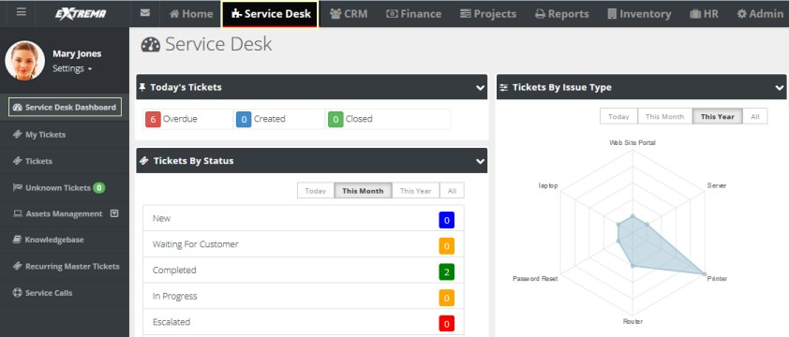See **Dashboard (Home)** for a description of general purpose dashlets that also display on this page.

## My Tickets

Home > My Tickets Service Desk > My Tickets

The **My Tickets** page manages tickets assigned to yourself as the *primary assignee*. If you assign the ticket to another employee, the ticket no longer displays on this page. Ticket assignments to queues are ignored by this page. You can search for all tickets assigned to the queues you are a member of using the **Queue** search parameter.

## Tickets

Service Desk > Tickets

The **Tickets** page manages tickets created for customer support issues. A support issue may be a question, a problem, a request for service, or a suggestion for a future enhancement.

Tickets are assigned to employees (technicians) and queues (groups of employees) to work on the support issue. The ticket helps track the progress of issue towards resolution. Based on billing agreements with each client, labor time entries can generate billable hours or deduct a pre-paid amount, or deduct retainer hours.

Tickets creation is initiated by:

* **Phone** - The client calls and a technician creates the ticket manually.
* **Email** - An email to support is converted into a ticket automatically.
* **Client Portal** - The customer creates the ticket manually.

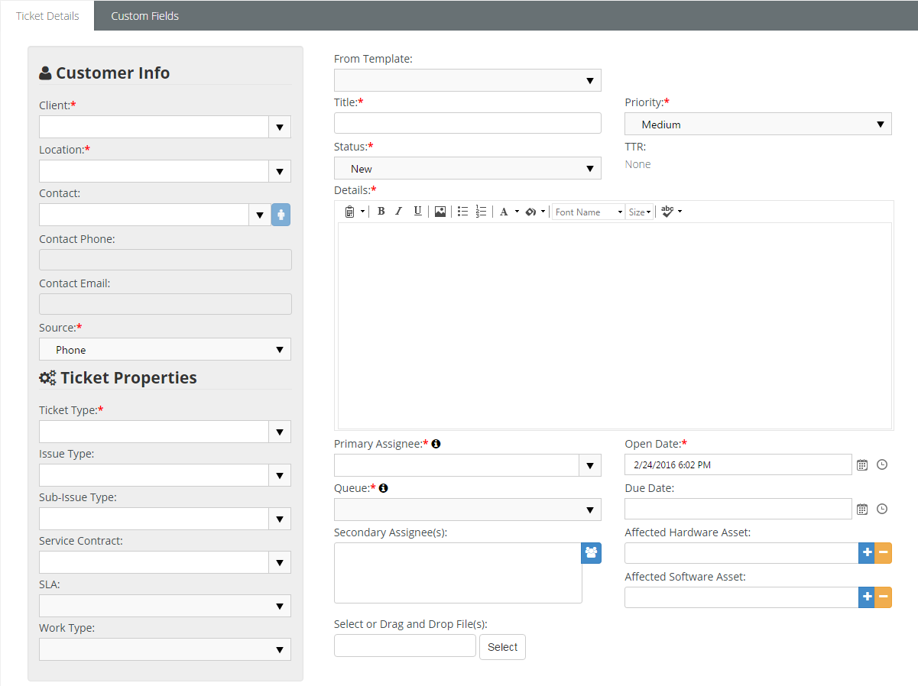

### Creating/Editing Tickets

Service Desk > Tickets

You can set any of the header fields of a new ticket when it is **New** or when you **Edit** the ticket.

##### Creating New Tickets Within CloudActiv8® SUPPORT

1. Select the Service Desk > **Tickets** page.
2. Click **New**.
3. You can pre-populate field values in the header of the ticket by selecting a **ticket template**

using the **From Template** drop-down list.

1. Enter the following in the Ticket Details > **Customer Info** panel.
   * Client
   * **Site**
   * **Contact**
   * **Contact Phone** - Defaults to the selected contact's phone number.
   * **Contact Email** - Defaults to the selected contact's email.
   * **Source** - The default source is maintained using the Admin > My Company > **Service Desk Settings** *(page* *22**)* tab.
2. Enter the following fields in the Ticket Details > **Ticket Properties** panel.
   * Ticket Type
   * **Issue Type**
   * **Sub-Issue Type**
   * **Service Contract** - The contract selected will determine how the labor is tracked on this ticket. If there is a default contract for tickets, it will automatically appear in this field. The default service contract are created using the Finance > **Contracts** page.
   * **SLA** - Displays the default service level agreement, if one is set, and allows you to assign one.
   * Work Type
3. Enter the following fields in the **Ticket Details** tab.
   * **Ticket Title** - A one line summary. Used to search tickets by title.
   * Ticket Priority
   * **Status** - New, Waiting for Customer, In Progress, Escalated, Assigned, Completed, Customer Responded. Defaults to New. Customize using the Admin > Service Desk Settings

> **Ticket Statuses** page.

* + **TTR** - Estimated time to the solution, in hours or minutes.
  + **Details** - Enter expanded description of the support issue.
  + **Primary Assignee** - The primary employee assigned to work this ticket.
  + **Open Date** - The date/time this ticket was created.
  + **Queue** - Assigns a ticket to queue. Employees assigned to a queue will see tickets assigned to the same queue displayed on their Home > **My Queues** page.
  + **Due Date** - The date/time the ticket is scheduled to be resolved.
  + **Secondary Assignees** - One or more employees also assigned to work this ticket. Secondary assignees can enter time and notes.
  + **Affected Hardware Asset** - Identifies a hardware asset affected by this issue. Records of a client's hardware assets are maintained using the Service Desk > Asset Management > **Hardware Assets** page.
  + **Affected Software Asset** - Identifies a software asset affected by this issue. Records of a client's software assets are maintained using the Service Desk > Asset Management > **Software Assets** page.
  + **Select or Drag and Drop Files** - Select files to attach to the ticket.

1. Click **Save**. See the following topics to maintain existing tickets:
   * **Adding Notes to Tickets**
   * **Processing Tickets**
   * **Adding Time to Tickets**
   * **Adding Expenses to Tickets** **Adding Charges to Tickets**
   * **Adding Service Calls to Tickets**
   * **Adding To-Dos to Tickets**
   * **Adding Related Tickets**
   * **Custom Fields, Attachments for Tickets**
   * **Batch Actions for Tickets**
   * **Unknown Tickets**

### Processing Tickets

Service Desk > Tickets

**Statuses**

Each ticket typically progresses through one or more statuses.

* A new install of SUPPORT provides the following statuses: New, Waiting for Customer, In Progress,

, Assigned, Completed, Customer Responded.

Escalated

* You can customize the list using the Admin > Service Desk Settings > **Ticket Statuses**

page.

* Three "system" statuses cannot be made inactive:

New, Waiting for Customer, and Completed.

* Tickets default to New.
* The **Tickets** and **My Tickets** list pages do not display Completed tickets by default. Clicking the

**Search** button without specifying any parameters includes Completed tickets.

**Actions**

Tickets support the following types of *actions*. Each action displays a dialog of additional settings.

* Audits
  + **Ticket Logs** tab - Displays a log of all changes to a ticket, by both *users* and *workflows*.
  + **Workflow Log** tab - Shows actions performed on a ticket by a workflow.
* Assign Ticket
  + **Status** - Changes the status of the ticket.
  + **Queue** - Assigns the ticket to a group of employees responsible for the ticket.
  + **Primary Technician** - Assigns an employee to the ticket.
  + Comments
* **Resolve Ticket**
  + **Status**
  + **Comments**
  + **Publish to Knowledge Base** - Yes or No - See **Knowledgebase**
* **Print Ticket** - Displays a printable PDF of the ticket.
  + With Notes
  + **With Time Entries**
  + **With Expenses**

**Business Processes**

Use the Admin > Business Process:

* **Email Templates** page to customize ticket email notifications.
* **Approval Routes** page to create approval items used in workflows.
* **Workflow** page to automate the processing of tickets.

##### Customer Info

When you first open a ticket, the **Ticket View** tab displays. Below the ticket title is the customer's name with a link. Click this link to show the **Customer Info** window with the following information:

* Name
* **Location**
* **Account Type**
* **Address**
* **Locate on Google Maps** - Click this link to show the address on Google Maps.
* Phone
* **Fax Number**
* **Contact Person**
  + **Name**
  + **Phone**
  + **Email**

**SLA Status**

On the **Ticket View** tab you will see both an **SLA** field and an **SLA Status** field. For tickets assigned an **SLA** *,*  the **SLA Status** field shows a link. Click this link to see the estimated and actual times specified for resolving the ticket by the SLA. The workflow assigned to a ticket can be used to specify when employees or customers should be notified, based on SLA benchmarks. The Waiting SLA State is time spent waiting for the customer to respond. SLA timers are paused while waiting for the customer to respond.

### Adding Notes to Tickets

Service Desk > Tickets > (selected ticket)

When you add notes to a ticket you can:

* Change the status of a ticket.
* Notify others of the note you're adding.
* Include an attachment with the note.

**Adding Notes to Tickets**

1. Select the Service Desk > **Tickets** page.
2. Click an existing ticket.
3. Click the **Activities** tab.
   * This same tab can be used to **Add Time** to a ticket.
4. Click **Add**.
   * **From Template** - Pre-populate field values in the note by selecting a **ticket note template**
   * Note Date
   * **Type** - The **ticket note type.**
   * **Status** - Optionally change the status of the ticket when this note is saved.
   * **Internal Note** - If Yes, this note is hidden from clients.
   * Details

* + **General Notes** - Optionally enter a note for this labor time entry that will display on the invoice.
  + **Internal Notes** - Optionally enter a hidden not that will not display the invoice.
  + Click **Save**.

### Adding Time to Tickets

Service Desk > Tickets > (selected ticket) > Time Logs

The **Time Logs** tab adds time to a ticket.

* Time log entries can be created with or without using a *timer*.
* Time entered on tickets automatically updates the user's timesheet.
* If linked to an active contract, time entered on a ticket can:
  + Create billable events for **Time & Materials**contracts
  + Deduct prepaid hours for **Retainer by Hours** contracts
  + Deduct prepaid amounts for **Retainer by Amount**contracts.
  + Track but not bill time for **Recurring Services** contracts.

**Adding Ticket Time Without Using a Timer**

1. Select the Service Desk > **Tickets** page.
2. Click an existing ticket.
3. Click the **Time Logs** tab.
4. Click **Add**.
   * **From Template** - Field values can be pre-populated by selecting a **ticket time entry template**
   * **Date Started** - The date this labor time started.
   * **Start Time** - The time this labor time started.
   * **Time Spent (hrs)** - The duration of hours worked.
   * **Role** - The **role**best describing the person performing this work. The role, and optionally the work time, determine the rate charged for billable hours.
   * **Work Type** - The **work type** best describing the work itself.
   * **Status** - Optionally change the **status** of the ticket when this time entry is saved. .
   * **General Notes** - Optionally enter a note for this labor time entry that will display on the invoice.
   * **Internal Notes** - Optionally enter a hidden not that will not display the invoice.
   * 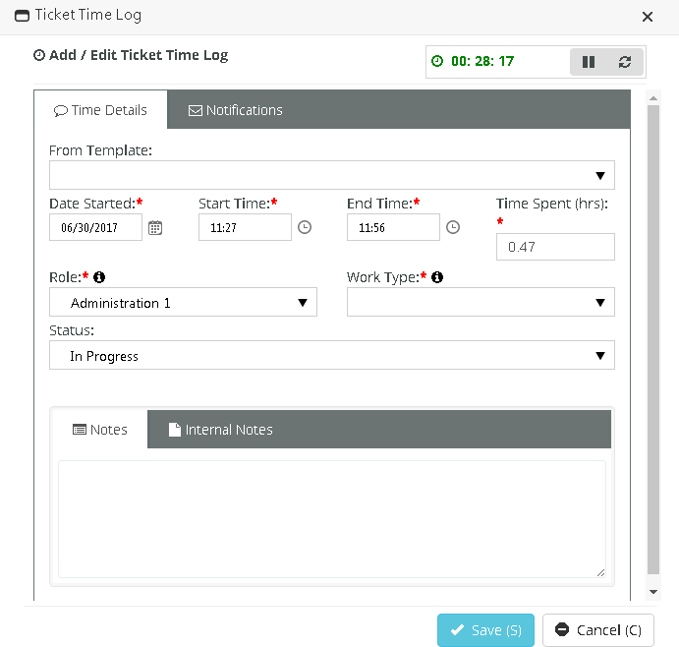Click **Save**.

##### Adding Ticket Time Using a Timer

You can start, stop and reset a timer when you open or edit a ticket. You can see the elapsed incrementing while you work the ticket. The elapsed time of a running timer populates the time log entry window when you open it and continues to update it while it runs.

You can configure the timer to start automatically whenever a ticket is opened by setting a Enable Stopwatch Auto start option to Yes. This option is located on the Admin > My Company > Company Settings > *Service* Desk tab.

1. Select the Service Desk > **Tickets** page.
2. Click an existing ticket.
3. Optional start, stop, reset the timer in the upper right corner.
4. Click the **Time Logs** tab.
5. Enter the following:
   * **From Template** - Field values can be pre-populated by selecting a **ticket time entry template**
   * **Date Started** - The date this labor time started.
   * **Start Time** - The time this labor time started.
   * **End Time** - The time this labor time ended.
   * **Time Spent (hrs)** - The duration of hours worked.
   * **Role** - The role best describing the person performing this work. The role, and optionally the work time, determine the rate charged for billable hours.
   * **Work Type** - The work type best describing the work itself.
   * **Status** - Optionally change the status of the ticket when this time entry is saved.
   * **General Notes** - Optionally enter a note for this labor time entry that will display on the invoice.
   * **Internal Notes** - Optionally enter a hidden not that will not display the invoice.
   * Click **Save**.

### Adding Expenses to Tickets

**Service Desk > Tickets > (selected ticket) > Expenses**

**Service Desk > Tickets > (selected ticket) > Expenses & Charges**

Expenses entered on tickets automatically update the user's expense sheets. Alternatively, users can enter an expense on an expense sheet and link it to a ticket. These can include:

* Expenses billed to customers.
* Expenses reimbursed by your company to the employee.

You can use pre-configured expense types to save time. You can also adjust the default amount for each expense.

##### Adding Expenses to a Ticket

1. Select the Service Desk > **Tickets** page.
2. Click an existing ticket.
3. Click the **Expenses** tab.
   * You can also add expenses using the **Expenses & Charges** tab. The same dialog displays either way.
4. Click **Add**.
5. Enter the following in the **Expense Info** tab.
   * Expense Type
   * **Date** - The date the expense was incurred
   * Amount Spent
   * **Mark Up / Down** - Adjust up or down by amount ($) or percent (%).
   * **Payment Types** - Check, Debit Card, Credit Card, Other, .

Company Credit Card

Cash,

* + **Classification** - Reimbursable or Non-Reimbursable
  + **Billable** - Yes or No
  + **Available Expense Sheets** - Select an existing expense sheet or add a new one.
  + **Add New Expense Sheet** - If checked, the following display:
    - New Expense Sheet Name
    - **New Expense Sheet Date**
  + **General Notes** - Optionally enter a note for this labor time entry that will display on the invoice.
  + **Internal Notes** - Optionally enter a hidden not that will not display the invoice.

1. Enter the following in the **Receipts** tab.
   * Upload a new file
   * **Have Receipt** - Yes or No
   * Notes
2. Enter the following in the **Notifications** tab.
   * Contact
   * **Resources**
   * **Email template to use**
   * **Other Emails**
3. Click **Save** to save the expense.
4. 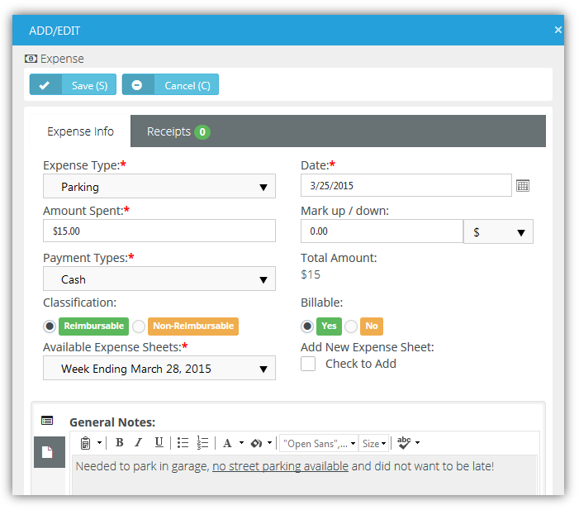Click **Save** to save the ticket.

### Adding Charges to Tickets

Service Desk > Tickets > (selected ticket) > Expenses & Charges

You can add charges to tickets that optionally:

* Are billable or not billable.
* Sells—or provides at no charge—products to your client, decrementing them from your inventory.
* Transfers the products to the client's **hardware assets** or **software assets.**

**Adding Charges to Tickets**

1. Select the Service Desk > **Tickets** page.
2. Click an existing ticket.
3. Click the **Expenses & Charges** tab.
4. Click **Add**.
5. Enter the following in the **Charge Info** tab.
   * Product
   * **Charge Name**
   * **Status** - Pending, Need to Order / Fulfill, Ready to Deliver / Ship, Cancelled. For reporting purposes only.
   * Price Level
   * **Purchase Date**
   * **Purchase Order**
   * **QTY**
   * **Price**
   * **Billable Amount**
   * **Description**
   * **Unit Cost**
   * **Total Cost**
   * **Billable** - Yes or No
   * **Create Multiple Items** - Yes or No - Selecting Yes for this option splits the total quantity into individual lines, each with a quantity of 1.
   * Optional review the **Stock Info** tab.
6. Enter the following in the **Receipts** tab.
   * Upload a new file
7. Click **Save** to save the charge.
8. Click **Save** to save the ticket.

### Adding Service Calls to Tickets

Service Desk > Tickets > (selected ticket) > Service Calls & To-Dos

The **Service Calls & To-Dos** tab adds service calls to a ticket.

* Each service call is added to the timesheet of the employee assigned that service call, for tracking purposes.
* Service calls are always non-billable.
* Service calls are first scheduled, then marked as complete after the service call has occurred.
* You can also manage service calls using the Service Desk > **Service Calls** page and within project tasks.
* You can see any unassigned service calls you create on your **My Service Calls**page.

**Adding Service Calls to Tickets**

1. Select the Service Desk > **Tickets** page.
2. Click an existing ticket.
3. Click the **Service Calls & To-Dos** tab and click **Add**.
4. On the **Service Call** tab:
   * Resource
   * **Start Date**
   * **End Date**
   * **Description** - The description is populated with some basic info.
     + Client
     + Location
     + Ticket Number
     + Ticket Title
5. On the **Notification** tab optionally enter:
   * **Resources** - Employees to be notified.
   * Email template to use
   * **Other Emails** - Other email recipients to be notified.
6. Click **Save**.

### Adding To-Dos to Tickets

Service Desk > Tickets > (selected ticket) > Service Calls & To-Dos

The **Service Calls & To-Dos** tab adds to-dos to a ticket. To-dos can be assigned to yourself or any other employee. To-dos provide each user with his or her own system-wide checklist of reminder tasks to perform, with due dates and completion states. Each user's entire to-do list displays on module dashboard pages.

**Adding To-Dos to Tickets**

1. Select the Service Desk > **Tickets** page.
2. Click an existing ticket.
3. Click the **Service Calls & To-Dos** tab click **Add**.
   * Client
   * **Location**
   * **Complete** - Yes or No
   * Start Date
   * **End Date**
   * **Description**
   * Click **Save**.

### Adding Related Tickets

Service Desk > Tickets > (selected ticket) > Related Tickets

The **Related Tickets** tab links other tickets with the current ticket. Clicking a related ticket opens the related ticket in a new window or tab, enabling you to work on both tickets in tandem. When you add a related link, links are created in both tickets.

### Custom Fields, Attachments for Tickets

Service Desk > Tickets > (selected ticket) > Custom Fields Service Desk > Tickets > (selected ticket) > Attachments

Additional ticket tabs include:

* Custom Fields
  + Enter values in the custom fields, as appropriate for this record.
  + Custom fields are maintained using the Admin > My Company > **Custom Fields**

page.

* Attachments
  + Lists all attachments for the ticket.
  + Click **Upload a new file** to upload files to this record. For example.

### Batch Actions for Tickets

Service Desk > Tickets Service Desk > My Tickets Home > My Tickets

The **Batch Actions** button on ticket search pages enables you to perform actions on multiple tickets at the same time. When you click the button, two options display:

* **Current Page** - Performs batch actions on tickets in the current page only.
* **All Pages (max 500)** - Performs batch actions on tickets in the current search context, up to 500 tickets at a time.

**Batch Tickets Wizard**

Clicking either of the options above displays a **Batch Tickets** wizard that steps you through the following choices:

* **Choose Tickets**
* **Choose Operation**
* **Operation Details**
* **Confirmation**

**Step 1 - Choose Tickets**

1. Select one or more tickets in the list to batch process.
2. Click **Next Step**.

##### Step 2 - Choose Operation

1. Select one of the following options.
   * **Update Tickets** - Updates selected fields in the tickets.
   * **Assign Tickets** - Assigns the tickets to an assignee and/or queue.
   * **Delete Tickets** - Deletes the tickets.
2. Click **Next Step**.

##### Step 3 - Operation Details

1. Complete the following, depending on the choice you made in step 2.
   * If **Update Tickets** was selected, you can update the following ticket fields.
     + Status
     + **Priority**
     + **Source**
     + **Issue Type**
     + **Sub Issue Type**
     + **Ticket Type**
   * If **Assign Tickets** was selected, you can change who the ticket is assigned to:
     + Change Primary Assignee
     + **Change Queue**
   * If **Delete Tickets** was selected, no detail choices are required.
2. Click **Next Step**.

##### Step 4 – Confirmation

1. Review the list of tickets that are about to be batch processed.
   * For **Update Tickets** and **Assign Tickets**, a list of the fields selected for updating shows the new values that will be assigned.
   * For **Delete Tickets**, a warning message displays before final confirmation.
2. Click **Confirm**.

### Unknown Tickets

Service Desk > Unknown Tickets

An **Unknown Tickets** page displays in the **Service Desk** module when an Admin > Service Desk > **Email Parser**receives email from an email address that is not recognized as belonging to any employee or company contact. Use the **Unknown Tickets** page to manually assign tickets to the appropriate customer account or delete them.

## Hardware Assets

**Service Desk > Asset Management > Hardware Assets**

The **Hardware Assets** page registers hardware owned by the client and located at client location. Hardware assets can be added using this page, or by **adding a charge to a ticket.**

**Adding Hardware Assets**

1. Select the Service Desk > Asset Management > **Hardware Assets** page.
2. Click **New**.
3. Enter the following in the **Asset Info** tab.
   * Name
   * **Category**
   * **Physical Location Info**
   * **Client**
   * **Client Location**
   * **Contact**
   * **Business Impact**
   * **State**
   * **Brand**
   * **Description**
4. Click to maintain/review the **Additional Info** tab.
   * Acquisition Date
   * **Expiration Date**
   * **Warranty Expiration Date**
   * **Purchase Cost**
   * **Bar Code**
   * **Vendor**
5. Click to maintain/review the **Asset Details** tab.
   * Manufacturer
   * **Serial**
   * **Model Number**
   * **Machine Group ID**
   * **Product Name**
   * **Machine Version**
   * **OS Type**
   * **OS Info**
   * **Version (Major | Minor)**
   * **Login Name**
   * **Last Login Name**
   * **Current User**
   * **First Check In**
   * **Last Check In**
   * **Last Reboot**
   * **Asset Tag**
   * **Max Memory Size**
   * **Max Memory Slots**
6. Click to maintain/review the **Network Details** tab.
   * IP Address
   * **Subnet Mask**
   * **Default Gateway**
   * **Mac Address**
   * **DNS Server(s)**
   * **Connection Gateway IP**
   * **Wins Enabled**: Yes or No
   * **DHCP Enabled**: Yes or No
   * Primary Wins Server
   * **Secondary Wins Server**
   * **DHCP**
7. Click to maintain/review the **Motherboard Info** tab.
   * Motherboard Manufacturer
   * **Motherboard Product Code**
   * **Motherboard Version**
   * **Motherboard Serial Number**
   * **Bus Speed**
8. Click to maintain/review the **Chassis Info** tab.
   * Chassis Manufacturer
   * **Chassis Type**
   * **Chassis Version**
   * **Chassis Serial Number**
   * **Chassis Asset Tag**
9. Click the **Custom Fields** tab.
   * Enter values in the custom fields, as appropriate for this record.
   * Custom fields are maintained using the Admin > My Company > **Custom Fields**

page

1. Click **Save**.

## Software Assets

Service Desk > Asset Management > Software Assets

The **Software Assets** page registers software owned by the client and located at a client location. Software assets can be added using this page, or by **adding a charge to a ticket.**

**Adding Software Assets**

1. Select the Service Desk > Asset Management > **Software Assets** page.
2. Click **New**.
3. Enter the following in the **Software Asset** tab.
   * Client
   * **Client Location**
   * **Contact**
   * **Name**
   * **Software Category**
   * **Version**
   * **Brand**
   * **Additional Location Info**
   * **Model Number**
   * **Description**
4. Click the following in the **Software License** tab.
   * License Name
   * **License Type**
   * **No. Of Licenses**
   * **Purchase Cost**
   * **Acquisition Date**
   * **Expiration Date**
   * **License Key**
   * **Description**
5. Click the **Custom Fields** tab.
   * Enter values in the custom fields, as appropriate for this record.
   * Custom fields are maintained using the Admin > My Company > **Custom Fields**

page.

1. Click **Save**.

##### Importing Software Assets

* Select the Service Desk > Asset Management > **Software Assets** page.
* Click **Import(I)**.
* Click **Download Template(T)**.
  + Enter values in the fields and save the template.
* Click **Select** and select import file from your directory.
* Click **Import(I)**.

## Knowledgebase

Service Desk > Knowledgebase

The **Knowledgebase** page manages knowledge base articles related to customer support issues. Typically knowledge base articles are started by copying them from an actual customer ticket **when the ticket is resolved**, then updating the article to serve as a general reference. You can also create a knowledge base article using this page.

* Each knowledge base article can be linked to one or more tickets.
* Each article can include attachments.
* You cannot browse for a knowledge base

**Creating New Knowledge Base Articles**

1. Select the Service Desk > **Knowledgebase** page.
2. Click **New**.
3. Enter the following in the **Articles** tab.
   * Title
   * **Category**
   * **Keywords**
   * **Publish Date**
   * **Details**
4. Select the **Related Tickets** tab.
   * Select one or more tickets.
   * Click **OK**.
5. Click **Attachments** tab.
   * Click **Upload a new file** to upload files to this record.
6. Click **Save**.

## Recurring Master Tickets

Service Desk > Recurring Master Tickets

The **Recurring Master Tickets** page creates a series of "child" tickets for a recurring support issue. For example, a maintenance service call might be required on a recurring basis for a hardware asset.

* You can create a series of service calls, with each service call linked to its own child ticket.
* You can link a recurring master ticket to a contract. When you do, each child ticket will be linked to that contract.
* Once the recurring master ticket is saved the first time, defaults on the **Defaults** tab cannot be changed.
* You can select any created child ticket from the **Tickets** tab of the recurring master ticket.
* You can create additional child tickets by extending the recurring time period on the **Recurrence**

tab. This is the only recurrence setting you can change.

**Creating New Recurring Master Tickets**

1. Select the Service Desk > **Recurring Master Tickets** page.
2. Click **New**.
3. Enter the following in the **Defaults** tab.
   * Title
   * **Client**
   * **Location**
   * **Main Branch**
   * **Contact**
   * **Primary Assignee**
   * **Queue**
   * **Issue Type**
   * **Sub-Issue Type**
   * **Ticket Type**
   * **Status**
   * **Priority**
   * **Medium**
   * **Work Type**
   * **Contract**
   * **Due Time**
   * **Estimated Hours**
   * **Affected Hardware Asset**
   * **Affected Software Asset**
   * **Ticket Details**
4. Select the **Recurrence** tab. Specify how many tickets to create in the series and the interval between them.

*Duration*

* + Start Date
  + **End After** <N> **occurrences**
  + **End On**

*Recurrence -* A recurrence can only be modified if it's incremental.

* + **Repeats** -weekly, Monthly, Yearly

Daily,

* + **Repeats** <periods>
  + **Repeats every** <N> <periods>

*for weekly* **Repeat on**

* + - Sun, Mon, Tue, Wed, Thu, Fri, Sat

*for monthly* **Repeat on**

* + - Day <N> of the month
    - The <N> <weekday> of the month

*for yearly* **Repeat on**

* + - Every <calendar_month> <day_of_month>
    - The <N> <weekday> of <calendar_month>

1. Select the **Service Calls** tab. Optionally create service calls, one for each ticket in the series.
   * **Create service calls** - Yes or No
   * Start Time
   * **End Time**
   * **Description**
2. Click the **Custom Fields** tab.
   * Enter values in the custom fields, as appropriate for this record.
   * Custom fields for the *Ticket Recurring Master* module are maintained using the Admin > My Company > **Custom Fields** page.
3. Click **Save**.
4. Click the new **Tickets** tab added to the recurring master ticket.
   * A series of child tickets are listed.
   * Click each ticket to view or work that individual ticket.
   * If service calls were created for each ticket, click the **Service Calls & To-Dos** tab inside the individual ticket to see it listed.
   * If a service contract was added to the recurring master ticket, each individual ticket is linked to this same contract.

## Service Calls

**Service Desk > Service Calls**

The **Service Calls** page creates and manages all service calls created throughout the system.

* Each service call is added to the timesheet of the employee assigned that service call, for tracking purposes.
* Service calls are always non-billable.
* Service calls are first scheduled, then marked as complete after the service call has occurred.
* Using a recurring master ticket you can create a series of child tickets and service calls, with each service call linked to its own child ticket.
* You can see any unassigned service calls you create on your **My Service Calls** page.

##### Adding Service Calls

You can add a Service Call:

* In a Task: see Service Calls topic.
* In a Ticket: see **Adding Service Calls to Tickets** topic.
* In a Dispatch Calendar: see **Dispatch Calendar** topic.

##### Editing a Service Call

1. Select the Service Desk > **Service Calls** page.
2. Select the Service call you would like to add. If the list is long, you narrow the search results by adding the following parameters:
   * Account
   * Start Date
   * End date
   * Complete (status)
   * Created By
   * Created On
3. Edit the following in the **Service Call** tab.
   * **Resource** - Select an employee.
   * **Complete** - Yes or No
   * Start Date
   * **End Date**
   * **Description**
4. On the **Notification** tab optionally enter:
   * **Resources** - Employees to be notified.
   * Email template to use
   * **Other Emails** - Other email recipients to be notified.
5. Click **Save**.

C h a p t e r 7

Projects

## Projects Dashboard

Projects > Projects Dashboard

The **Projects Dashboard** displayed in the **Projects** module provides instant access to projects and tasks requiring your attention. Drill into dashlet indicators to view lists of corresponding projects and tasks.

Specialized dashlets provided by the **Projects Dashboard** include:



* **My Open Projects** - Lists each project assigned to you as the project manager.
* **Project Vitals** - Projects Over Budget, Projects Over Hours, Unstaffed Projects - Click any count to display a list of projects in the **All Projects** page using this filter criteria.
* **Projects by Status** - Today, This Month, This Year, All - Displays a bar chart by project status.
* **Tasks Statistics** - Due Today, Due This Week, Due This Month - Click any count to display a list of tasks in the **All Tasks**page using this filter criteria.
* **Timesheets Statistics** - Opened, Submitted, Approved, Rejected

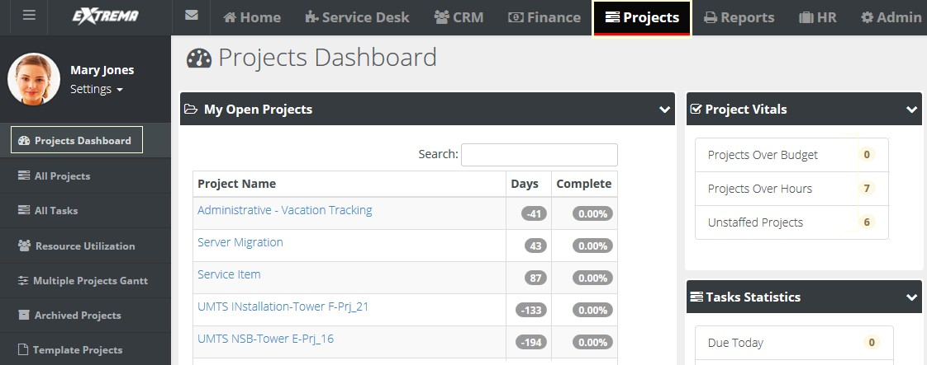See **Dashboard (Home)** for a description of general purpose dashlets that also display on this page.



## Projects

**Projects > All Projects**

Projects and tasks are often better suited than a ticket to track and manage more complex work efforts.

* The **All Projects** page lists all projects currently being used. Projects are removed from the page when **archived** . By default, the search filter does not include **template projects.**
* You can quickly create new projects by copying an existing project or template project.
* A SUPPORT project supports dependencies between tasks, unique deadlines for each task, and can coordinate the allocation of resources and service calls across multiple projects and tasks.
* Each project provides a complete financial summary of the costs and pricing associated with that project. All labor time entries, expenses and charges applied to a project are tracked by the **Finance** module for both billing and reporting purposes.
* Projects can be created from a service quotation and linked to a corresponding contract. The method used to bill a project depends on the contract linked to the project. If no contract is linked, the project is billed on a time and materials basis.
* Expenses can be entered for a project. Alternatively, users can enter an expense on a expensesheet and link it to a project.
* Products required to complete the project are entered using a charge. Charged products can be added to the customer hardware assets or software assets.

Once you create or select an existing project you add, maintain and view project details using the following tabs:

* Projects
  + **Financials**
  + **Related Opportunities**
  + **Expenses**
  + **Charges**
  + **Receipts**
  + **Custom Fields**
  + **Attachments**
* **Tasks**
  + **Basics**
  + **Members**
  + **Time Logs**
  + **Service Calls**
  + **Notes**
  + **Custom Fields**
  + **Attachments**

Some tabs are not available until the first time you save the project.

### Creating a New Project

**Projects > All Projects > New > Project**

You start a new project by entering general information in the **Project** tab.

##### Project Actions

* Copy Project - Copies the open project to new project
* **Archive Project** - **Archives the open project**

##### Creating a New Project

This procedure describes just the main **Projects** tab within a project. Child tabs are described in other topics.

1. Select the Projects > **All Projects** page.
2. Click **New**.
3. Enter the following in the **Project** tab.
   * Project Number
   * **Project Name**
   * **Client**
   * **Percent Done**
   * **PO# (Project Code)**
   * **Project Type**
   * **Status** - Defaults to Open. Users assigned to tasks are not allowed to enter time entries when the project status is set to Hold or Completed or Closed. Project managers can always add time regardless of the status.
   * Priority
   * **Project Assessment** - Classifies the risk level of this project.
   * Project Manager
   * **Department** - Department leading this project. You can run a projects by department report.
   * Project Management
   * **Contract** - If blank, this project is billed on a time and materials basis.
     + Contracts must be activated before they display in this drop-down list.
     + If both a contract and project were converted from a quotation, activating the contract automatically populates this field with the converted contract.
     + If multiple contracts and a project were converted from a quotation and the contracts activated, *ensure the correct contract is linked to the project.*
   * **Start Date** - The start date of the entire project. Once tasks are entered, this field is determined by the earliest start date of any task in the project. See **Scheduling Projects and Tasks**
   * **Planned End Date** - The planned end date of the entire project. Once tasks are entered, this field is determined by the latest end date of any task in the project.
   * **Actual End Date** - The actual end date of the entire project. You can manually maintain this date without being constrained by any tasks.
   * **Timesheet Route** - The timesheet approval route. If None, then timesheets are auto-approved.
   * **Expense sheet Route -** The expense sheet approval route. If None, then expense sheets are auto-approved.
   * Site
   * **Template** - Yes or No
   * **Allow Tasks on Weekends** - Yes or No
   * Project Description
4. Click **Save**. Additional tabs display after the first save.

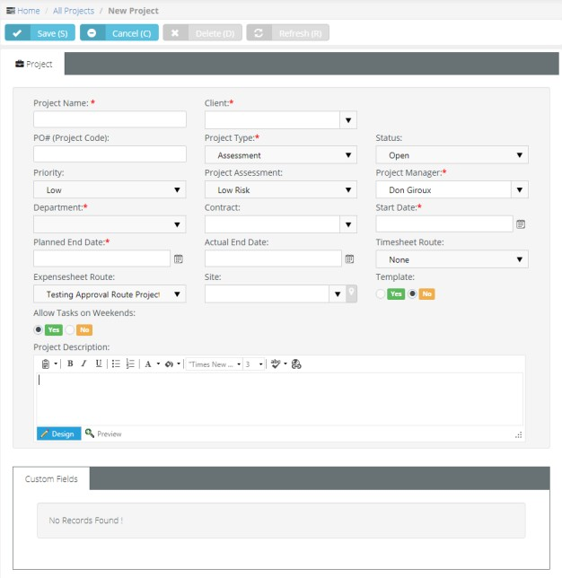

### Adding/Viewing Project Financials

Projects > All Projects > (selected project) > Financials

The **Financials** tab summarizes the costs and pricing associated with a project. All labor time entries, expenses and charges applied to a project are totaled in this tab and tracked by the **Finance** module for both billing and reporting purposes.

You can edit the following fields:

* Planned Budgets
* **Planned Hours**
* **PO Amount**
* **Cost Type**
* **Cost Center**

**Adding/Viewing Project Financials**

1. Select the Projects > **All Projects** page.
2. Click an existing project.
3. Select the Project > **Financials** tab.
   * **Planned Budget** - Estimated cost to complete the project.
   * **Used Budget Labor (Dollars)** - Auto-calculated. The number of *hours of labor* entered

*multiplied* by the wages of those employees.

* + **Used Budget Expenses (Dollars)** - Auto-calculated. The total of all expenses submitted for the project. Expenses are added to tasks by employees or added to the project by the project manager using the **Expenses** tab.
  + **Remaining Budget** - The total of **Planned Budget** minus the **Used Budget**.
  + **Percent Used (Budget)** - Auto-calculated.
  + **Planned Hours** - Estimated hours to complete the project.
  + **Used Hours** - Auto-calculated. Hours entered for the project's by employees.
  + **Remaining Hours** - The total of **Planned Hours** minus **Used Hours**.
  + **Percent Used (Hours)** - Auto-calculated.
  + **PO Amount** - Enter the monetary amount of this project as it appears on the purchase order provided by the client.
  + **Total Billing** - Estimated total billings for the project.
  + **Actual Billing** - Auto calculated.
  + Remained Unbilled
  + **Cost Type** - Define if project is CAPEX, OPEX, None or Client Billable.
  + Cost Center

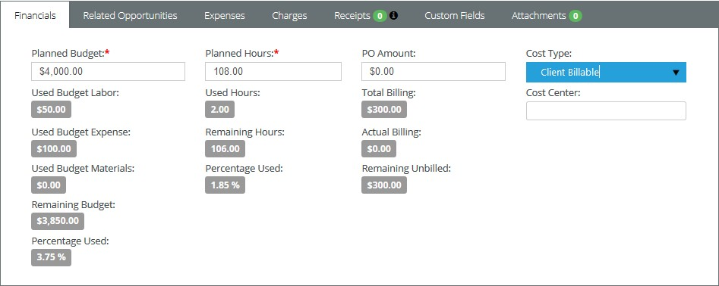

### 

### Adding Related Opportunities to Projects

**Projects > All Projects > (selected project) > Related Opportunities**

The **Related Opportunities** tab shows the links between a project and quotation and one or more opportunities. If a project was created by converting an opportunity into a service quotation, and then converting the service quotation into a project, these display as **Converted From** links.

**Adding Related Opportunities**

1. Select the Projects > **All Projects** page.
2. Click an existing project.
3. Select the Project > **Related Opportunities** tab.
4. Click **Add**.
   * Select one or more opportunities created for this same customer.
   * Click **OK**.
5. Click **Save**.

### Adding Expenses to Projects

Projects > All Projects > (selected project) > Expenses

Expenses entered on projects automatically update the user's expense sheets. Alternatively, users

can enter an expense on an expense sheet and link it to a project. These can include:

* Expenses billed to customers.
* Expenses reimbursed by your company to the employee.

You can use pre-configured expense types to save time. You can also adjust the default amount for each expense.

**Adding Expenses to a Project**

1. Select the Projects > **All Projects** page.
2. Click an existing project.
3. Click the Project > **Expenses** tab.
4. Click **Add**.
5. Enter the following in the **Expense Info** tab.
   * Expense Type
   * **Date** - The date the expense was incurred
   * Amount Spent
   * **Mark Up / Down** - Adjust up or down by amount ($) or percent (%).
   * **Payment Types** - Check, Debit Card, Credit Card, Other, .

Company Credit Card

Cash,

* + **Classification** - Reimbursable or Non-Reimbursable
  + **Billable** - Yes or No
  + **Available Expense Sheets** - Select an existing expense sheet or add a new one.
  + **Add New Expense Sheet** - If checked, the following display:
    - New Expense Sheet Name
    - **New Expense Sheet Date**
  + **General Notes** - Optionally enter a note for this labor time entry that will display on the invoice.
  + **Internal Notes** - Optionally enter a hidden not that will not display the invoice.

1. Enter the following in the **Receipts** tab.
   * Upload a new file
   * **Have Receipt** - Yes or No
   * Notes
2. Click **Save** to save the expense.
3. Click **Save** to save the project.

### Adding Charges to Projects

Projects > All Project > (selected project) > Charges

You can add charges to projects that optionally:

* Are billable or not billable.
* Sells—or provides at no charge—products to your client, decrementing them from your inventory.
* Transfers the products to the client's **hardware assets** or **software assets**

**Adding Charges to Tickets**

1. Select the Projects > **Project** page.
2. Click an existing ticket.
3. Click the Project > **Charges** tab.
4. Click **Add**.
5. Enter the following in the **Charge Info** tab.
   * Product
   * **Charge Name**
   * **Status** - Pending, Need to Order / Fulfill, Ready to Deliver / Ship, Cancelled. For reporting purposes only.
   * Price Level
   * **Purchase Date**
   * **Purchase Order**
   * **QTY**
   * **Price**
   * **Billable Amount**
   * **Description**
   * **Unit Cost**
   * **Total Cost**
   * **Billable** - Yes or No
   * **Create Multiple Items** - Yes or No - Selecting Yes for this option splits the total quantity into individual lines, each with a quantity of 1.
6. Optionally review the **Stock Info** tab.
7. Enter the following in the **Receipts** tab.
   * Upload a new file
8. Click **Save** to save the charge.
9. Click **Save** to save the project.

### Receipts, Custom Fields, Attachments for Projects

Projects > All Projects > (selected project) > Receipts, Custom Fields, Attachments

Additional child tabs on the **Projects** tab include:

* Receipts
  + Lists all expense receipts for the project.
* Custom Fields
  + Enter values in the custom fields, as appropriate for this record.
  + Custom fields are maintained using the Admin > My Company > **Custom Fields**

page.

* Attachments
  + Lists all attachments, for both the project and for specific tasks.
  + Click **Upload a new file** to upload files to this record. For example, a project proposal or statement of work.

### Copy Projects

Projects > All Projects > (selected project) > Copy Project

Use the Action > **Copy Project** button to quickly create new projects by copying an existing project or template project.

**Copying Projects**

1. Select the Projects > **All Projects** page.
2. Click an existing project.
3. Click Actions > **Copy Project**.
   * Original Project Name
   * **New Project Name**
   * **Start Date**
   * **Planned End Date**
   * **Additional Options**
     + Copy Tasks - Includes tasks, but not members.
     + Copy Tasks and Resources - Includes tasks and members.
     + None - Excludes tasks and members.
   * **Copy Tasks Status** - Yes or No
   * **Enforce Project End Date on Tasks** - If Yes, all tasks are scheduled within the **Start Date** and

**Planned End Date** you specify in the dialog. If No, the **Planned End Date** is reset, if necessary.

1. Click **Finish**. The newly copied project displays.

## Tasks

Projects > All Projects > (selected project) > Tasks

Within a selected project the **Tasks** tab maintains all the tasks for that project.

* A project usually comprises a series of shorter-duration **tasks**.
* You can define an unlimited number of tasks for each project.
* Tasks can be multi-level.
* Each task's start and end date must be within the start and end date of its parent task or project.
* Employees enter labor time for a task, not a project, so at least one task is required to log time. Time entered for a task is also entered in that employee's timesheet.
* Employees can be assigned to tasks and are called **Members** of the task. Tasks assigned to an employee display on the employee's **My Task** page and on the employee's timesheet, if the task and timesheet date ranges overlap.

**Four Types of Tasks**

There are four types of tasks you can include in a project:

* **Task** - A standard task.
* **Summary Tasks** - A container task. You cannot assign members and enter time for summary tasks. This supports the project convention of reporting actual work using the lowest level tasks in a project.
* **Clock Task** - Reserved for future use.
* **Milestones** - A zero duration task with only an end date. Milestone tasks mark the completion of a phase in a project. Milestone tasks are typically used with a **fixed priced** contract to trigger milestone payments. Enabling the **Alter From Project** option in a fixed price contract adds a milestone task to a linked project each time you add a new milestone payment to the contract.

### Using the Tasks Tab

Projects > All Projects > (selected project) > Tasks

The **Tasks** tab displays and manages all the tasks in your project.

**Project Actions**

* **Add Task** - **Adds a new task** *.* When you open a **standard**task the following tabs display:
  + **Basics** - **Sets general properties for a task.**
  + **Members** - **Assigns employees to a task.**
  + **Time Logs** - **Enters labor time.**
  + **Service Calls** - **Schedules a service call.**
  + **Notes** - **Add notes to a task.**
  + **Custom Fields** - **Updates custom fields.**
  + **Attachments** - **Adds attachments.**
* **Import Tasks** - Imports tasks from an Excel spreadsheet into a project. You can download a template to guide you on how to format your data for import.
* **Gantt Chart** - Displays all tasks as a Gantt chart. See **Adding Task Dependencies.** See

**Multiple Projects Gantt** *.*

* **Batch Actions** - **Updates task by batch**within the project.

**Task Actions**

* **Edit Task** - Click the task icon— —to **edit an existing task.**
* **In-Line Edit** Click  to enable in-line editing of cells in a selected row. Click  to save your inline edits.
  + Task name
  + **Duration**
  + **Start Date**
  + **End Date**
  + **Plan Hrs**
  + **Status**
  + **% Done**
* **Add Dependency Click ** enter a **dependency**between the selected row any other row.
* **Add Sub-Task** - Click  add sub-task to the currently selected task.
* **Delete** - Click  to delete the task.
* **Expand/Collapse** - Click and to toggle the expansion/collapse of a selected row's child tasks.
* **Move** - Drag and drop a  to move a task.

### Adding Task Basics

Projects > All Projects > (selected project) > Tasks > Add Task > Basics

The **Basics** tab provides general information about a task.

**Adding Task Basics**

This procedure is based on a standard **Task** .

1. Select the Projects > **All Projects** page.
2. Select an existing project.
3. Select the **Tasks** tab.
4. Click **Add Task**.
5. Select **Task**. This is a *standard* **task.**
   * Task Name
   * **Status** - New, Open, In Progress, Completed, Closed. Set to Open to allow employees to enter time. A program manager can always enter time, regardless of the status.
   * Used Hours
   * **Percent Used**
   * **Cost Type**
     + (blank) - None.
     + Capex - Capital expense.
     + Oper ting expense.

Opex

* + - Client Billable
  + Planned Hours
  + **Percent Done**
  + **Work Type**
  + **Duration (Days)** - The number of days between the **Start Date** and **End Date**.
  + **Start Date** - The *planned start date* of this task. See **Scheduling Projects and Tasks**
  + **End Date** - The *planned end date* of this task.
  + Task Description

1. Click **Save** to save the task.
2. Click **Save** to save the project.

### Scheduling Projects and Tasks

Projects are scheduled from the *project start date*. Initially you set the project start date and project planned end date manually. Once you start adding tasks:

* The earliest start date for any task in the project determines the entire project's start date.
* The latest end date for any task in the project determines the entire project's planned end date.
* You can manually maintain an *actual end date* for the entire project without being constrained by any tasks.

When working with task date ranges, you'll notice that:

* The start date and end date of a new task defaults to either its parent task, if it has one, or to the start date and planned end date for the entire project.
* Manually changing the start date of a task causes the task end date to shift, *preserving the same duration for the task.*
* Manually changing the end date of a task causes the task duration to change, *preserving the start date of the task.*
* Making tasks *dependent* enables you to shift the dates for an entire series of tasks at one time. See **Adding Task Dependencies**. Dependencies also enable you to schedule backwards if you like, from the last task in a series of tasks to the first task in that series.

When working with the date ranges of parent tasks and child tasks:

* Parent task date ranges cannot be adjusted manually. The date range for a parent task is determined by the date ranges of its child tasks. The same is true for multiple levels of parent tasks.

### 

### Adding Members to Tasks

Projects > All Projects > (selected project) > Tasks > (selected task) > Members

The **Members** tab assigns one or more employees to a task. Tasks assigned to an employee:

* Display on the employee's **My Task** page.
* Display on the employee's timesheet, if the task and timesheet date ranges overlap and Admin >

**Time Sheet** > **Preload Timesheets** is enabled.

* Display on the **Resource Utilization** page.

**Constraining Employee Hours for a Task**

For each task you can *constrain:*

* The number of **Hours** a specific employee is allowed to enter for a task. If **Hours** is set to zero, any number of hours can be entered.
* The **Role** a specific employee must use when entering time for a task. If set to ALL, the employee can select any role enabled for his or her employee record.

##### Adding Task Members

This procedure is based on a standard **Task** .

1. Select the Projects > **All Projects** page.
2. Select an existing project.
3. Select the **Tasks** tab.
4. Select an existing task.
5. Click the **Members** tab.
6. Click **Add**.
   * Select an employee.
   * Click **OK**.
7. Change the role from ALL, if more than one role can be selected.
8. Click the clock  icon in the **Hours** cell.
   * The **From Date** and **To Date** default to the start and end date of the task. These date ranges are for forecasting and employee calendars only. They do not constrain when an employee can enter time.
   * Enter the number of **Hours** this employee is allowed to enter for this task.
   * Clicking the **Populate Periods** button enables you to quickly add a series of time periods:
     + Daily Recurring Periods
     + **Weekly Periods**
     + **Monthly Periods**
     + **Monthly Periods**
9. Click **Save** to save the **Members** tab. 10.Click **Save** to save the project.

### Adding Time to Tasks

Projects > All Projects > (selected project) > Tasks > (selected task) > Time Log

The **Time Logs** tab adds time to a task.

* Time log entries can be created with or without using a *timer*.
* Time entered on a task automatically updates the user's timesheet.
* If linked to an active contract, time entered on a task can:
  + Create billable events for **Time & Materials** contracts
  + Deduct prepaid hours for **Retainer by Hours** contracts
  + Deduct prepaid amounts for **Retainer by Amount** contracts.
* Track but not bill time for **Recurring Services** contracts.
* These procedures are based on a standard **Task**

.

**Adding Time to a Task Without Using a Timer**

1. Select the Projects > **All Projects** page.
2. Click an existing project.
3. Select the **Tasks** tab.
4. Click an existing task.
5. Click **Add**.
6. Click the **Time Logs** tab.
   * **Date Started** - The date this labor time started.
   * **Start Time** - The time this labor time started.
   * **End Time** - The time this labor time started.
   * **Time Spent (hrs)** - The duration of hours worked.
   * **Role** - The employee's **role** when performing the work. The role, and optionally the work time, determine the rate charged for billable hours.
   * **Work Type** - The type of **work** performed.
   * **General Notes** - Optionally enter a note for this labor time entry that will display on the invoice.
   * **Internal Notes** - Optionally enter a hidden not that will not display the invoice.
7. Click the **Notifications** tab.
   * Resourses
   * **Email templates to use**
   * **Other emails**
   * Click **Save** to save the time entry.
8. Click **Save** to save the **Time Logs** tab.
9. Click **Save** to save the task.
10. Click **Save** to save the project.

##### Adding Time to a Task Using a Timer

1. Select the Projects > **All Projects** page.
2. Click an existing project.
3. Select the **Tasks** tab.
4. Click an existing task.
5. Click the **Time Logs** tab.
6. Click **Start Timer**.
   * A new green row displays.
   * The **Start Timer** is replaced by a **Stop Timer** button.
   * You may close the ticket and return later.
7. Click **Stop Timer**. The **Time Details** tab displays. Enter the following:
   * **Date Started** - The date this labor time started.
   * **Start Time** - The time this labor time started.
   * **End Time** - The time this labor time started.
   * **Time Spent (hrs)** - The duration of hours worked.
   * **Role** - The **role** best describing the work performed. The role, and optionally the work time, determine the rate charged for billable hours.
   * **Work Type** - Another way of classifying the **work** performed.
   * **General Notes** - Optionally enter a note for this labor time entry that will display on the invoice.
   * **Internal Notes** - Optionally enter a hidden not that will not display the invoice.
8. Click the **Notifications** tab.
   * Resourses
   * **Email templates to use**
   * **Other emails**
   * Click **Save** to save the time entry. The green row no longer displays.
9. Click **Save** to save the **Time Logs** tab. 10.Click **Save** to save the task.

11.Click **Save** to save the project.

### Adding Service Calls to Tasks

Projects > All Projects > (selected project) > Tasks > (selected task) > Service Calls

The **Service Calls** tab adds service calls to a task.

* Each service call is added to the timesheet of the employee assigned that service call, for tracking purposes.
* Service calls are always non-billable.
* Service calls are first scheduled, then marked as complete after the service call has occurred.
* You can also manage service calls using the Service Desk > **Service Calls** page and within tickets.
* You can see any unassigned service calls you create on your **My Service Calls** page.

**Adding Service Calls to Tasks**

This procedure is based on a standard **Task** .

1. Select the Projects > **All Projects** page.
2. Click an existing project.
3. Select the **Tasks** tab.
4. Click an existing task.
5. On the **Service Calls** tab click **Add**.
6. On the **Service Cal**l tab enter the following:
   * Resource
   * **Start Date**
   * **End Date**
   * **Description** - The description is populated with some basic info.
     + Client
     + Project Number
     + Project Name
     + Task Name
7. On the **Notification** tab optionally enter:
   * **Resources** - Employees to be notified.
   * Email template to use
   * **Other Emails** - Other email recipients to be notified.
8. Click **Save**.
9. Click **Save** to save the task. 10.Click **Save** to save the project.

### Adding Notes to Tasks

**Projects > All Projects > (selected project) > Tasks > (selected task) > Notes**

The **Notes** tab adds notes to a task.

##### Adding Notes to Tasks

This procedure is based on a standard **Task** .

1. Select the Projects > **All Projects** page.
2. Click an existing project.
3. Select the **Tasks** tab.
4. Click an existing task.
5. Click **Add Note**.
   * Note Date
   * **Details** - Enter a note for this task.
   * Click **Save** to save the note.
6. Click **Save** to save the task.
7. Click **Save** to save the project.

### Custom Fields, Attachments for Projects

Projects > All Projects > (selected project) > Tasks > (selected task) > Custom Fields, Attachments

Additional tabs for each task include:

* Custom Fields
  + Enter values in the custom fields, as appropriate for this record.
  + Custom fields are maintained using the Admin > My Company > **Custom Fields**

page.

* Attachments
  + Lists all attachments for task.
  + The Project > **Attachments** tab displays all attachments, for both the project and for all tasks.
  + Click **Upload a new file** to upload files to this record. For example, a statement of work.

### Adding Task Dependencies

Projects > All Projects > (selected project) > Tasks >

The **Dependency ** dialog enables you to define a dependency between a selected task and one or more other tasks.

**Dependencies**

Adding a dependency to a task makes its scheduling dependent on the "other" task.

* If you change the date range of the *other* task, the dependent task will change automatically to accommodate the change.
* If you change the date range of the *dependent* task, the dependency is removed.
* A task can be dependent on multiple other tasks.

##### Dependencies in the Gantt Chart

Click the **Gantt Chart** button after setting a dependency. Dependencies are identified by an arrow running between the tasks. The arrowhead points to the dependent task.

**Four Types of Dependency**

Dependencies are classified from the point of view of the dependent task looking towards the "other" task.

* Finish-to-Start (FS) - The other task's *finish* determines the dependent task's *start*. This is the most common way to set a dependency between two tasks.
* Start-to-Start (SS) - The other task's *start* determines the dependent task's *start*.
* Finish-to-Finish (FF) - The other task's *finish* determines the dependent task's *finish*.
* Start-to-Finish (SF) - The other task's *start* determines the dependent task's *finish*. This is the least common way to set a dependency between two tasks.

##### Lag Days

Lag days shift the *dependent* task forward in time (positive) or backward in time (negative) from the *other* task. The result either causes a scheduling gap between the two tasks, or an scheduling overlap. Lag days do not change the scheduling of the *other* task.

##### Setting a Task Dependency

1. Select the Projects > **All Projects** page.
2. Click an existing project.
3. Select the **Tasks** tab.
4. Click the  icon for a task and enter the following:
   * Row
   * **Task**
   * **Type** - Defaults to Finish-to-Start (FS).
   * Lag Days
   * Click **OK**.
5. Click **Gantt Chart** to view the dependency.
6. Click **Save** to save the project.

### Updating Tasks by Batch

Projects > All Projects > (selected project) > Tasks > Batch Actions

**Batch Actions** enables you to update several tasks at once. A two step wizard prompts you to:

* Select tasks.
* Select an action.

**Running Batch Actions**

1. Select the Projects > **All Projects** page.
2. Click an existing project.
3. Select the **Tasks** tab.
4. Click **Batch Actions**.
5. Select tasks on the **Choose Tasks** tab.
6. Select one of the following actions to perform on the **Choose Action** tab.
   * **Slide Tasks** - Slide dates forward or backward by a specific number of days or months for selected tasks.
     + **Slide** - Forward or Backward
     + **Slide Dates** - Start Dates, End Dates, Start & End Dates
     + **Duration** - <N> <periods>
   * **Assign Members** - Assign selected users to selected tasks.
   * **Remove Members** - Remove selected users from selected tasks.
   * **Delete Tasks** - Delete selected tasks and their related data.
   * **Update Status** - Update the status of selected tasks.
     + **New Status** - Select as status.
   * **Update Percentage** - Update percentage of selected tasks.
     + **New Percentage** - Select as status.
7. Click **Finish**.
8. Click **Save** to save the project.

### All Tasks

Projects > All Tasks

The **All Tasks** page lists all tasks in all projects currently being used. Click a task to display only the details of that task. This enables you to rapidly update a series of tasks in multiple projects, without having to open each project separately.

When you open a **standard**task the following tabs display:

* **Basics** - **Sets general properties for a task.**
* **Time Logs** - **Enters labor time.**
* **Service Calls** - **Schedules a service call.**
* **Notes** - **Add notes to a task.**
* **Custom Fields** - **Updates custom fields.**
* **Attachments** - **Adds attachments.**

**Additional Guidelines**

* All project managers can view all tasks in all projects using the **All Tasks** page
* The **Members** tab is hidden when a task is opened using the **All Tasks** page.
* Tasks are removed from the **All Tasks** page when their corresponding projects are **archived**.

## Resource Utilization

Projects > Resource Utilization

The **Resource Utilization** page shows a timeline of each employee's scheduled task assignments. Click any task to to edit that task.

The resource allocation bar for each employee displays line segments in three colors.

* - Indicates this employee has available hours to allocate to a task.
*  - Indicates this employee has been assigned too many hours. Over-utilization occurs when:
  + The same employee is scheduled concurrently for multiple tasks.
  + The employee is assigned too many hours, even for a single task.
* - Indicates this employee is assigned hours, but not yet fully allocated.

The page displays resource utilization by **Week**, **Month** or **Year**. Use the search bar to filter the page by specific users, department, start date or end date.

## Multiple Projects Gantt

**Projects > Multiple Projects Gantt**

The **Multiple Projects Gantt** page shows a timeline of all projects and tasks. Click any task to to edit the **Title**, **Start**, **End** and **Completion** percentage for that task. You can also use this page to check for gaps and overlaps between projects. The page displays by **Week**, **Month** or **Year**. Use the search bar to filter the page by project, start date or end date.

## Archived Projects

Projects > Archive Projects

The **Archived Projects** page maintains archived projects. All project data remains intact. You can unarchive a project at any time. Archiving a project removes it from the following pages:

* Projects Dashboard
* **All Projects**
* **Multiple Projects Gantt**

**Archiving a Project**

1. Open a project on the Projects > **All Projects** page.
2. Click Actions > **Archive Project**.

**Unarchiving a Project**

1. Open a project on the Projects > **Archived Projects** page.
2. Click Actions > **Unarchive Project**.

## Template Projects

Projects > Template Projects

The **Template Projects** page maintains template projects. By default, the search filter only displays template projects. Billables cannot be entered for project templates. Project templates do not display the **Time Log** and **Expenses**tabs. Changes to template projects to not update projects after they are copied.

If billables are already entered for a project and the project is converted to a template, then the data is preserved. If the template project is converted back to a project, the billable data redisplays.

**Converting a Project to a Project Template**

1. Select the Projects > **All Projects** page.
2. Click the **Project** tab.
3. Set the **Template** option to Yes.
   * Set this option to No to convert a project template to a project.
4. Click **Save**.

##### Copying Projects from Template Projects

1. Select the Projects > **Template Projects** page.
2. Click an existing template project.
3. Click Actions > **Copy Project**.
   * Original Project Name
   * **New Project Name**
   * **Start Date**
   * **Planned End Date**
   * **Additional Options**
     + Copy Tasks - Includes tasks, but not members.
     + - Includes tasks and members.

Copy Tasks and Resources

* + - None - Excludes tasks and members.
  + **Copy Tasks Status** - Yes or No
  + **Enforce Project End Date on Tasks** - If Yes, all tasks are scheduled within the **Start Date** and

**Planned End Date** you specify in the dialog. If No, the **Planned End Date** is reset, if necessary.

1. Click **Finish**. The newly copied project displays.

C h a p t e r 8

**Inventory**

## Inventory Dashboard

Inventory > Inventory Dashboard

The **Inventory Dashboard** provides instant access to inventory activities requiring your attention. Drill into dashlet indicators to view lists of corresponding inventory activities.

Specialized dashlets provided by the **Inventory Dashboard** include:

* **Purchase Order Amount By Status** - Today, This Month, This Year, All - Displays a bar chart of purchase order amounts by status.
* **Purchase Orders By Status** - Today, This Month, This Year, All - Displays a list of purchase order counts by status.

See **Dashboard (Home)** for a description of general purpose dashlets that also display on this page.

## Manage Products

**Inventory > Products > Manage Products**

The **Manage Products** page lists all the inventory-managed products in your company. Once a product record is created you can:

* Assign and adjust quantities of products in inventory storage locations.
* Procure products using purchase orders.
* Add products to tickets as charges.
* Add products to tickets as charges.
* Add products to sales orders.

**Products and UPC Codes**

Each product can have multiple UPC codes created for it. Each **Product** and **UPC Code** record is maintained separately, using the following set of tabs.

* UPC
* **Suppliers** - You must add a supplier to a product record before you can create a purchase order for that supplier to deliver that product. The cross-reference includes the default unit cost for the product from that supplier.
* Locations
* **Pricing Levels**
* **Composition**
* **Options**
* **Stock By Location**
* **Stock By Project**
* **Notes**
* **Custom Fields**
* **Attachments**

The parent **Product Info** tab is shared by all combinations of products and UPS codes.

##### Creating Product Records

1. Select the Inventory > Products > **Manage Products** page.
2. Click **New**.
3. Enter the following on the **Product Info** tab.
   * Product Name
   * **Product Number**
   * **Product Type**
   * **Product Category**
   * **Product Sub Category**
   * **Brand**
   * **Manufacturer**
   * **Product Description**
4. Enter the following on the **UPC** tab.
   * **UPC** - Click the gear icon to generate a new universal product code.
     + You can also click the **Add New UPC** to add an additional UPC code.
   * **Maximum Level** - *Not yet implemented.* When **Autogen PO** is set to Yes on the **Options** tab and the stock level for this product drops to equal or below the **Reorder Level**, a purchase order is automatically created to replenish inventory to the **Maximum Level**.
   * **Warranty**
   * **SKU/Unique ID**
   * **Optimal Level**
   * **Expense Account**
   * **Width**
   * **Low Level**
   * **Income Account**
   * **Height**
   * **Reorder Level** - *Not yet implemented.* When **Autogen PO** is set to Yes on the **Options** tab and the stock level for this product drops to equal or below the **Reorder Level**, a purchase order is automatically created to replenish inventory to the **Maximum Level**.
   * Cost Code
   * **Length**
   * **Stacking**
   * **Pack**
   * **Weight**
   * **Color**
   * **UOM** - Units of measure.
5. Click **Save** to save this product record.
   * Additional product tabs display.
6. Click the **Suppliers** tab. Click **Add**. For each supplier enter:
   * **Supplier** - You must add a supplier to a product record before you can create a purchase order for that supplier to deliver that product. The cross-reference includes the default unit cost for the product from that supplier.
   * Primary Contact
   * **Product Id/Part No**
   * **Unit Cost**
   * **Reorder Qty**
   * **Tax Rate**
7. Click the **Pricing Levels** tab. Click **Add**. For each pricing level enter:
   * Pricing Level
   * **Price**
8. Click the **Composition** tab. Click **Add**. For each composition enter:
   * Material
   * **Qty**
   * **UOM** - Unit of measure.
   * Notes
9. Click the **Composition** tab. Click **Add**. For each composition enter:
   * Material
   * **Qty**
   * **UOM** - Unit of measure.
   * Notes
10. Click the **Options** tab.
    * **Autogen PO** - *Not yet implemented.* When Yes and the stock level for this product drops to equal or below the **Reorder Level**, a purchase order is automatically created to replenish inventory to the **Maximum Level**.
    * **Prelabeled** - Yes or No
    * **Requires Procurement** - If No, you do not need a purchase order to add quantities to storage locations for this product. Intended for temporary items.
    * **Use Levels** - Yes or No
    * **Serialized** - Yes or No
    * **Assembly Req'd** - Yes or No
    * **Discontinued** - Yes or No
    * **Hazardous** - Yes or No
    * **Taxable** - Yes or No
11. Click the **Stock By Location** tab.
    * Review the current quantity stored in each warehouse location list. 12.Click the **Stock By Project** tab.
    * Review the current quantity stored in each warehouse location list, allocated to a project. 13.Click the **Notes** tab. Click **Add** to add a note.
12. Click the **Custom Fields** tab.
    * Enter values in the custom fields, as appropriate for this record.
    * Custom fields are maintained using the Admin > My Company > **Custom Fields**

page.

1. Click **Attachments** tab.
   * Click **Upload a new file** to upload files to this record. 16.Click **Save** to save this product and UPC code record.

## Product Availability

Inventory > Products > Manage Products

Use the **Product Availability** page to check the quantities available for each product and UPC code combination. Selecting a row shows two tabs.

* **Product by Location** - Shows the quantity available at each location for the selected product.
* **Product by Project** - Shows the quantity available at each location, grouped by project, for the selected product.

The parent **Product Information** tab displays the following:

* Product Number
* **Product Name**
* **UPC**
* **Product Description**
* **Product Type**
* **Category**
* **Sub Category**
* **Brand**
* **Manufacturer**
* **QTY In Stock**
* **QTY Available**
* **QTY Committed** - The quantity committed to pick orders.
* QTY On Order
* **Low Level**
* **Re-Order Level**
* **Max Level**
* **Optimal Level**

## Purchase Orders

**Inventory > Procurement > Purchase Orders**

The **Purchase Orders** page creates an order to purchase products from a supplier. The purchase order includes product quantities, an expected delivery date, the delivery location, and prices for each product in the purchase order. On delivery the inventory storage quantities are incremented. Payment terms usually specify an agreed to number of days after delivery for payment. The supplier sends an invoice, which is matched against the delivery record, then processed by your company to pay the supplier.

**Product/Supplier Cross-Reference**

A supplier must be added to the **Manage Products** > **Supplier** tab, before you can create a purchase order for that supplier to deliver that product. The cross-reference includes the default unit cost for the product from that supplier.

##### Creating New Purchase Orders

1. Select the Inventory > Procurement > **Purchase Orders** page.
2. Click **New**.
3. Enter the following on the **New Purchase Order** tab. Notice this tab does not yet identify the supplier.
   * (PO) Date
   * **Ship Method**
   * **Payment Term**
   * **(PO) Expected Date**
   * **Location**
   * **Default Discount**
   * **Reference #**
   * **Project**
   * **Notes**
4. Click **Add** on the on the **Purchase Order Item** tab.
   * Select one or more **Products**.
   * Click **OK**.
   * **QTY** - Enter the quantity to order for each time. You can also specify this later.
5. Click **Continue** in the upper right corner of the page.
   * **Suppliers** who are eligible to deliver the products you added to your purchase order are listed in the upper panel of the page.
   * If no suppliers are eligible to deliver the products you added in the previous page, that product cannot be included in the creation of purchase orders.
   * Click the **Select Lowest Cost** button in the lower panel to list each item and the suppliers who can deliver them. The lower cost supplier for each product is selected by default.
   * Optionally change the selected supplier for each item. For example, you may wish to consolidate the creation of POs by selecting the fewest number of suppliers possible.
6. Click **Create POs**.
   * The message box lists the newly created purchase order numbers.
   * The status of the newly created purchase orders is New.
7. Open a purchase order you just created.
   * A **Supplier Info** panel displays in the header of the purchase order.
   * A **PO #** field has been added to the header. It cannot be edited.
8. Optionally adjust the editable fields for each item in the **Purchase Orders Items** tab. A **Grand Total**

displays at the bottom of this tab.

* + Qty
  + **Unit Cost**
  + **Discount**
  + **Tax**

1. Click the **Purchase Order Charges** tab click **Add**.
   * Charge
   * **Currency**
   * **Amount**
   * **Date**
   * **Notes**
   * Click **Save**.
2. Click the **Custom Fields** tab.
   * Enter values in the custom fields, as appropriate for this record.
   * Custom fields are maintained using the Admin > My Company > **Custom Fields**

page.

1. Click **Attachments** tab.
   * Click **Upload a new file** to upload files to this record. 12.Click **Save**.

## Processing Purchase Orders

Inventory > Procurement > Purchase Orders

**Statuses**

Typically each purchase order progresses through one or more of the following statuses:

* New
* Ready to Send
* Sent
* Partially Received
* Received
* Fully Received
* Voided

**Actions**

Clicking the **Action** button sets the appropriate status for the purchase order and usually displays a dialog or window for you to complete the action or review the results.

* **Generate Order** - Creates a printable purchase order. Sets purchase order to Ready to Send.
* **Print Order** - Displays a printable PDF of the purchase order.
* **Email Order** - Sends the PDF to email recipients. Sets purchase order status to Sent.
* **Void Order** - Cancels the order. Partially Received and Received orders cannot be voided nor regenerated.

Messages confirm an action has completed successfully.

##### Processing Purchase Orders

1. Select the Inventory > Procurement > **Purchase Order** tab.
2. Click a purchase order with a **Status** of New.
3. Click Actions > **Generate Order**.
   * The **Status** is set to Ready to Send.
4. Click Actions > **Print Order**.
   * Review the PDF to ensure it is correct.
   * If necessary, make changes to the purchase order, regenerate and review the PDF again.
5. Click Actions > **Email Order**.
   * Email Template
   * **Send Email** - Separate Recipients or Combined Recipients
   * **Contacts** - Check to include.
   * **Other Email** - Enter email addresses manually.
   * **Attachments** - Optionally check to *include*.
   * Click **Send**.
   * The **Status** is set to Sent.
6. Click **Save**.
   * See **Receiving Purchase Orders**

## Receiving Purchase Orders

Inventory > Fulfillment > Receiving Purchase Orders

The **Receiving Purchase Orders** page processes receipt of inventory quantities requested by a purchase order. Each *receiving order* is assigned a unique order number. There may be multiple receiving orders created for a single purchase order, one for each separate delivery by the supplier. A purchase order must be Sent to the supplier to display on this page.

**Receiving Location**

Received inventory is received into a warehouse's default "virtual location". The location is identified by the **warehouse prefix** and word Default. For example, W105_:Default.

##### Statuses

Typically each receiving order progresses through one or more of the following statuses:

* Open - No item quantities have been received.
* Partially Received - Some item quantities have been received.
* Fully Received - All item quantities have been received.
* Received - Receiving is finished for this receiving order, regardless of whether it is currently Partially Received or Fully Received. Typically used to prevent further receiving quantities on a partially received order.

**Actions**

Clicking the **Action** button sets the appropriate status for the receiving order.

* **Finish Receiving** - The receiving order status is set to Received.

##### Creating Receiving Orders

1. Select the Inventory > Fulfillment > **Receiving Purchase Orders** page.
2. Select an existing purchase order with an **RO Status** of Open.
3. Note the following on the **Receiving Order** tab.
   * Supplier
   * **Contact**
   * **Contact Phone**
   * **Contact Email**
   * **Currency**
   * **RO #**
   * **(PO) Order #**
   * **Order Date**
   * **(PO) Order Expected Date**
   * **Notes**
4. On the **Receiving Order Items** tab click a row to record receipt of the item quantity.
   * For a *non-serial controlled* quantity enter the following:
     + **Qty Received** - Enter the quantity received for this item. You can compare the quantity entered with the quantity ordered and quantity already received in the header of this dialog.
     + **Lot #** - The lot number, if item quantities are lot tracked.
     + Reference #
     + **Expiry Date** - Enter if the inventory has a shelf life expiration date.
     + Notes
     + Click **OK**.
   * For a *serial controlled* quantity enter the following *for each item*.
     + Serial #
     + **Lot #**
     + **Expiry Date**
     + **Reference**
     + **Notes**
     + Click **OK**.
5. Click **Save** to save the receiving order.

## Deliver Product Charges

Inventory > Fulfillment > Deliver Product Charges

The **Deliver Product Charges** page processes the delivery of product quantities demanded by associated tickets or projects. By default product deliveries consume inventory. You can optionally populate the list of hardware assets or software assets with the product quantities delivered.

**Listing Product Charge Deliveries**

You must first create product charges in tickets or projects. Then on this page:

1. Click **Search Product Charges**.
2. Click **Search**.
3. Optionally filter the list by entering a string in the **Result** field.
4. Optionally review the history of previous deliveries for any one row by clicking the history  icon.

##### Delivering Product Charges

1. For a selected delivery, click the truck  icon.
2. Enter the following:
   * Delivery Method
   * **Delivered By**
   * **Delivery Date**
   * **QTY In Stock** - The stock available in inventory to deliver.
   * **QTY Delivered** - The quantity already delivered.
   * **QTY To Deliver** - Accept or modify the quantity to be delivered.
   * **Remove From Inventory** - Yes, No
   * **Create Asset** - None, Hardware, Software

## Stock Adjustments

Inventory > Stock Adjustments

The **Stock Adjustments** page adjusts the quantity of inventory shown by the system to be available in warehouse locations. It's a quick way:

* Initialize inventory quantities.
* Correct inventory inaccuracies discovered during cycle job counts. Each stock adjustment references a single warehouse.

**Statuses**

Stock adjustments progress through the following statuses:

* Open - The stock adjustment is new and unposted.
* Posted - The stock adjustment has been posted.

##### Actions

Clicking the **Action** button sets the appropriate status for the stock adjustment.

* **Post Adjustments** - Sets the stock adjustment record to Posted.

##### Adjusting Inventory Stock Levels

1. Select the Inventory > **Stock Adjustments** page.
2. Click **New**.
3. Enter the following in the **Adjustment** tab.
   * Adjustment #
   * **Warehouse**
   * **Created Date**
   * **Posted Date**
   * **Notes**
4. Click **Save** to save the stock adjustment record.
5. Click **Add** on the **Inventory Items** tab.
   * Select one or more products.
   * Click **OK**.
6. Enter the following for each item:
   * New Qty
   * **Reason**
7. Click **Save** to save your stock adjustment record.
8. Click the Action > **Post Adjustments**.
   * The stock adjustment is Posted.
   * Item quantities are adjusted in the warehouse you specified.

C h a p t e r 9

**Home**

Every user in the system has access to the **Home**. It’s the starting point for day to day use. Your security role determines what **Home** options you have.

## Dashboard (Home)

Home > Dashboard Admin > Dashboard HR > Dashboard



All modules have a dashboard to display important data. The **Administrator Dashboard** tracks important events and activities, not necessarily identified as a ticket or project or CRM activity.

1. Click the **Admin** module on the far right of the *global navigation bar*.



1. Click **Admin Dashboard**, the first selection on the *local navigator bar* on the left.





* **My To Do List** - A place to set reminders. For example: stop by HR and get benefit change form. Enter text, then click the calendar and set the date, or simply enter the word tomorrow. Press the **Enter** key on your keyboard to add the entry. To Dos created for a ticket display the name of the ticket along with a link. You can click the link to access the ticket immediately.
* **My Notes** - A quick summary of thoughts or ideas that you don’t want to forget during the day.
* **News** - **Company news**generated from the **Admin** module.

##### Sharing

If user has the rights, he or she can use the system to share information such as events, announcements, and news.

##### Removing My To-Do List Items

The user can remove items in the **My To-Do List** by clicking the red X in the **Already Done** tab and clicking on the red X. The user can reset the **My To-Do List** by clicking the yellow arrow, if an item was completed by mistake.

##### Deleting

The user can simply erase **My Notes** *by highlighting the words* and selecting delete on the keyboard.

## Views

Home > Views

A *view* is a user-defined filtered search of a specific *list page*. The **Views** page shows all views created by yourself or shared with you by others. Selecting a view selects both the specific list page and the search filter parameters saved with that view.

**Creating a View**

To create and save a new view by name on any *list page*:

1. From the **Views** combo box, select an existing view, or enter new search parameters from scratch.
2. Click the gear  icon, then click the **Save As** option, then enter a name.
3. Optionally make your view **Public** or set it be your **Default** for the page you're working with.

**Working with Views**

* You can **Save**, **SaveAs**, **Edit**, **Delete**, or **Share** your own view.
* You can **SaveAs** a view shared by someone else.
* When you **Share** your own view, you can select both individual **employees**or **queues**

*(page* *54**)* of service desk employees to share it with.

##### Column Chooser

All list pages display a **Column Chooser** icon. Click the icon to select and order your column choices for a list page. You can then optionally save it as a view or export the data.

##### Export

All list pages support the ability to **Export** the Current Page or All Pages to an .xls format file.

Only currently displayed columns are exported in the order they are displayed. Use the **Column Chooser** to add,

remove or reorder columns before exporting.

## My Queues

Home > My Queues

The **My Queues** folder displays one or more queues if you are a member of any ticket queues. A ticket is assigned to a queue using the Service > Tickets > **Ticket Details** tab. You can search for all tickets assigned to the queues you are a member of using the **Queue** search parameter on the **My Tickets**page.

Employees are added to ticket queues using the:

* Admin > Service Desk > **Queues** page.
* HR > Employee > **Associated Queues** tab.

If you are not assigned to any queues, the **My Queues** folder does not display in your **Home** module.

## My Tickets

Home > My Tickets Service Desk > My Tickets

The **My Tickets** page manages tickets assigned to yourself as the *primary assignee*. If you assign the ticket to another employee, the ticket no longer displays on this page. Ticket assignments to queues are ignored by this page. You can search for all tickets assigned to the queues you are a member of using the **Queue** search parameter.

## My Tasks

Home > My Tasks

The **My Tasks** page enables you to update tasks assigned to you by project managers of projects. You can enter time and update other properties of tasks. A task may have child tasks you can update as well. Time entered on tasks updates your timesheet as well. This page does not display tasks of archived projects.

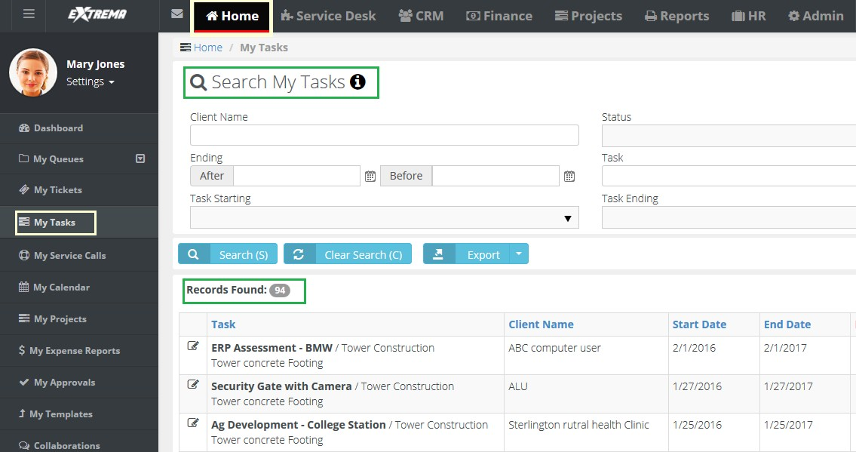



## My Grouped Tasks

**Home > My Grouped Tasks**

The **My Grouped Tasks** page lists all tasks you are assigned to *by project first, then by task*.

The **My Grouped Tasks** page enables you to update tasks assigned to you by project managers of projects. You can enter time and update other properties of tasks. A task may have child tasks you can update as well. Time entered on tasks updates your timesheet as well. This page does not display tasks of archived projects.

## My Service Calls

Home > My Service Calls

The **My Service Calls** page enables you to update service calls created to assist customers. Service calls are usually associated with one or more tickets or tasks, but can also be scheduled independently. You can see any unassigned service calls you create on your **My Service Calls** page.

## My Calendar

**Home > My Calendar**

The **My Calendar** page provides a calendar view of all your scheduled SUPPORT events.

* Appointments
* **Activities**
* **Tasks**
* **To-Dos**
* **Service Calls**

**Options**

* You can hide all events for a category by clicking its button off.
* Calendar views include: Day, Work Week, Month, Timeline.
* You can add a new *appointment* by clicking anywhere in the calendar. Enter the following:
  + Subject
  + **Start Time**
  + **End Time**
  + **Reminder**
  + **Description**
  + **Recurrence** - Click to enter recurring appointment options.
* Click the **Export Calendar** button to download an "icalendar" file for importing into other calendar software packages.
* Click the **Download Outlook Extension** to download an **Outlook Extension** that synchronizes your SUPPORT calendar with your Outlook calendar.

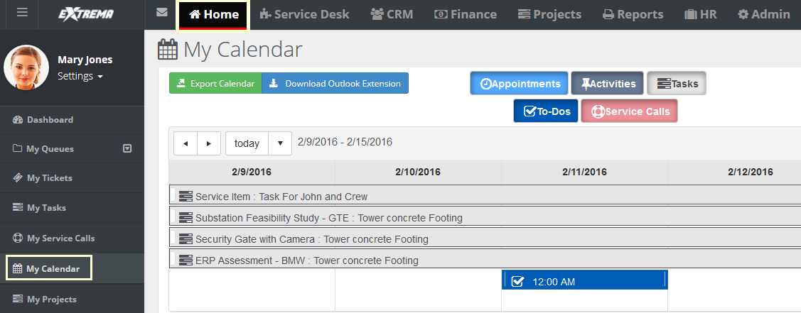



### 

### Outlook Extension

Home > My Calendar

The **Outlook Extension** synchronizes your SUPPORT calendar with your Outlook calendar. This includes:

* Appointments
* **Activities**
* **Tasks**
* **To-Dos**
* **Service Calls**

**Installing the Extension**

1. In SUPPORT, select the Home > **My Calendar** page.
2. Click **Download Outlook Extension**.
3. Run the installer on the computer containing your Outlook application.
4. Start Outlook.
   * A new tab displays in your Outlook application.
5. Enter the following in the Settings > **Login** tab.
   * User Name
   * **Password**
   * **Company Name**
   * Click **Save**.

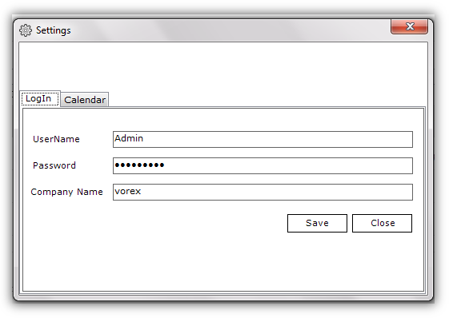

1. Set your preferences on the **Calendar** tab.
   * Enable Calendar Integration
   * **Get Past Calendar Items**
   * **Get Future Calendar Items**
   * **When Opening Outlook**
   * **Calendar Options**
   * **Tasks**
   * **CRM Activities**
   * **To-Dos**
   * **Enable Automatic Update Every <N> Minutes**
   * Click **Save**.
     + 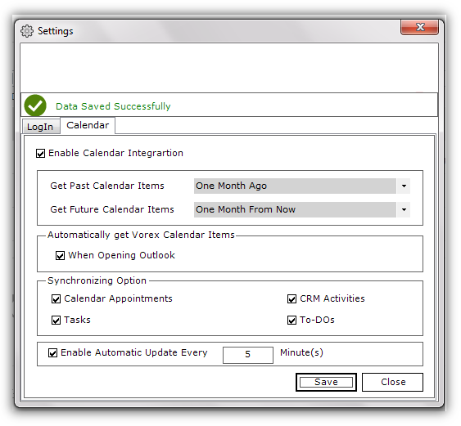A 'data saved' confirmation message displays.

## My Projects

Home > My Projects

The **My Projects** page enables you to update the projects you are assigned to as project manager.

## My Expense Reports

Home > My Expense Reports

The **My Expenses** page enables you to maintain all your expenses, no matter where they are entered in the system. This includes expenses for tickets and tasks. You can also enter expenses without linking them to tickets or tasks, such as for your own company's expenses.

You can enter expense entries for any date on any expense report. You are required to enter a date in the header of the expense report but the date does not restrict you.

**Approving Expense Reports**

Submitted expense reports can be manually approved or auto approved.

* If your company uses **approval routes**, submitted expense reports display in the **My Approval** folder of the appropriate persons for review. The submitted expense report is then approved or rejected.
* If your company does *not* use approval routes, the submitted expense report is auto approved.
* The **Approval History** tab shows the history of submitted expense reports.

##### Statuses

An expense report can have the following statuses.

* Open
* Submitted
* Approved
* Rejected

A Submitted or Approved expense report cannot be edited. A Rejected expense report can be subsequently Submitted and Approved.

##### Notification

You are notified about approvals and rejections in several ways.

* A message displays in the Settings > **My Messages** inbox.
* You may also receive an email message.
* The status of the expense report will show Approval or Rejected.

##### Actions

* Print Expense Sheet
* **Submit for Approval**

**Adding Expenses**

1. Select the Home > **My Expense Reports** page.
2. Click **New**.
3. Enter the following in the **Expense Sheet Info** tab.
   * Name
   * **Date**
   * **Notes**
4. Enter the following in the **Expense Info** tab.
   * Expense Type
   * **Date** - The date the expense was incurred
   * Amount Spent
   * **Mark Up / Down** - Adjust up or down by amount ($) or percent (%).
   * **Payment Types** - Cash, Check, Debit Card, Credit Card, Other, Company Credit Card.
   * **Classification** - Reimbursable or Non-Reimbursable
   * Notes
   * **Billable** - Yes or No
   * Expense Associated with
     + **Project** - Select a project.
     + **Ticket** - Select a ticket.
     + **Internal Expense** - Expenses are added internally.
5. Enter the following in the Expense Entries > **Receipts** tab.
   * Upload a new file
   * **Have Receipt** - Yes or No
   * Notes
6. Click **Save** to save the expense report.

## My Approvals

**Home > My Approvals**

The **My Approvals** page approves or rejects timesheets and expense reports submitted by employees on two separate tabs. If you are not an approver, or submitted timesheets and expense reports are auto approved, the **My Approvals** page does not display in your **Home** module.

Your designation as an *direct* approver or *secondary* approver is defined using the Admin > Business Process > **Approval Routes** page. There are separate approval routes for Expenses and Timesheets.

##### Notification

You are notified about submitted timesheets and expense reports in several ways.

* A message displays in the Settings > **My Messages** inbox.
* You may also receive an email message.
* The **My Approval** page lists timesheets and expense reports waiting to be approved or rejected.

##### Approving or Rejecting Timesheets and Expense Reports

1. Select the Home > **My Approvals** page.
2. Click **Timesheet Approvals** tab.
3. Select submitted timesheets in the **Direct Approvals** or **Secondary Approvals** sections.
4. Click **Approve Selected** or **Reject Selected**.
   * If you reject the selected rows, you can include an explanatory note. Rejected timesheets can be subsequently submitted for approval.
5. Select the **Expense Reports** tab.
6. Repeat steps 3 and 4 for expense reports.

## My Templates

Home > My Templates

The **My Templates** page enables you to maintain your own set of ticket templates. To make ticket creation easier, when you create a ticket, you can select one of your ticket templates to pre-populate selected fields for you.

Ticket templates can include adding questions in the description field of the ticket. These questions can then prompt ticket editors to ask these standard questions when contacting customers.

Your ticket templates can be shared with other team members. If you don't share a ticket template, it can only be viewed by yourself and SUPPORT administrators.

**Creating Tickets Templates**

1. Select the Home > **Ticket Templates** page.
2. Click **New**.
3. Select one of three types of ticket template.
   * **Ticket Templates** - Defines custom templates for tickets. You select this type of template using the **From Template** field when adding a new ticket.
   * **Ticket Note Templates** - Defines custom templates for notes in tickets. You select this type of template using the **From Template** field when adding a note to a ticket.
   * **Ticket Time Entry Templates** - Defines custom templates for time log entries in tickets. You select this type of template using the **From Template.**
   * **ate** field when adding a time log entry to a ticket.
4. Enter values in each of the fields provided.
   * These will serve as default field values when you create a new ticket, note, or time entry, based on this template.
5. Click **Save**.

## Collaborations

Home > Collaborations

The **Collaborations** page maintains discussion threads about a project, shared with all project team members. Project team members include the project manager and any employees assigned to be members of a task. You can create new thread topic at any time.

**Creating Project Discussions Threads**

1. Select the Home > **Collaboration** page.
2. Select a project.
3. Select **New Thread** to create the first comment in the thread.
   * Subject
   * **Type** - Question, Reply, Information, News
   * Content
   * Click **Save**.
4. Once you create a comment, you can optionally select the following **Actions**:
   * **Edit** - Changes a comment you created.
   * **Comment** - Replies to this specific comment.
   * **Delete** - Deletes the comment.
5. As another user reading this thread, you can click **Reply** to create a new comment for the entire thread.

## My Timesheet

Home > My Timesheets

The **My Timesheets** page maintains your timesheets. Timesheets are saved automatically after you add or change time entries.

* Timesheets include all the time entries you enter anywhere in the system. This includes time entries for tickets and tasks.
* You can also enter timesheet entries without linking them to tickets or tasks, such as for administrative tasks. Work types for classifying administrative tasks are defined using the Admin

> My Company > **Administrative Work** page.

* A timesheet specifies a weekly date range when it is created, always starting on the same day of the week. Each user can only have one timesheet for each weekly date range.
* Timesheets are automatically created the first time a time entry is created within that timesheet's weekly date range. Or you can manually create a timesheet for a new weekly date range, before any entries have been created.
* The scheduling pattern for creating timesheets is specified using the Admin > Company Settings

> **Time Sheet** tab. This same page sets whether future and past timesheets can be viewed.

* If **Preload Timesheets** is Yes on the **Time Sheet** tab then scheduled events on ticket and tasks will preload any future timesheets you create. If No, then only actual time entries display on timesheets.
* If your administrative task timesheet entries are similar from one week to the next, you can save time by copying a timesheet to a new weekly date range. Ticket and task timesheet entries will not be include.
* If you attempt to add a task that is closed or on hold, then 0 time is shown allotted. You cannot change this.

**Approving Timesheets**

Submitted timesheets can be manually approved or auto approved.

* If your company uses **approval routes**, submitted timesheets display in the **My Approval** folder of the appropriate persons for review. The submitted timesheet is then approved or rejected.
* If your company does *not* use approval routes, the submitted timesheet is auto approved.
* The **Approval History** tab shows the history of submitted timesheets.

##### Statuses

An timesheet can have the following statuses.

* Open
* Submitted
* Approved
* Rejected

A Submitted or Approved timesheet cannot be edited. A Rejected timesheet can be subsequently

Submitted and Approved.

##### Notification

You are notified about approvals and rejections in several ways.

* A message displays in the Settings > **My Messages** inbox.
* You will also receive an email notification.
* The status of the timesheet will show Approval or Rejected.

##### Actions

* **Add Tasks** - Adds time entries to tasks in projects.
* **Add Admin Tasks** - Adds administrative work tasks.
* **Submit for Approval** - Submits the timesheet for approval.
* **Print Timesheet** - Creates a PDF of the timesheet.
* **Copy Timesheet** - Copies administrative task timesheet entries to a new timesheet with a different weekly date range. Ticket and task time entries are not copied.

##### Adding Timesheets

1. Select the Home > **My Timesheet** page.
2. Click **New**. A **Create Timesheet** dialog displays.
   * **Select Week Range** - You can only select a weekly date range that does not yet exist for your user account.
   * Click Create.
   * A blank timesheet display, since this is a new timesheet.
3. Click **Add Admin Tasks**.
   * Select the **Training** task. The administrative work task is added to the timesheet.
   * Enter hours for at least one day of the week.

Click **Add Tasks**.

* + Select a project task.
  + Enter hours for at least one day in the project task. See **Adding Time to Tasks.**
  + The timesheet is saved automatically.

## Dispatch Calendar

Home > Dispatch Calendar

The **Dispatch Calendar** page provides a calendar view of all employee scheduled SUPPORT events. Event types can include:

* Appointments
* **Activities**
* **Tasks**
* **To-Dos**
* **Service Calls**

**Actions**

* **Employee calendar filtering** - By default you see your own calendar and the calendars of all subordinate employees that report to you. You filter the list of employee calendars displayed by:
  + Resource
  + **Queue**
  + **Event Type**
* **Employee calendar time selection** - Change the scale of calendar time displayed using the Day, Work Week, Month, Timeline options. You can also jump to a date by using the date picker.
* **Add appointments** - Click a date for a single employee to add a new appointment.
  + Subject
  + **Start Time**
  + **End Time**
  + **Reminder**
  + **Description**
  + **Recurrence** - Click to enter recurring appointment options.
* **Dispatch Actions** - Click this link to display:
  + **Dispatch Only** - Displays only employee dispatch calendars.
  + **View Tickets** - Displays a ticket search list. Select a view to filter the ticket list.
* **Adding Service Calls to Tickets** - When **View Tickets** is selected, you can drag and drop a specific ticket on to an employee's calendar date. Doing so opens the **service call** dialog. Enter additional details for the service call, then click **Save**. The new service call now displays in the **Dispatch Calendar**, employee's **My Service Calls**page, and in the corresponding ticket.

## Adjust Timesheets

**Home > Adjust Timesheets**

Use the **Adjust Timesheets** page to adjust the timesheets of any employee. *Access to this page is determined by your assigned security role.*

By default the page lists all timesheets for all users. Enter search parameters to filter the list.

* Week Start, From, To
* **Week End**, **From**, **To**
* Status
* **Employee Name**

Click any timesheet row to adjust timesheet entries. See **My Timesheet**for details about editing timesheet entries.

## Adjust Expenses

Home > Adjust Expenses

Use the **Adjust Expenses** page to adjust the expenses of any employee. *Access to this page is determined by your assigned security role.*

By default the page lists all expense reports for all users. Enter search parameters to filter the list.

* Name
* **Status**
* **Date**, **From**, **To**
* Last Update, From, To
* **Employee Name**

Click any expense report row to adjust expense report entries. See **My Expense Reports** for details about editing expense report entries.

## Downloads

Home > Downloads

The **Downloads** page provides connector tools you can use to integrate and synchronize data between SUPPORT and external applications.

Click any of the **Download** buttons to download these tools to your local machine.

* *QuoteWerks Connector* - For more information see the **QuoteWerks Integration Guide**
* *QuickBooks Sync* - For more information see **Quickbooks Sync**
* *Outlook Sync* - For more information see **Outlook Extension**

C h a p t e r 1 0

**Client Portal**

The **Client Portal** module enables customers to log into the SUPPORT system and track their own SUPPORT issues.

## Enabling Client Portal Access

**Client Portal** access is enabled using a **Contacts** record of a CRM account.

##### Configuring Client Portal Access

1. Select the CRM > **Contacts** page.
2. Select a contact record to edit.
3. Click the **Client Portal Access** tab.
4. Set the **Has Client Portal Access** to Yes.
5. Enter a **User Name** the contact will use to logon to **Client Portal**.
6. Select a **Security Role**. There are two built-in security roles you can use immediately that have access to the **Client Portal** module enabled.
   * External User - Allows the client to view/edit their own profile and messages, as well as tickets assigned to them.
   * External Manager - Allows the client to view/edit their own profile and messages. Also allows the client to view all of their account's tickets, contracts and invoices.
7. Click **Save**.

## Client Portal Dashboard

Client Portal > Client Portal Dashboard

The **Client Portal Dashboard** help customers manage their activities in the SUPPORT system. Dashlets include:

* **My To Do List** - A place to set reminders. For example: check on certification for site install. Enter text, then click the calendar and set the date, or simply enter the word tomorrow.
* **My Notes** - A quick summary of thoughts or ideas that you don’t want to forget during the day.
* **News** - Company news.

**Removing My To-Do List Items**

The user can remove items in the **My To-Do List** by clicking the red X in the **Already Done** tab and clicking on the red X. The user can reset the **My To-Do List** by clicking the yellow arrow, if an item was completed by mistake.

##### Deleting

The user can simply erase **My Notes** *by highlighting the words* and selecting delete on the keyboard.

## My Tickets (in Client Portal)

Client Portal > My Tickets

The **My Tickets** page manages tickets assigned to you as the **Contact Person** of your customer organization. If you create a new ticket using this page, the ticket is assigned to you as the customer **Contact Person** by default.

When you open an existing ticket:

* The **Ticket View** displays general properties of the ticket.
* You can also click **Add Note** to add a note for support to read.
* You may also see notes about this ticket for you, as the customer contact, to review and possibly act on.

**Quick Tickets**

**Security roles** have a **Client Portal** option called **Quick Tickets**. When checked in a security role, customers are presented with a simplified page layout when adding new tickets. If unchecked, customers are presented with the same page layout that employees see.

##### Creating a New Ticket

1. Select the Client Portal > **My Tickets** page.
2. Click **New**.
3. Enter the following in the **Quick Add Ticket** page.
   * Site
   * **Ticket Type**
   * **Priority**
   * **Issue Type**
   * **Sub-Issue Type**
   * **Affected Hardware Asset**
   * **Affected Software Asset**
   * **Attach File**
   * **Title** - A one line summary of the issue.
   * **Details** - A longer description of the issue.

## My Profile (in Client Profile)

Client Portal > My Profile

The **My Profile** section enables you to personalize your SUPPORT client portal experience.

* Sets your SUPPORT photo.
* Displays your personal ticket counts.
* Stores your personal information and contact information.
* Changes your password.
* Sets your default landing page when you login.

**Reviewing My Profile**

1. Select the Settings > **My Profile** page.
2. Review the **Personal Information** tab.
   * Reset (Photo)
   * **Select Photo** - jpg, jpeg, png, gif
   * Your Ticket Statistics
     + **Opened**
     + **Resolved**
   * **User Name**
   * **E-mail**
   * **First Name**
   * **Last Name**
3. Optionally change your password using the **Change Password** tab.
   * Old Password
   * **New Password**
   * **Confirm New Password**
4. Optionally change the default landing page using the **Preferences** tab.

## My Messages (in Client Profile)

Client Portal > My Messages

Customer contacts can use the **My Messages** page to send and receive messages with SUPPORT support personnel and other customer accounts contacts. These messages are not linked to tickets.

When you receive new messages from support personnel, you will see an envelope icon  with a count of unopened tickets in the upper left hand corner, indicating messages are waiting for you.

**Actions**

* **Compose Message** - Creates a new message.
* **Reply** - Replies to receives message.
* **Archive/Archived** - Move selected messages to the **Archived** folder.
* **Delete** - Deletes selected messages.
* **Inbox** - Moves selected messages to the Inbox folder.
* **Starred** - This folder lists messages that have the star toggled on.
* **Save/Draft** - Saved unsent messages are stored in the **Draft** folder.

## Tickets (in Client Portal)

Client Portal > Tickets

The **Tickets** page manages all tickets in your customer organization, regardless of the customer contact person assigned to the ticket. See **My Tickets (in Client Portal)** for details on how to work with tickets in the **Client Portal** module.

## Contracts (in Client Portal)

Client Portal > Contracts

The **Contracts** page enables you to view all *active* contracts in your customer organization. See

**Contracts**for a discussion of the different types of contracts and field information.

**Contract Information**

* Contract Name
* **Contract Type** - Time & Materials, Recurring, Fixed Price, Retainer by Amount, Retainer by Hours.
* Reference Number
* **Start Date**
* **End Date**
* **SLA**
* **Setup Fees**
* **Contract Status**
* **Default Contract**
* **Billing Cycle** - Applies to recurring and retainer by hours contracts.
* **Contract Billing Price** - Applies to recurring, fixed price, and retainer by amount contracts.
* **Bill Amount** - Applies to fixed priced contracts.
* **Remaining Amount** - Applies to fixed price contracts.
* **Consumed Amount** - Applies to retainer by amount contracts.
* Description

**Additional Tabs**

* **Billing Information**
* **Contract History** - Applies to recurring contracts.
* **PrePaid Hours Summary** - Applies to retainer by hours contracts.

## Invoices (in Client Portal)

Client Portal > Invoices

The **Contracts** page enables you to view all invoices sent by SUPPORT to your customer organization.

**Contract Information**

* Invoice Number
* **Invoice Status**
* **P.O. Number**
* **From**
* **To**
* **Invoice Date**
* **Due Date**
* **Sales Representative**
* **Project**
* **Payment Due**
* **Paid Amount**
* **Total Tax**
* **Total Price**
* **Grand Total**
* **Sent On**
* **Notes**

**Additional Tabs**

* **Invoice Details**
* **Invoice Discount**
* **Payments**

C h a p t e r 1 1

**SUPPORT SOAP API**

**Introduction**

The Open API provides a way for customers to make SOAP-protocol authenticated calls to CloudActiv8® SUPPORT™—using either https://Support.CloudActiv8.com/ or https://Supportemea.CloudActiv8.com/—from their existing applications or third-party tools. This SOAP API offers the functionalities for various operations dealing with projects, tasks and more.

##### Assumptions

The partner is using SUPPORT services and is registered for an account with SUPPORT.

##### API Authentication

As a security mechanism, every call of the SUPPORT Open API is authenticated. Each API Call has to be accompanied by a custom SOAP header holding the authorized user SUPPORT credentials consisting of:

* UserName
* Password
* CompanyName

##### Supported Operations

The OpenAPI itself provides self-documentation for all supported SOAP operations. Add

/WS/OpenAPI.asmx to any SUPPORT website URL.

## Authenticate

Authenticates the connecting user within SUPPORT. Returns a boolean representing whether he is authenticated or not.

##### Request

|  |  |  |
| --- | --- | --- |
| **Type** | **Params** | **Values** |
| Body | companyName | string |
| Body | userName | string |
| Body | password | string |

**Example Request**

POST /WS/OpenAPI.asmx HTTP/1.1 Host: Support.CloudActiv8.com

Content-Type: text/xml; charset=utf-8 Content-Length: length

SOAPAction: "https://vorexlogin.com/Authenticate"

<?xml version="1.0" encoding="utf-8"?>

<soap:Envelope xmlns:xsi="[http://www.w3.org/2001/XMLSchema-instance"](http://www.w3.org/2001/XMLSchema-instance) xmlns:xsd="<http://www.w3.org/2001/XMLSchema>" xmlns:soap=["ht](http://schemas.xmlsoap.org/soap/envelope/)t[p://schemas.xmlsoap.org/soap/envelope/](http://schemas.xmlsoap.org/soap/envelope/)">

<soap:Body>

<Authenticate xmlns="https://vorexlogin.com/">

<companyName>string</companyName>

<userName>string</userName>

<password>string</password>

</Authenticate>

</soap:Body>

</soap:Envelope>

**Response**

|  |  |
| --- | --- |
| **Type** | **Response** |
| Boolean | AuthenticateResult |

**Example Response**

HTTP/1.1 200 OK

Content-Type: text/xml; charset=utf-8 Content-Length: length

<?xml version="1.0" encoding="utf-8"?>

<soap:Envelope xmlns:xsi="[http://www.w3.org/2001/XMLSchema-instance"](http://www.w3.org/2001/XMLSchema-instance) xmlns:xsd="<http://www.w3.org/2001/XMLSchema>" xmlns:soap=["ht](http://schemas.xmlsoap.org/soap/envelope/)t[p://schemas.xmlsoap.org/soap/envelope/](http://schemas.xmlsoap.org/soap/envelope/)">

<soap:Body>

<AuthenticateResponse xmlns="https://vorexlogin.com/">

<AuthenticateResult>boolean</AuthenticateResult>

</AuthenticateResponse>

</soap:Body>

</soap:Envelope>

## Create Ticket

Creates a service desk ticket in your SUPPORT account using a ticketObj.

**Request**

|  |  |  |
| --- | --- | --- |
| **Type** | **Params** | **Values** |
| HEAD | WSUserCredentials | Object |
| PARAM | ticketObj | Object |
| PARAM | outputMessage | OUTPUT String |

* WSUserCredentials - A custom authentication SOAP header object consisting of:

➢

UserName

➢

Password

* + CompanyName
* ticketObj (Ticket Object) - The ticket information will be specified in this Ticket Object consisting of the following parameters:
  + ClientId (Int)
  + Required
* ClientName (string) - Links the ticket to a specific client. Soap Action /GetClientAccounts can be used to get the Accounts and their IDs
* ClientSiteId (Int) - Optional. If not specified the Main Location will be automatically specified. Soap Action /GetAccountLocations can be used to get the locations and their IDs.
* ClientContactId (Int) - Optional. Soap Action /ExportAccountsAndContacts can be used to get contacts information
* TicketTitle (string) - Required.
* TicketDetails (string) - Required.
* TicketTypeId (Int) - Required. Soap Action /GetTicketTypes can be used to get ticket types.
* TicketStatusId (Int) - Required. Soap Action /GetTicketStatuses can be used to get ticket statuses.
* TicketPriorityId (Int) - Required. Soap Action /GetTicketPriorities can be used to get ticket priorities.
* TicketQueueId (Int) - Optional if Primary Assignee is specified. Soap Action /GetTicketQueues can be used to get ticket Queues.
* TicketPrimaryAssigneeId (Int) - Optional if Queue is specified. Soap Action /GetEmployeesList can be used to Employees User IDs
* TicketSourceId (Int) - Required. Soap Action /GetTicketSources can be used to get Ticket Sources.
* TicketOpenDate (datetime) - Required.

##### Example Request

POST /WS/OpenAPI.asmx HTTP/1.1 Host: Support.CloudActiv8.com

Content-Type: text/xml; charset=utf-8 Content-Length: length

SOAPAction: "https://vorexlogin.com/CreateTicket"

<?xml version="1.0" encoding="utf-8"?>

<soap:Envelope xmlns:xsi="[http://www.w3.org/2001/XMLSchema-instance"](http://www.w3.org/2001/XMLSchema-instance)

xmlns:xsd="<http://www.w3.org/2001/XMLSchema>" xmlns:soap=["ht](http://schemas.xmlsoap.org/soap/envelope/)t[p://schemas.xmlsoap.org/soap/envelope/](http://schemas.xmlsoap.org/soap/envelope/)">

<soap:Header>

<WSUserCredentials xmlns="https://vorexlogin.com/">

<UserName>string</UserName>

<Password>string</Password>

<CompanyName>string</CompanyName>

</WSUserCredentials>

</soap:Header>

<soap:Body>

<CreateTicket xmlns="https://vorexlogin.com/">

<ticketObj>

<ClientId>int</ClientId>

<ClientSiteId>int</ClientSiteId>

<ClientContactId>int</ClientContactId>

<TicketTitle>string</TicketTitle>

<TicketDetails>string</TicketDetails>

<TicketTypeId>int</TicketTypeId>

<TicketStatusId>int</TicketStatusId>

<TicketPriorityId>int</TicketPriorityId>

<TicketQueueId>int</TicketQueueId>

<TicketPrimaryAssigneeId>int</TicketPrimaryAssigneeId>

<TicketSourceId>int</TicketSourceId>

<TicketOpenDate>dateTime</TicketOpenDate>

</ticketObj>

</CreateTicket>

</soap:Body>

</soap:Envelope>

**Response**

|  |  |
| --- | --- |
| **Status** | **Response** |
| Success | CreateTicketResult:   * Integer representing the new Ticket ID outputMessage: * "Ticket #ticket_number# created successfully." |
| Failure | CreateTicketResult:   * Returns Null outputMessage: * "A valid ticket object is required." * "Ticket Title is required!" * "Ticket Details is required!" * "Ticket Assignee or/and Queue must be specified!" * "Failed to Create new Ticket." |

**Example Response**

HTTP/1.1 200 OK

Content-Type: text/xml; charset=utf-8 Content-Length: length

<?xml version="1.0" encoding="utf-8"?>

<soap:Envelope xmlns:xsi="[http://www.w3.org/2001/XMLSchema-instance"](http://www.w3.org/2001/XMLSchema-instance) xmlns:xsd="<http://www.w3.org/2001/XMLSchema>" xmlns:soap=["ht](http://schemas.xmlsoap.org/soap/envelope/)t[p://schemas.xmlsoap.org/soap/envelope/](http://schemas.xmlsoap.org/soap/envelope/)">

<soap:Body>

<CreateTicketResponse xmlns="https://vorexlogin.com/">

<CreateTicketResult>int</CreateTicketResult>

<outputMessage>string</outputMessage>

</CreateTicketResponse>

</soap:Body>

</soap:Envelope>

## Create Ticket Note

Creates a ticket note for a specific TicketId in your SUPPORT account using a ticketNote object.

##### Request

|  |  |  |
| --- | --- | --- |
| **Type** | **Params** | **Values** |
| HEAD | WSUserCredentials | Object |
| PARAM | ticketNote | Object |
| PARAM | outputMessage | OUTPUT String |

* WSUserCredentials - A custom authentication SOAP header object consisting of:

➢

UserName

➢

Password

* + CompanyName
* ticketNote (Ticket Note Object) - The ticket note information will be specified in this Ticket Note Object consisting of the following parameters:
* TicketId (Int) - Required. Links the note to a specific ticket.
* UserId (Int) - Optional. If not specified the note will appear to be created by the system. Soap Action https://Support.CloudActiv8.com/GetEmployeesList can be used to Employees User IDs
* NoteDetails (string) - Required.
* NoteTypeId (Int) - Required. Soap Action https://Support.CloudActiv8.com/GetTicketNoteTypes can be used to get ticket types.
* IsInternalNote (boolean) - Required. Specifies if this note is internal or public to the client to see.
* NoteDate (datetime) - Required.

##### Example Request

POST /WS/OpenAPI.asmx HTTP/1.1 Host: Support.CloudActiv8.com

Content-Type: text/xml; charset=utf-8 Content-Length: length

SOAPAction: "https://vorexlogin.com/CreateTicketNote"

<?xml version="1.0" encoding="utf-8"?>

<soap:Envelope xmlns:xsi="[http://www.w3.org/2001/XMLSchema-instance"](http://www.w3.org/2001/XMLSchema-instance) xmlns:xsd="<http://www.w3.org/2001/XMLSchema>" xmlns:soap=["ht](http://schemas.xmlsoap.org/soap/envelope/)t[p://schemas.xmlsoap.org/soap/envelope/](http://schemas.xmlsoap.org/soap/envelope/)">

<soap:Header>

<WSUserCredentials xmlns="https://vorexlogin.com/">

<UserName>string</UserName>

<Password>string</Password>

<CompanyName>string</CompanyName>

</WSUserCredentials>

</soap:Header>

<soap:Body>

<CreateTicketNote xmlns="https://vorexlogin.com/">

<ticketNote>

<TicketId>int</TicketId>

<UserId>int</UserId>

<NoteDetails>string</NoteDetails>

<NoteTypeId>int</NoteTypeId>

<IsInternalNote>boolean</IsInternalNote>

<NoteDate>dateTime</NoteDate>

</ticketNote>

</CreateTicketNote>

</soap:Body>

</soap:Envelope>

**Response**

|  |  |
| --- | --- |
| **Status** | **Response** |
| Success | CreateTicketNoteResult:   * Integer representing the new Ticket Note ID outputMessage: * Empty String |
| Failure | CreateTicketNoteResult:   * Returns Null outputMessage: * "Failed to create new note." * "A valid ticket note object is required." * "Note Details is required!" * "Invalid Ticket Number." * "Referenced Ticket could not be found!" |

**Example Response**

HTTP/1.1 200 OK

Content-Type: text/xml; charset=utf-8 Content-Length: length

<?xml version="1.0" encoding="utf-8"?>

<soap:Envelope xmlns:xsi="[http://www.w3.org/2001/XMLSchema-instance"](http://www.w3.org/2001/XMLSchema-instance) xmlns:xsd="<http://www.w3.org/2001/XMLSchema>" xmlns:soap=["ht](http://schemas.xmlsoap.org/soap/envelope/)t[p://schemas.xmlsoap.org/soap/envelope/](http://schemas.xmlsoap.org/soap/envelope/)">

<soap:Body>

<CreateTicketNoteResponse xmlns="https://vorexlogin.com/">

<CreateTicketNoteResult>int</CreateTicketNoteResult>

<outputMessage>string</outputMessage>

</CreateTicketNoteResponse>

</soap:Body>

</soap:Envelope>

## Export Accounts And Contacts

Returns an array of accounts and, if requested, related data such as account locations, contacts, contacts phones and emails. The result set is returned in a data set format having various data tables filled in case the data is requested.

##### Request

|  |  |  |
| --- | --- | --- |
| **Type** | **Params** | **Values** |
| HEAD | WSUserCredentials | Object |
| PARAM | dateFrom | dateTime |

|  |  |  |
| --- | --- | --- |
| PARAM | dateTo | dateTime |
| PARAM | clientNames | string |
| PARAM | businessTypes | string |
| PARAM | accountTypes | string |
| PARAM | withLocations | boolean |
| PARAM | withContacts | boolean |
| PARAM | outputMessage | OUTPUT String |

* WSUserCredentials - A custom authentication SOAP header object consisting of:

➢

UserName

➢

Password

* + CompanyName
* clientNames - Specify the clients(s) value(s) by which to filter accounts based on. For multiple clients you have to separate by Comma (,). If Null or Empty ("") this will be ignored.
* dateFrom - Specify the earliest account acquired date. If Null this will be ignored.
* dateTo - Specify the latest account acquired date. If Null this will be ignored.
* businessTypes - Specify the business type(s) value(s) by which to filter accounts based on. For multiple business types you have to separate by Comma (,). If Null or Empty ("") this will be ignored.
* accountTypes - Specify the account type(s) value(s) by which to filter accounts based on. For multiple account types you have to separate by Comma (,). If Null or Empty ("") this will be ignored.
* withLocations - Boolean value to specify if the accounts locations should be loaded as well.
* withContacts - Boolean value to specify if the accounts Contacts should be loaded as well.

##### Example Request

<businessTypes>string</businessTypes>

<accountTypes>string</accountTypes>

<withLocations>boolean</withLocations>

<withContacts>boolean</withContacts>

</ExportAccountsAndContacts>

</soap:Body>

</soap:Envelope>

POST /WS/OpenAPI.asmx HTTP/1.1 Host: Support.CloudActiv8.com

Content-Type: text/xml; charset=utf-8 Content-Length: length

SOAPAction: "https://vorexlogin.com/ExportAccountsAndContacts"

<?xml version="1.0" encoding="utf-8"?>

<soap:Envelope xmlns:xsi="[http://www.w3.org/2001/XMLSchema-instance"](http://www.w3.org/2001/XMLSchema-instance) xmlns:xsd="<http://www.w3.org/2001/XMLSchema>" xmlns:soap=["ht](http://schemas.xmlsoap.org/soap/envelope/)t[p://schemas.xmlsoap.org/soap/envelope/](http://schemas.xmlsoap.org/soap/envelope/)">

<soap:Header>

<WSUserCredentials xmlns="https://vorexlogin.com/">

<UserName>string</UserName>

<Password>string</Password>

<CompanyName>string</CompanyName>

</WSUserCredentials>

</soap:Header>

<soap:Body>

<ExportAccountsAndContacts xmlns="https://vorexlogin.com/">

<dateFrom>dateTime</dateFrom>

<dateTo>dateTime</dateTo>

<clientNames>string</clientNames>

**Response**

|  |  |
| --- | --- |
| **Status** | **Response** |
| Success | ExportAccountsAndContactsResult:   * DataSet outputMessage: * Empty String |
| Failure | ExportAccountsAndContactsResult:   * Returns Null outputMessage: * "An Error has Occurred while processing the request." |

**Example Response**

HTTP/1.1 200 OK

Content-Type: text/xml; charset=utf-8 Content-Length: length

<?xml version="1.0" encoding="utf-8"?>

<soap:Envelope xmlns:xsi="[http://www.w3.org/2001/XMLSchema-instance"](http://www.w3.org/2001/XMLSchema-instance) xmlns:xsd="<http://www.w3.org/2001/XMLSchema>" xmlns:soap=["ht](http://schemas.xmlsoap.org/soap/envelope/)t[p://schemas.xmlsoap.org/soap/envelope/](http://schemas.xmlsoap.org/soap/envelope/)">

<soap:Body>

<ExportAccountsAndContactsResponse xmlns="https://vorexlogin.com/">

<ExportAccountsAndContactsResult>

<xsd:schema>schema</xsd:schema>xml</ExportAccountsAndContactsResult>

<outputMessage>string</outputMessage>

</ExportAccountsAndContactsResponse>

</soap:Body>

</soap:Envelope>

## Get Accounts Locations

Returns an AccountLocation array of possible locations defined in your SUPPORT account for a specified client **accountId**.

##### Request

|  |  |  |
| --- | --- | --- |
| **Type** | **Params** | **Values** |
| HEAD | WSUserCredentials | Object |
| PARAM | accountId | Int |
| PARAM | outputMessage | OUTPUT String |

* WSUserCredentials - A custom authentication SOAP header object consisting of:
  + UserName
  + Password
  + CompanyName
* accountId - This represents the identification number of the account (client) for which you would like to retrieve the list of locations for.

##### Example Request

POST /WS/OpenAPI.asmx HTTP/1.1 Host: Support.CloudActiv8.com

Content-Type: text/xml; charset=utf-8 Content-Length: length

SOAPAction: "https://vorexlogin.com/GetAccountLocations"

<?xml version="1.0" encoding="utf-8"?>

<soap:Envelope xmlns:xsi="[http://www.w3.org/2001/XMLSchema-instance"](http://www.w3.org/2001/XMLSchema-instance) xmlns:xsd="<http://www.w3.org/2001/XMLSchema>" xmlns:soap=["ht](http://schemas.xmlsoap.org/soap/envelope/)t[p://schemas.xmlsoap.org/soap/envelope/](http://schemas.xmlsoap.org/soap/envelope/)">

<soap:Header>

<WSUserCredentials xmlns="https://vorexlogin.com/">

<UserName>string</UserName>

<Password>string</Password>

<CompanyName>string</CompanyName>

</WSUserCredentials>

</soap:Header>

<soap:Body>

<GetAccountLocations xmlns="https://vorexlogin.com/">

<accountId>int</accountId>

</GetAccountLocations>

</soap:Body>

</soap:Envelope>

**Response**

|  |  |
| --- | --- |
| **Status** | **Response** |
| Success | GetAccountLocationsResult:   * Array of AccountLocation:   + LocationId (int)   + LocationName (string)   + IsMain (boolean)   + IsActive (boolean) * outputMessage:   + Empty String |
| Failure | GetAccountLocationsResult:   * Returns Null outputMessage: * "Failed to get Account Locations list." |

**Example Response**

<IsActive>boolean</IsActive>

</AccountLocation>

<AccountLocation>

<LocationId>int</LocationId>

<LocationName>string</LocationName>

<IsMain>boolean</IsMain>

<IsActive>boolean</IsActive>

</AccountLocation>

</GetAccountLocationsResult>

<outputMessage>string</outputMessage>

</GetAccountLocationsResponse>

</soap:Body>

</soap:Envelope>

HTTP/1.1 200 OK

Content-Type: text/xml; charset=utf-8 Content-Length: length

<?xml version="1.0" encoding="utf-8"?>

<soap:Envelope xmlns:xsi="[http://www.w3.org/2001/XMLSchema-instance"](http://www.w3.org/2001/XMLSchema-instance) xmlns:xsd="<http://www.w3.org/2001/XMLSchema>" xmlns:soap=["ht](http://schemas.xmlsoap.org/soap/envelope/)t[p://schemas.xmlsoap.org/soap/envelope/](http://schemas.xmlsoap.org/soap/envelope/)">

<soap:Body>

<GetAccountLocationsResponse xmlns="https://vorexlogin.com/">

<GetAccountLocationsResult>

<AccountLocation>

<LocationId>int</LocationId>

<LocationName>string</LocationName>

<IsMain>boolean</IsMain>

## Get Client Accounts

Returns an Account array of type "Client" defined in your SUPPORT account.

##### Request

|  |  |  |
| --- | --- | --- |
| **Type** | **Params** | **Values** |
| HEAD | WSUserCredentials | Object |
| PARAM | outputMessage | OUTPUT String |

* WSUserCredentials - A custom authentication SOAP header object consisting of:

➢

UserName

➢

Password

* + CompanyName

##### Example Request

POST /WS/OpenAPI.asmx HTTP/1.1 Host: Support.CloudActiv8.com

Content-Type: text/xml; charset=utf-8 Content-Length: length

SOAPAction: "https://vorexlogin.com/GetClientAccounts"

<?xml version="1.0" encoding="utf-8"?>

<soap:Envelope xmlns:xsi="[http://www.w3.org/2001/XMLSchema-instance"](http://www.w3.org/2001/XMLSchema-instance) xmlns:xsd="<http://www.w3.org/2001/XMLSchema>" xmlns:soap=["ht](http://schemas.xmlsoap.org/soap/envelope/)t[p://schemas.xmlsoap.org/soap/envelope/](http://schemas.xmlsoap.org/soap/envelope/)">

<soap:Header>

<WSUserCredentials xmlns="https://vorexlogin.com/">

<UserName>string</UserName>

<Password>string</Password>

<CompanyName>string</CompanyName>

</WSUserCredentials>

</soap:Header>

<soap:Body>

<GetClientAccounts xmlns="https://vorexlogin.com/" />

</soap:Body>

</soap:Envelope>

**Response**

|  |  |
| --- | --- |
| **Status** | **Response** |
| Success | GetClientAccountsResult:   * Array of Account:   + AccountId (int)   + AccountName (string)   + IsActive (boolean)   + IsInternal (boolean) outputMessage: * Empty String |
| Failure | GetClientAccountsResult:   * Returns Null outputMessage: * "Failed to get clients list." |

**Example Response**

HTTP/1.1 200 OK

Content-Type: text/xml; charset=utf-8 Content-Length: length

<?xml version="1.0" encoding="utf-8"?>

<soap:Envelope xmlns:xsi="[http://www.w3.org/2001/XMLSchema-instance"](http://www.w3.org/2001/XMLSchema-instance) xmlns:xsd="<http://www.w3.org/2001/XMLSchema>" xmlns:soap=["ht](http://schemas.xmlsoap.org/soap/envelope/)t[p://schemas.xmlsoap.org/soap/envelope/](http://schemas.xmlsoap.org/soap/envelope/)">

<soap:Body>

<GetClientAccountsResponse xmlns="https://vorexlogin.com/">

<GetClientAccountsResult>

<Account>

<AccountId>int</AccountId>

<AccountName>string</AccountName>

<IsActive>boolean</IsActive>

<IsInternal>boolean</IsInternal>

</Account>

<Account>

<AccountId>int</AccountId>

<AccountName>string</AccountName>

<IsActive>boolean</IsActive>

<IsInternal>boolean</IsInternal>

</Account>

</GetClientAccountsResult>

<outputMessage>string</outputMessage>

</GetClientAccountsResponse>

</soap:Body>

</soap:Envelope>

## Get Employees List

Returns an api_EmployeesListingResult array of your SUPPORT Account employees, with the ability to filter by employee name, department, job title, location and username.

##### Request

|  |  |  |
| --- | --- | --- |
| **Type** | **Params** | **Values** |
| HEAD | WSUserCredentials | Object |

|  |  |  |
| --- | --- | --- |
| PARAM | name | string |
| PARAM | departmentName | string |
| PARAM | jobTitle | string |
| PARAM | location | string |
| PARAM | userNames | string |
| PARAM | outputMessage | OUTPUT String |

* WSUserCredentials - A custom authentication SOAP header object consisting of:

➢

UserName

➢

Password

* + CompanyName
* name - Specify the name value by which to filter employees based on their first name or last name. If Null or Empty ("") this will be ignored.
* departmentName - Specify the department(s) value(s) by which to filter employees based on. For multiple departments you have to separate by Comma (,). If Null or Empty ("") this will be ignored.
* jobTitle - Specify the Job Titles(s) value(s) by which to filter employees based on. For multiple Job Titles you have to separate by Comma (,). If Null or Empty ("") this will be ignored.
* location - Specify the branches(s) value(s) by which to filter employees based on. For multiple branches (locations) you have to separate by Comma (,). If Null or Empty ("") this will be ignored.
* userNames - Specify the username(s) value(s) by which to filter employees based on. For multiple usernames you have to separate by Comma (,). If Null or Empty ("") this will be ignored.

##### Example Request

POST /WS/OpenAPI.asmx HTTP/1.1 Host: Support.CloudActiv8.com

Content-Type: text/xml; charset=utf-8 Content-Length: length

SOAPAction: "https://vorexlogin.com/GetEmployeesList"

<?xml version="1.0" encoding="utf-8"?>

<soap:Envelope xmlns:xsi="[http://www.w3.org/2001/XMLSchema-instance"](http://www.w3.org/2001/XMLSchema-instance) xmlns:xsd="<http://www.w3.org/2001/XMLSchema>" xmlns:soap=["ht](http://schemas.xmlsoap.org/soap/envelope/)t[p://schemas.xmlsoap.org/soap/envelope/](http://schemas.xmlsoap.org/soap/envelope/)">

<soap:Header>

<WSUserCredentials xmlns="https://vorexlogin.com/">

<UserName>string</UserName>

<Password>string</Password>

<CompanyName>string</CompanyName>

</WSUserCredentials>

</soap:Header>

<soap:Body>

<GetEmployeesList xmlns="https://vorexlogin.com/">

<name>string</name>

<departmentName>string</departmentName>

<jobTitle>string</jobTitle>

<location>string</location>

<userNames>string</userNames>

</GetEmployeesList>

</soap:Body>

</soap:Envelope>

**Response**

|  |  |
| --- | --- |
| **Status** | **Response** |
| Success | Get Employees List Result:   * Array of api Employees Listing Result: |

|  |  |
| --- | --- |
|  | * UserId (int) * UserName (string) * EmployeeName (string) * MiddleName (string) * Manager (string) * EmployementType (string) * Gender (string) * MaritalStatus (string) * IsActive (boolean) * Description (string) * CreatedOn (dateTime) * ModifiedOn (dateTime) * EmailAddress (string) * EmployeeId (string) * JobTitle (string) * Department (string) * HireDate (dateTime) * TerminationDate (dateTime) * BranchName (dateTime) output Message: * Empty String |
| Failure | Get Employees List Result:   * Returns Null output Message: * "An Error has Occurred while processing the request." |

**Example Response**

HTTP/1.1 200 OK

Content-Type: text/xml; charset=utf-8 Content-Length: length

<?xml version="1.0" encoding="utf-8"?>

<soap:Envelope xmlns:xsi="[http://www.w3.org/2001/XMLSchema-instance"](http://www.w3.org/2001/XMLSchema-instance) xmlns:xsd="<http://www.w3.org/2001/XMLSchema>" xmlns:soap=["ht](http://schemas.xmlsoap.org/soap/envelope/)t[p://schemas.xmlsoap.org/soap/envelope/](http://schemas.xmlsoap.org/soap/envelope/)">

<soap:Body>

<GetEmployeesListResponse xmlns="https://vorexlogin.com/">

<GetEmployeesListResult>

<api_EmployeesListingResult>

<UserId>int</UserId>

<UserName>string</UserName>

<EmployeName>string</EmployeName>

<MiddleName>string</MiddleName>

<Manager>string</Manager>

<EmploymentType>string</EmploymentType>

<Gender>string</Gender>

<MaritalStatus>string</MaritalStatus>

<IsActive>boolean</IsActive>

<Description>string</Description>

<CreatedOn>dateTime</CreatedOn>

<ModifiedOn>dateTime</ModifiedOn>

<EmailAddress>string</EmailAddress>

<EmployeeId>string</EmployeeId>

<JobTitle>string</JobTitle>

<Department>string</Department>

<HireDate>dateTime</HireDate>

<TerminationDate>dateTime</TerminationDate>

<BranchName>string</BranchName>

</api_EmployeesListingResult>

<outputMessage>string</outputMessage>

</GetEmployeesListResponse>

</soap:Body>

</soap:Envelope>

## Get Expense Sheets

Returns an api_GetExpenseSheetsResult array of expenses and related information based on a date range, clients and or usernames of employees.

##### Request

|  |  |  |
| --- | --- | --- |
| **Type** | **Params** | **Values** |
| HEAD | WSUserCredentials | Object |
| PARAM | dateFrom | dateTime |
| PARAM | dateTo | dateTime |
| PARAM | clientNames | string |
| PARAM | userNames | string |
| PARAM | outputMessage | OUTPUT String |

* WSUserCredentials - A custom authentication SOAP header object consisting of:

➢

UserName

➢

Password

* + CompanyName
* clientNames - Specify the clients(s) value(s) by which to filter expenses based on. For multiple clients you have to separate by Comma (,). If Null or Empty ("") this will be ignored.
* dateFrom - Specify the earliest expense sheet date. If Null this will be ignored.
* dateTo - Specify the latest expense sheet date. If Null this will be ignored.
* userNames - Specify the employee username(s) value(s) by which to filter expenses based on. For multiple usernames you have to separate by Comma (,). If Null or Empty ("") this will be ignored.

##### Example Request

POST /WS/OpenAPI.asmx HTTP/1.1 Host: Support.CloudActiv8.com

Content-Type: text/xml; charset=utf-8 Content-Length: length

SOAPAction: "https://vorexlogin.com/GetExpenseSheets"

<?xml version="1.0" encoding="utf-8"?>

<soap:Envelope xmlns:xsi="[http://www.w3.org/2001/XMLSchema-instance"](http://www.w3.org/2001/XMLSchema-instance) xmlns:xsd="<http://www.w3.org/2001/XMLSchema>" xmlns:soap=["ht](http://schemas.xmlsoap.org/soap/envelope/)t[p://schemas.xmlsoap.org/soap/envelope/](http://schemas.xmlsoap.org/soap/envelope/)">

<soap:Header>

<WSUserCredentials xmlns="https://vorexlogin.com/">

<UserName>string</UserName>

<Password>string</Password>

<CompanyName>string</CompanyName>

</WSUserCredentials>

</soap:Header>

<soap:Body>

<GetExpenseSheets xmlns="https://vorexlogin.com/">

<dateFrom>dateTime</dateFrom>

<dateTo>dateTime</dateTo>

<clientNames>string</clientNames>

<userNames>string</userNames>

</GetExpenseSheets>

</soap:Body>

</soap:Envelope>

##### Response

|  |  |
| --- | --- |
| **Status** | **Response** |
| Success | GetExpenseSheetsResult:   * Array of api_GetExpensesheetResult:   + pkExpenseEntryId (int)   + ExpenseSheetId (int)   + EmployeeName (string)   + ExpenseName (string)   + Client (string)   + Project_Ticket (string)   + ExpenseDate (dateTime)   + ExpenseType(string)   + Billable (boolean)   + Notes (string)   + Amount (decimal) outputMessage: * Empty String |
| Failure | GetExpenseSheetsResult:   * Returns Null outputMessage: * "An Error has Occurred while processing the request." |

**Example Response**

HTTP/1.1 200 OK

Content-Type: text/xml; charset=utf-8 Content-Length: length

<?xml version="1.0" encoding="utf-8"?>

<soap:Envelope xmlns:xsi="[http://www.w3.org/2001/XMLSchema-instance"](http://www.w3.org/2001/XMLSchema-instance) xmlns:xsd="<http://www.w3.org/2001/XMLSchema>" xmlns:soap=["ht](http://schemas.xmlsoap.org/soap/envelope/)t[p://schemas.xmlsoap.org/soap/envelope/](http://schemas.xmlsoap.org/soap/envelope/)">

<soap:Body>

<GetExpenseSheetsResponse xmlns="https://vorexlogin.com/">

<GetExpenseSheetsResult>

<api_GetExpensesheetResult>

<pkExpenseEntryId>int</pkExpenseEntryId>

<ExpenseSheetId>int</ExpenseSheetId>

<EmployeeName>string</EmployeeName>

<ExpenseName>string</ExpenseName>

<Client>string</Client>

<Project_Ticket>string</Project_Ticket>

<ExpenseDate>dateTime</ExpenseDate>

<ExpenseType>string</ExpenseType>

<Billable>boolean</Billable>

<Reimbursable>boolean</Reimbursable>

<Notes>string</Notes>

<Amount>decimal</Amount>

</api_GetExpensesheetResult>

</GetExpenseSheetsResult>

<outputMessage>string</outputMessage>

</GetExpenseSheetsResponse>

</soap:Body>

</soap:Envelope>

## 

## Get Projects

Returns an api Project Listing Result array of your projects defined in your SUPPORT account, with the ability to filter by clients, dates, departments, and status.

##### Request

|  |  |  |
| --- | --- | --- |
| **Type** | **Params** | **Values** |
| HEAD | WSUserCredentials | Object |
| PARAM | clients | string |
| PARAM | startDateFrom | dateTime |
| PARAM | startDateTo | dateTime |
| PARAM | dueDateFrom | dateTime |
| PARAM | dueDateTo | dateTime |
| PARAM | departments | string |
| PARAM | statuses | string |
| PARAM | outputMessage | OUTPUT String |

* WSUserCredentials - A custom authentication SOAP header object consisting of:

➢

UserName

➢

Password

* + CompanyName
* clients - Specify the clients(s) value(s) by which to filter projects based on. For multiple clients you have to separate by Comma (,). If Null or Empty ("") this will be ignored.
* startDateFrom - Specify the earliest project start date. If Null this will be ignored.
* startDateTo - Specify the latest project start date. If Null this will be ignored.
* dueDateFrom - Specify the earliest project due date. If Null this will be ignored.
* dueDateTo - Specify the latest project due date. If Null this will be ignored.
* departments - Specify the department(s) value(s) by which to filter projects based on. For multiple departments you have to separate by Comma (,). If Null or Empty ("") this will be ignored.
* statuses - Specify the project status(s) value(s) by which to filter projects based on. For multiple statuses you have to separate by Comma (,). If Null or Empty ("") this will be ignored.

##### Example Request

POST /WS/OpenAPI.asmx HTTP/1.1 Host: Support.CloudActiv8.com

Content-Type: text/xml; charset=utf-8 Content-Length: length

SOAPAction: "https://vorexlogin.com/GetProjects"

<?xml version="1.0" encoding="utf-8"?>

<soap:Envelope xmlns:xsi="[http://www.w3.org/2001/XMLSchema-instance"](http://www.w3.org/2001/XMLSchema-instance) xmlns:xsd="<http://www.w3.org/2001/XMLSchema>" xmlns:soap=["ht](http://schemas.xmlsoap.org/soap/envelope/)t[p://schemas.xmlsoap.org/soap/envelope/](http://schemas.xmlsoap.org/soap/envelope/)">

<soap:Header>

<WSUserCredentials xmlns="https://vorexlogin.com/">

<UserName>string</UserName>

<Password>string</Password>

<CompanyName>string</CompanyName>

</WSUserCredentials>

</soap:Header>

<soap:Body>

<GetProjects xmlns="https://vorexlogin.com/">

<clients>string</clients>

<startDateFrom>dateTime</startDateFrom>

<startDateTo>dateTime</startDateTo>

<dueDateFrom>dateTime</dueDateFrom>

<dueDateTo>dateTime</dueDateTo>

<departments>string</departments>

<statuses>string</statuses>

</GetProjects>

</soap:Body>

</soap:Envelope>

**Response**

|  |  |
| --- | --- |
| **Status** | **Response** |
| Success | GetProjectsResult:   * Array of api_ProjectListingResult:   + pkProjectId (int)   + ClientName (string)   + ProjectNumber (string)   + ProjectName (string)   + ProjectCode (string)   + ContractName (string)   + Manager (string)   + ProjectStatus(string)   + StartDate (dateTime)   + DueDate (dateTime)   + Completion (dateTime)   + PlannedHours (decimal)   + UsedHours (decimal)   + PlannedBudget (decimal)   + ActualBudget (decimal) outputMessage: * Empty String |
| Failure | GetProjectsResult:   * Returns Null outputMessage: * "An Error has Occurred while processing the request." |

**Example Response**

HTTP/1.1 200 OK

Content-Type: text/xml; charset=utf-8 Content-Length: length

<?xml version="1.0" encoding="utf-8"?>

<soap:Envelope xmlns:xsi="<http://www.w3.org/2001/XMLSchema-instance>" xmlns:xsd="<http://www.w3.org/2001/XMLSchema>" xmlns:soap=["ht](http://schemas.xmlsoap.org/soap/envelope/)t[p://schemas.xmlsoap.org/soap/envelope/](http://schemas.xmlsoap.org/soap/envelope/)">

<soap:Body>

<GetProjectsResponse xmlns="https://vorexlogin.com/">

<GetProjectsResult>

<api_ProjectListingResult>

<ClientName>string</ClientName>

<ProjectNumber>string</ProjectNumber>

<ProjectName>string</ProjectName>

<ProjectCode>string</ProjectCode>

<ContractName>string</ContractName>

<Manager>string</Manager>

<ProjectStatus>string</ProjectStatus>

<StartDate>dateTime</StartDate>

<DueDate>dateTime</DueDate>

<Completion>dateTime</Completion>

<PlannedHours>decimal</PlannedHours>

<UsedHours>decimal</UsedHours>

<PlannedBudget>decimal</PlannedBudget>

<ActualBudget>decimal</ActualBudget>

<pkProjectId>int</pkProjectId>

</api_ProjectListingResult>

</GetProjectsResult>

<outputMessage>string</outputMessage>

</GetProjectsResponse>

</soap:Body>

</soap:Envelope>

## Get Tasks

Returns an api_TaskListingResult array of your project tasks defined in your SUPPORT account, with the ability to filter by clients, dates, projects, and status.

##### Request

|  |  |  |
| --- | --- | --- |
| **Type** | **Params** | **Values** |
| HEAD | WSUserCredentials | Object |
| PARAM | clients | string |
| PARAM | startDateFrom | dateTime |
| PARAM | startDateTo | dateTime |
| PARAM | endDateFrom | dateTime |
| PARAM | endDateTo | dateTime |
| PARAM | projects | string |
| PARAM | statuses | string |
| PARAM | outputMessage | OUTPUT String |

* WSUserCredentials - A custom authentication SOAP header object consisting of:

➢

UserName

➢

Password

* + CompanyName
* clients - Specify the clients(s) value(s) by which to filter tasks based on. For multiple clients you have to separate by Comma (,). If Null or Empty ("") this will be ignored.
* startDateFrom - Specify the earliest task start date. If Null this will be ignored.
* startDateTo - Specify the latest task start date. If Null this will be ignored.
* endDateFrom - Specify the earliest task end date. If Null this will be ignored.
* endDateTo - Specify the latest task end date. If Null this will be ignored.
* projects - Specify the project(s) value(s) by which to filter tasks based on. For multiple projects you have to separate by Comma (,). If Null or Empty ("") this will be ignored.
* statuses - Specify the project status(s) value(s) by which to filter tasks based on. For multiple statuses you have to separate by Comma (,). If Null or Empty ("") this will be ignored.

**Example Request**

POST /WS/OpenAPI.asmx HTTP/1.1 Host: Support.CloudActiv8.com

Content-Type: text/xml; charset=utf-8 Content-Length: length

SOAPAction: "https://vorexlogin.com/GetTasks"

<?xml version="1.0" encoding="utf-8"?>

<soap:Envelope xmlns:xsi="[http://www.w3.org/2001/XMLSchema-instance"](http://www.w3.org/2001/XMLSchema-instance) xmlns:xsd="<http://www.w3.org/2001/XMLSchema>" xmlns:soap=["ht](http://schemas.xmlsoap.org/soap/envelope/)t[p://schemas.xmlsoap.org/soap/envelope/](http://schemas.xmlsoap.org/soap/envelope/)">

<soap:Header>

<WSUserCredentials xmlns="https://vorexlogin.com/">

<UserName>string</UserName>

<Password>string</Password>

<CompanyName>string</CompanyName>

</WSUserCredentials>

</soap:Header>

<soap:Body>

<GetTasks xmlns="https://vorexlogin.com/">

<clients>string</clients>

<startDateFrom>dateTime</startDateFrom>

<startDateTo>dateTime</startDateTo>

<endDateFrom>dateTime</endDateFrom>

<endDateTo>dateTime</endDateTo>

<projects>string</projects>

<statuses>string</statuses>

</GetTasks>

</soap:Body>

</soap:Envelope>

**Response**

|  |  |
| --- | --- |
| **Status** | **Response** |
| Success | GetTasksResult:   * Array of api_TaskListingResult:   + pkTaskId (int)   + ParentTaskId (int)   + ClientName (string)   + ProjectName (string)   + TaskStatus (string)   + StartDate (dateTime)   + EndDate (dateTime)   + UsedHours (decimal)   + PercentageUsed (decimal)   + EstimatedHours (decimal)   + TaskType (string) outputMessage: * Empty String |
| Failure | GetTasksResult:   * Returns Null outputMessage: * "An Error has Occurred while processing the request." |

**Example Response**

xmlns:xsd="<http://www.w3.org/2001/XMLSchema>" xmlns:soap=["ht](http://schemas.xmlsoap.org/soap/envelope/)t[p://schemas.xmlsoap.org/soap/envelope/](http://schemas.xmlsoap.org/soap/envelope/)">

<soap:Body>

<GetTasksResponse xmlns="https://vorexlogin.com/">

<GetTasksResult>

<api_TaskListingResult>

<TaskName>string</TaskName>

<ProjectName>string</ProjectName>

<ClientName>string</ClientName>

<TaskStatus>string</TaskStatus>

<StartDate>dateTime</StartDate>

<EndDate>dateTime</EndDate>

<UsedHours>decimal</UsedHours>

<PercentUsed>decimal</PercentUsed>

<EstimatedHours>decimal</EstimatedHours>

<TaskType>string</TaskType>

<pkTaskId>int</pkTaskId>

<ParentTaskId>int</ParentTaskId>

</api_TaskListingResult>

</GetTasksResult>

<outputMessage>string</outputMessage>

</GetTasksResponse>

</soap:Body>

</soap:Envelope>

HTTP/1.1 200 OK

Content-Type: text/xml; charset=utf-8 Content-Length: length

<?xml version="1.0" encoding="utf-8"?>

<soap:Envelope xmlns:xsi="<http://www.w3.org/2001/XMLSchema-instance>"

## Get Ticket Note Types

Returns a TicketNoteType array of possible ticket note types defined in your SUPPORT account.

##### Request

|  |  |  |
| --- | --- | --- |
| **Type** | **Params** | **Values** |
| HEAD | WSUserCredentials | Object |
| PARAM | outputMessage | OUTPUT String |

* WSUserCredentials - A custom authentication SOAP header object consisting of:

➢

UserName

➢

Password

* + CompanyName

##### Example Request

<GetTicketNoteTypes xmlns="https://vorexlogin.com/" />

</soap:Body>

</soap:Envelope>

POST /WS/OpenAPI.asmx HTTP/1.1 Host: Support.CloudActiv8.com

Content-Type: text/xml; charset=utf-8 Content-Length: length

SOAPAction: "https://vorexlogin.com/GetTicketNoteTypes"

<?xml version="1.0" encoding="utf-8"?>

<soap:Envelope xmlns:xsi="[http://www.w3.org/2001/XMLSchema-instance"](http://www.w3.org/2001/XMLSchema-instance) xmlns:xsd="<http://www.w3.org/2001/XMLSchema>" xmlns:soap=["ht](http://schemas.xmlsoap.org/soap/envelope/)t[p://schemas.xmlsoap.org/soap/envelope/](http://schemas.xmlsoap.org/soap/envelope/)">

<soap:Header>

<WSUserCredentials xmlns="https://vorexlogin.com/">

<UserName>string</UserName>

<Password>string</Password>

<CompanyName>string</CompanyName>

</WSUserCredentials>

</soap:Header>

<soap:Body>

**Response**

|  |  |
| --- | --- |
| **Status** | **Response** |
| Success | GetTicketNoteTypesResult:   * Array of TicketNoteType:   + TypeId (int)   + TypeName (string) outputMessage: * Empty String |
| Failure | GetTicketNoteTypesResult:   * Returns Null outputMessage: * "Failed to get note types list." |

**Example Response**

HTTP/1.1 200 OK

Content-Type: text/xml; charset=utf-8 Content-Length: length

<?xml version="1.0" encoding="utf-8"?>

<soap:Envelope xmlns:xsi="[http://www.w3.org/2001/XMLSchema-instance"](http://www.w3.org/2001/XMLSchema-instance) xmlns:xsd="<http://www.w3.org/2001/XMLSchema>" xmlns:soap=["ht](http://schemas.xmlsoap.org/soap/envelope/)t[p://schemas.xmlsoap.org/soap/envelope/](http://schemas.xmlsoap.org/soap/envelope/)">

<soap:Body>

<GetTicketNoteTypesResponse xmlns="https://vorexlogin.com/">

<GetTicketNoteTypesResult>

<TicketNoteType>

<TypeId>int</TypeId>

<TypeName>string</TypeName>

</TicketNoteType>

<TicketNoteType>

<TypeId>int</TypeId>

<TypeName>string</TypeName>

</TicketNoteType>

</GetTicketNoteTypesResult>

<outputMessage>string</outputMessage>

</GetTicketNoteTypesResponse>

</soap:Body>

</soap:Envelope>

## Get Ticket Priorities

Returns a Ticket Priority array of possible ticket priorities defined in your SUPPORT account.

##### Request

|  |  |  |
| --- | --- | --- |
| **Type** | **Params** | **Values** |
| HEAD | WSUserCredentials | Object |
| PARAM | outputMessage | OUTPUT String |

* WSUserCredentials - A custom authentication SOAP header object consisting of:

➢

UserName

➢

Password

* + CompanyName

##### Example Request

POST /WS/OpenAPI.asmx HTTP/1.1 Host: Support.CloudActiv8.com

Content-Type: text/xml; charset=utf-8 Content-Length: length

SOAPAction: "https://vorexlogin.com/GetTicketPriorities"

<?xml version="1.0" encoding="utf-8"?>

<soap:Envelope xmlns:xsi="[http://www.w3.org/2001/XMLSchema-instance"](http://www.w3.org/2001/XMLSchema-instance) xmlns:xsd="<http://www.w3.org/2001/XMLSchema>" xmlns:soap=["ht](http://schemas.xmlsoap.org/soap/envelope/)t[p://schemas.xmlsoap.org/soap/envelope/](http://schemas.xmlsoap.org/soap/envelope/)">

<soap:Header>

<WSUserCredentials xmlns="https://vorexlogin.com/">

<UserName>string</UserName>

<Password>string</Password>

<CompanyName>string</CompanyName>

</WSUserCredentials>

</soap:Header>

<soap:Body>

<GetTicketPriorities xmlns="https://vorexlogin.com/" />

</soap:Body>

</soap:Envelope>

**Response**

|  |  |
| --- | --- |
| **Status** | **Response** |
| Success | GetTicketPrioritiesResult:   * Array of TicketPriority:   + PriorityId (int)   + PriorityName (string)   + PriorityColor (string) outputMessage: * Empty String |
| Failure | GetTicketPrioritiesResult:   * Returns Null outputMessage: * "Failed to get Priorities list." |

**Example Response**

HTTP/1.1 200 OK

Content-Type: text/xml; charset=utf-8 Content-Length: length

<?xml version="1.0" encoding="utf-8"?>

<soap:Envelope xmlns:xsi="[http://www.w3.org/2001/XMLSchema-instance"](http://www.w3.org/2001/XMLSchema-instance) xmlns:xsd="<http://www.w3.org/2001/XMLSchema>" xmlns:soap=["ht](http://schemas.xmlsoap.org/soap/envelope/)t[p://schemas.xmlsoap.org/soap/envelope/](http://schemas.xmlsoap.org/soap/envelope/)">

<soap:Body>

<GetTicketPrioritiesResponse xmlns="https://vorexlogin.com/">

<GetTicketPrioritiesResult>

<TicketPriority>

<PriorityId>int</PriorityId>

<PriorityName>string</PriorityName>

<PriorityColor>string</PriorityColor>

</TicketPriority>

<TicketPriority>

<PriorityId>int</PriorityId>

<PriorityName>string</PriorityName>

<PriorityColor>string</PriorityColor>

</TicketPriority>

</GetTicketPrioritiesResult>

<outputMessage>string</outputMessage>

</GetTicketPrioritiesResponse>

</soap:Body>

</soap:Envelope>

## Get Ticket Queues

Returns a Ticket Queue array of possible ticket queues defined in your SUPPORT account.

##### Request

|  |  |  |
| --- | --- | --- |
| **Type** | **Params** | **Values** |
| HEAD | WSUserCredentials | Object |
| PARAM | outputMessage | OUTPUT String |

* WSUserCredentials - A custom authentication SOAP header object consisting of:

➢

UserName

➢

Password

* + CompanyName

##### Example Request

POST /WS/OpenAPI.asmx HTTP/1.1 Host: Support.CloudActiv8.com

Content-Type: text/xml; charset=utf-8 Content-Length: length

SOAPAction: "https://vorexlogin.com/GetTicketQueues"

<?xml version="1.0" encoding="utf-8"?>

<soap:Envelope xmlns:xsi="[http://www.w3.org/2001/XMLSchema-instance"](http://www.w3.org/2001/XMLSchema-instance) xmlns:xsd="<http://www.w3.org/2001/XMLSchema>" xmlns:soap=["ht](http://schemas.xmlsoap.org/soap/envelope/)t[p://schemas.xmlsoap.org/soap/envelope/](http://schemas.xmlsoap.org/soap/envelope/)">

<soap:Header>

<WSUserCredentials xmlns="https://vorexlogin.com/">

<UserName>string</UserName>

<Password>string</Password>

<CompanyName>string</CompanyName>

</WSUserCredentials>

</soap:Header>

<soap:Body>

<GetTicketQueues xmlns="https://vorexlogin.com/" />

</soap:Body>

</soap:Envelope>

**Response**

|  |  |
| --- | --- |
| **Status** | **Response** |
| Success | GetTicketQueuesResult:   * Array of TicketQueue:   + QueueId (int)   + QueueName (string) |

|  |  |
| --- | --- |
|  | outputMessage:   * Empty String |
| Failure | GetTicketQueuesResult:   * Returns Null outputMessage: * "Failed to get Queues list." |

**Example Response**

HTTP/1.1 200 OK

Content-Type: text/xml; charset=utf-8 Content-Length: length

<?xml version="1.0" encoding="utf-8"?>

<soap:Envelope xmlns:xsi="[http://www.w3.org/2001/XMLSchema-instance"](http://www.w3.org/2001/XMLSchema-instance) xmlns:xsd="<http://www.w3.org/2001/XMLSchema>" xmlns:soap=["ht](http://schemas.xmlsoap.org/soap/envelope/)t[p://schemas.xmlsoap.org/soap/envelope/](http://schemas.xmlsoap.org/soap/envelope/)">

<soap:Body>

<GetTicketQueuesResponse xmlns="https://vorexlogin.com/">

<GetTicketQueuesResult>

<TicketQueue>

<QueueId>int</QueueId>

<QueueName>string</QueueName>

</TicketQueue>

<TicketQueue>

<QueueId>int</QueueId>

<QueueName>string</QueueName>

</TicketQueue>

</GetTicketQueuesResult>

<outputMessage>string</outputMessage>

</GetTicketQueuesResponse>

</soap:Body>

</soap:Envelope>

## Get Ticket Sources

Returns a Ticket Source array of possible ticket sources defined in your SUPPORT account.

##### Request

|  |  |  |
| --- | --- | --- |
| **Type** | **Params** | **Values** |
| HEAD | WSUserCredentials | Object |
| PARAM | outputMessage | OUTPUT String |

* WSUserCredentials - A custom authentication SOAP header object consisting of:

➢

UserName

➢

Password

* + CompanyName

##### Example Request

POST /WS/OpenAPI.asmx HTTP/1.1 Host: Support.CloudActiv8.com

Content-Type: text/xml; charset=utf-8 Content-Length: length

SOAPAction: "https://vorexlogin.com/GetTicketSources"

<?xml version="1.0" encoding="utf-8"?>

<soap:Envelope xmlns:xsi="[http://www.w3.org/2001/XMLSchema-instance"](http://www.w3.org/2001/XMLSchema-instance) xmlns:xsd="<http://www.w3.org/2001/XMLSchema>" xmlns:soap=["ht](http://schemas.xmlsoap.org/soap/envelope/)t[p://schemas.xmlsoap.org/soap/envelope/](http://schemas.xmlsoap.org/soap/envelope/)">

<soap:Header>

<WSUserCredentials xmlns="https://vorexlogin.com/">

<UserName>string</UserName>

<Password>string</Password>

<CompanyName>string</CompanyName>

</WSUserCredentials>

</soap:Header>

<soap:Body>

<GetTicketSources xmlns="https://vorexlogin.com/" />

</soap:Body>

</soap:Envelope>

**Response**

|  |  |
| --- | --- |
| **Status** | **Response** |
| Success | GetTicketSourcesResult:   * Array of TicketSource:   + SourceId (int)   + SourceName (string) outputMessage: * Empty String |
| Failure | GetTicketSourcesResult:   * Returns Null outputMessage: * "Failed to get ticket sources list." |

**Example Response**

HTTP/1.1 200 OK

Content-Type: text/xml; charset=utf-8 Content-Length: length

<?xml version="1.0" encoding="utf-8"?>

<soap:Envelope xmlns:xsi="[http://www.w3.org/2001/XMLSchema-instance"](http://www.w3.org/2001/XMLSchema-instance) xmlns:xsd="<http://www.w3.org/2001/XMLSchema>" xmlns:soap=["ht](http://schemas.xmlsoap.org/soap/envelope/)t[p://schemas.xmlsoap.org/soap/envelope/](http://schemas.xmlsoap.org/soap/envelope/)">

<soap:Body>

<GetTicketSourcesResponse xmlns="https://vorexlogin.com/">

<GetTicketSourcesResult>

<TicketSource>

<SourceId>int</SourceId>

<SourceName>string</SourceName>

</TicketSource>

<TicketSource>

<SourceId>int</SourceId>

<SourceName>string</SourceName>

</TicketSource>

</GetTicketSourcesResult>

<outputMessage>string</outputMessage>

</GetTicketSourcesResponse>

</soap:Body>

</soap:Envelope>

## Get Ticket Statuses

Returns a Ticket Status array of possible ticket statuses defined in your SUPPORT account.

**Request**

|  |  |  |
| --- | --- | --- |
| **Type** | **Params** | **Values** |
| HEAD | WSUserCredentials | Object |
| PARAM | outputMessage | OUTPUT String |

* WSUserCredentials - A custom authentication SOAP header object consisting of:

➢

UserName

➢

Password

* + CompanyName

##### Example Request

POST /WS/OpenAPI.asmx HTTP/1.1 Host: Support.CloudActiv8.com

Content-Type: text/xml; charset=utf-8 Content-Length: length

SOAPAction: "https://vorexlogin.com/GetTicketStatuses"

<?xml version="1.0" encoding="utf-8"?>

<soap:Envelope xmlns:xsi="[http://www.w3.org/2001/XMLSchema-instance"](http://www.w3.org/2001/XMLSchema-instance) xmlns:xsd="<http://www.w3.org/2001/XMLSchema>" xmlns:soap=["ht](http://schemas.xmlsoap.org/soap/envelope/)t[p://schemas.xmlsoap.org/soap/envelope/](http://schemas.xmlsoap.org/soap/envelope/)">

<soap:Header>

<WSUserCredentials xmlns="https://vorexlogin.com/">

<UserName>string</UserName>

<Password>string</Password>

<CompanyName>string</CompanyName>

</WSUserCredentials>

</soap:Header>

<soap:Body>

<GetTicketStatuses xmlns="https://vorexlogin.com/" />

</soap:Body>

</soap:Envelope>

**Response**

|  |  |
| --- | --- |
| **Status** | **Response** |
| Success | GetTicketStatusesResult:   * Array of TicketStatus:   + StatusId (int)   + StatusName (string) StatusOrder (int) * outputMessage:   + Empty String |
| Failure | GetTicketStatusesResult:   * Returns Null outputMessage: * "Failed to get statuses list." |

**Example Response**

HTTP/1.1 200 OK

Content-Type: text/xml; charset=utf-8 Content-Length: length

<?xml version="1.0" encoding="utf-8"?>

<soap:Envelope xmlns:xsi="[http://www.w3.org/2001/XMLSchema-instance"](http://www.w3.org/2001/XMLSchema-instance) xmlns:xsd="<http://www.w3.org/2001/XMLSchema>" xmlns:soap=["ht](http://schemas.xmlsoap.org/soap/envelope/)t[p://schemas.xmlsoap.org/soap/envelope/](http://schemas.xmlsoap.org/soap/envelope/)">

<soap:Body>

<GetTicketStatusesResponse xmlns="https://vorexlogin.com/">

<GetTicketStatusesResult>

<TicketStatus>

<StatusId>int</StatusId>

<StatusName>string</StatusName>

<StatusOrder>int</StatusOrder>

</TicketStatus>

<TicketStatus>

<StatusId>int</StatusId>

<StatusName>string</StatusName>

<StatusOrder>int</StatusOrder>

</TicketStatus>

</GetTicketStatusesResult>

<outputMessage>string</outputMessage>

</GetTicketStatusesResponse>

</soap:Body>

</soap:Envelope>

## 

## Get Ticket Types

Returns a TicketType array of possible ticket types defined in your SUPPORT account.

##### Request

|  |  |  |
| --- | --- | --- |
| **Type** | **Params** | **Values** |
| HEAD | WSUserCredentials | Object |
| PARAM | outputMessage | OUTPUT String |

* WSUserCredentials - A custom authentication SOAP header object consisting of:

➢

UserName

➢

Password

* + CompanyName

##### Example Request

POST /WS/OpenAPI.asmx HTTP/1.1 Host: Support.CloudActiv8.com

Content-Type: text/xml; charset=utf-8 Content-Length: length

SOAPAction: "https://vorexlogin.com/GetTicketTypes"

<?xml version="1.0" encoding="utf-8"?>

<soap:Envelope xmlns:xsi="[http://www.w3.org/2001/XMLSchema-instance"](http://www.w3.org/2001/XMLSchema-instance) xmlns:xsd="<http://www.w3.org/2001/XMLSchema>" xmlns:soap=["ht](http://schemas.xmlsoap.org/soap/envelope/)t[p://schemas.xmlsoap.org/soap/envelope/](http://schemas.xmlsoap.org/soap/envelope/)">

<soap:Header>

<WSUserCredentials xmlns="https://vorexlogin.com/">

<UserName>string</UserName>

<Password>string</Password>

<CompanyName>string</CompanyName>

</WSUserCredentials>

</soap:Header>

<soap:Body>

<GetTicketTypes xmlns="https://vorexlogin.com/" />

</soap:Body>

</soap:Envelope>

##### Response

|  |  |
| --- | --- |
| **Status** | **Response** |
| Success | GetTicketTypesResult:   * Array of TicketType:   + TypeId (int)   + TypeName (string) outputMessage: * Empty String |
| Failure | GetTicketTypesResult:   * Returns Null outputMessage: * "Failed to get ticket types list." |

**Example Response**

HTTP/1.1 200 OK

Content-Type: text/xml; charset=utf-8 Content-Length: length

<?xml version="1.0" encoding="utf-8"?>

<soap:Envelope xmlns:xsi="[http://www.w3.org/2001/XMLSchema-instance"](http://www.w3.org/2001/XMLSchema-instance) xmlns:xsd="<http://www.w3.org/2001/XMLSchema>" xmlns:soap=["ht](http://schemas.xmlsoap.org/soap/envelope/)t[p://schemas.xmlsoap.org/soap/envelope/](http://schemas.xmlsoap.org/soap/envelope/)">

<soap:Body>

<GetTicketTypesResponse xmlns="https://vorexlogin.com/">

<GetTicketTypesResult>

<TicketType>

<TypeId>int</TypeId>

<TypeName>string</TypeName>

</TicketType>

<TicketType>

<TypeId>int</TypeId>

<TypeName>string</TypeName>

</TicketType>

</GetTicketTypesResult>

<outputMessage>string</outputMessage>

</GetTicketTypesResponse>

</soap:Body>

</soap:Envelope>

## Get Tickets

Returns an array of objects of type Ticket in your SUPPORT account. The list can be filtered by any text value in the searchStr parameter. The result set can be retrieved in a paged manner by supplying a startIndex and endIndex.

##### Request

|  |  |  |
| --- | --- | --- |
| **Type** | **Params** | **Values** |
| HEAD | WSUserCredentials | Object |
| PARAM | outputMessage | OUTPUT String |

* WSUserCredentials - A custom authentication SOAP header object consisting of:

➢

UserName

➢

Password

* + CompanyName
* searchStr - Remains empty to retrieve all tickets. If a value is supplied the system tries to match all text and date fields to get the matching tickets.
* startIndex (required) - Allows you to retrieve tickets based on their row index. This will give the ability to implement paging.
* endIndex (required) - The following example retrieves the first 50 records matching "Ticket xyz".
  + searchStr - Ticket xyz
  + startIndex - 0
  + endIndex – 50

##### Example Request

POST /ws/OpenAPI.asmx HTTP/1.1 Host: staging.Support.CloudActiv8.com

Content-Type: text/xml; charset=utf-8 Content-Length: length

SOAPAction: "https://vorexlogin.com/GetTickets"

<?xml version="1.0" encoding="utf-8"?>

<soap:Envelope xmlns:xsi="[http://www.w3.org/2001/XMLSchema-instance"](http://www.w3.org/2001/XMLSchema-instance) xmlns:xsd="<http://www.w3.org/2001/XMLSchema>" xmlns:soap=["ht](http://schemas.xmlsoap.org/soap/envelope/)t[p://schemas.xmlsoap.org/soap/envelope/](http://schemas.xmlsoap.org/soap/envelope/)">

<soap:Header>

<WSUserCredentials xmlns="https://vorexlogin.com/">

<UserName>string</UserName>

<Password>string</Password>

<CompanyName>string</CompanyName>

</WSUserCredentials>

</soap:Header>

<soap:Body>

<GetTickets xmlns="https://vorexlogin.com/">

<searchStr>string</searchStr>

<startIndex>int</startIndex>

<endIndex>int</endIndex>

</GetTickets>

</soap:Body>

</soap:Envelope>

**Response**

|  |  |
| --- | --- |
| **Status** | **Response** |
| Success | GetTicketsResult:   * Array of Ticket:   + TicketId (int)   + TicketNumber (string)   + ClientId (int)   + ClientName (string)   + ClientSiteId (int)   + ClientSiteName (string)   + ClientContactId (int) |

|  |  |
| --- | --- |
|  | * ClientContactName (string) * TicketTitle (string) * TicketDetails (string) * TicketTypeId (int) * TicketType (string) * TicketStatusId (int) * TicketStatus (string) * TicketPriorityId (int) * TicketPriority (string) * TicketQueueId (int) * TicketQueue (string) * TicketPrimaryAssigneeId (int) * TicketPrimaryAssignee (string) * TicketSourceId (int) * TicketSource (string) * TicketOpenDate (DateTime) * TicketDueDate (DateTime) * TicketCompletedDate (DateTime) * TicketWorkType (string) * TicketContractName (string) * TicketLastUpdate (DateTime) * TicketSLAName (string) outputMessage: * Empty String |
| Failure | GetTicketsResult:   * Returns Null outputMessage: * "Failed to get tickets list." |

**Example Response**

HTTP/1.1 200 OK

Content-Type: text/xml; charset=utf-8 Content-Length: length

<?xml version="1.0" encoding="utf-8"?>

<soap:Envelope xmlns:xsi="[http://www.w3.org/2001/XMLSchema-instance"](http://www.w3.org/2001/XMLSchema-instance) xmlns:xsd="<http://www.w3.org/2001/XMLSchema>" xmlns:soap=["ht](http://schemas.xmlsoap.org/soap/envelope/)t[p://schemas.xmlsoap.org/soap/envelope/](http://schemas.xmlsoap.org/soap/envelope/)">

<soap:Body>

<GetTicketsResult>

<Ticket>

<TicketId>int</TicketId>

<TicketNumber>string</TicketNumber>

<ClientId>int</ClientId>

<ClientName>string</ClientName>

<ClientSiteId>int</ClientSiteId>

<ClientSiteName>string</ClientSiteName>

<ClientContactId>int</ClientContactId>

<ClientContactName>string</ClientContactName>

<TicketTitle>string</TicketTitle>

<TicketDetails>string</TicketDetails>

<TicketTypeId>int</TicketTypeId>

<TicketType>string</TicketType>

<TicketStatusId>int</TicketStatusId>

<TicketStatus>string</TicketStatus>

<TicketPriorityId>int</TicketPriorityId>

<TicketPriority>string</TicketPriority>

<TicketQueueId>int</TicketQueueId>

<TicketQueue>string</TicketQueue>

<TicketPrimaryAssigneeId>int</TicketPrimaryAssigneeId>

<TicketPrimaryAssignee>string</TicketPrimaryAssignee>

<TicketSourceId>int</TicketSourceId>

<TicketSource>string</TicketSource>

<TicketOpenDate>dateTime</TicketOpenDate>

<TicketDueDate>dateTime</TicketDueDate>

<TicketCompletedDate>dateTime</TicketCompletedDate>

<TicketWorkType>string</TicketWorkType>

<TicketContractName>string</TicketContractName>

<TicketLastUpdate>dateTime</TicketLastUpdate>

<TicketSLAName>string</TicketSLAName>

</Ticket>

</GetTicketsResult>

<outputMessage>string</outputMessage>

</GetTicketsResponse>

</soap:Body>

</soap:Envelope>

## 

## Get Time Sheets

Returns an api_GetTimeSheetsResult array of time entries and related information based on a date range, projects, clients and or usernames of employees.

##### Request

|  |  |  |
| --- | --- | --- |
| **Type** | **Params** | **Values** |
| HEAD | WSUserCredentials | Object |
| PARAM | dateFrom | dateTime |
| PARAM | dateTo | dateTime |
| PARAM | clientNames | string |
| PARAM | userNames | string |
| PARAM | projectNames | string |
| PARAM | outputMessage | OUTPUT String |

* WSUserCredentials - A custom authentication SOAP header object consisting of:

➢

UserName

➢

Password

* + CompanyName
* clientNames - Specify the clients(s) value(s) by which to filter time logs based on. For multiple clients you have to separate by Comma (,). If Null or Empty ("") this will be ignored.
* dateFrom - Specify the earliest time entry date. If Null this will be ignored.
* dateTo - Specify the latest time entry date. If Null this will be ignored.
* userNames - Specify the employee username(s) value(s) by which to filter time logs based on. For multiple usernames you have to separate by Comma (,). If Null or Empty ("") this will be ignored.
* projectNames - Specify the project(s) value(s) by which to filter time logs based on. For multiple usernames you have to separate by Comma (,). If Null or Empty ("") this will be ignored.

##### Example Request

POST /WS/OpenAPI.asmx HTTP/1.1 Host: Support.CloudActiv8.com

Content-Type: text/xml; charset=utf-8 Content-Length: length

SOAPAction: "https://vorexlogin.com/GetTimeSheets"

<?xml version="1.0" encoding="utf-8"?>

<soap:Envelope xmlns:xsi="[http://www.w3.org/2001/XMLSchema-instance"](http://www.w3.org/2001/XMLSchema-instance) xmlns:xsd="<http://www.w3.org/2001/XMLSchema>" xmlns:soap=["ht](http://schemas.xmlsoap.org/soap/envelope/)t[p://schemas.xmlsoap.org/soap/envelope/](http://schemas.xmlsoap.org/soap/envelope/)">

<soap:Header>

<WSUserCredentials xmlns="https://vorexlogin.com/">

<UserName>string</UserName>

<Password>string</Password>

<CompanyName>string</CompanyName>

</WSUserCredentials>

</soap:Header>

<soap:Body>

<GetTimeSheets xmlns="https://vorexlogin.com/">

<dateFrom>dateTime</dateFrom>

<dateTo>dateTime</dateTo>

<clientNames>string</clientNames>

<userNames>string</userNames>

<projectNames>string</projectNames>

</GetTimeSheets>

</soap:Body>

</soap:Envelope>

**Response**

|  |  |
| --- | --- |
| **Status** | **Response** |
| Success | GetTimeSheetsResult:   * Array of api_GetTimeSheetsResult:   + pkTimeEntryId (int)   + TimesheetId (int)   + UserName(string)   + Client (string)   + Source(string)   + Title (string)   + StartDate(dateTime)   + TimeSpent (decimal)   + Billable (int)   + RoleName (string)   + RoleRate (decimal)   + WorkTypName (string)   + Notes (string)   + Billed (boolean)   + IsPosted (boolean) outputMessage: * Empty String |
| Failure | GetTimeSheetsResult:   * Returns Null outputMessage: * "An Error has Occurred while processing the request." |

**Example Response**

HTTP/1.1 200 OK

Content-Type: text/xml; charset=utf-8 Content-Length: length

<?xml version="1.0" encoding="utf-8"?>

<soap:Envelope xmlns:xsi="[http://www.w3.org/2001/XMLSchema-instance"](http://www.w3.org/2001/XMLSchema-instance) xmlns:xsd="<http://www.w3.org/2001/XMLSchema>" xmlns:soap=["ht](http://schemas.xmlsoap.org/soap/envelope/)t[p://schemas.xmlsoap.org/soap/envelope/](http://schemas.xmlsoap.org/soap/envelope/)">

<soap:Body>

<GetTimeSheetsResponse xmlns="https://vorexlogin.com/">

<GetTimeSheetsResult>

<api_GetTimeSheetsResult>

<pkTimeEntryId>int</pkTimeEntryId>

<TimesheetId>int</TimesheetId>

<UserName>string</UserName>

<Client>string</Client>

<Source>string</Source>

<title>string</title>

<StartDate>dateTime</StartDate>

<TimeSpent>decimal</TimeSpent>

<Billable>int</Billable>

<RoleName>string</RoleName>

<RoleRate>decimal</RoleRate>

<WorkTypName>string</WorkTypName>

<Notes>string</Notes>

<Billed>boolean</Billed>

<IsPosted>boolean</IsPosted>

</api_GetTimeSheetsResult>

</GetTimeSheetsResult>

<outputMessage>string</outputMessage>

</GetTimeSheetsResponse>

</soap:Body>

</soap:Envelope>

**SUPPORT REST API**

Click **KB Documents**

to access the SUPPORT REST API documentation.

# Reports

The **Reports** module provides two kinds of reports:

* **Predefined Reports** - You can run predefined reports immediately for each module.
* **Ad Hoc Reports** - Customize your own reports.
  + **Express View** - Explore data and get quick answers using drag & drop in a highly-interactive designer.
  + **Express Report** - Quickly create tabular reports with essential operations like sorting, filtering and calculations. Easily format and summarize data.
  + **Standard Report** - Create advanced reports containing charts, maps, gauges, and images. Add group sections to provide more flexibility in how data is displayed.
  + **Crosstab Report** - Create reports that pivot data. The number of columns and rows in the crosstab expands based on the data itself.
  + **Dashboard** - Create an interactive canvas containing reports, visualizations, images, charts, maps, gauges, text and web pages.
  + **Chained Report** - Combine multiple related or disparate reports into a single export.